CV Assignment2
Udit singh parihar
2018701024

Google Drive Link (https://drive.google.com/open?id=11ncT3uLi6d539NDDyzVa6iQF2jCHVIvH)

Case 1: Mountain

Sift correspondences:

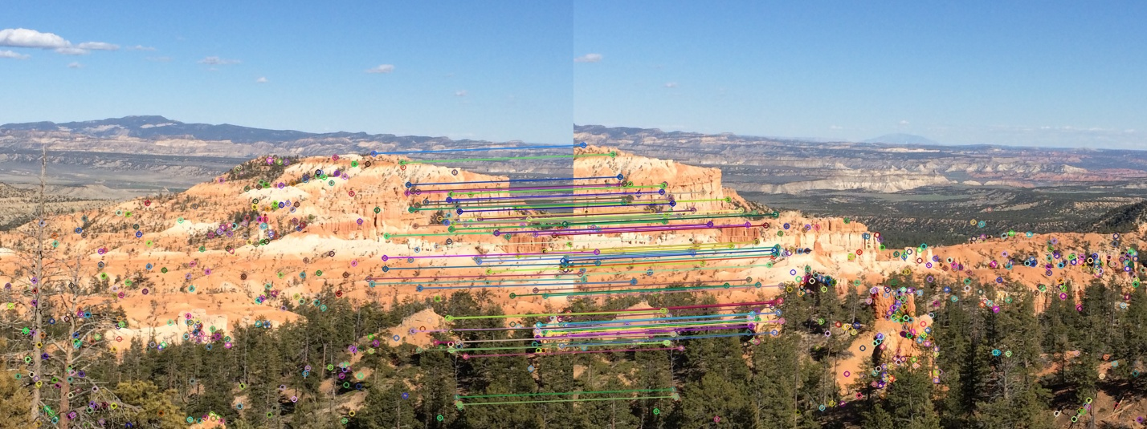

Stiched panaroma:
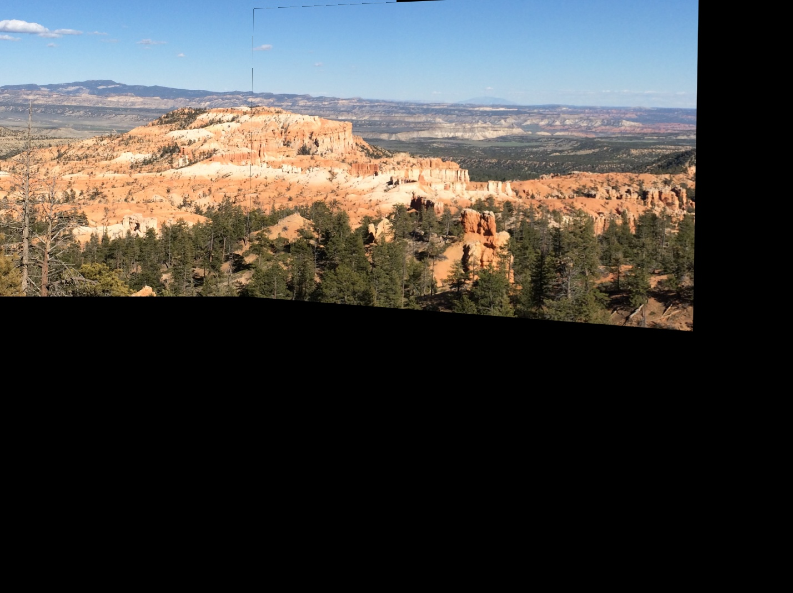
Case 2: Historic Monument

Sift Correspondences:
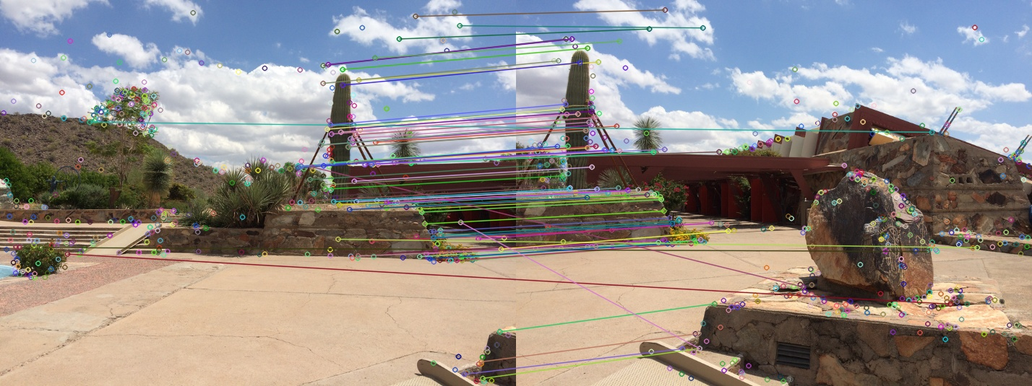
Stiched panaroma:
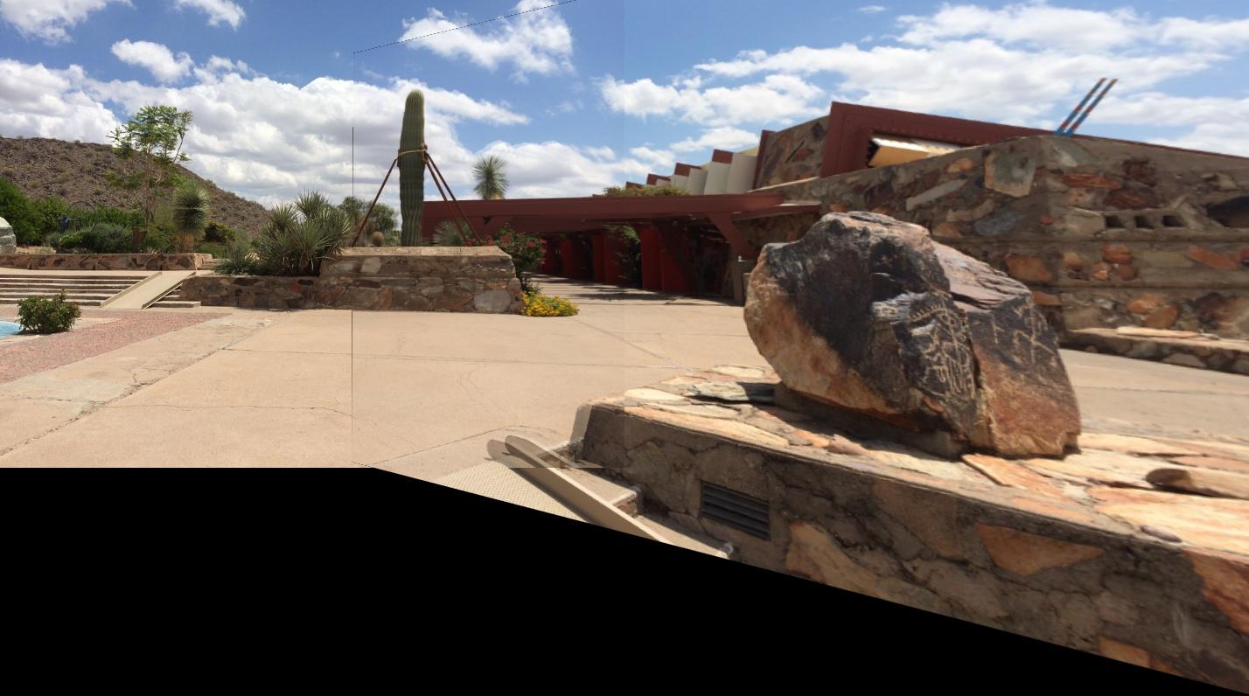
Case 3: Taj Mahal

Sift Correspondences 1

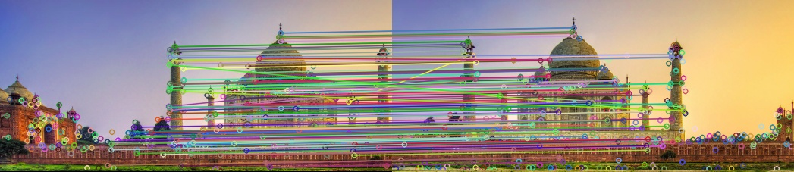

Sift Correspondences 2

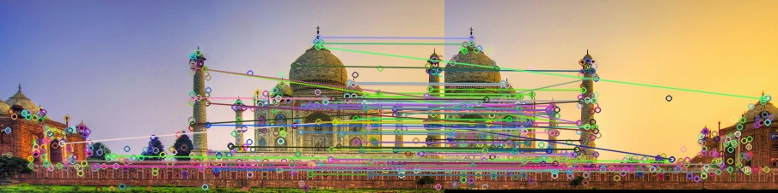
Sift Correspondences 3

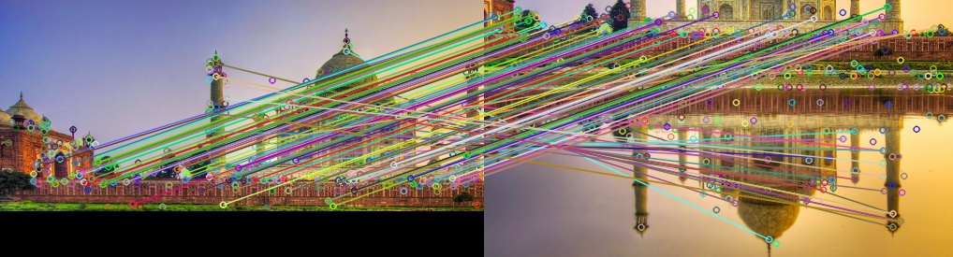
Sift Correspondences 4

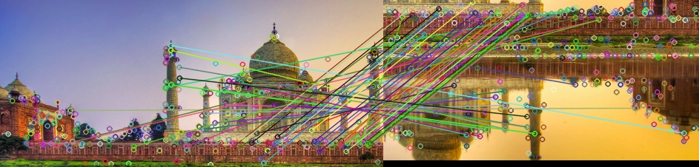
Stiched Panaroma:

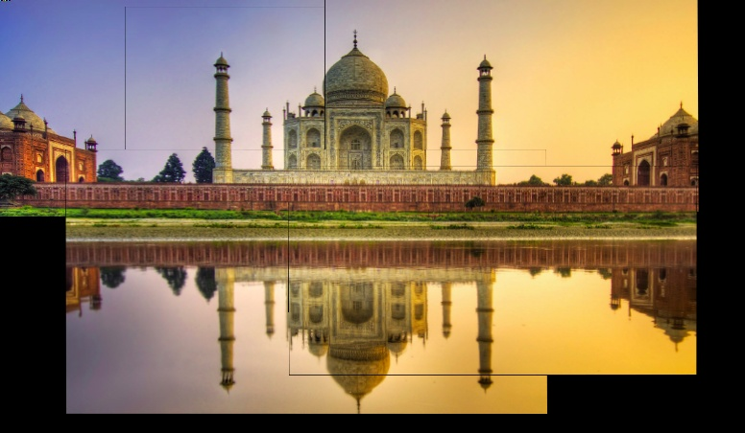

Case 4 : Self camera images

Sift Correspondences

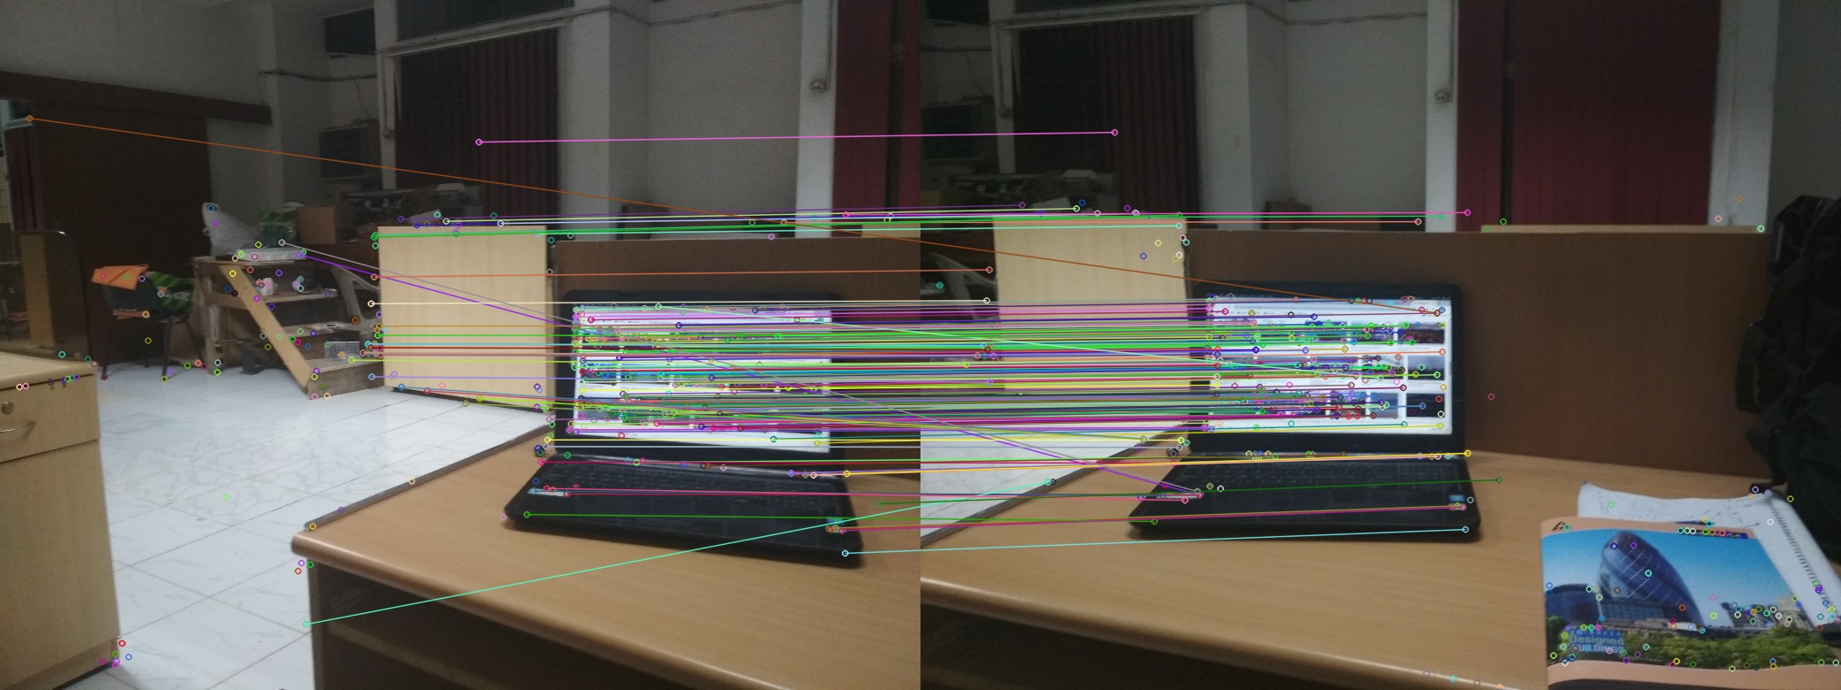

Stiched Panaroma:
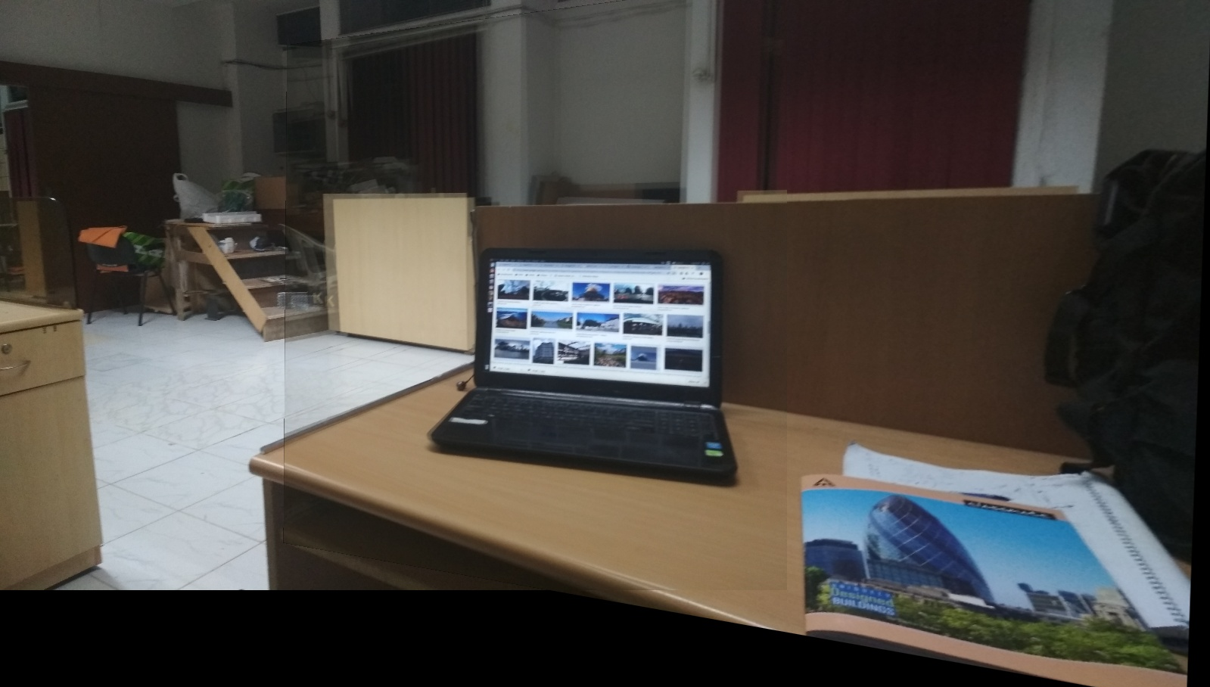

Case 5 : Self camera images

Sift Correspondences :

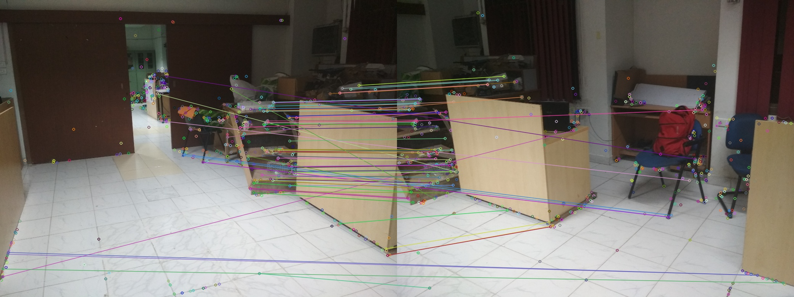
Stiched images:
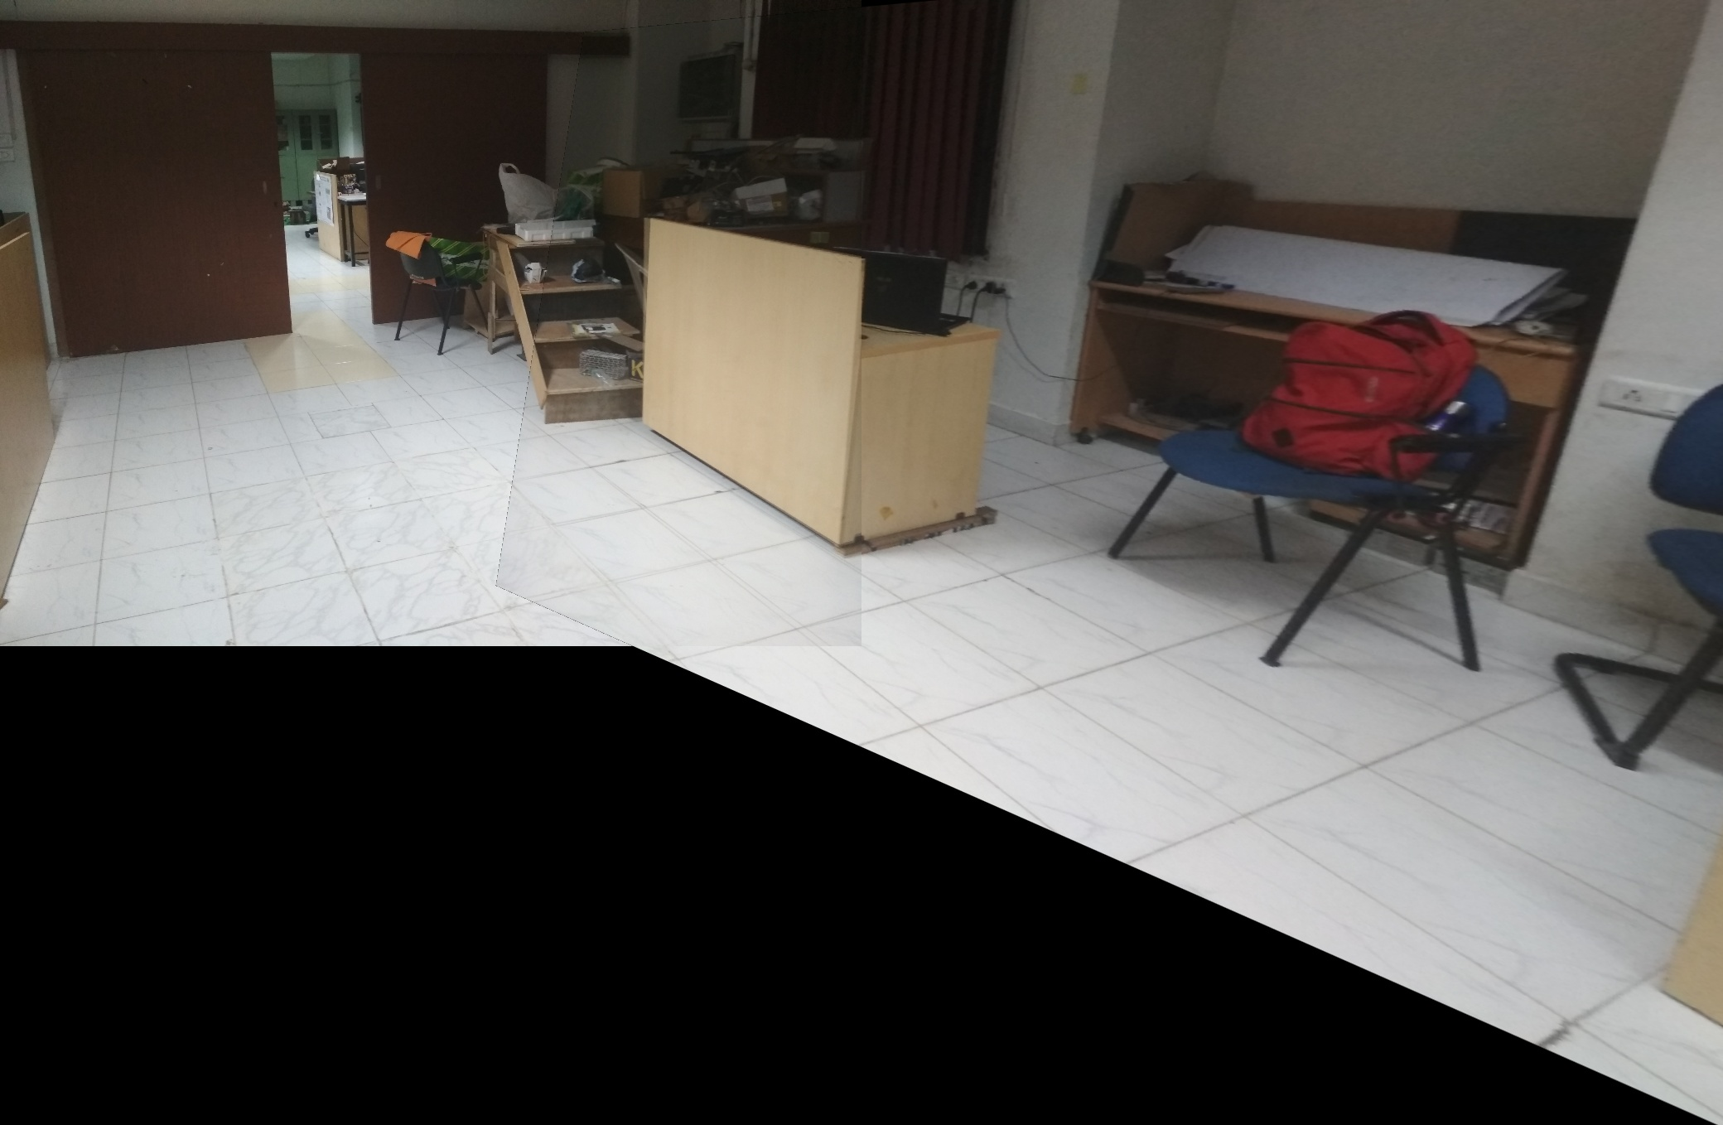

PROCEDURE:

1. Keypoints are calculated using SIFT features and FLANNBASED descriptor is used to get the correspondences.
2. For the cases which are failing to identify the correspondences like snippets of words or the image pair of taj mahal(3-4), I have done ORB and SURF feature detectors as well. Since there was very less overlapping area, most of the correspondences were outliers. For this case I have used a mask such that left part of source image corresponds to right part of target image.
3. After getting correpondence homography matrix is found using 4 points as a sample set for RANSAC algorithm. SVD of a matrix formed using image correspondences gives the homography matrix. After dividing the whole matrix with the last element, we could use this matrix for warping.
4. For warping image 2 is warped(transformed) to the coordinates frame of image 1 using homography matrix.
For generic panaroma, containing multiple images, I first calculate homography matrix between adjacent matrices and then final homography matrices of all images is calculated with repect to the first image. Thus all the images are warped with respect to the coordinate frame of first image.
For cases like Taj Mahal, I used the prior infomation of generic order to arrange the warped images, since images are taken in no particular order. And contain images in downward plane also.

Code:
1. The code is written using opencv in c++. It contains two files in src directory:
a. panaroma_taj_mahal.cpp - Code for specific taj mahal images using prior information.
b. sift_matcher.cpp – Generic code for stiching pairs of images, we can also specify the use of mask or not to assist feature detectors.

