**2_Exercises_STIBO_Assignment**

**Exercise 01 : Define Classification Object Types & Structure.**

**Solution :**

* Go to System setup -> Object Types & Structures -> Alternate Classifications -> Web Hierarchy Root ->Website -> New Object Type.

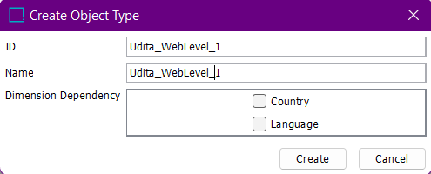

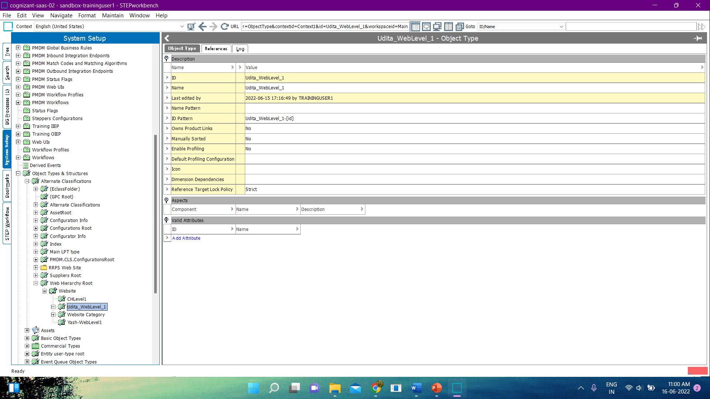

* Right Click on Udita_WebLevel_1-> New object type.

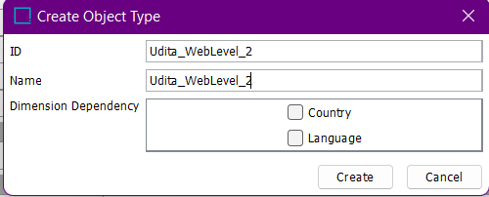

* Id Pattern :
* Udita_WebLevel_1:

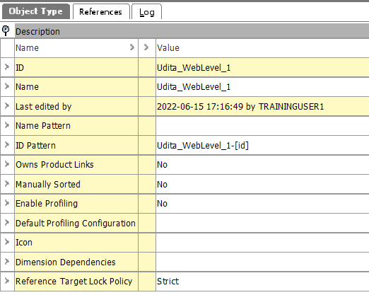

* Udita_WebLevel_2:

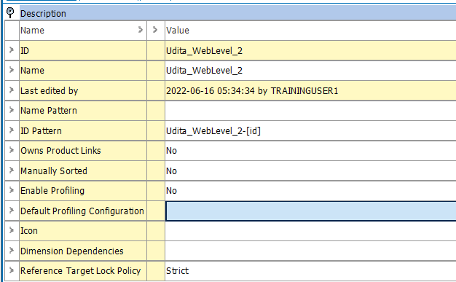

**Exercise 02 : Instantiate the Hierarchy.**

**Solution :**

* Go to Tree -> Web Hierarchy -> Right Click -> New Classification.

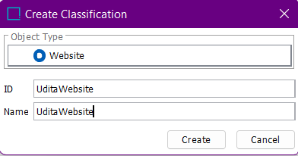

* Right click on UditaWebsite -> New Classification.

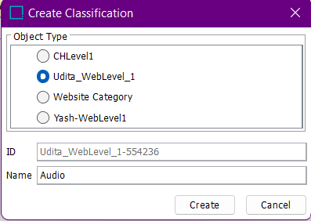

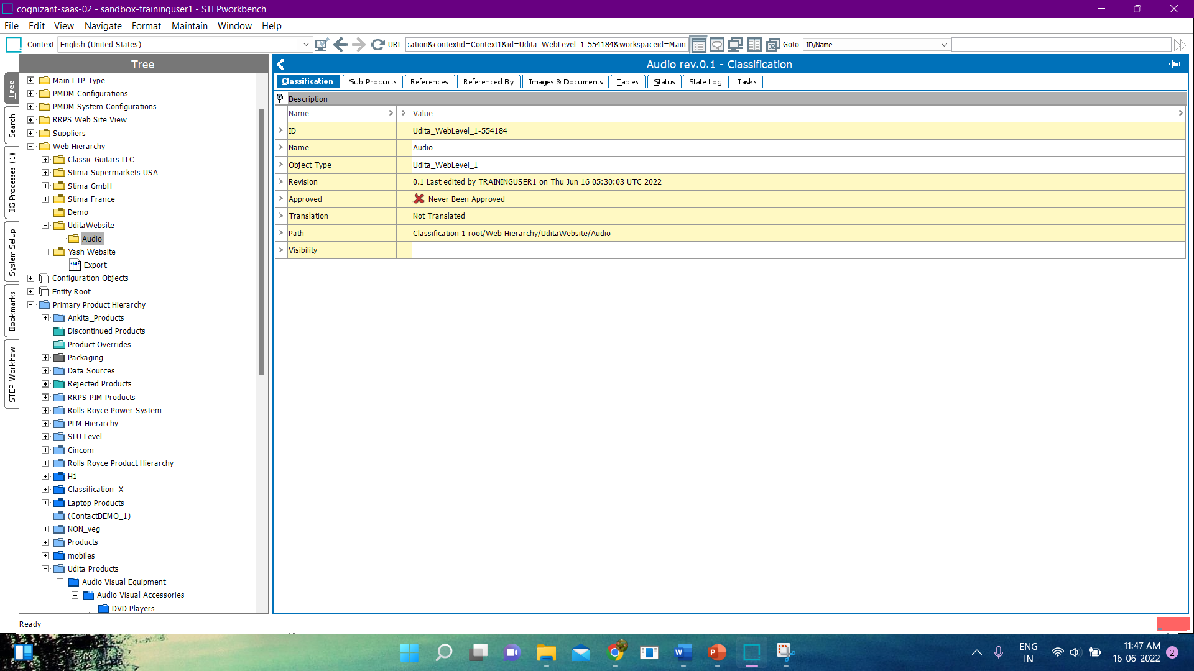

* Right Click on UditaWebsite -> New Classification.

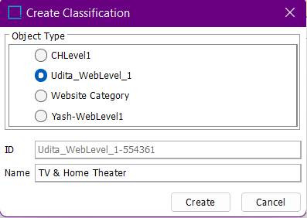

* Add Products and after adding products the hierarchy looks like :

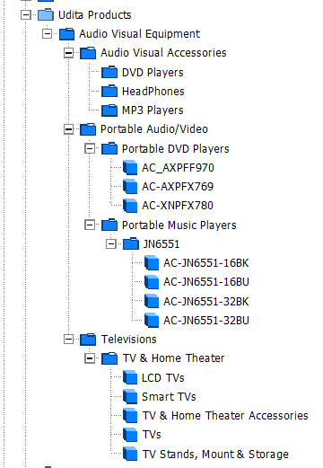

**Exercise 03 : Create New Product to Classification Link type.**

**Solution :**

* Go to System setup -> Reference Type -> Product to Classification link type.
* Right click on Product to Classification link type -> New Product to Classification link type.

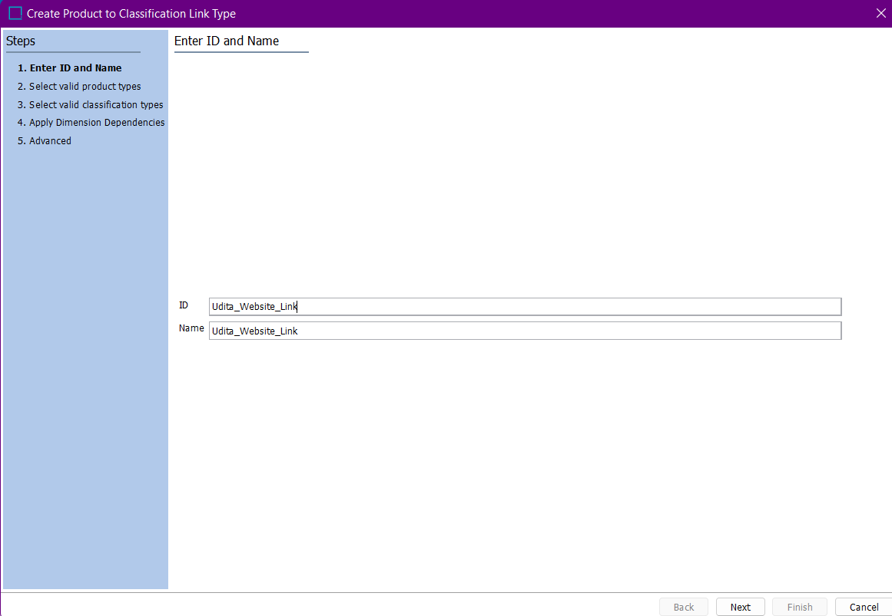

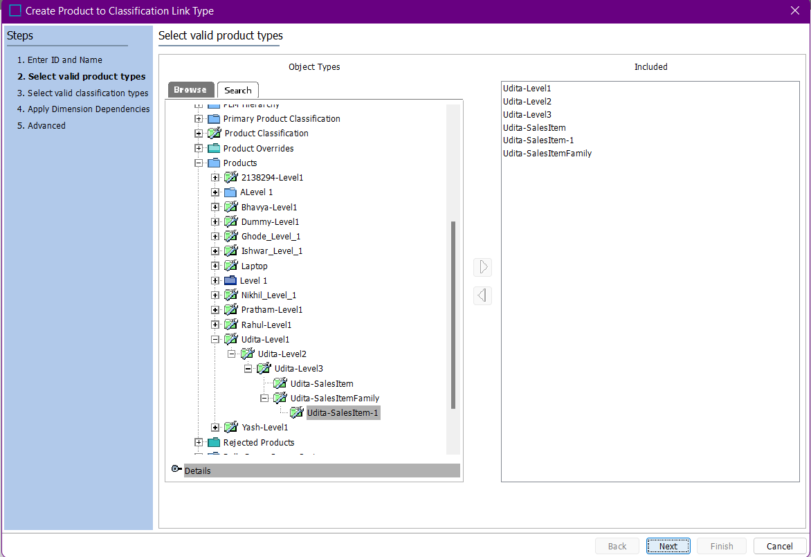

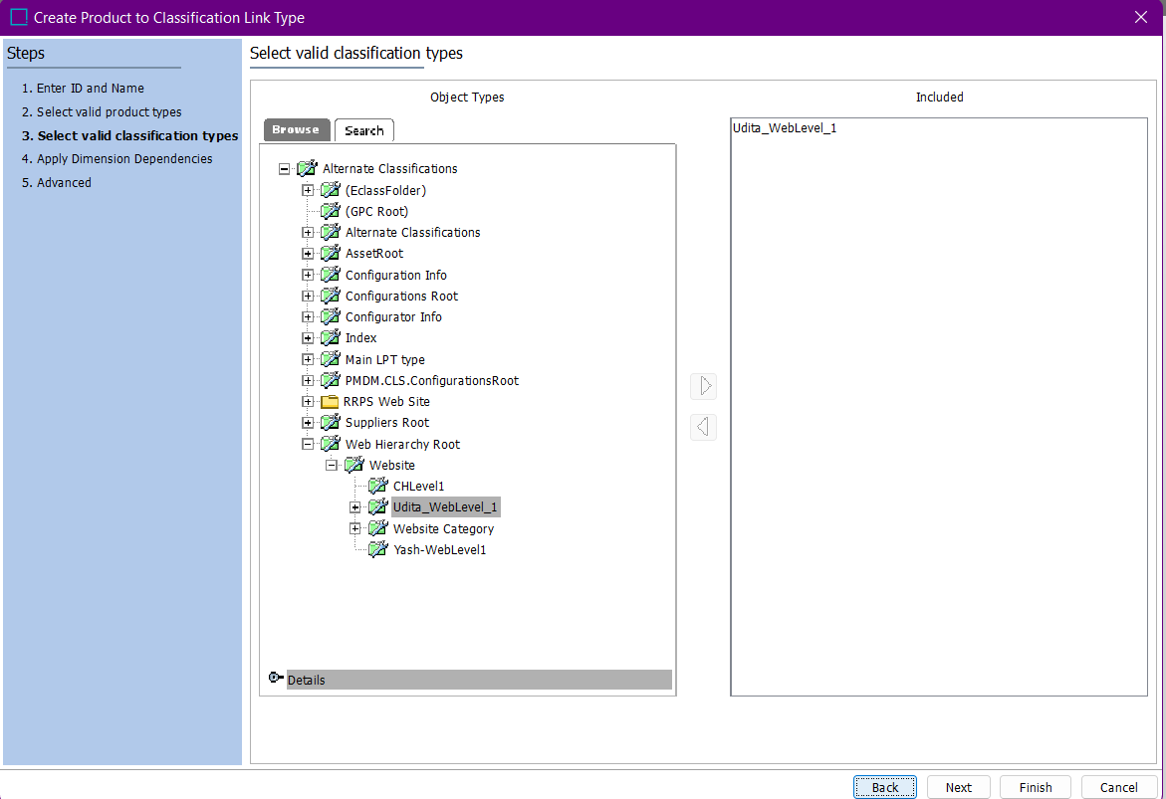

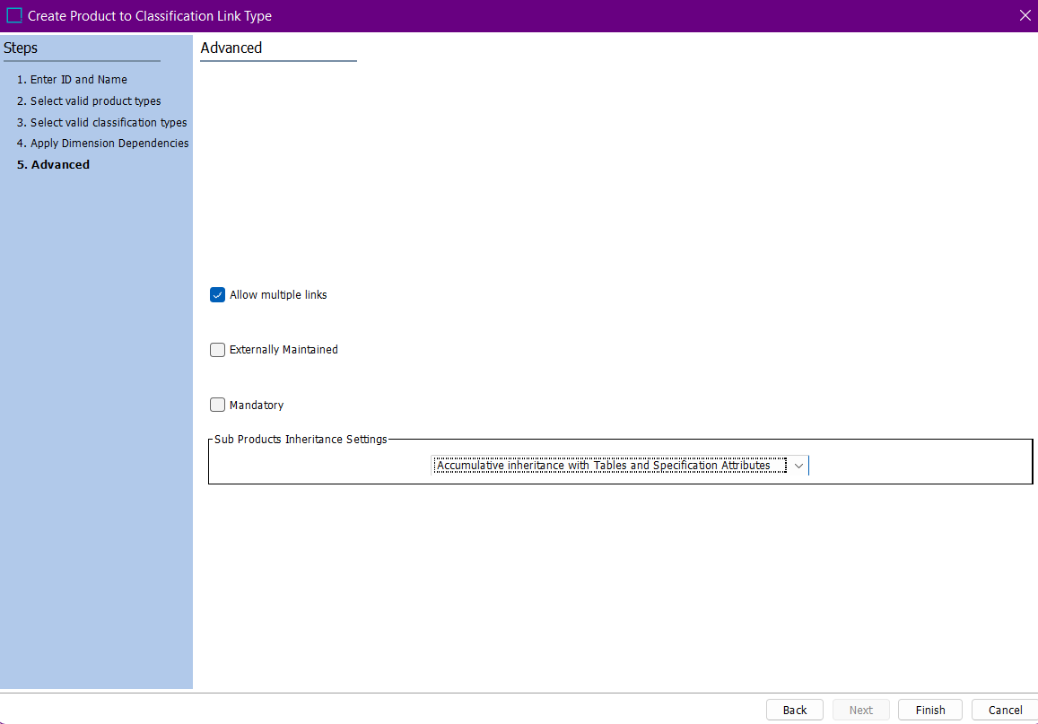

* Add Attribute Group.

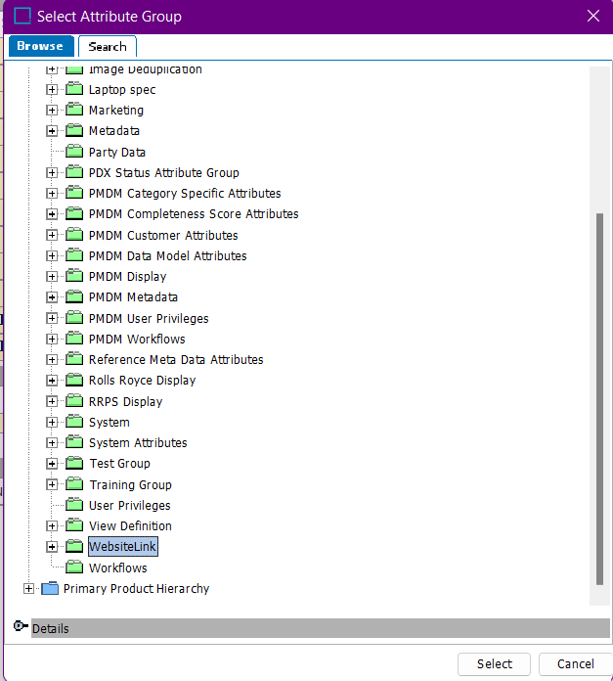

* Creating Links .

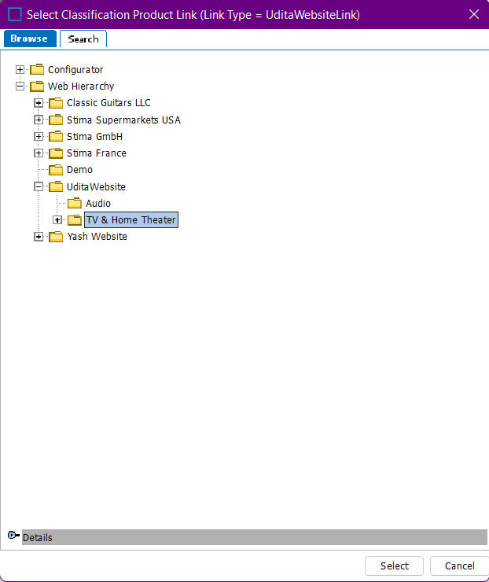

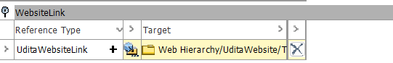

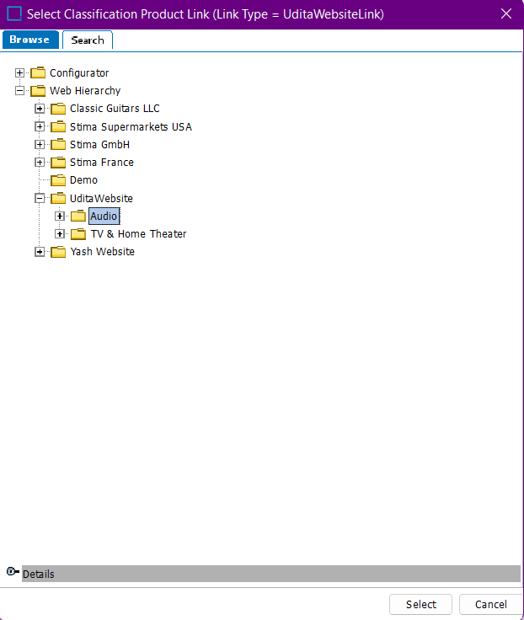

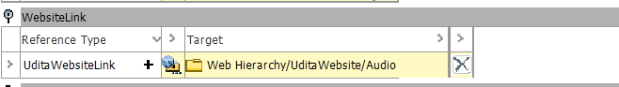

* Finally , it looks like :

