**3_Exercises_STIBO_Assignment_Solution**

**Exercise 01 :** Create a B2B customer.

**Solution :**

* Go to System Setup -> Object Types & Structures ->Entity User-type root -> Customer Data.
* Right click on Customer Data-> New Object Type.

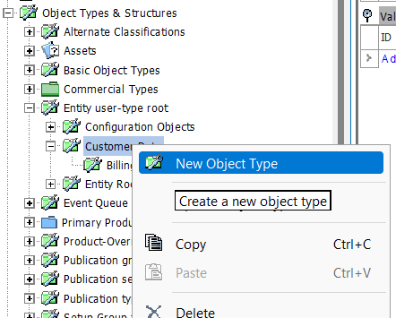

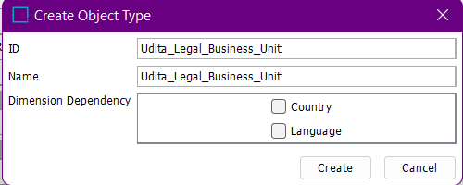

* Right click on Udita_Legal_Business_Unit -> New object type.

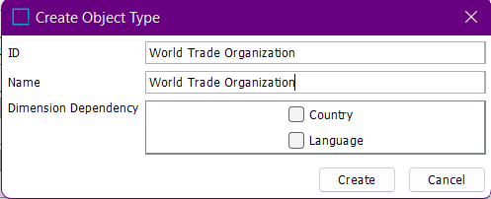

* Right click on Customer Data -> New Object type.

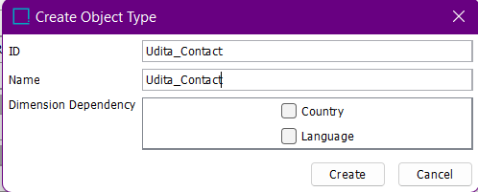

* Right click on Udita_Contacts -> New object type.

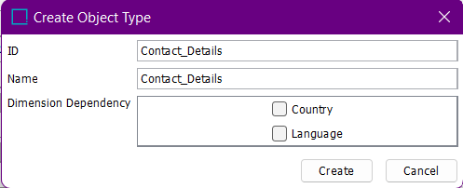

* Right click on Customer Data -> New Object type.

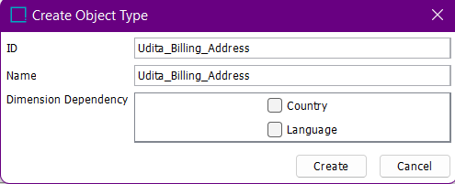

* Right click on Udita_Billing_Address -> New Object Type.

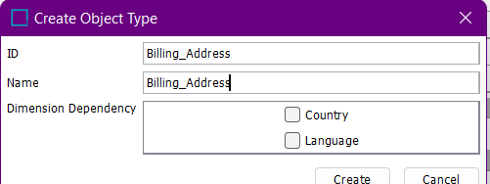

* Right click on Customer Data -> Udita_Ship-to_Address.

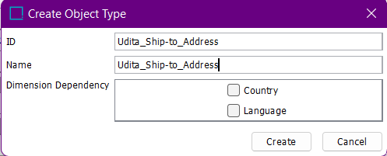

* Right click on Udita_Ship-to_Address -> New Object Type.

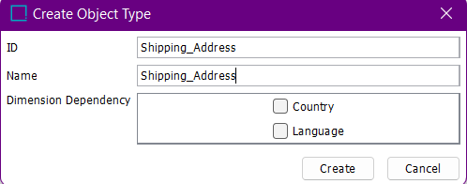

* It will look like this:

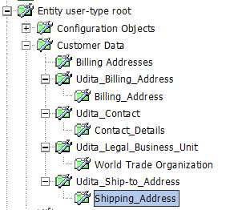

* Go to Tree -> Customer Data.
* Right click on Customer Data -> New Entity Node.

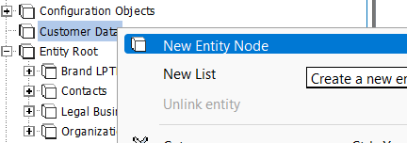

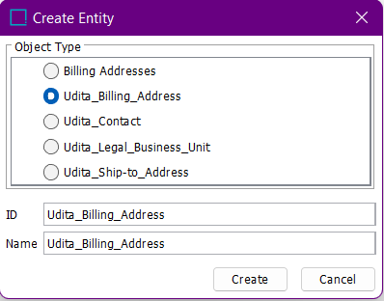

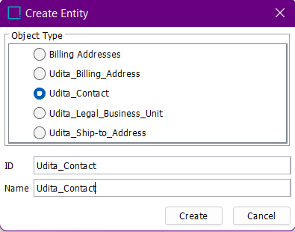

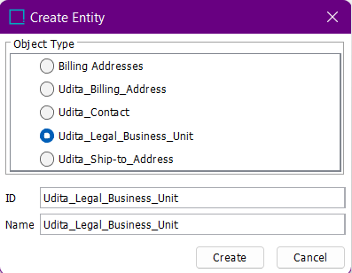

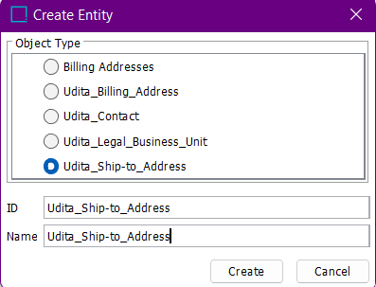

* Go to System setup-> Reference Types -> Entity Reference Types.
* Right click on Entity Reference Types -> New Entity Reference Type.

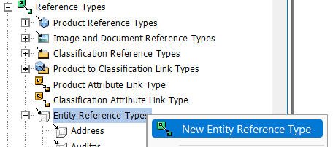

* Udita_Billing_Address Entity Reference Type:

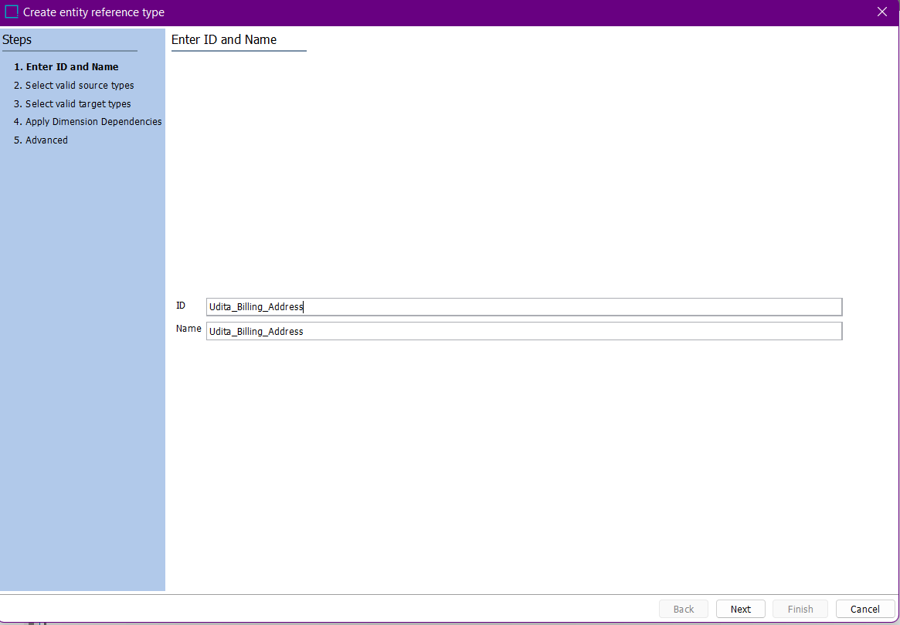

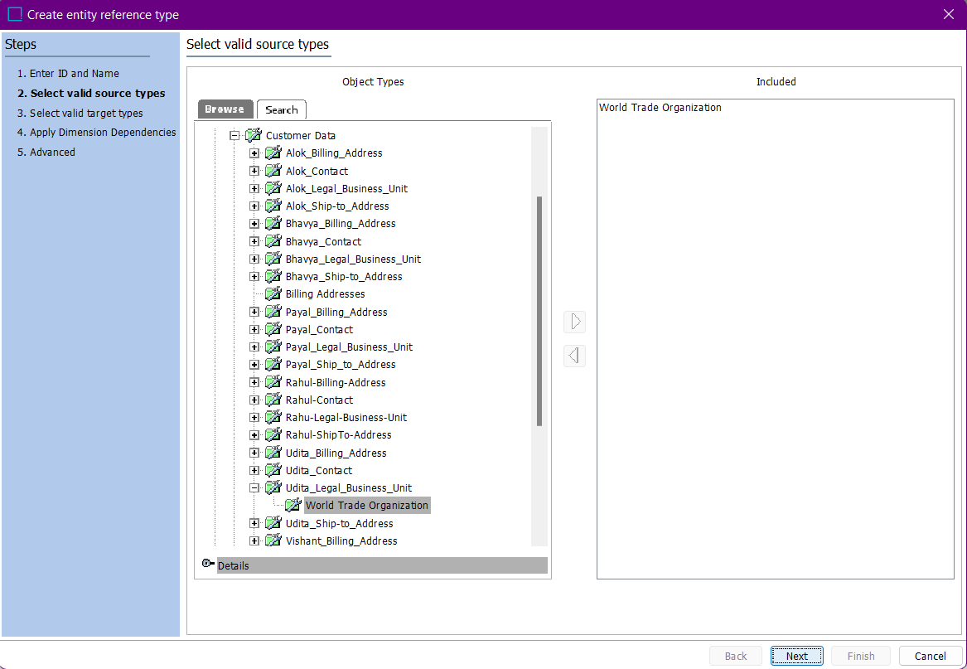

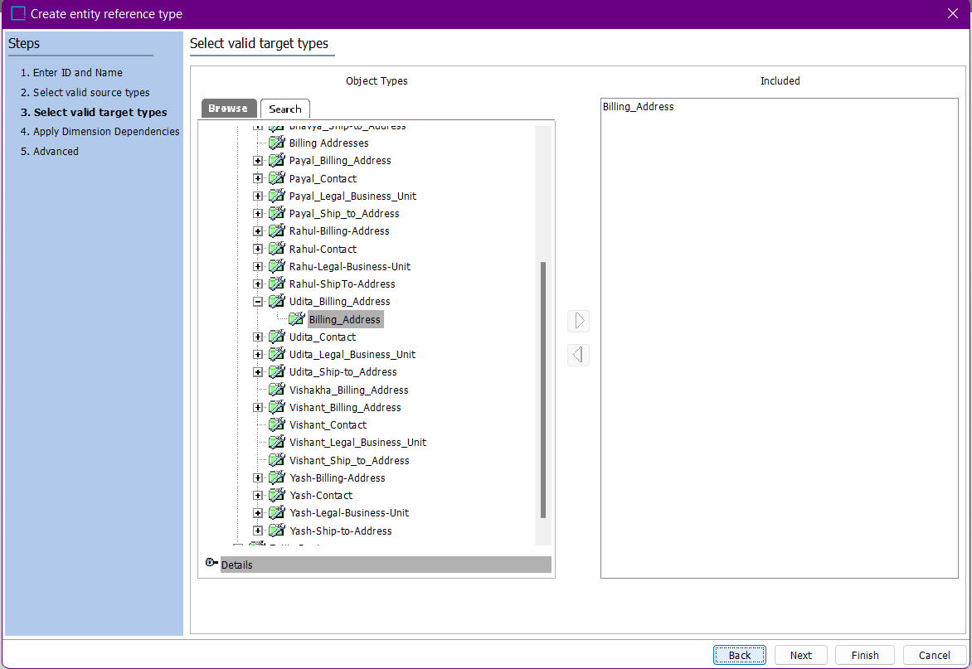

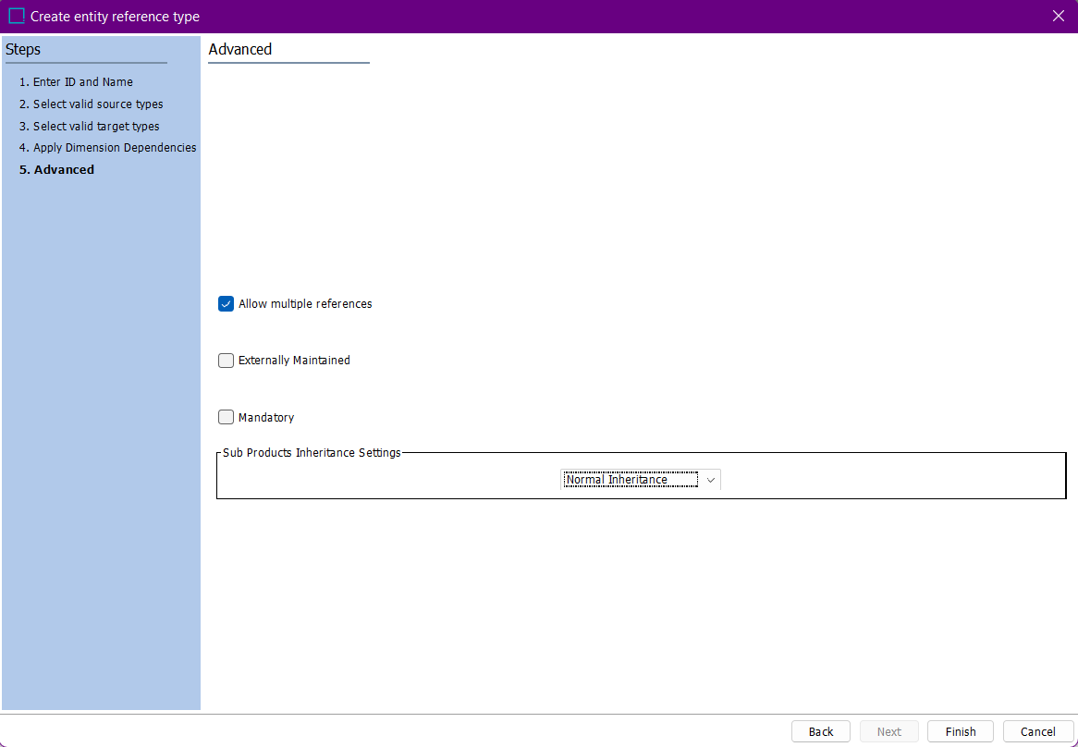

* Udita_Contact Entity Reference Type :

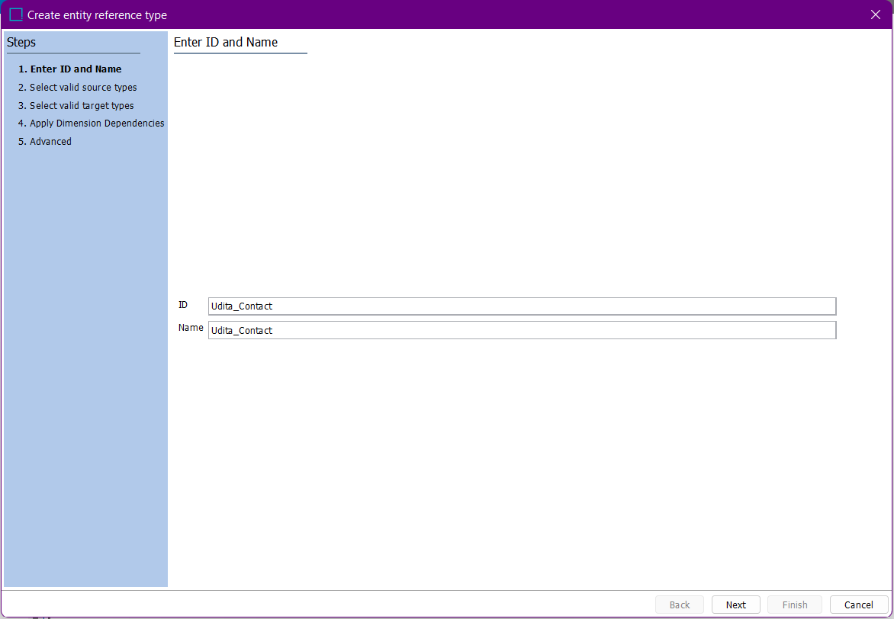



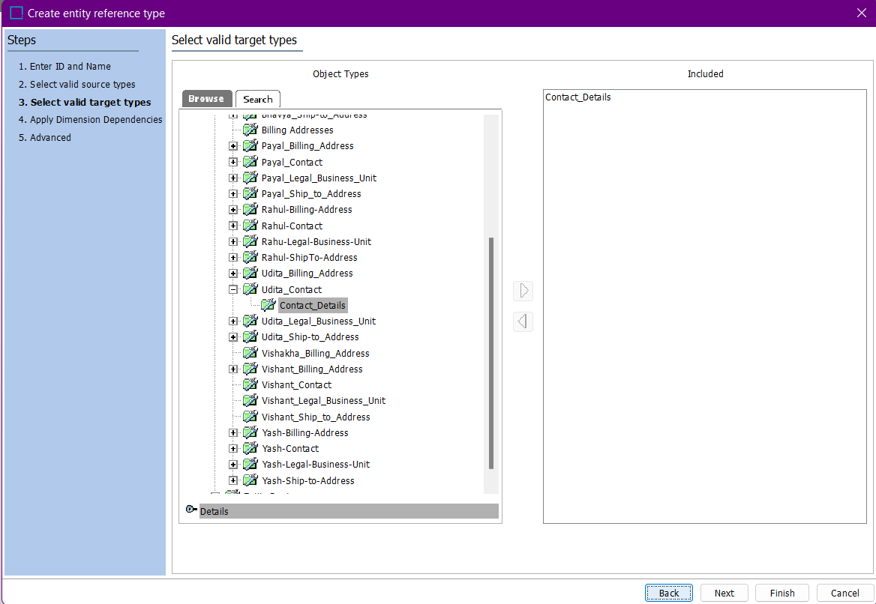

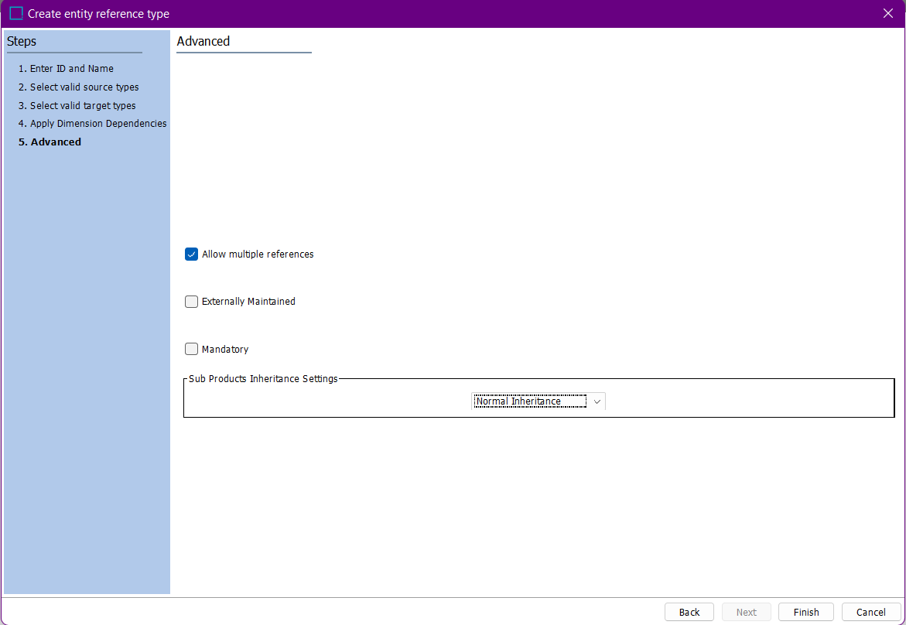

* Udita_Shipping_Address Entity Reference Type :

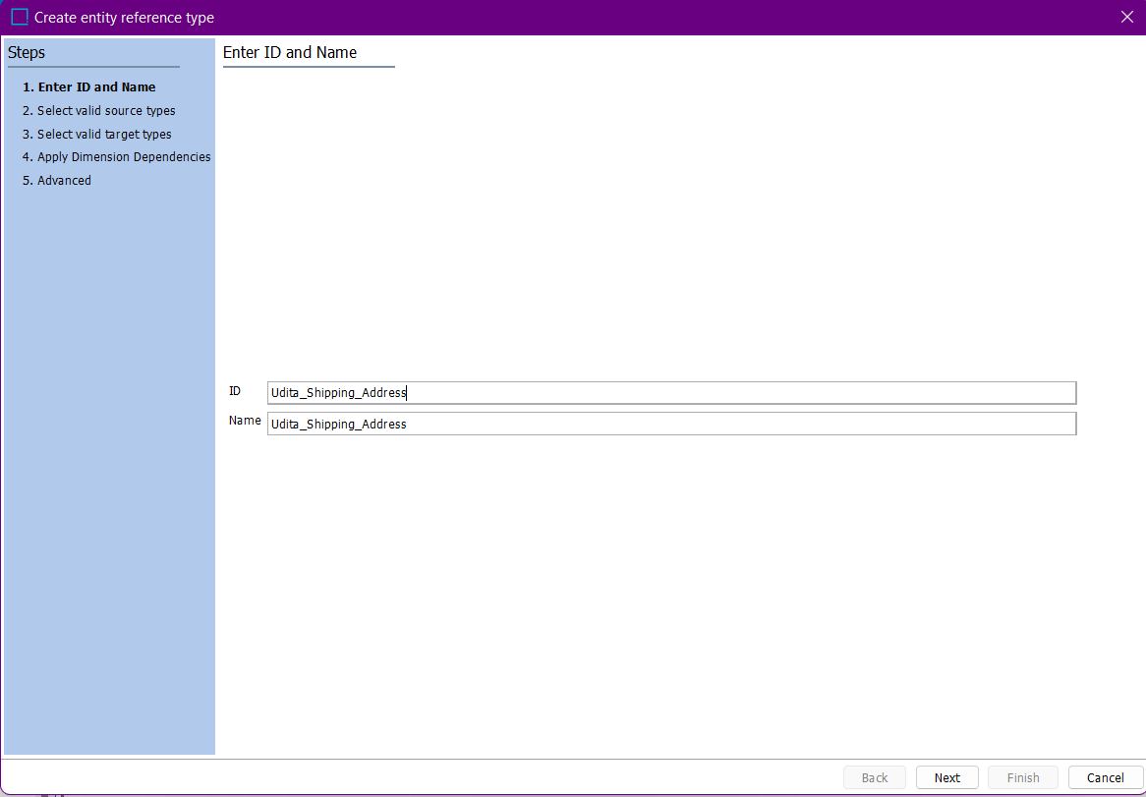



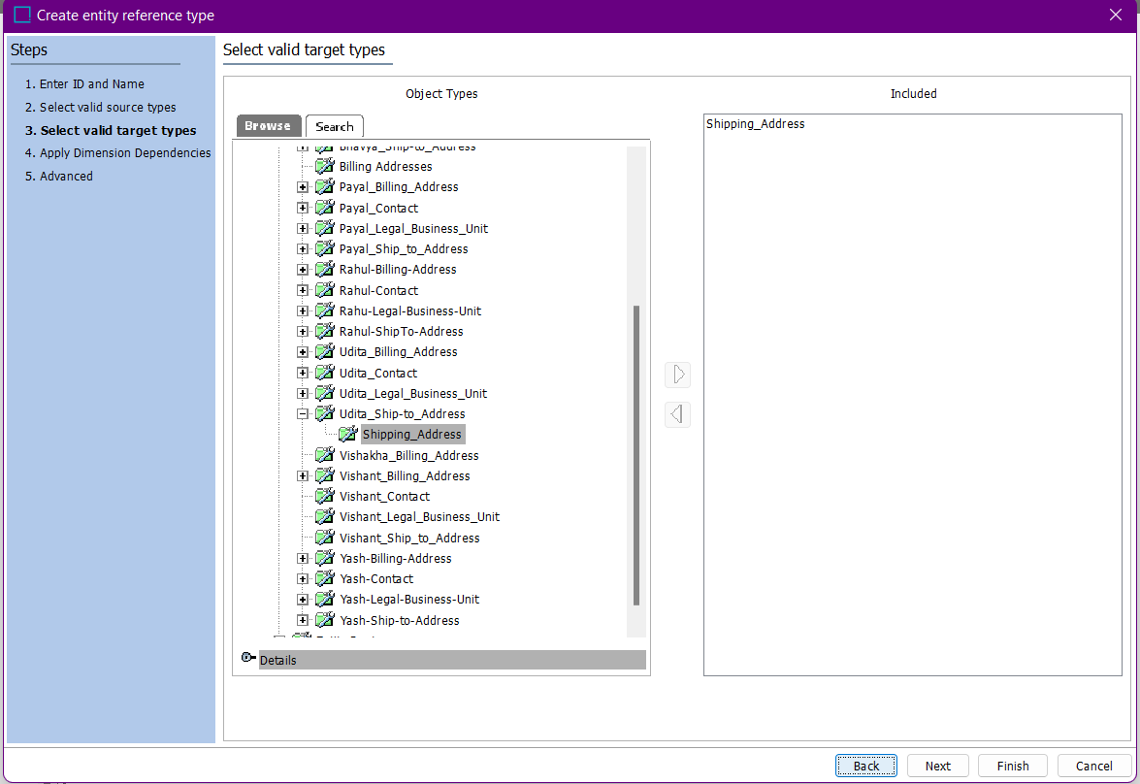

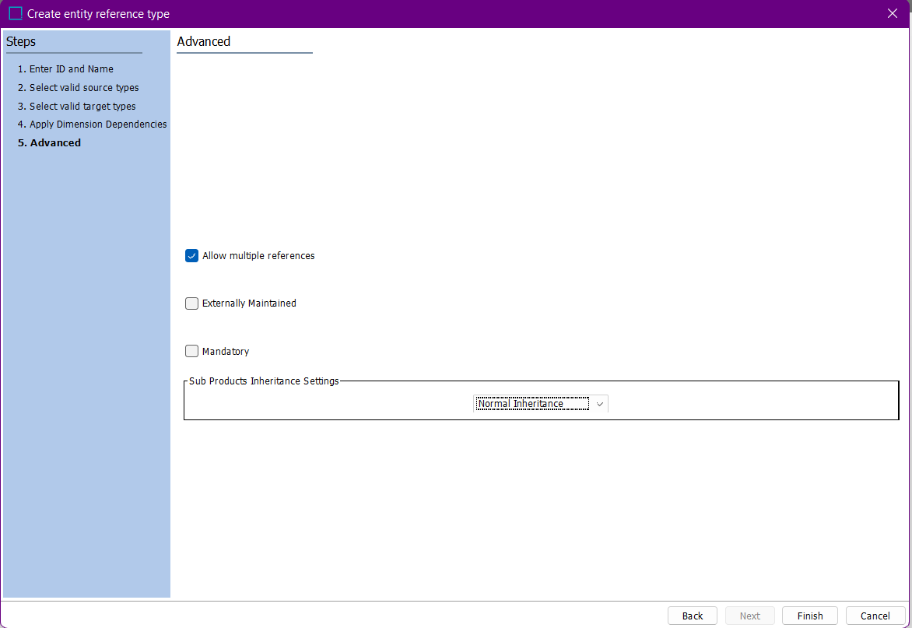

* Udita_Legal_Business_Unit Entity Reference Type :

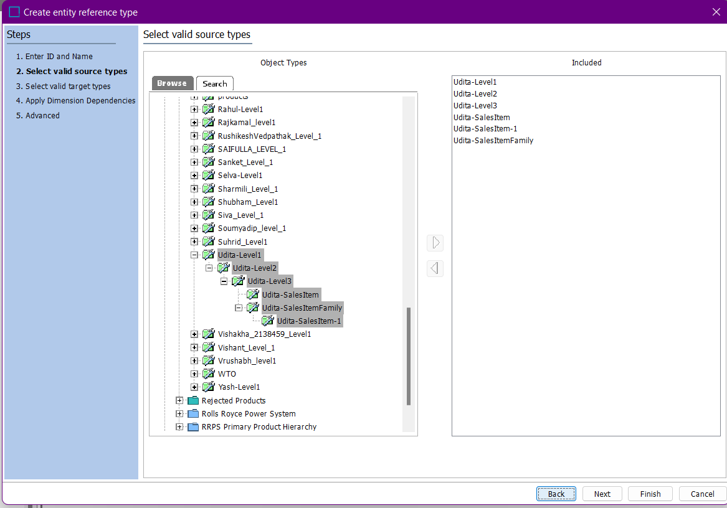

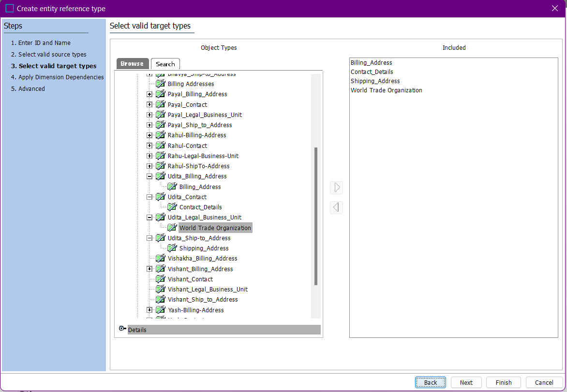

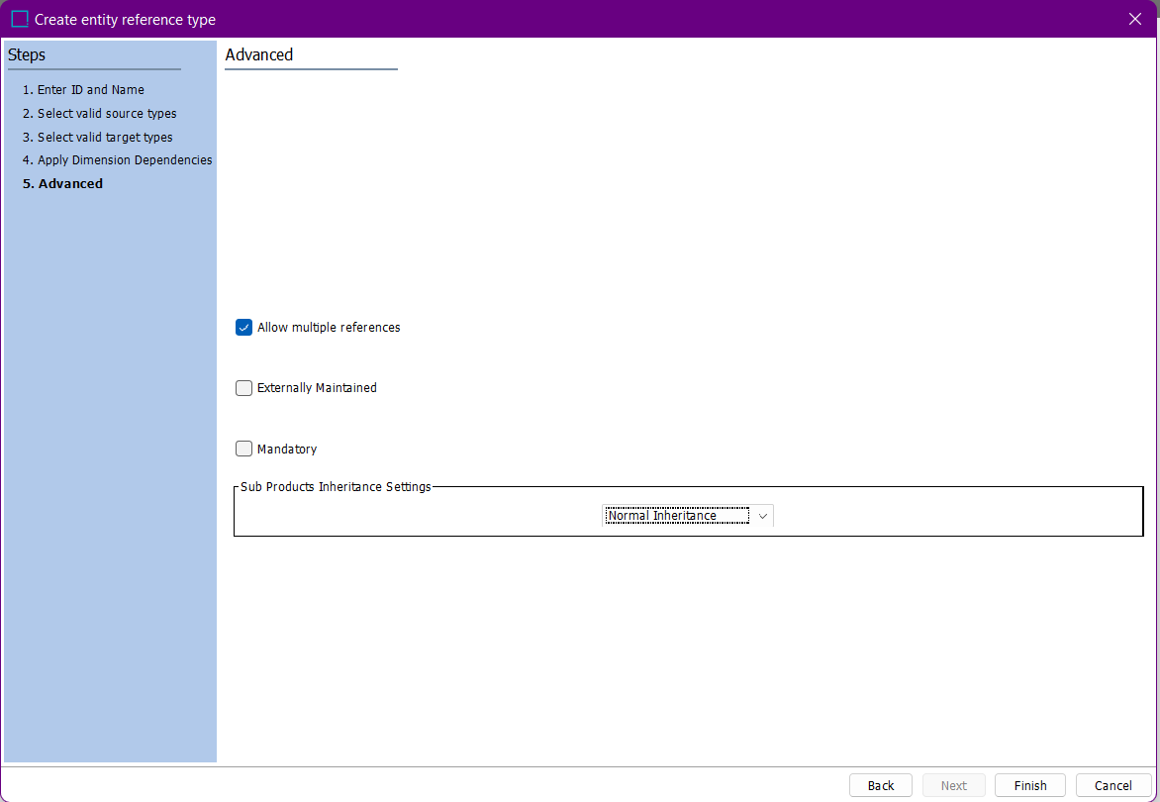

* Go to Tree -> Customer Data -> Udita_Billing_Address.
* Right click on Udita_Billing_Address-> New Entity Node.

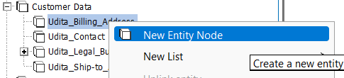

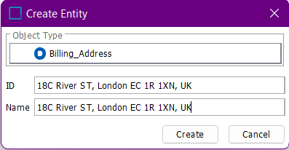

* Right click on Udita_Contact -> New Entity Node.

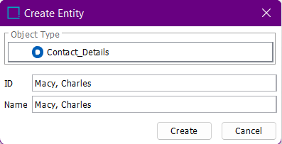

* Right click on Udita_Ship-to_Address -> New Entity Node.

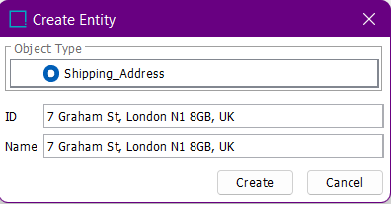

* Right click on Udita_Legal_Business_Unit -> New Entity Node.

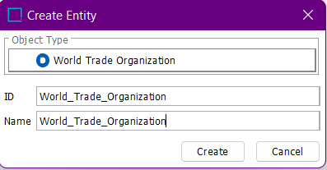

* Go to Tree -> Customer Data -> Udita_Legal_Business_Unit-> World_Trade_Organization.
* Click on Reference Tab and link each entity by clicking on + symbol.

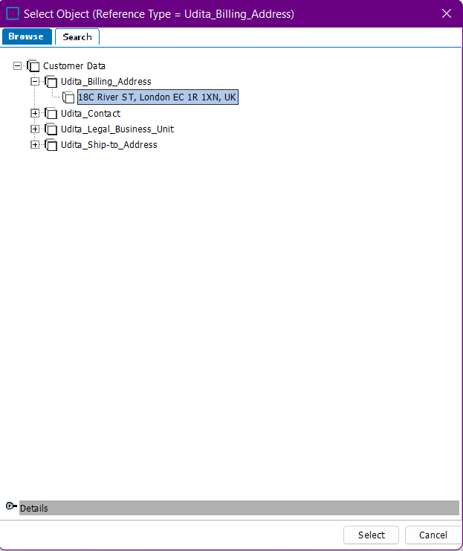

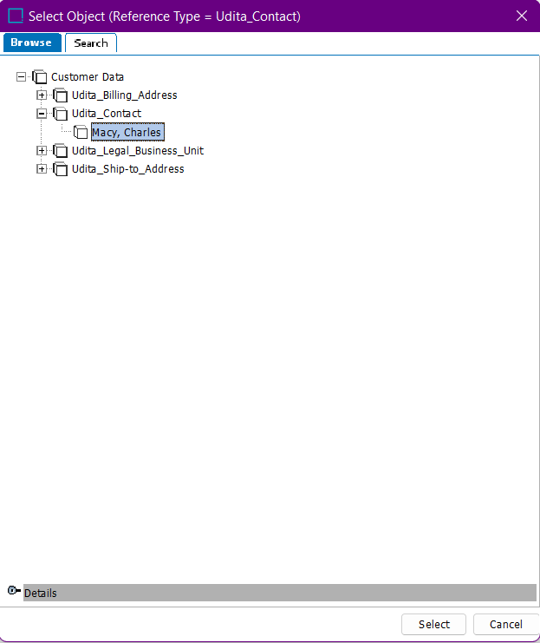

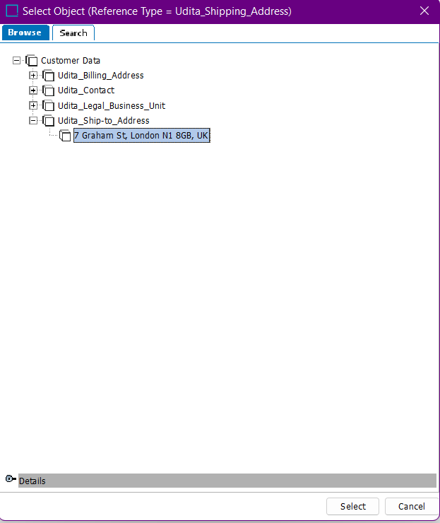

* Finally , it looks like this:

