**4_Exercises_STIBO_Assignment_Solution**

**Exercise 01 : Simple Excel Export.**

**Solution :**

* Go to Tree -> Primary Product Hierarchy-> Udita Products -> Audio Visual Equipment -> Televisions -> LCD-> P7000.
* Right Click on P7000 -> Export data below.

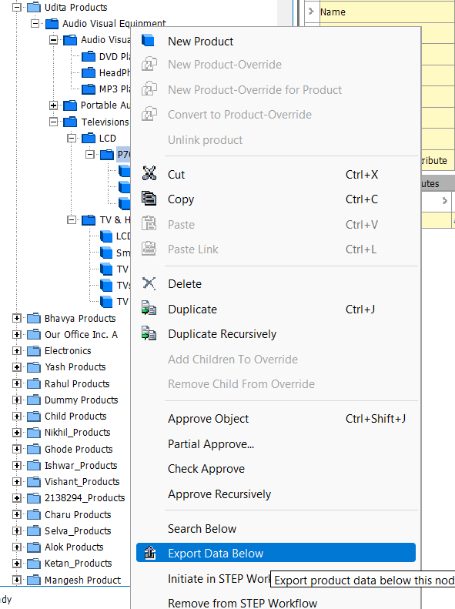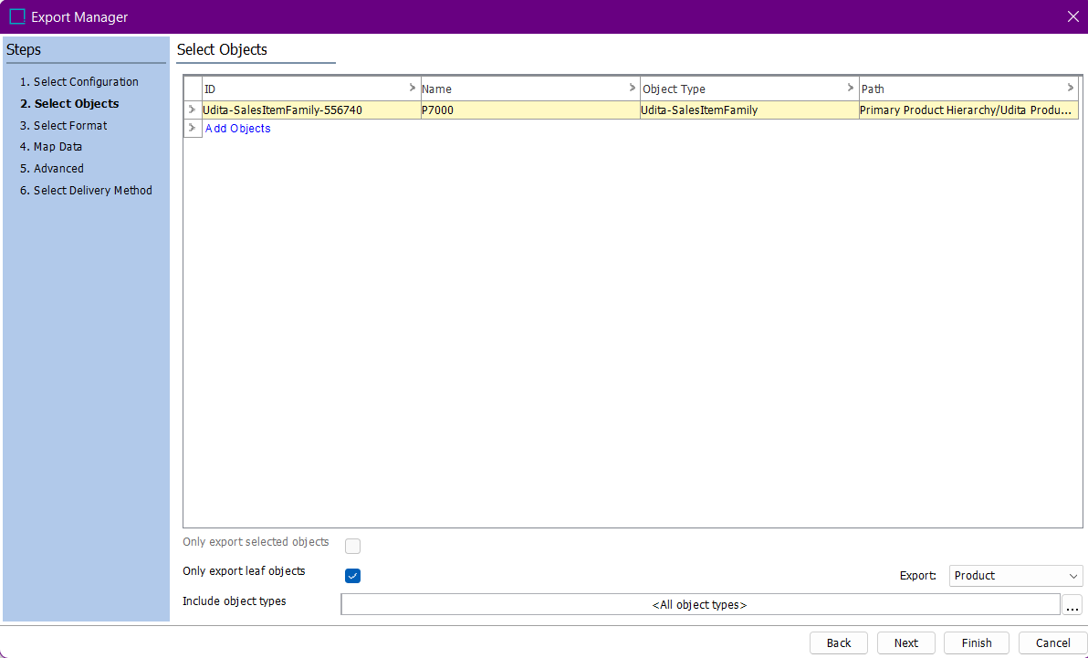

* Select Excel format :

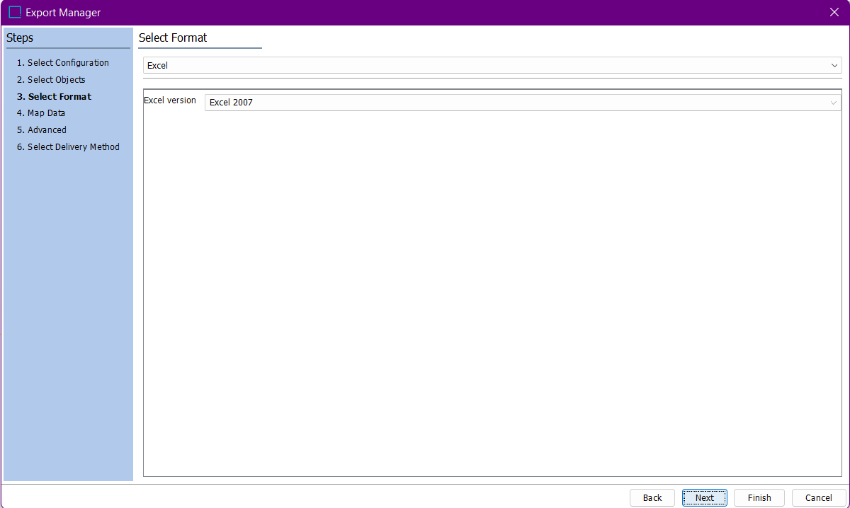

* Map ID, Name, All attributes:

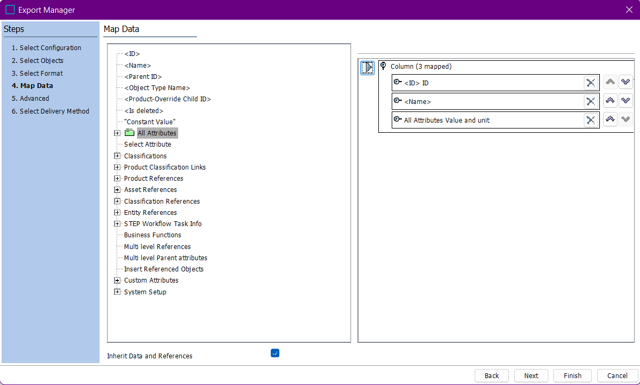

* Select Delivery method as File :

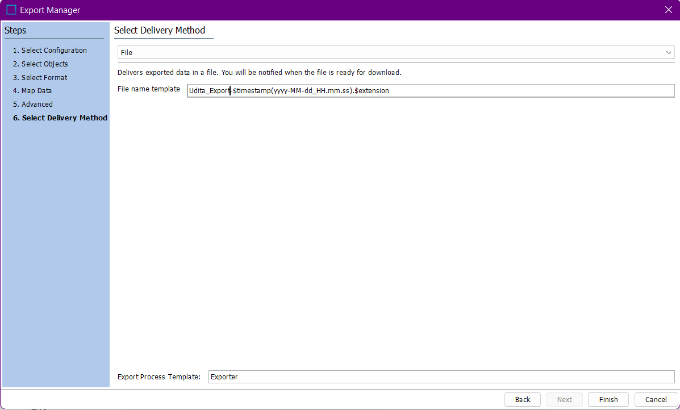

* Click on finish.

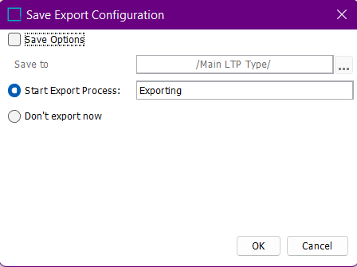

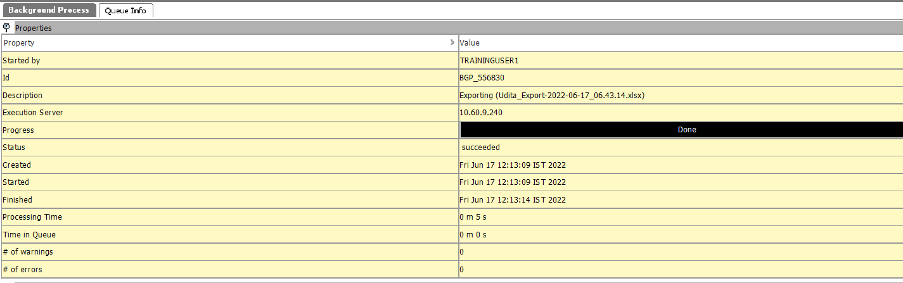

* Save the file on the local machine.

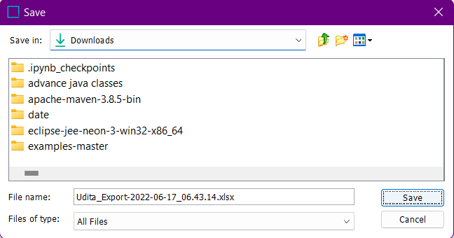

* Output :

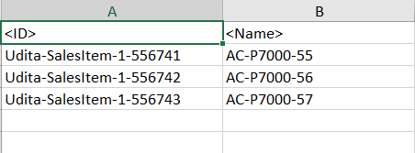

**Exercise 02 : Advanced Excel Export.**

**Solution :**

* Go to File -> Export -> Data.

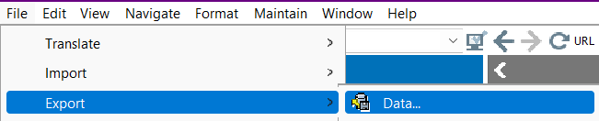

* Select P7000 object from Udita Products.

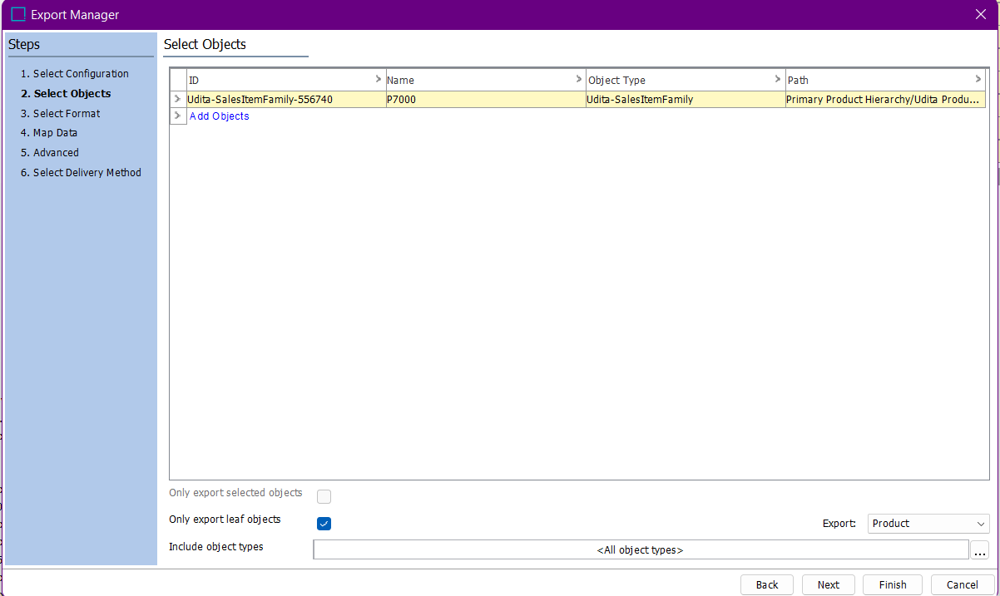

* Select Excel as format.

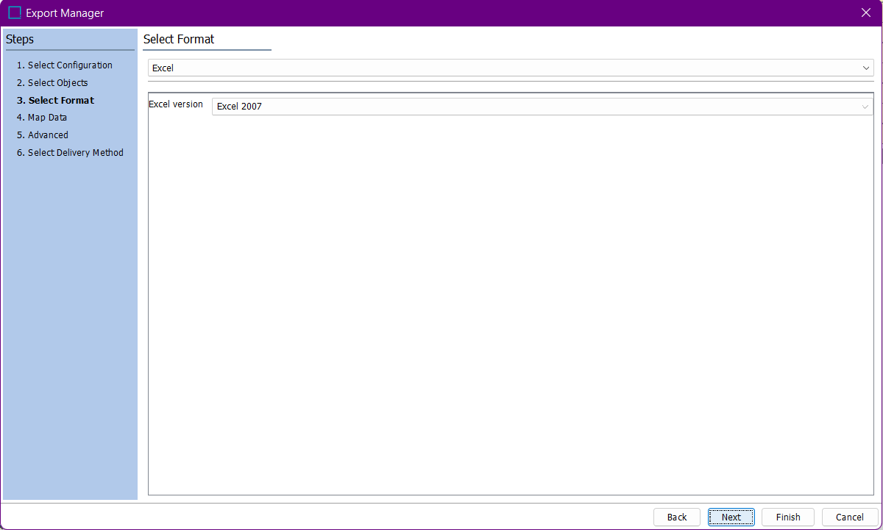

* Map Name and use Constant for creating output column and use Multi level references for Accessory.

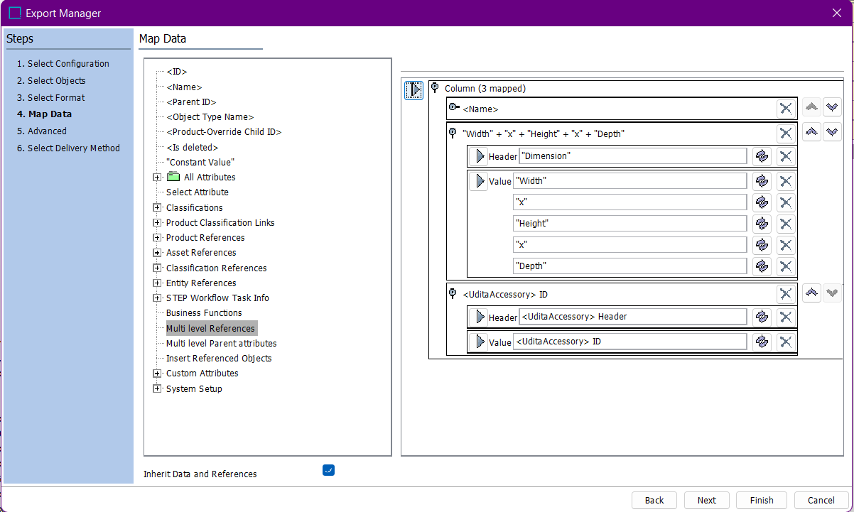

* Select Delivery Method as File.

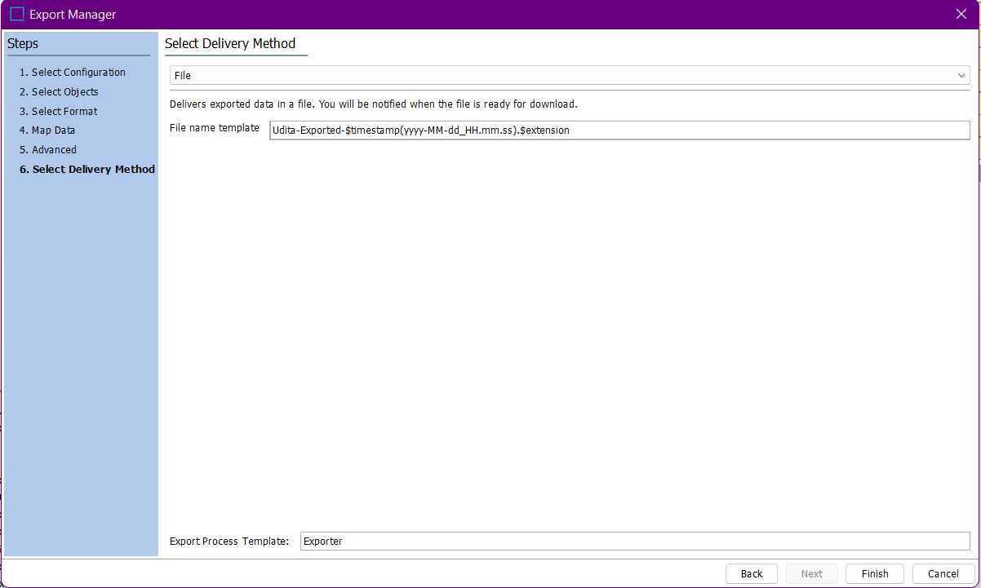

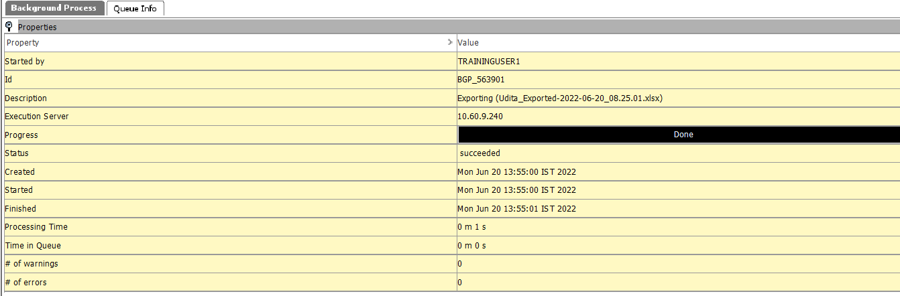

* Save on local machine.
* Output :

