**5_Exercises_STIBO_Assignment_Solution**

**Exercise 01 : CSV Import.**

**Solution :**

* Download file from STEP.
* Go to File -> Import-> Data.

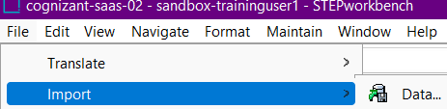

* Select location of file.

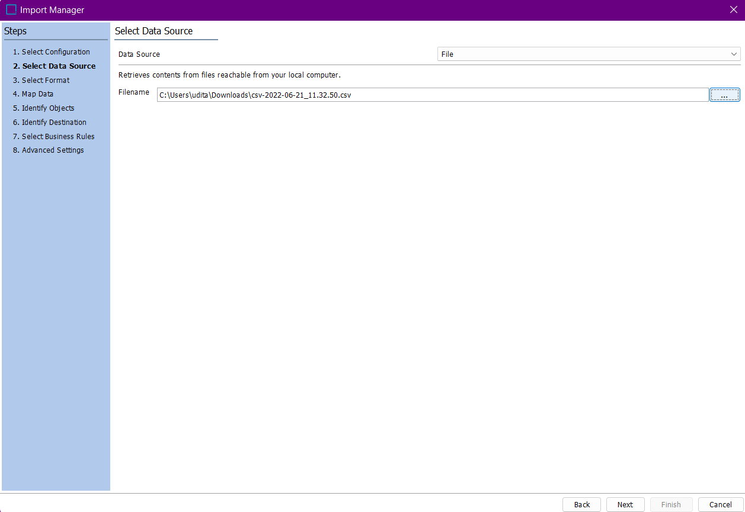

* Map the data and select header .

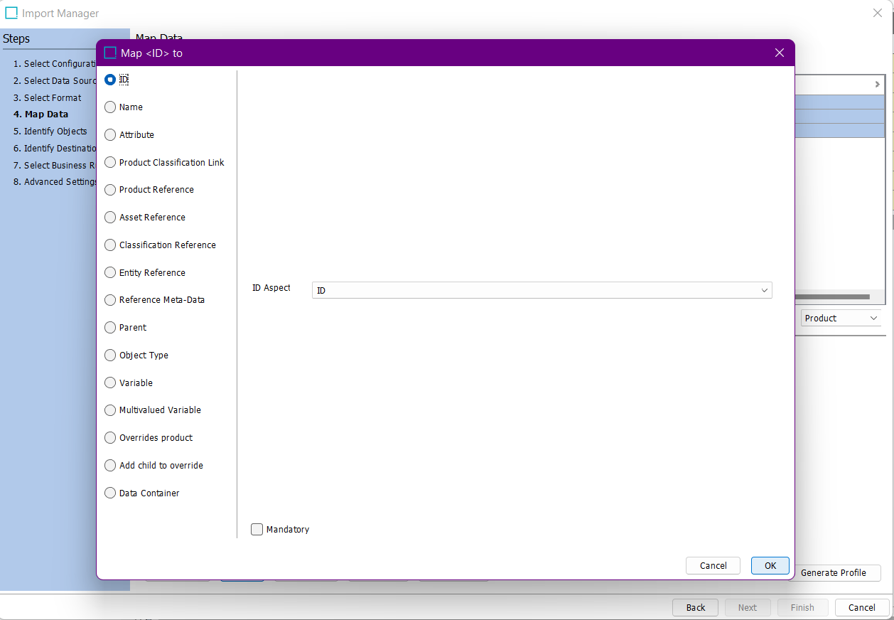

* Select Approve Import Changes.

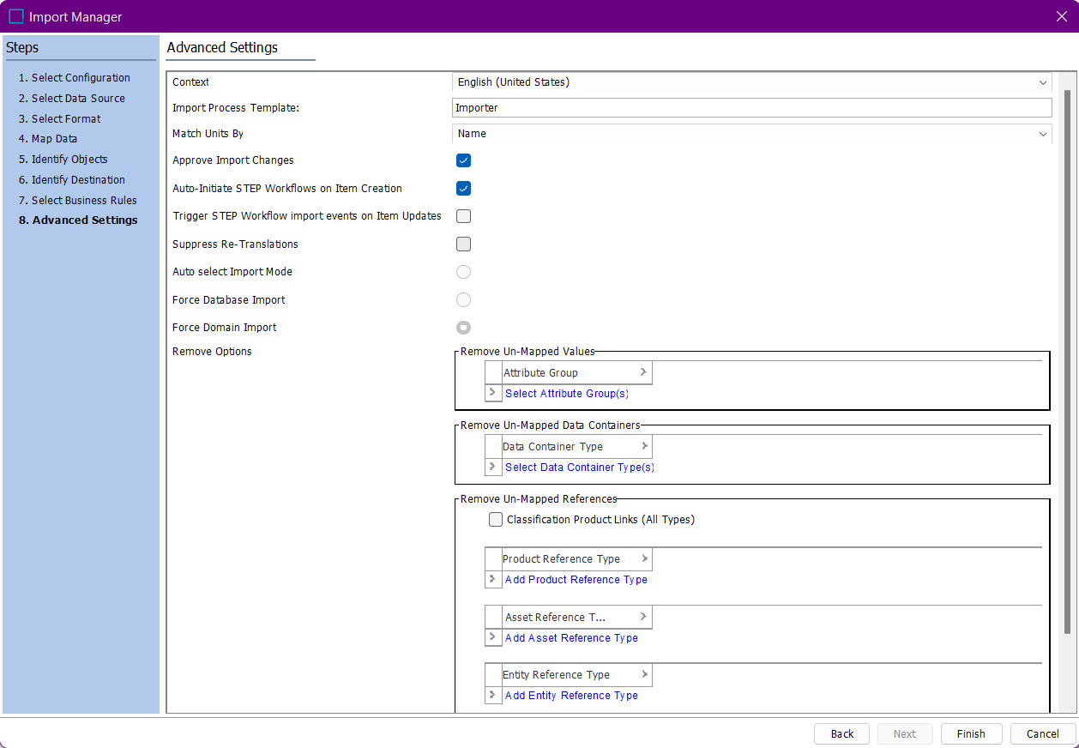

* Save Import Configuration.

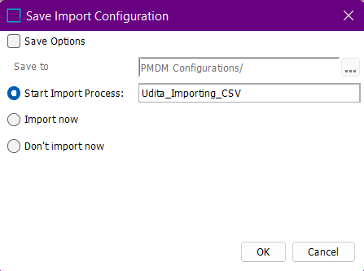

* Imported Successfully.

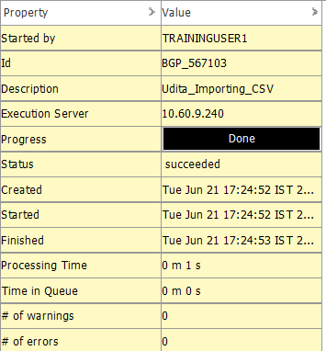

**Exercise 02 : Excel Import.**

**Solution :**

* Download file from STEP.
* Go to File -> Import -> Data.



* Select location of file.

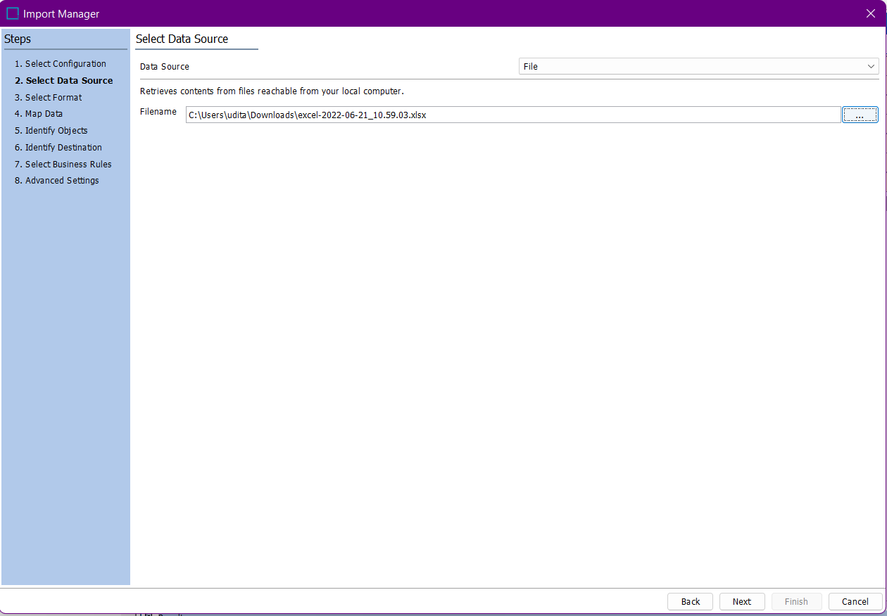

* Map the data using AutoMap/Map.

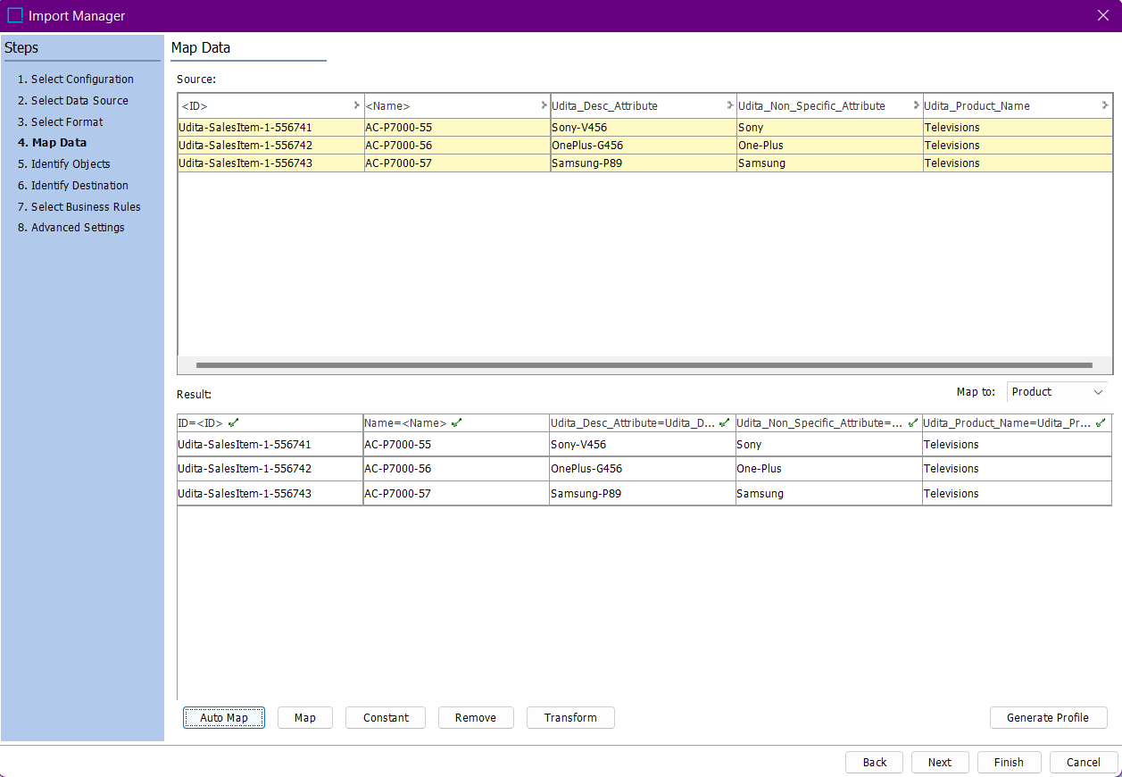

* Click on Approve Import Changes in Advanced Settings.

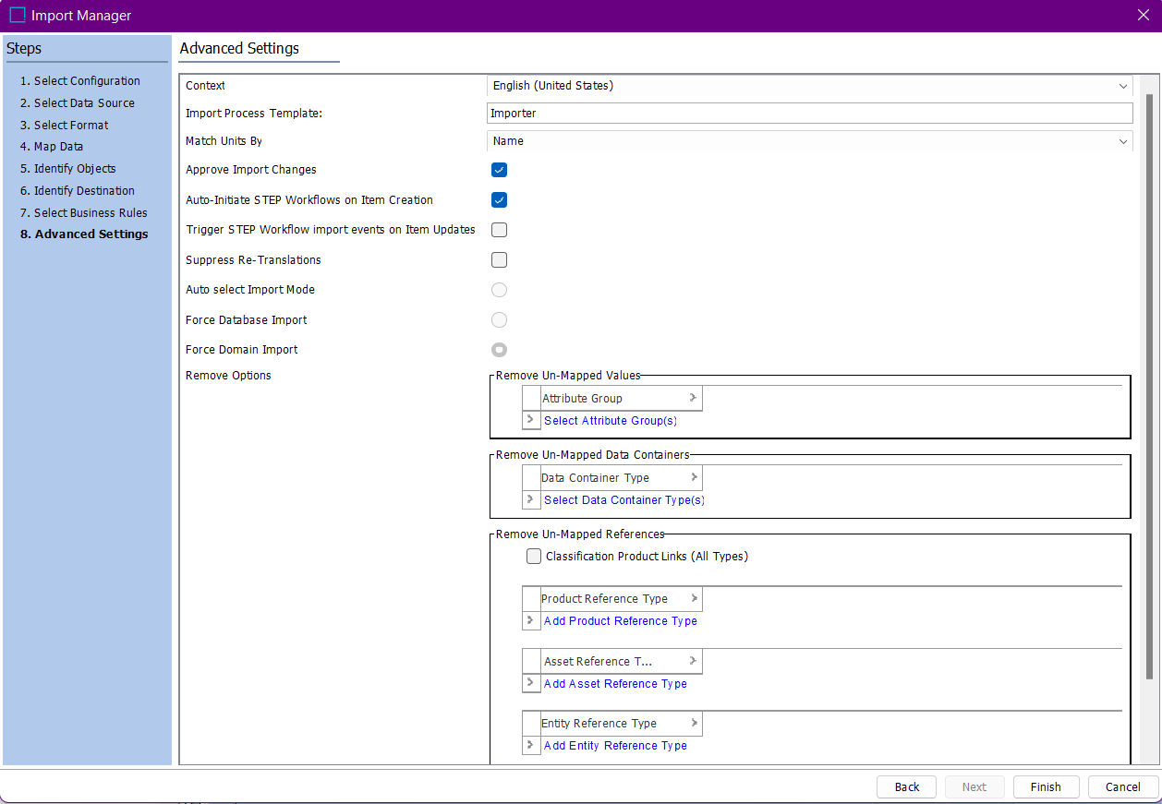

* Click on finish.
* Save Import Configuration.

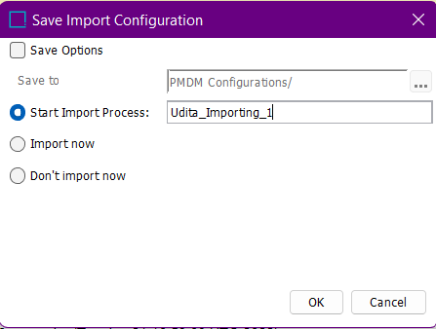

* Imported Successfully.

