**6_Exercises_STIBO_Assignment_Solution**

**Exercise 01 : Export STEP XML.**

**Solution :**

* Go to Tree -> Primary Product Hierarchy -> Udita Products -> Audio Visual Equipment -> Televisions -> LCD -> P7000.
* Right click on P7000-> Export Data below.

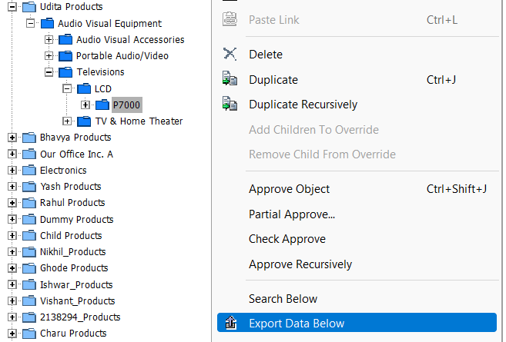

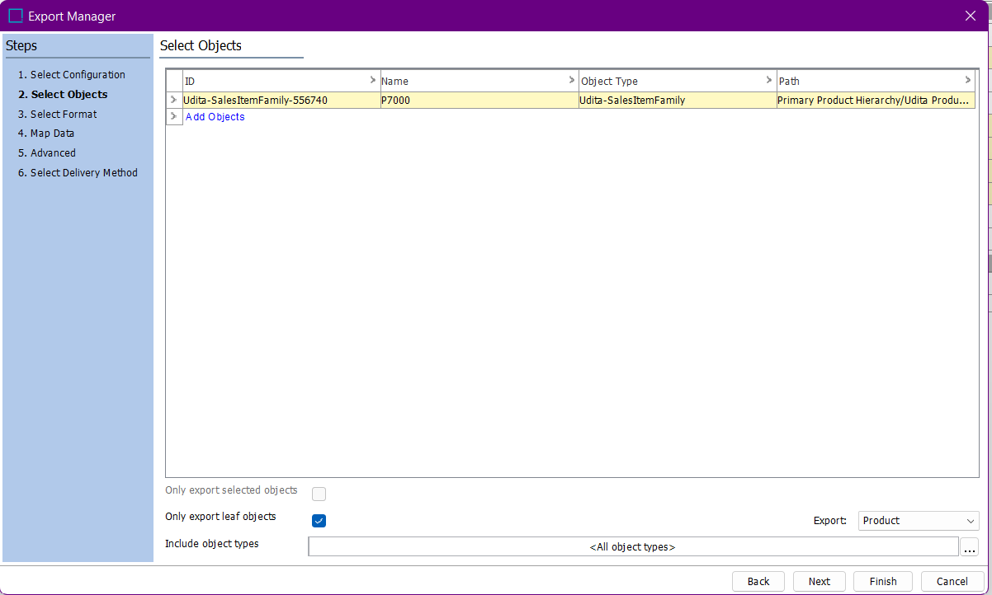

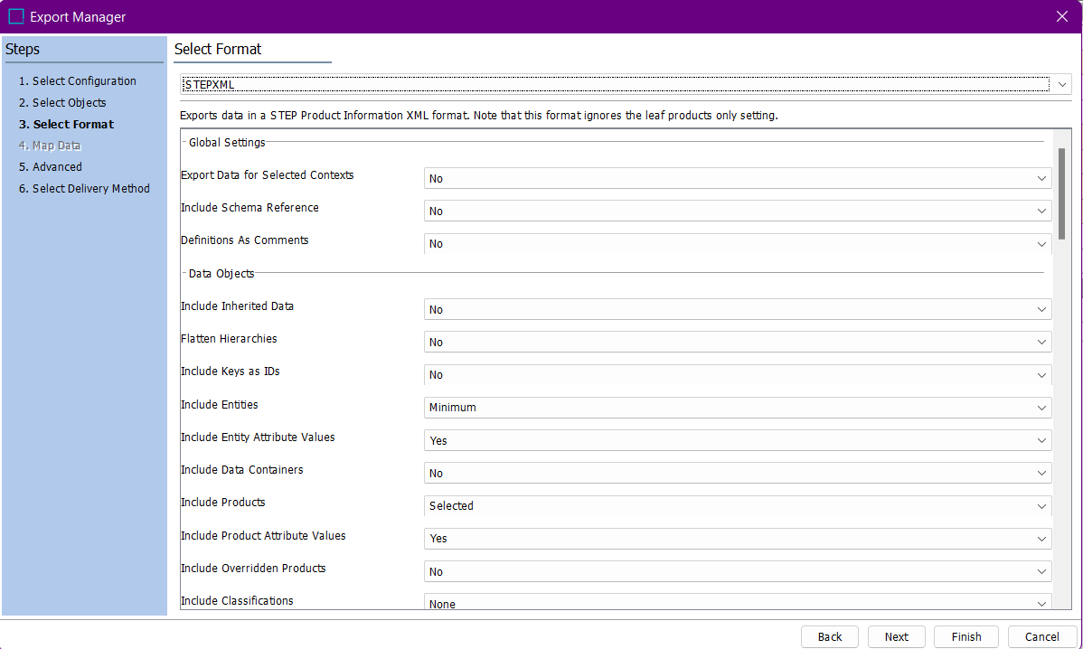

* Select few parameters in the STEPXML configurations:

Include Products – Selected

Include Product Attribute Values – Yes

Include Attributes - Minimum

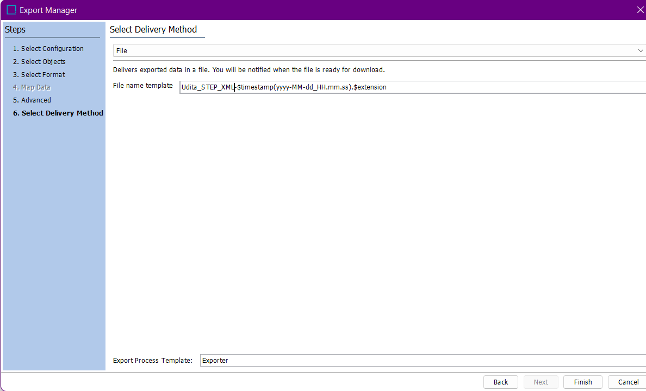

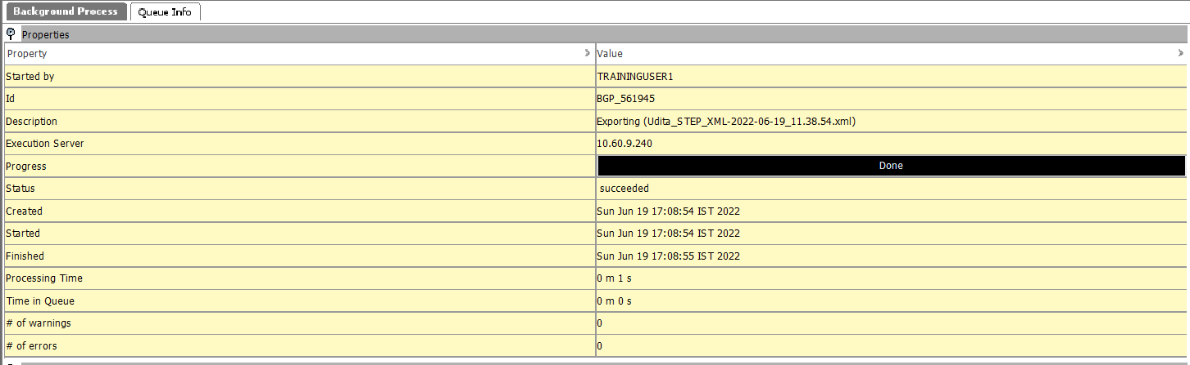

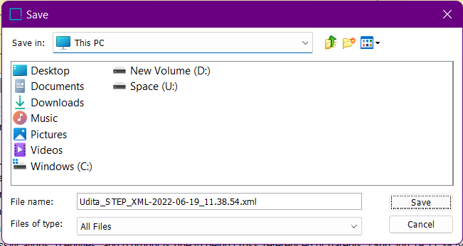

* Output :

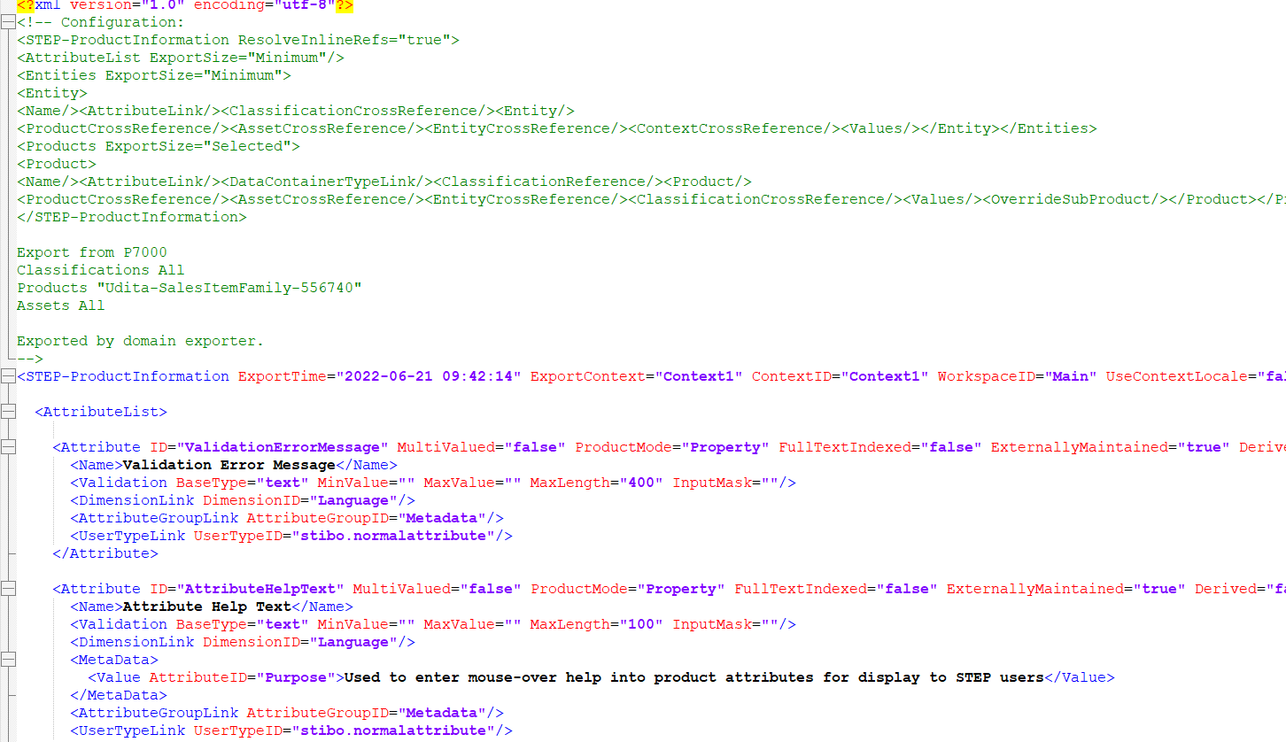

**Exercise 02 : Modify and Import STEP XML File.**

**Solution :**

* Modify previous exported file, save and import it.
* Go to File -> Import -> Data.

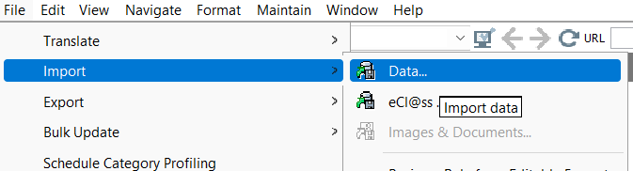

* Select Data Source.

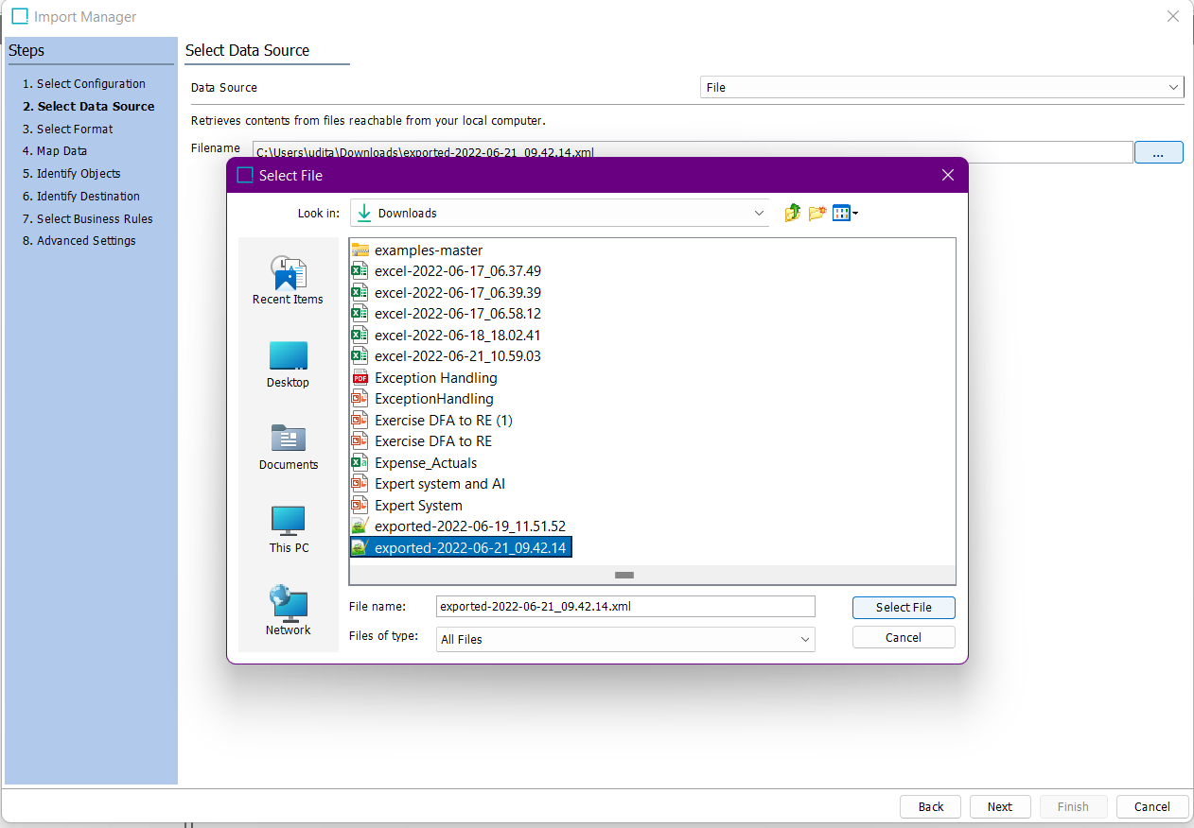

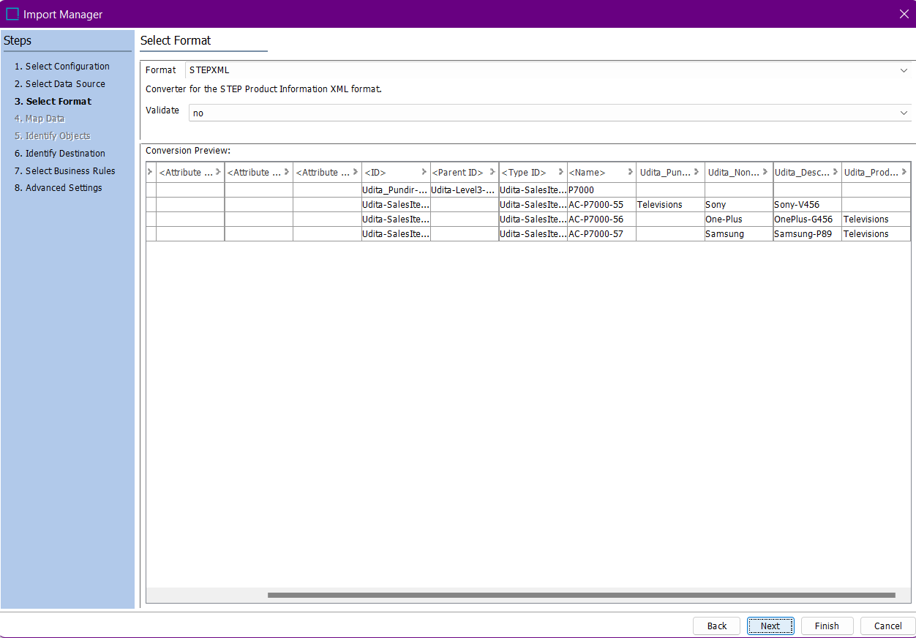

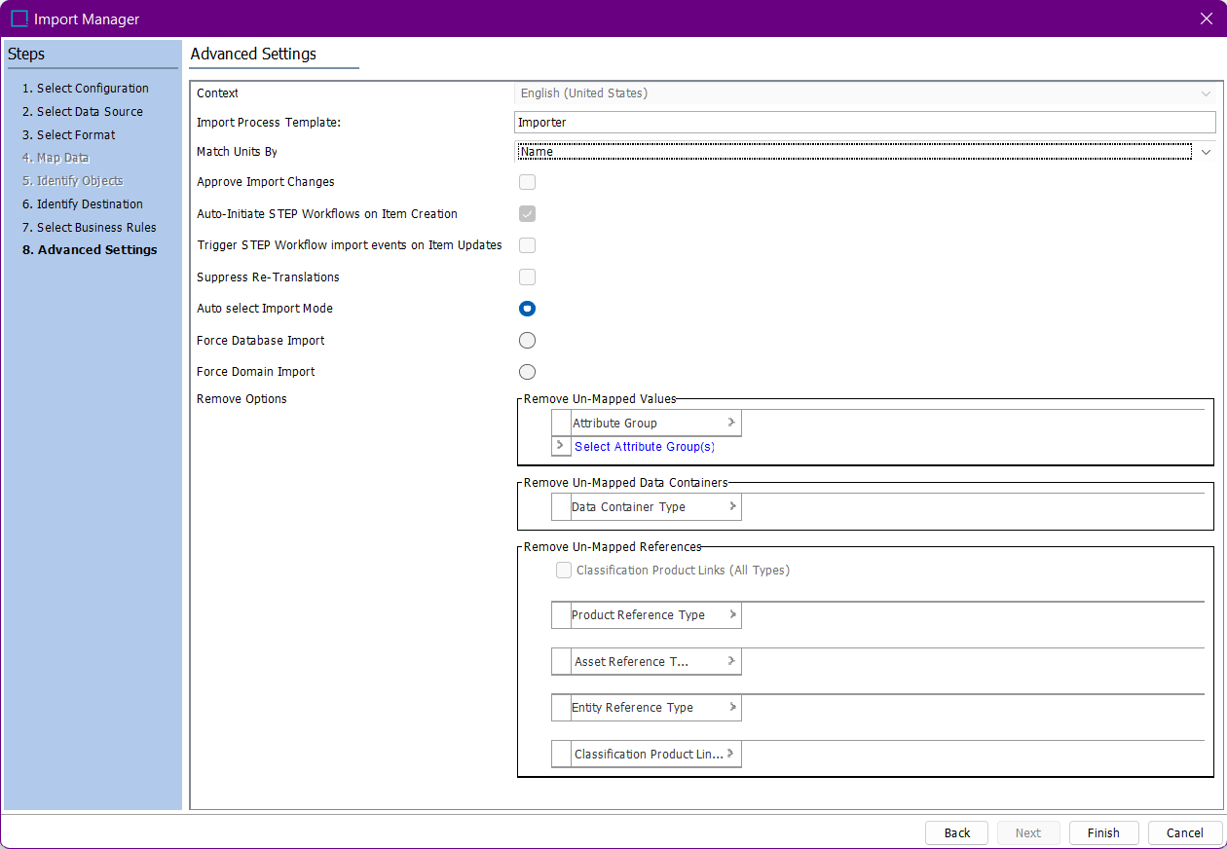

* Click finish and save import configuration.

