**Centennial College**

**COMP 228: Java Programming**

**LAB #1 – Java Class**

# Uditesh Jha

**301224991**

**Exercise – 1**

1. **Screenshot 1**

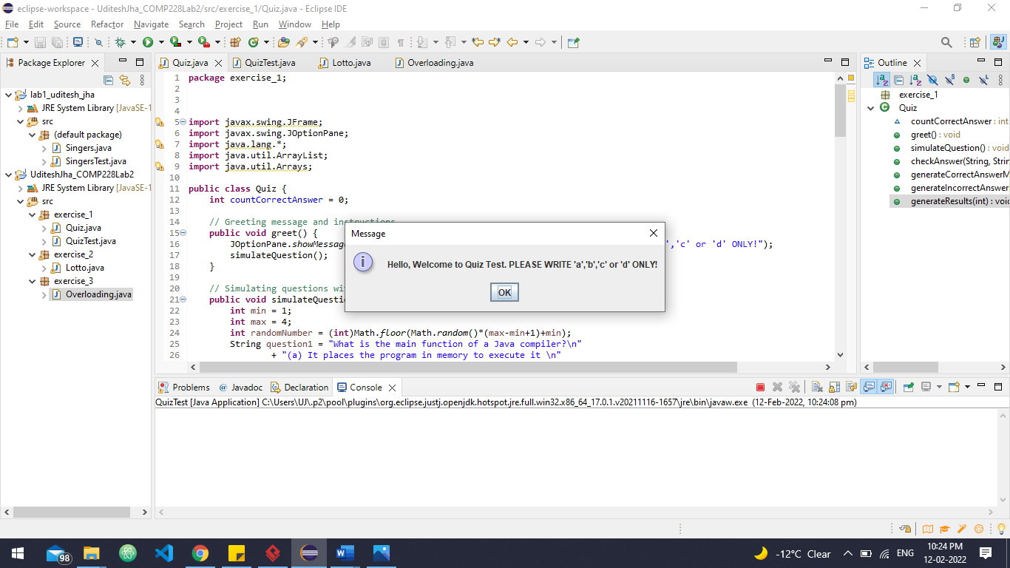

1. **Screenshot 2**

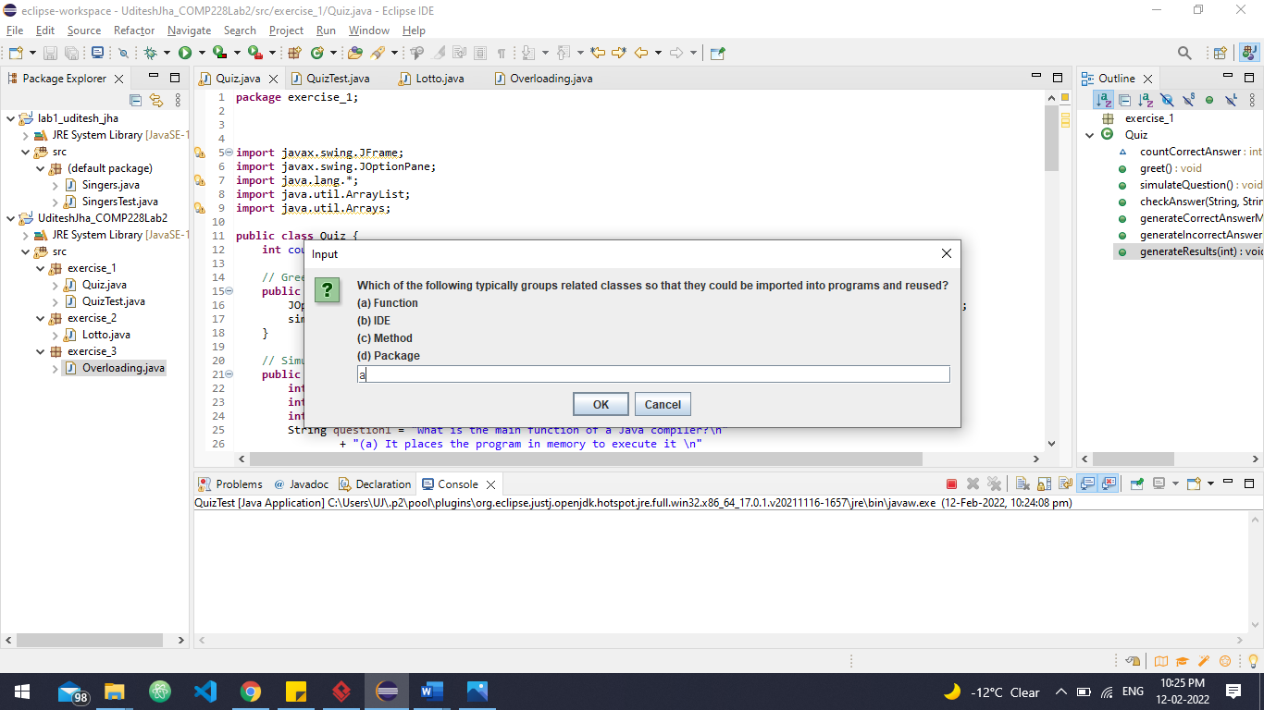

1. **Screenshot 3**

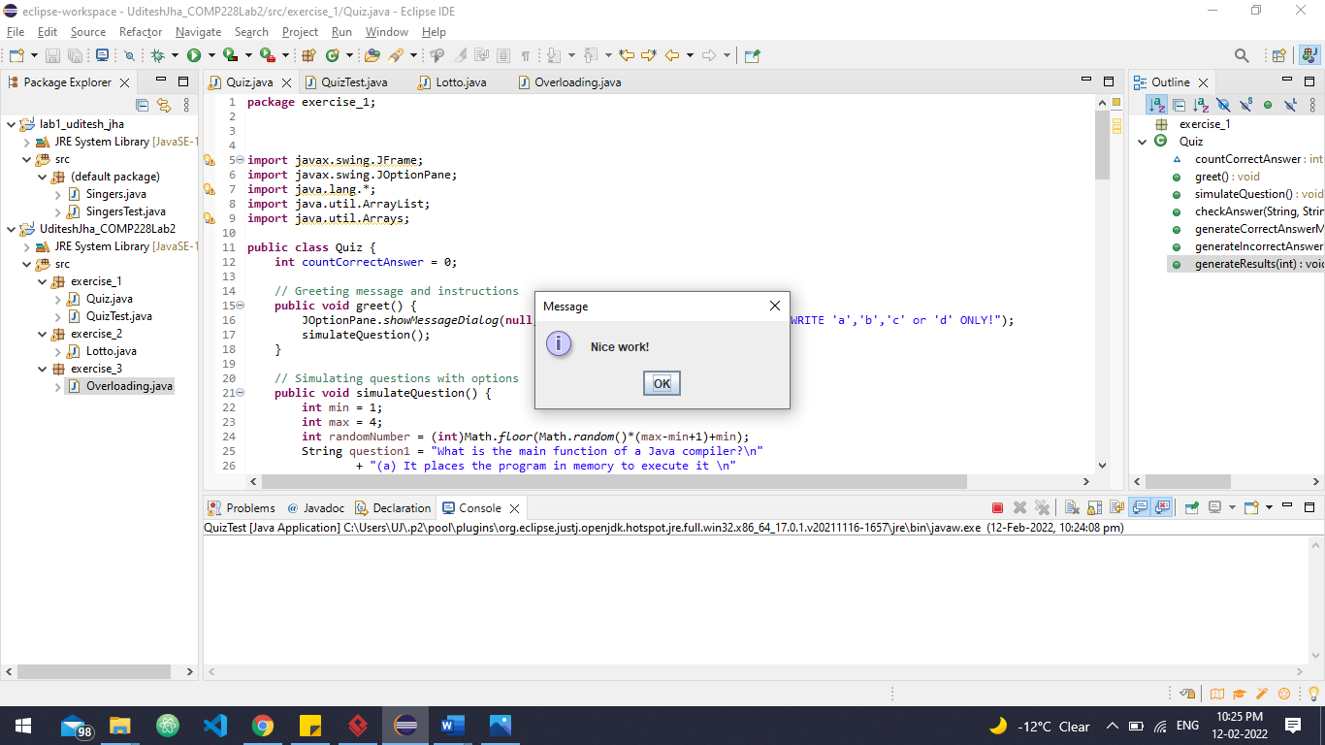

1. **Screenshot 4**

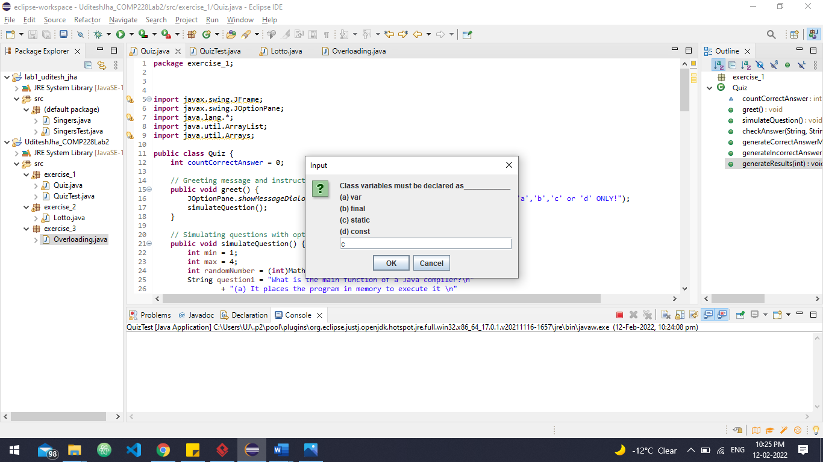

1. **Screenshot 5**

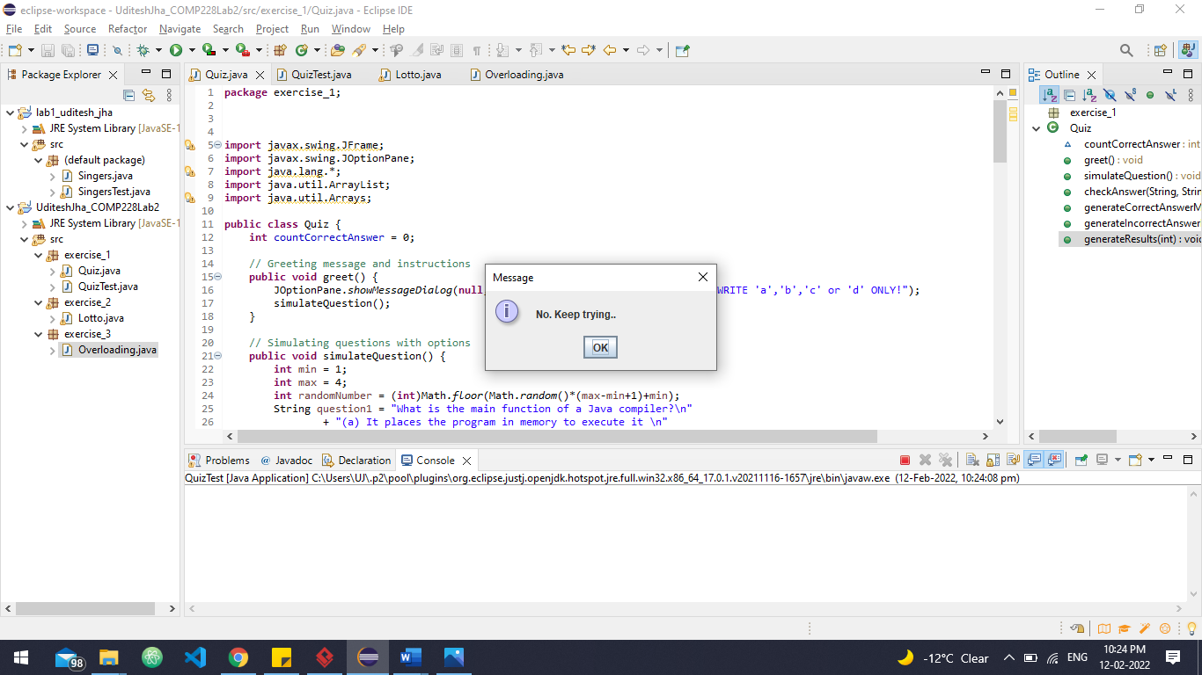

(6) **Screenshot 6**

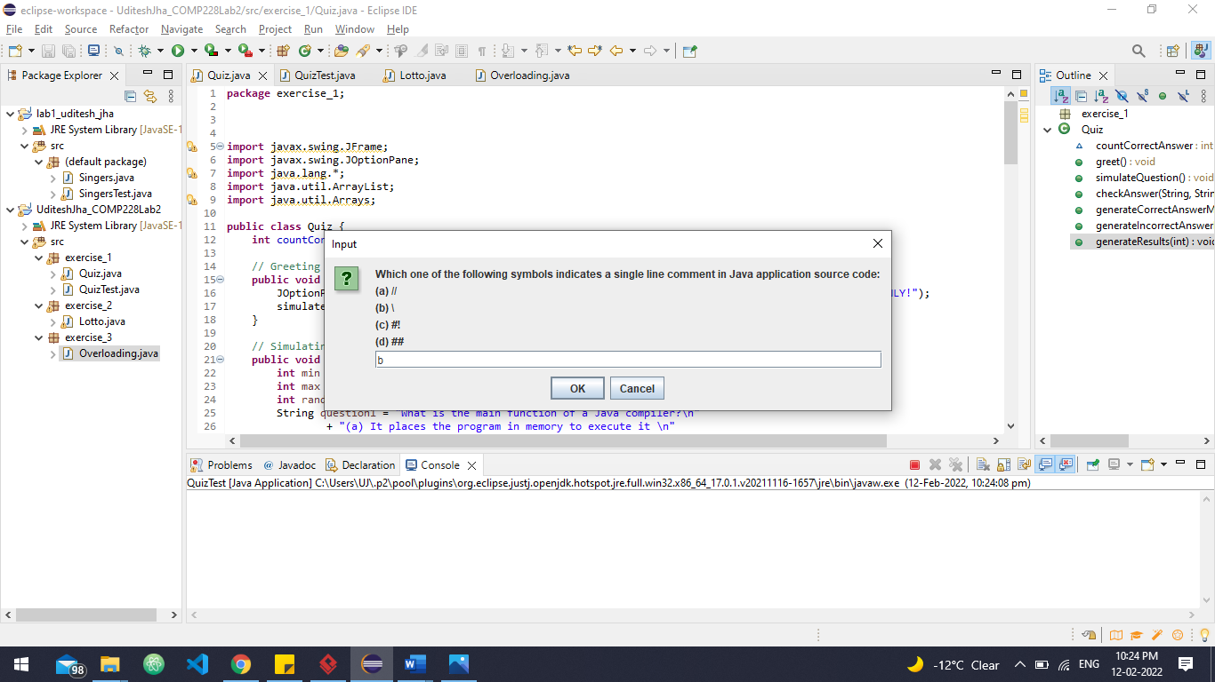

1. **Screenshot 7**

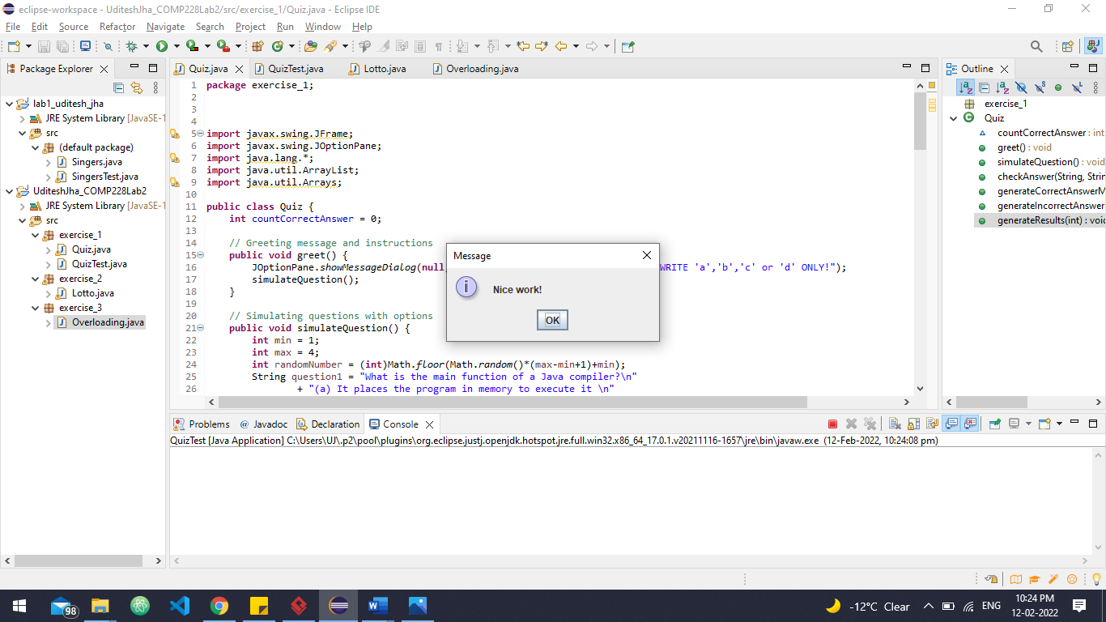

1. **Screenshot 8**



1. **Screenshot 9**

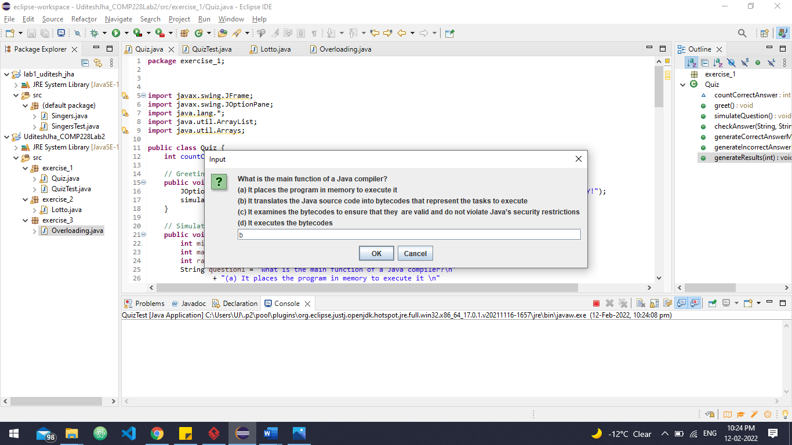

**(10) Screenshot 10**

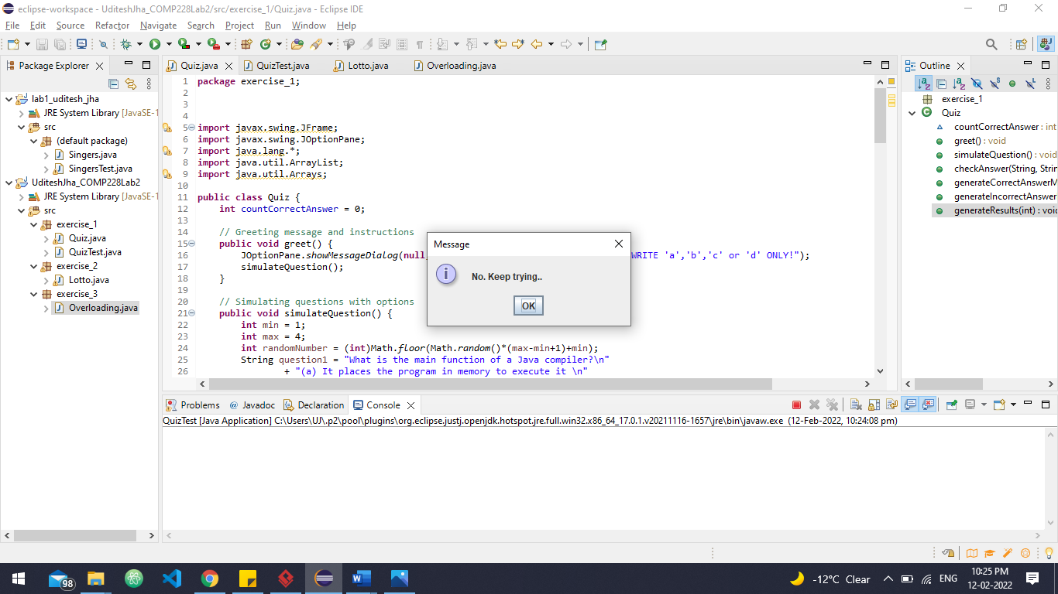

**(11) Screenshot 11**

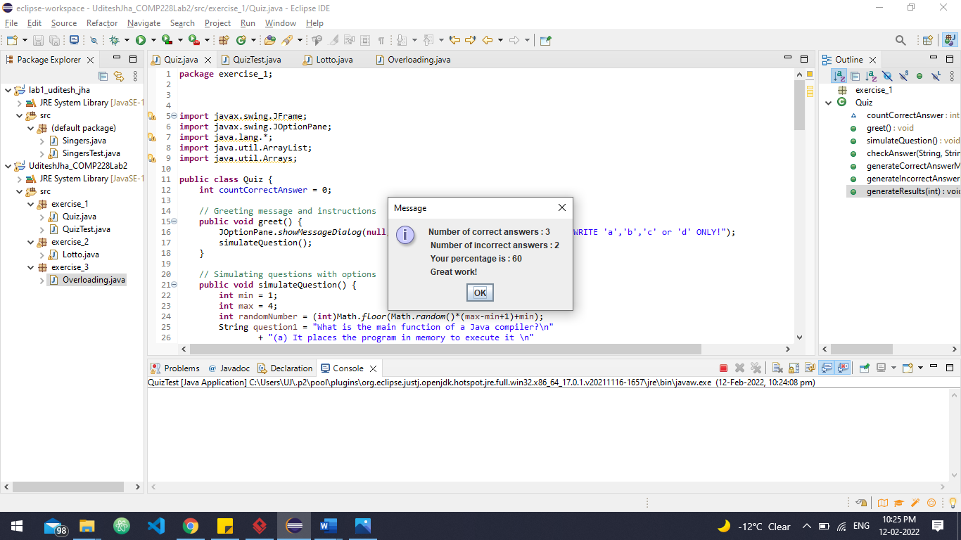

**Code**

1. **Quiz.java**

**package** exercise_1;

**import** javax.swing.JFrame;

**import** javax.swing.JOptionPane;

**import** java.lang.*;

**import** java.util.ArrayList;

**import** java.util.Arrays;

**public** **class** Quiz {

**int** countCorrectAnswer = 0;

// Greeting message and instructions

**public** **void** greet() {

JOptionPane.*showMessageDialog*(**null**,"Hello, Welcome to Quiz Test. PLEASE WRITE 'a','b','c' or 'd' ONLY!");

simulateQuestion();

}

// Simulating questions with options

**public** **void** simulateQuestion() {

**int** min = 1;

**int** max = 4;

**int** randomNumber = (**int**)Math.*floor*(Math.*random*()*(max-min+1)+min);

String question1 = "What is the main function of a Java compiler?\n"

+ "(a) It places the program in memory to execute it \n"

+ "(b) It translates the Java source code into bytecodes that represent the tasks to execute \n"

+ "(c) It examines the bytecodes to ensure that they are valid and do not violate Java’s security restrictions \n"

+ "(d) It executes the bytecodes";

String question2 = "Which of the following processes is typically used by JVM to execute bytecode? \n"

+ "(a) A combination of interpretation and just-in-time (JIT) compilation \n"

+ "(b) Regular time compilation only \n"

+ "(c) Interpretation \n"

+ "(d) Just-in-time (JIT) compilation";

String question3 = "Which one of the following symbols indicates a single line comment in Java application source code: \n"

+ "(a) // \n"

+ "(b) \\ \n"

+ "(c) #! \n"

+ "(d) ##";

String question4 = "Class variables must be declared as___________ \n"

+ "(a) var \n"

+ "(b) final \n"

+ "(c) static \n"

+ "(d) const ";

String question5 = "Which of the following typically groups related classes so that they could be imported into programs and reused? \n"

+ "(a) Function \n"

+ "(b) IDE \n"

+ "(c) Method \n"

+ "(d) Package ";

String questionsArray [] = {question1,question2,question3,question4,question5};

String actualAnswersArray [] = {"b","a","a","c","d"};

ArrayList<String> userAnswersArray = **new** ArrayList<String>();

**for**(**int** i = 0 ; i < questionsArray.length ; i++) {

userAnswersArray.add((String)JOptionPane.*showInputDialog*(**null**,questionsArray [i]));

checkAnswer(actualAnswersArray[i],userAnswersArray.get(i),randomNumber);

}

//JOptionPane.showMessageDialog(null,userAnswersArray);

generateResults(questionsArray.length);

}

// checking user answers

**public** **void** checkAnswer(String actualAnswer,String userAnswer,**int** randomNumber) {

**if**(actualAnswer.equals(userAnswer)) {

generateCorrectAnswerMessage(randomNumber);

countCorrectAnswer ++;

}

**else** {

generateIncorrectAnswerMessage(randomNumber);

}

}

// generating messages

**public** **void** generateCorrectAnswerMessage(**int** randomNumber) {

String correctAnswerArray [] = {"Excellent!","Good!","Keep up the good work!", "Nice work!"};

**switch** (randomNumber) {

**case** 1: {

JOptionPane.*showMessageDialog*(**null**, correctAnswerArray[0]);

**break**;

}

**case** 2:{

JOptionPane.*showMessageDialog*(**null**, correctAnswerArray[1]);

**break**;

}

**case** 3:{

JOptionPane.*showMessageDialog*(**null**, correctAnswerArray[2]);

**break**;

}

**case** 4:{

JOptionPane.*showMessageDialog*(**null**, correctAnswerArray[3]);

**break**;

}

**default**:

**throw** **new** IllegalArgumentException("Unexpected value: " + randomNumber);

}

}

**public** **void** generateIncorrectAnswerMessage(**int** randomNumber) {

String incorrectAnswerArray [] = {"No. Please try again", "Wrong. Try once more", "Don't give up!", "No. Keep trying.."};

**switch** (randomNumber) {

**case** 1: {

JOptionPane.*showMessageDialog*(**null**, incorrectAnswerArray[0]);

**break**;

}

**case** 2:{

JOptionPane.*showMessageDialog*(**null**, incorrectAnswerArray[1]);

**break**;

}

**case** 3:{

JOptionPane.*showMessageDialog*(**null**, incorrectAnswerArray[2]);

**break**;

}

**case** 4:{

JOptionPane.*showMessageDialog*(**null**, incorrectAnswerArray[3]);

**break**;

}

}

}

// generating results

**public** **void** generateResults(**int** totalQuestions) {

**int** correctAnsPercentage = (100 * countCorrectAnswer) / totalQuestions;

JOptionPane.*showMessageDialog*(**null**, "Number of correct answers : " + countCorrectAnswer +

"\n Number of incorrect answers : " + (totalQuestions - countCorrectAnswer) +

"\n Your percentage is : " + correctAnsPercentage + "\n Great work!");

}

}

**(2) QuizTest.java**

**package** exercise_1;

**public** **class** QuizTest {

**public** **static** **void** main(String[] args) {

// **TODO** Auto-generated method stub

Quiz quiz = **new** Quiz();

quiz.greet();

}

}

**Exercise -2**

**(1) Screenshot - 1**

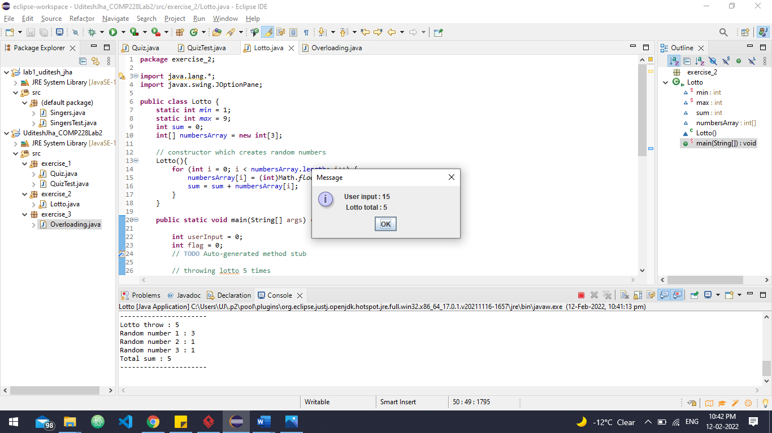

**(2) Screenshot - 2**

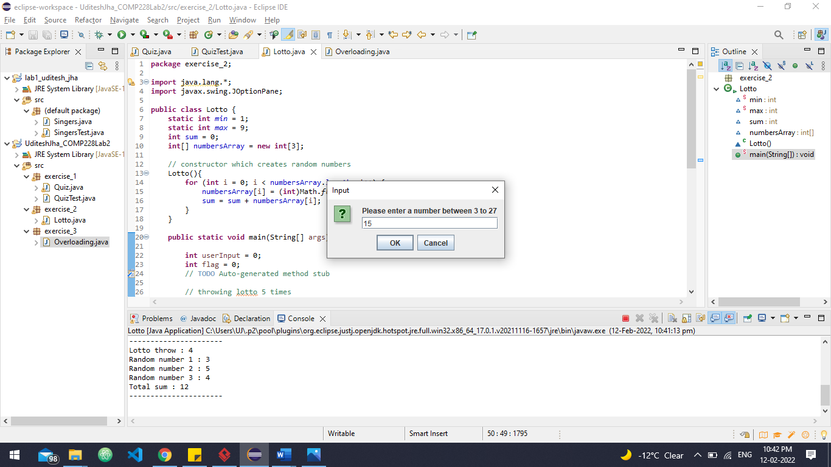

**(3) Screenshot - 3**

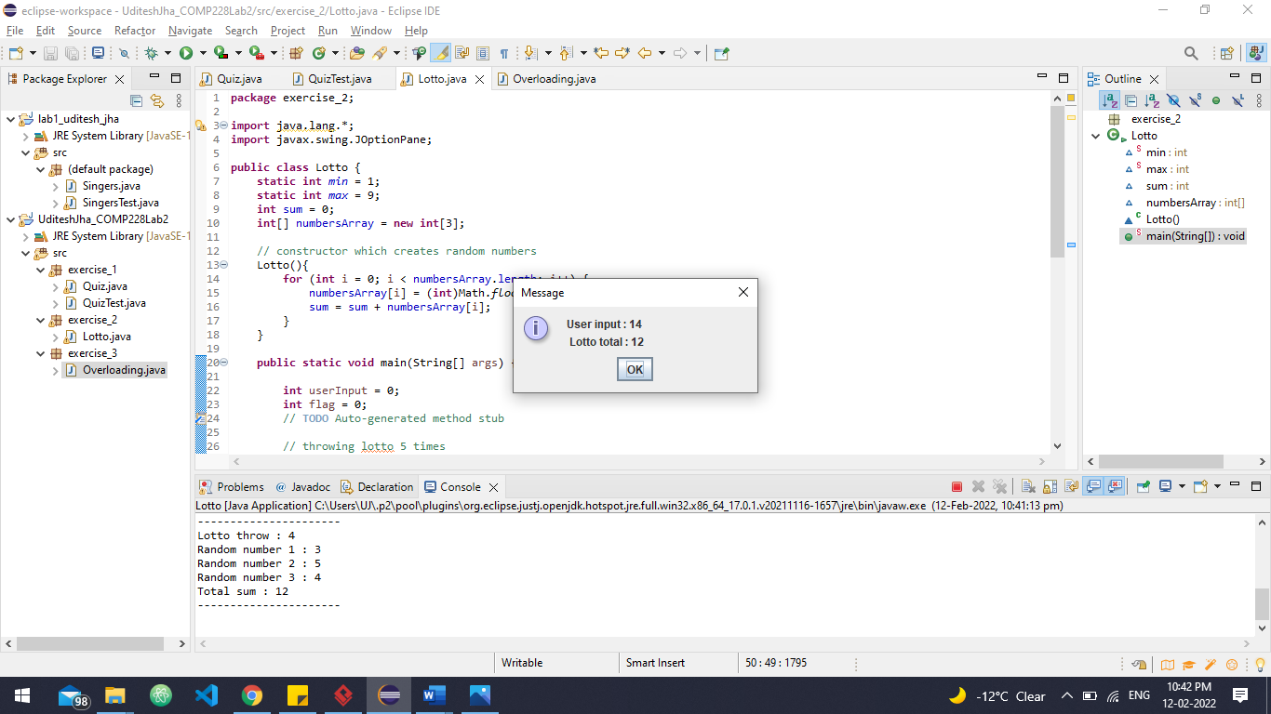

**(4) Screenshot - 4**

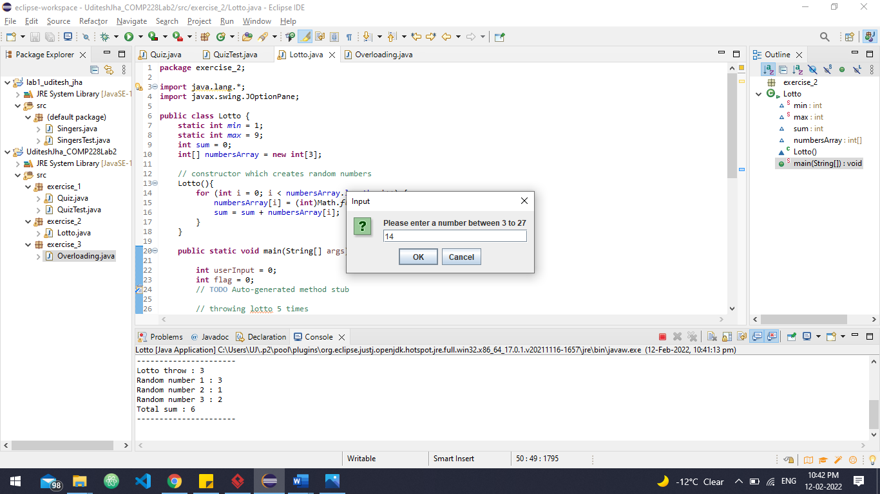

1. **Screenshot - 5**

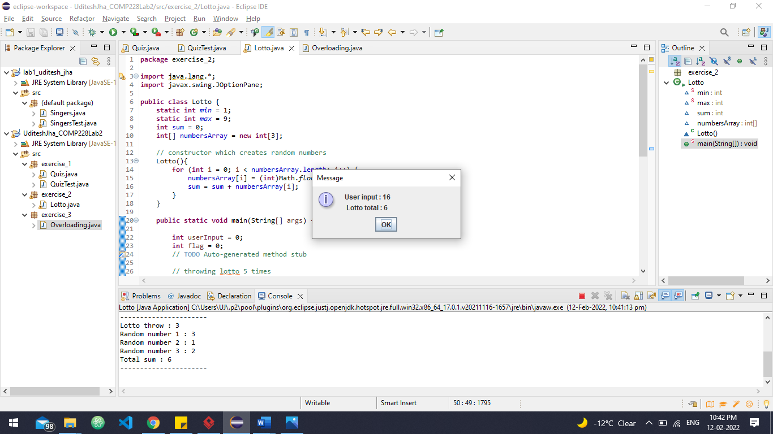

1. **Screenshot - 6**

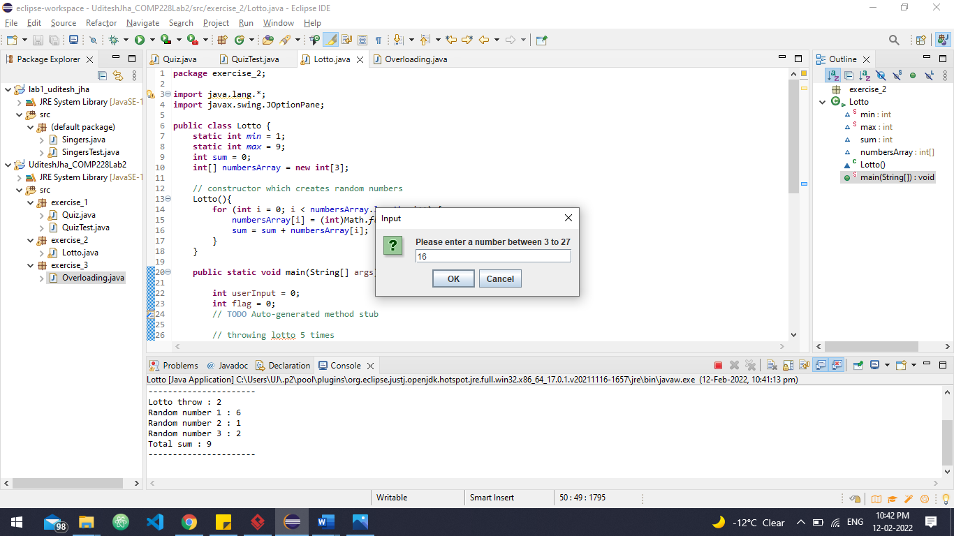

1. **Screenshot - 7**

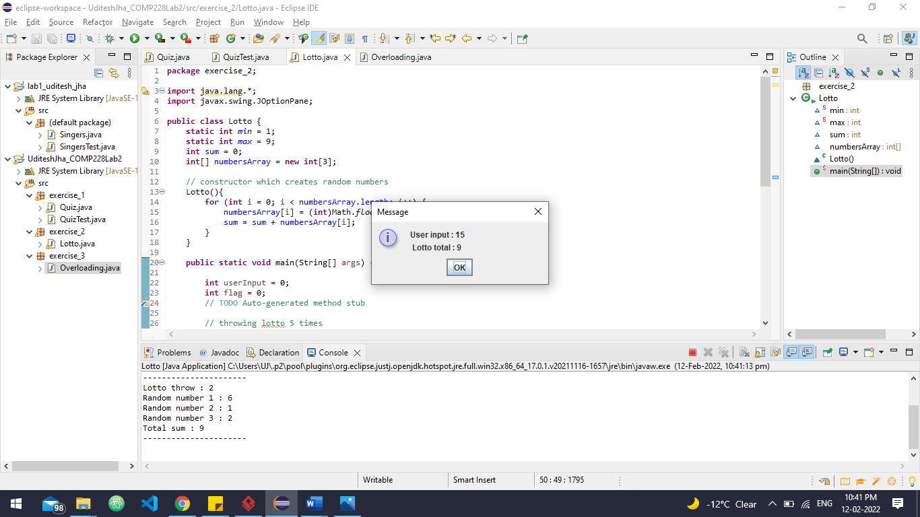

1. **Screenshot - 8**

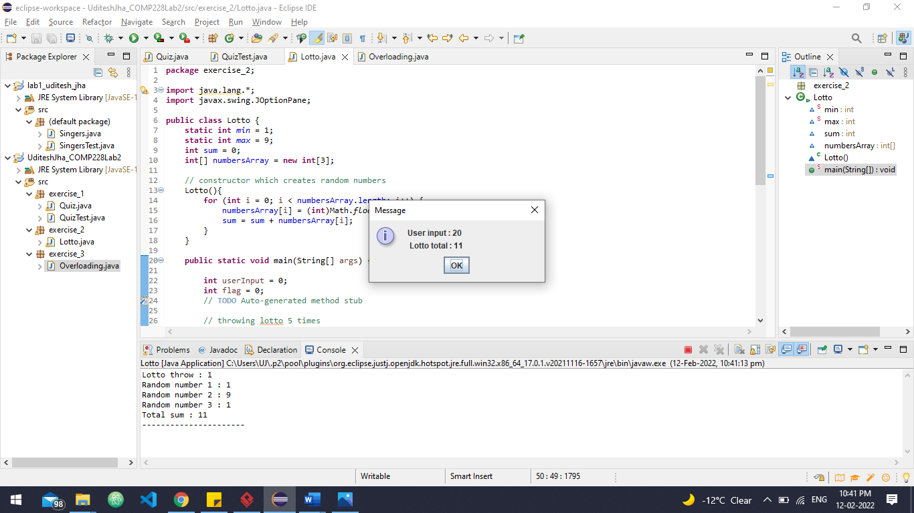

1. **Screenshot - 9**

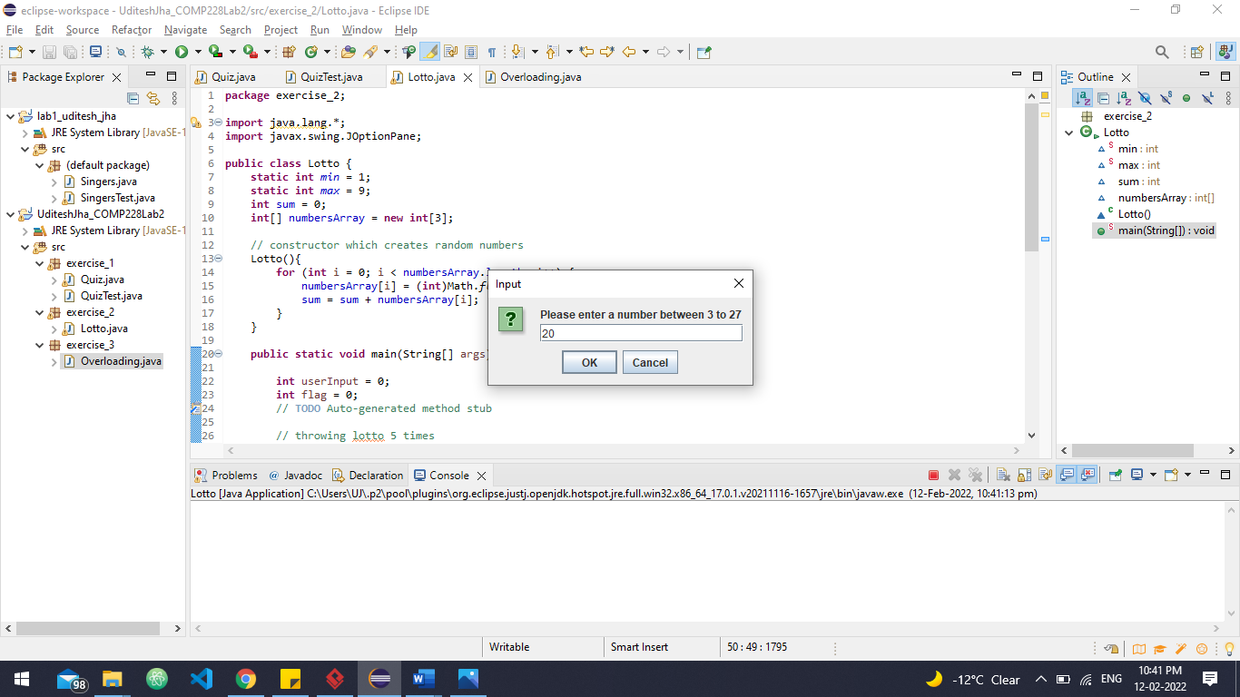

1. **Screenshot - 10**

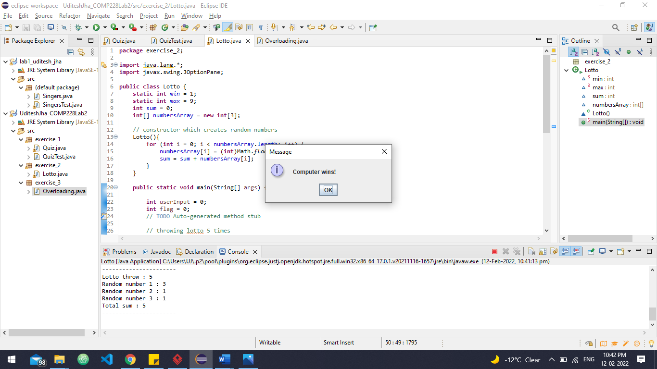

**Code**

1. **Lotto.java**

**package** exercise_2;

**import** java.lang.*;

**import** javax.swing.JOptionPane;

**public** **class** Lotto {

**static** **int** *min* = 1;

**static** **int** *max* = 9;

**int** sum = 0;

**int**[] numbersArray = **new** **int**[3];

// constructor which creates random numbers

Lotto(){

**for** (**int** i = 0; i < numbersArray.length; i++) {

numbersArray[i] = (**int**)Math.*floor*(Math.*random*()*(*max*-*min*+1)+*min*);

sum = sum + numbersArray[i];

}

}

**public** **static** **void** main(String[] args) {

**int** userInput = 0;

**int** flag = 0;

// **TODO** Auto-generated method stub

// throwing lotto 5 times

**for**(**int** i=0;i<5;i++) {

userInput = Integer.*parseInt*(JOptionPane.*showInputDialog*(**null**,"Please enter a number between 3 to 27"));

Lotto lotto = **new** Lotto();

// every loop we check if sum of 3 random numbers equals user input

**if**(userInput == lotto.sum) {

System.***out***.println("Lotto throw : " + (i+1));

System.***out***.println("Random number 1 : " + lotto.numbersArray[0]);

System.***out***.println("Random number 2 : " + lotto.numbersArray[1]);

System.***out***.println("Random number 3 : " + lotto.numbersArray[2]);

System.***out***.println("Total sum : " + lotto.sum);

JOptionPane.*showMessageDialog*(**null**, "User wins!");

flag = 1;

**break**;

}

System.***out***.println("Lotto throw : " + (i+1));

System.***out***.println("Random number 1 : " + lotto.numbersArray[0]);

System.***out***.println("Random number 2 : " + lotto.numbersArray[1]);

System.***out***.println("Random number 3 : " + lotto.numbersArray[2]);

System.***out***.println("Total sum : " + lotto.sum);

System.***out***.println("----------------------");

JOptionPane.*showMessageDialog*(**null**, "User input : "+ userInput +"\n Lotto total : "+lotto.sum);

lotto.sum = 0;

}

// if user is not won then computer wins

**if**(flag != 1) {

JOptionPane.*showMessageDialog*(**null**, "Computer wins!");

}

}

}

**Exercise - 3**

1. **Screenshot 1**

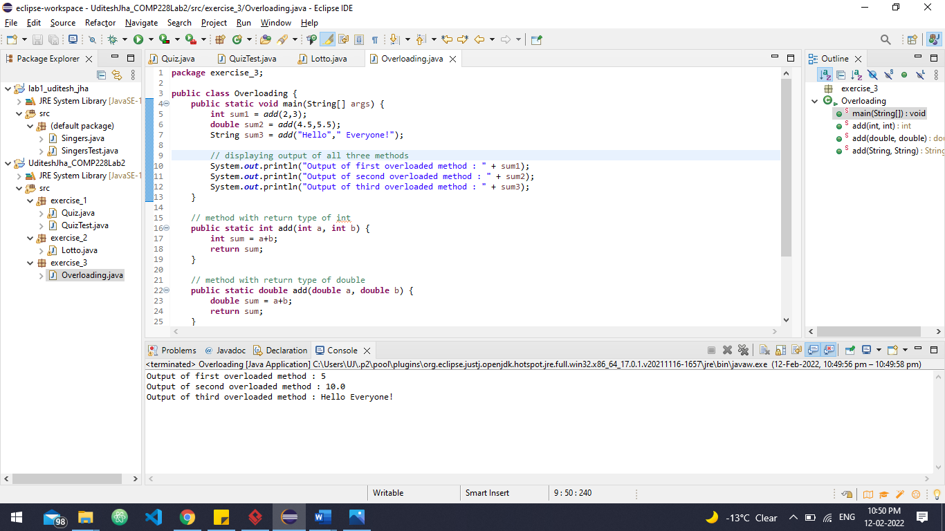

**Code**

1. **Overloading.java**

**package** exercise_3;

**public** **class** Overloading {

**public** **static** **void** main(String[] args) {

**int** sum1 = *add*(2,3);

**double** sum2 = *add*(4.5,5.5);

String sum3 = *add*("Hello"," Everyone!");

// displaying output of all three methods

System.***out***.println("Output of first overloaded method : " + sum1);

System.***out***.println("Output of second overloaded method : " + sum2);

System.***out***.println("Output of third overloaded method : " + sum3);

}

// method with return type of int

**public** **static** **int** add(**int** a, **int** b) {

**int** sum = a+b;

**return** sum;

}

// method with return type of double

**public** **static** **double** add(**double** a, **double** b) {

**double** sum = a+b;

**return** sum;

}

// method with return type of String

**public** **static** String add(String a, String b) {

String sum = a+b;

**return** sum;

}

}