1. Used Different types of libraries

Google Colab Library

TensorFlow Library

Matplotlib libraries

Python imaging library

PIL Image library

Torch packages

Torch packages with optimisation algorithm

Numpy libraries

Torchvision libraries

Ipython libraries

Scipy libraries

BytesIo packages

VGG19 library

Used DeepDream library

2. Imported libraries in first cell

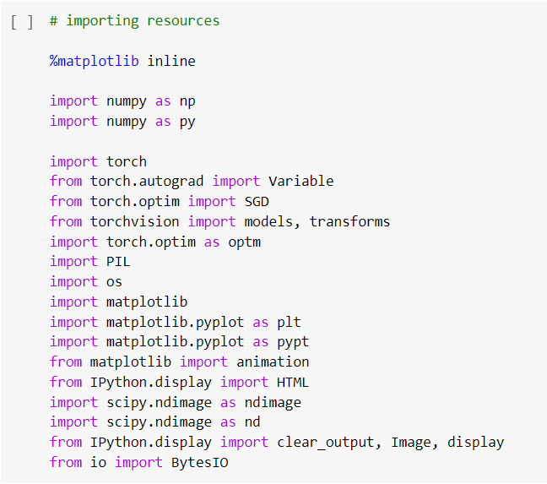

3. Getting the features function of the vgg19

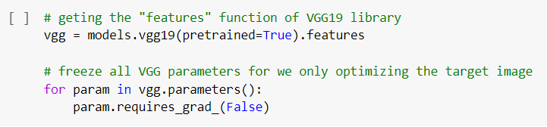

4. Declare a function Prepossessing building the image function

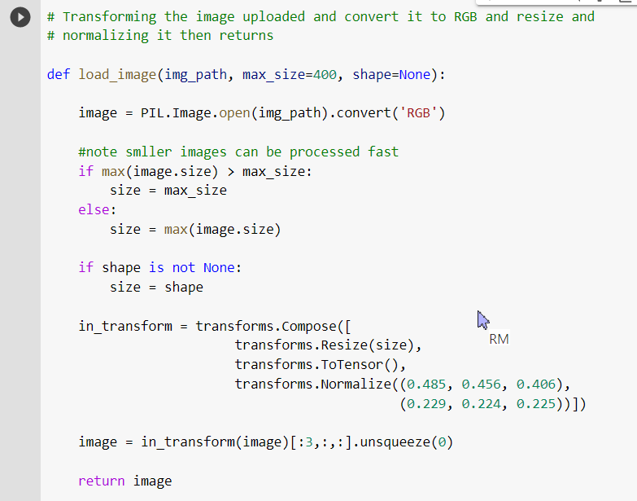

5. upoad image using colab

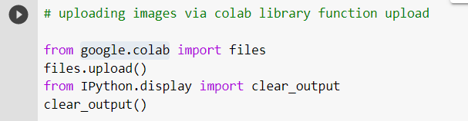

6. Deepdream version code 1

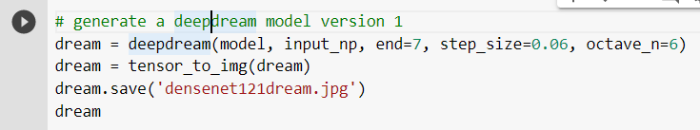

7. Deepdream version code 2

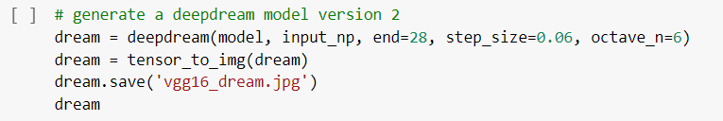

8. Deepdream version code 3

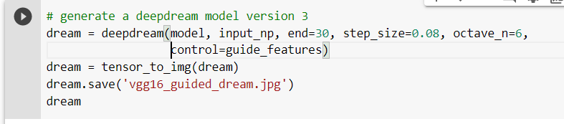

9. Deepdream version code 4

