Final Report – AI Agent System Implementation
Applied System Software (ASD)
Student Name: Herath Mudiyanselage Udesha Uditha Kumara Herath
Student ID: 221AMB073

Final System Description and Goal
The system developed is an AI agent written in Python, which uses Google Gemini API for generating responses to user queries and performing tasks that use built-in tools. The system is agent based and is a command-line interface (CLI) application.
The purpose of the system is to showcase the connection between Natural Language Processing and structured tools and how it enables modern AI agents to resolve real-world challenges in a practical manner. The system is modular, extensible and maintainable.

Programming Concepts and Their Usage
Applied important software engineering and programming concepts:

- Object-Oriented Programming (OOP)
The system is structured using classes such as Agent, Tool Registry and individual tool classes.
- Modular Design
Each component (agent, tools, memory, registry) is separated into independent modules.
- Separation of Concerns
Each class has a clear responsibility (e.g., tools execute logic, agent manages flow).
- Tool Registry Pattern
Tools are dynamically registered and accessed, allowing easy extension without modifying core logic.
- ReAct Pattern (Reason → Act → Observe):
The agent processes user input, decides on actions, executes tools and returns results.
- Error Handling
The system safely handles invalid inputs, missing files, and incorrect tool usage.
- API Integration
The Gemini API is used for reasoning and decision-making.

Tools and Their Roles

- Calculator Tool: Performs arithmetic operations based on user input.
- File Reader Tool: Reads and returns content from text files.
- Time Tool: Provides the current system time.
- Translator Tool: Translates text between languages.
Each tool is implemented as a separate class and follows a consistent interface, making the system scalable.

Testing Results and Conclusions
Testing was performed using Python’s unittest framework.

Results:
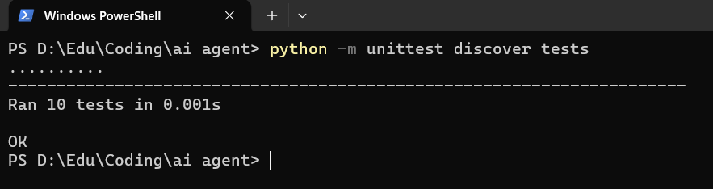Total tests: 10
Passed: 10
Failed: 0
Conclusion:
All system components function correctly under both normal and edge case scenarios. Error handling mechanisms successfully prevent system crashes and provide meaningful feedback to user.

Deployment Preparation
The system is prepared for execution in a controlled environment.

- Key elements: requirements.txt for dependency management, modular project structure, CLI-based execution
- Running the system:
pip install -r requirements.txt
python main.py
The system is easy to set up and run on any machine with Python installed.

Deployment Strategy
The proposed deployment strategy is a local CLI application.

- Justification: simple and lightweight, no need for server infrastructure, suitable for testing and demonstration
- Future improvements could include: deploying as a web service, integrating with APIs
expanding to multi-agent architecture

