Day 9 - 28th July 2026

Spring Framework - Quick revise

Task 1:

Can you create a Maven based spring project using ide.. To print a welcome..note
9.04 to 9.08

Task 2:

Now create a POJO class for student so that can be managed as a spring bean
9.09 to 9.14

Task 3:
Configure the above Student bean in the bean-factory-demo.xml file.
That means you need to configure the Student bean in the XML file so the BeanFactory knows how to create it.
And create a main class and run it.. A pictorial rep of the scenario is given below
9.15 to 9.20

Task 4:
Can you explain application context with the syntax..
ApplicationContext is a Spring IoC Container that reads configuration metadata, creates and manages Spring beans, and provides them whenever required through getBean().
ApplicationContext context =
new ClassPathXmlApplicationContext(
"bean-factory-demo.xml");

Task 4:
Can you explain application context with the syntax..
ApplicationContext is an advanced Spring IoC container that reads configuration metadata, creates and manages beans, performs dependency injection, handles bean lifecycle management, supports events, and provides bean access through getBean().
Reads Spring configuration files.
Creates and manages Spring beans.
Supports Dependency Injection.
Manages bean lifecycle.
Provides additional features like event handling and internationalization.
TASK 6:
What are features of Spring Framework .. list them with 1 or 2 lines explanation?
Features of Spring Framework
- IoC (Inversion of Control)
- Dependency Injection
- Bean Management
- Aspect-Oriented Programming (AOP)
- Transaction Management
- Spring MVC
- Database Integration
- Easy Integration with other frameworks
- Flexible Configuration
- Lightweight and Modular Architecture
Task 7:
Why do you think we use Spring Framework? What are its advantages?
Spring Framework reduces tight coupling using Dependency Injection and IoC. It simplifies object management, improves maintainability, promotes code reuse, supports transaction management, integrates with various technologies, and helps develop enterprise applications quickly and efficiently.
TASK 8:
What do you understand by IoC (Inversion of Control)? Explain with diagram.
The control of object creation and management is transferred from the programmer to the Spring Container.

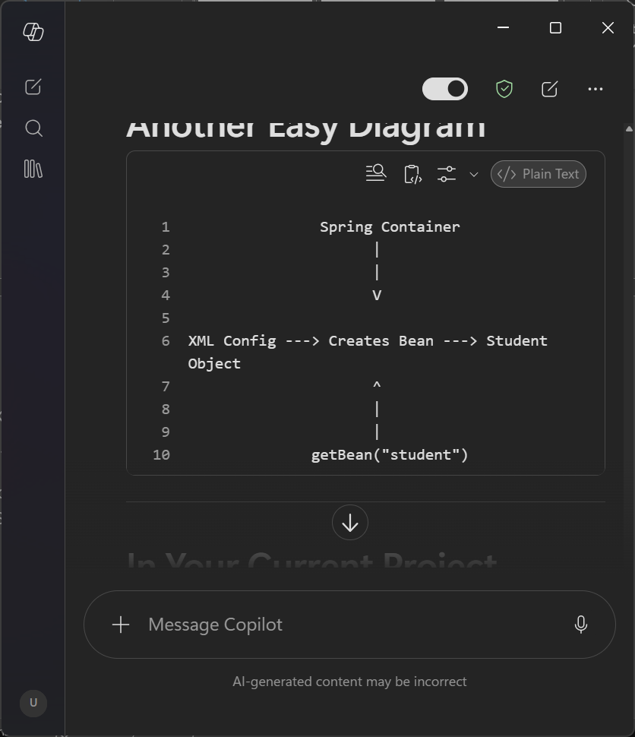

IoC (Inversion of Control) is a principle in which the responsibility of creating and managing objects is transferred from the programmer to the Spring Container. The container creates beans, injects dependencies, and provides objects when required.

Task 9 :
How many types of IoC do we have in Spring?
What are they with explanation?
SSpring supports two major types of IoC through Dependency Injection:
- Constructor Injection – dependencies are injected using constructors.
- Setter Injection – dependencies are injected using setter methods.
Constructor Injection is generally preferred for mandatory dependencies, while Setter Injection is suitable for optional dependencies.

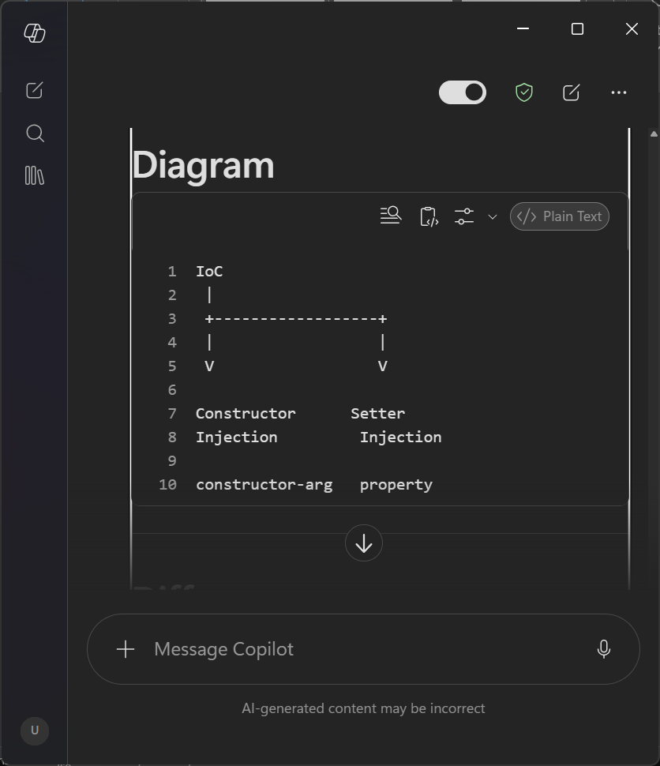

Task 10:
Dependency Injection (DI) is a technique in which Spring provides the required dependency objects to a class instead of the class creating them itself.
Dependency Injection is a design pattern used by Spring in which the container provides the required dependency objects to a class instead of the class creating them manually. It helps achieve loose coupling, better maintainability, and easier testing.
TASK 11:
How many types of DI do we have?
Explain.
How many types of IoC do we have in Spring?
What are they with explanation?
SSpring supports two major types of IoC through Dependency Injection:
- Constructor Injection – dependencies are injected using constructors.
- Setter Injection – dependencies are injected using setter methods.
Constructor Injection is generally preferred for mandatory dependencies, while Setter Injection is suitable for optional dependencies.
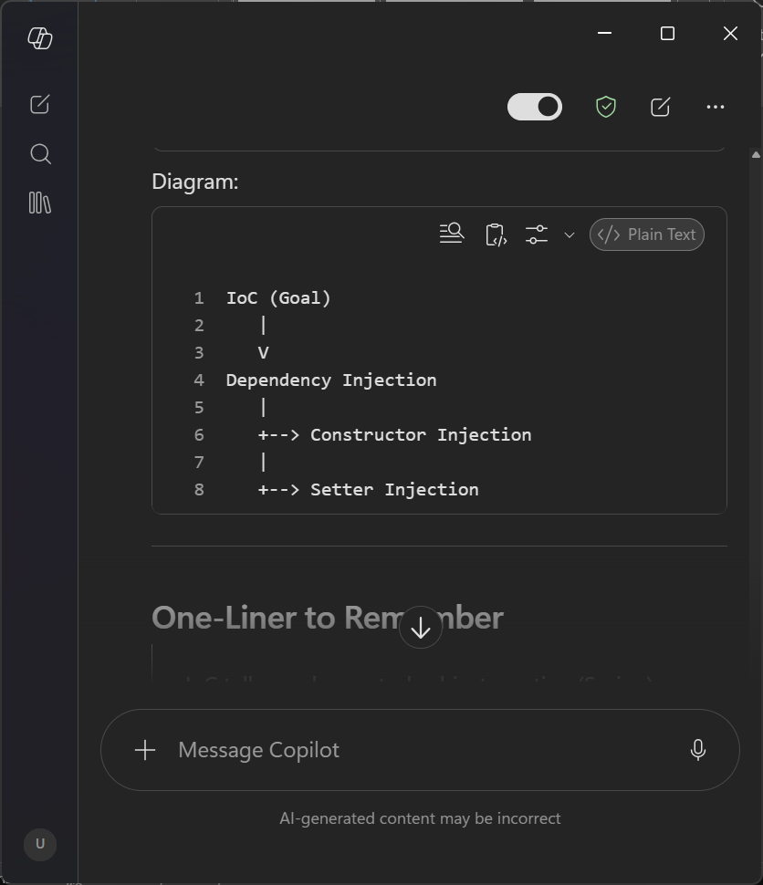

Task 12:
What is Spring Application Configuration?
Spring Application Configuration is the process of telling Spring:
"Which objects (beans) should be created, managed, and how they are connected with each other."
Spring needs configuration to know:
- Which classes are beans
- What values to inject
- What dependencies to inject
- How beans are related
Task 13:
What are the different ways to configure Spring Applications?

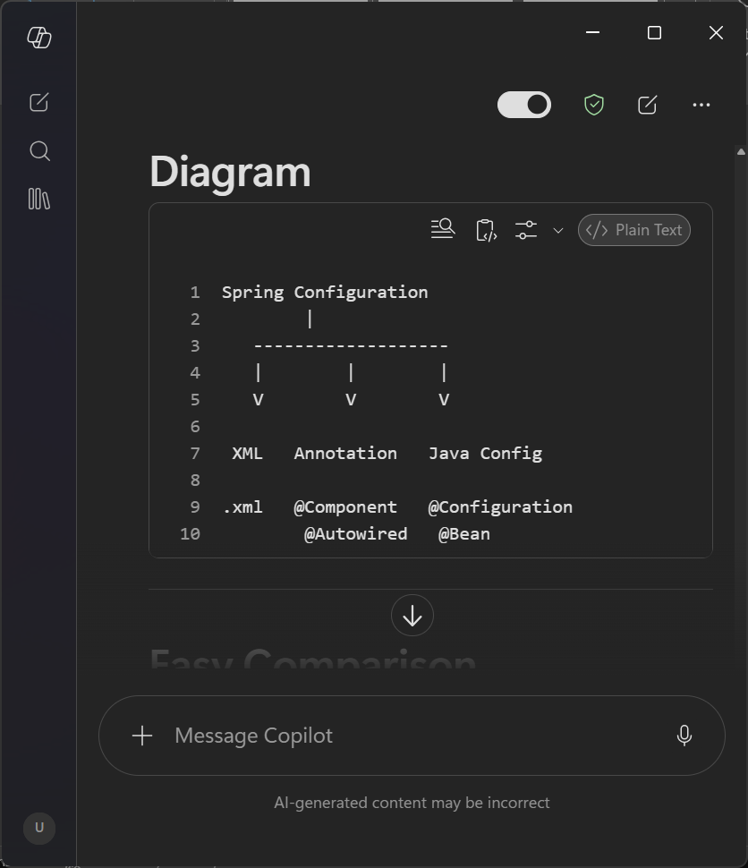
Spring applications can be configured in three ways:
- XML Configuration using XML files such as applicationContext.xml.
- Annotation-Based Configuration using annotations like @Component, @Autowired, and @Service.
- Java-Based Configuration using @Configuration and @Bean annotations.

Task 14:
Why do we need Spring Application Configuration?
Spring Application Configuration is needed because Spring must know:
- Which objects (beans) to create
- How to create them
- What values to assign
- What dependencies to inject
- How beans are related
Without configuration, Spring doesn't know what to manage.

Task 15 :
What are the different ways to configure Spring Applications?
Spring applications can be configured in three ways:
- XML-Based Configuration using XML files.
- Annotation-Based Configuration using annotations such as @Component and @Autowired.
- Java-Based Configuration using @Configuration and @Bean.

Task 16 :
What is Bean Scope? Give different scopes with description.

Types of Bean Scope
1. Singleton (Default)
Only one bean object is created.
The same object is returned every time.
Default scope in Spring.
2. Prototype
A new bean object is created every time it is requested.
Multiple requests result in multiple objects.
3. Request
One bean object is created for each HTTP request.
Used in web applications.
4. Session
One bean object is created for each user session.
Different users get different bean instances.
5. Application
One bean object is shared across the entire web application.
Available to all users of the application.
Task 17
What is Autowiring in Spring?
Autowiring is a feature in Spring that automatically injects dependent objects (beans) into another bean.
In simple words:
Instead of manually connecting objects in XML, Spring automatically finds and injects the required dependency.

Why do we use Autowiring?
- Reduces XML configuration.
- Reduces manual coding.
- Automatically connects dependent beans.
- Makes development easier and faster.

Task 18:
What are the different ways of Autowiring?
Spring provides different autowiring modes such as byName, byType, constructor, and no. Autowiring automatically injects dependent beans, reducing the need for explicit configuration.

Task 19 :
A Normal Java Object is created and managed by the programmer using the new keyword. A Spring Bean is an object created, configured, and managed by the Spring Container, which also handles dependency injection and lifecycle management.
Task 20:
Difference between @Component and @Bean
A Normal Java Object is created and managed by the programmer using the new keyword. A Spring Bean is an object created, configured, and managed by the Spring Container, which also handles dependency injection and lifecycle management.
Task 24:
What are the Features of Spring Boot?

Features of Spring Boot
- Auto Configuration
  - Automatically configures Spring applications based on the dependencies available in the classpath.
- Standalone Application
  - Spring Boot applications can run independently without requiring an external server.
- Embedded Server
  - Provides embedded servers such as Tomcat, Jetty, and Undertow.
- Starter Dependencies
  - Simplifies dependency management by providing predefined starter packages.
- Production Ready Features
  - Includes health checks, metrics, logging, monitoring, and application management.
- Minimal Configuration
  - Reduces XML configuration and promotes convention over configuration.
- Spring Boot CLI
  - Allows rapid application development using command-line tools.
Task 25:
What are the Advantages of Spring Boot?

Advantages of Spring Boot
- Reduces Development Time
  - Auto-configuration and starter dependencies speed up development.
- Easy to Learn and Use
  - Minimal configuration makes it beginner-friendly.
- Embedded Servers
  - No need to deploy WAR files on external servers.
- Microservices Support
  - Well-suited for building microservice-based applications.
- Simplified Dependency Management
  - Maven and Gradle dependencies are managed easily.
- Production Ready
  - Comes with Actuator for monitoring and management.
- Easy Integration
  - Integrates seamlessly with Spring Framework modules.
Task 26 :
What are the Key Components of Spring Boot?

1. Spring Boot Starters
Predefined dependency descriptors that simplify Maven/Gradle configurations.
Example:
XML
1
<dependency>
2
<groupId>org.springframework.boot</groupId>
3
<artifactId>spring-boot-starter-web</artifactId>
4
</dependency>
Show more lines

2. Auto Configuration
Automatically configures beans based on project dependencies.

3. Spring Boot Actuator
Provides monitoring, health checks, metrics, and application insights.

4. Embedded Servers
Supports Tomcat, Jetty, and Undertow.

5. SpringApplication
Used to bootstrap and launch Spring Boot applications.

6. Spring Boot CLI
Command-line tool used for rapid development and testing.
Task 27:
Why Spring Boot over Spring?

pring Framework vs Spring Boot

Spring Framework
- Requires extensive XML configuration.
- Manual dependency management.
- External server deployment required.
- More boilerplate code.

Spring Boot
- Auto configuration.
- Minimal setup.
- Embedded servers.
- Starter dependencies.
- Faster development.
- Suitable for microservices.

Why Spring Boot?
- Reduces boilerplate code.
- Faster application development.
- Embedded web server support.
- Easy deployment.
- Better production support.
- Simplified configuration.
Task 28:
Explain the Internal Working of Spring Boot
Main Method
↓
SpringApplication.run()
↓
Create ApplicationContext
↓
Component Scan
↓
Bean Creation
↓
Auto Configuration
↓
Embedded Server Startup
↓
Application Ready

Task 29 :
List out the Starter Dependencies for Spring Boot

Common Spring Boot Starter Dependencies

1. Spring Boot Starter Core
XML
1
spring-boot-starter
Show more lines

2. Spring Boot Starter Web
XML
1
spring-boot-starter-web
Show more lines

3. Spring Boot Starter JDBC
XML
1
spring-boot-starter-jdbc
Show more lines

4. Spring Boot Starter Data JPA
XML
1
spring-boot-starter-data-jpa
Show more lines

5. Spring Boot Starter Security
XML
1
spring-boot-starter-security

Task 30:
import org.springframework.boot.SpringApplication;
import org.springframework.boot.autoconfigure.SpringBootApplication;
@SpringBootApplication
public class MyApplication
{
public static void main(String[] args) {
SpringApplication.run(MyApplication.class, args);
}
}
In this above code ..
What is the internal working of above code ..
Give thhe step by step explanation

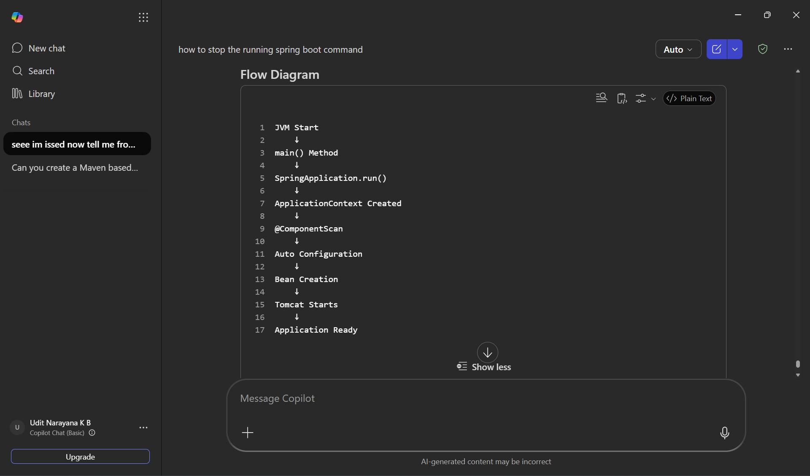

Task 31:
What is the syntax to change the port of the embedded Tomcat server in Spring Boot?

By default, Spring Boot runs on port 8080.
To change the port number, add the following line in application.properties:
.properties
1
server.port=9090
2
`
Show more lines
Now the application will run on:
Plain Text
1
http://localhost:9090
Show more lines
instead of:
Plain Text
1
http://localhost:8080
Show more lines

Example
application.properties
.properties
1
server.port=9090
Show more lines

Conclusion
The syntax to change the embedded Tomcat server port in Spring Boot is:
.properties
1
server.port=<port_number>
Show more lines
Example:
.properties
1
server.port=9090

