Task 1:
What is an Actuator in Spring boot?
Spring Boot Actuator is a module provided by Spring Boot that helps us monitor, manage, and inspect a running application in production.
It exposes various endpoints that give information about:
- Application health
- Metrics
- Environment properties
- Beans
- Loggers
- Mappings
- Application info
- Thread details

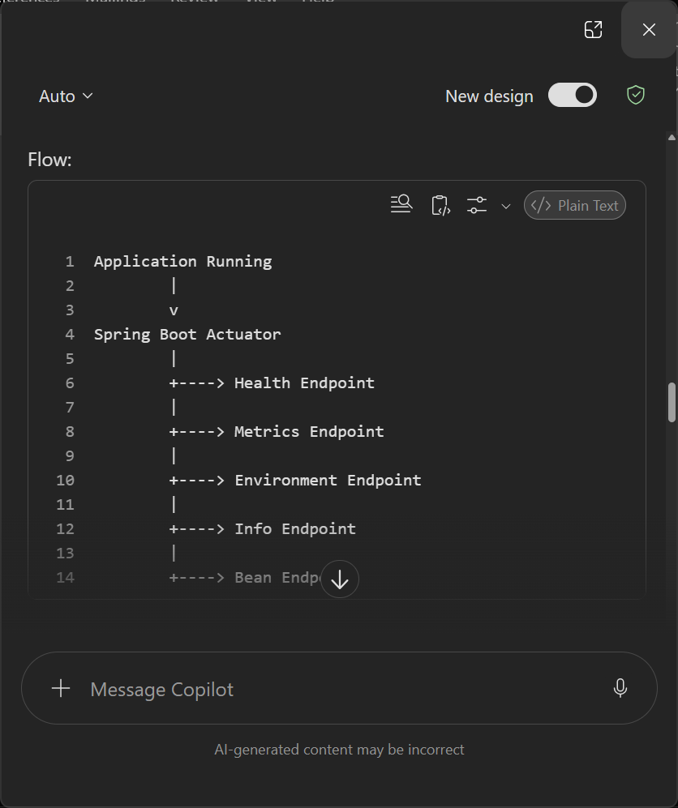
Task 2:
Advantages of spring boot Actuators:
✅ Health Monitoring
✅ Metrics Collection
✅ Performance Tracking
✅ Production Debugging
✅ Runtime Insights
✅ Integration with Prometheus/Grafana
✅ Secure Endpoints
✅ Microservices Monitoring
✅ Improved Reliability
✅ Reduced Development Effort

Task 3:
What are the commonly used Actuator end points?

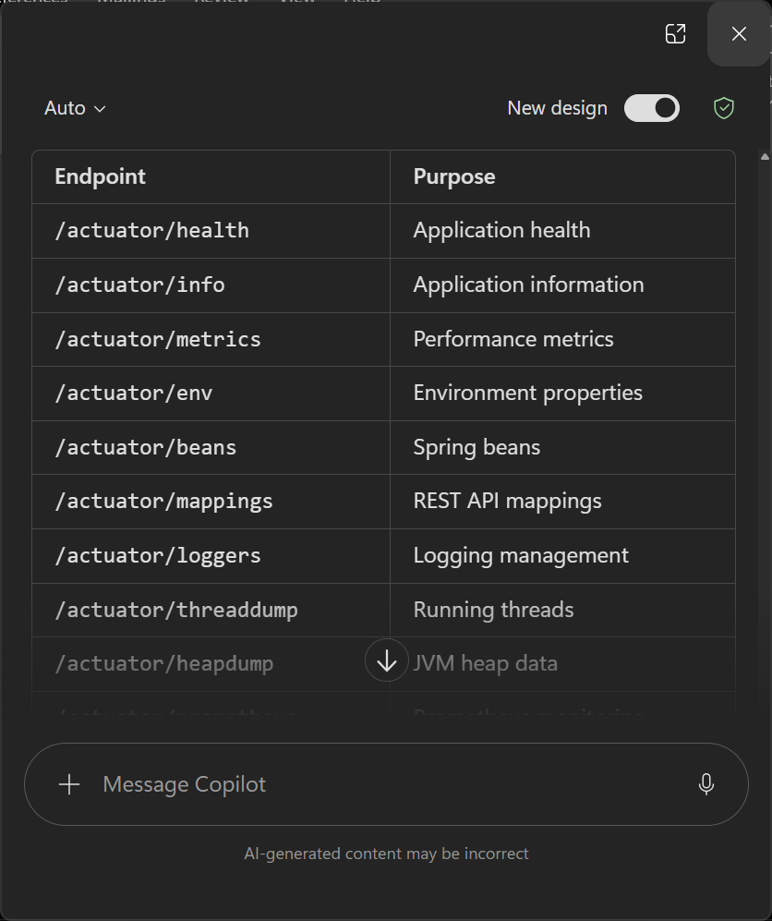

Task 4:
Create a Small demo of Actuator to know the functionality
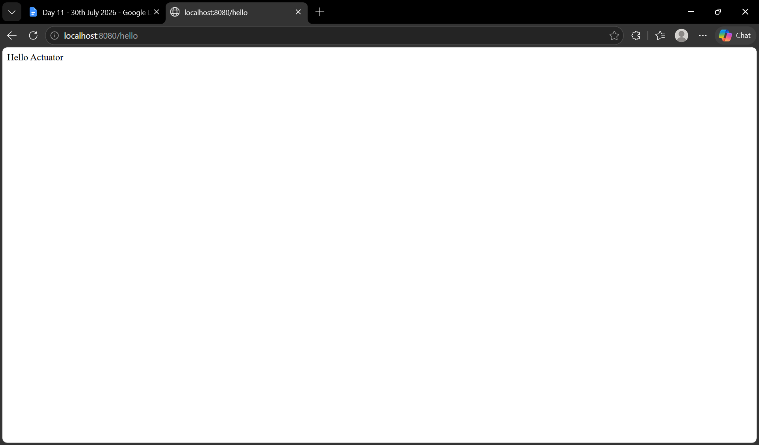

Task 5 :
What is Spring Security Architecture?
Spring Security is a framework that provides:
- Authentication (Who are you?)
- Authorization (What can you access?)
- Protection against common attacks
- Spring Security Architecture is a security framework that handles authentication and authorization for Spring applications. Every request passes through the Security Filter Chain, where Spring validates the user's identity and permissions before allowing access to application resources. It provides features such as login authentication, role-based authorization, session management, CSRF protection, and password encryption.

Task 6 :
What are the core components of Spring security architecture
The core components of Spring Security are Security Filter Chain, Authentication Manager, Authentication Provider, UserDetailsService, PasswordEncoder, and SecurityContext. The Security Filter Chain intercepts requests, Authentication Manager coordinates authentication, Authentication Provider validates credentials, UserDetailsService loads user details, PasswordEncoder verifies encrypted passwords, and SecurityContext stores authenticated user information for the current request/session.

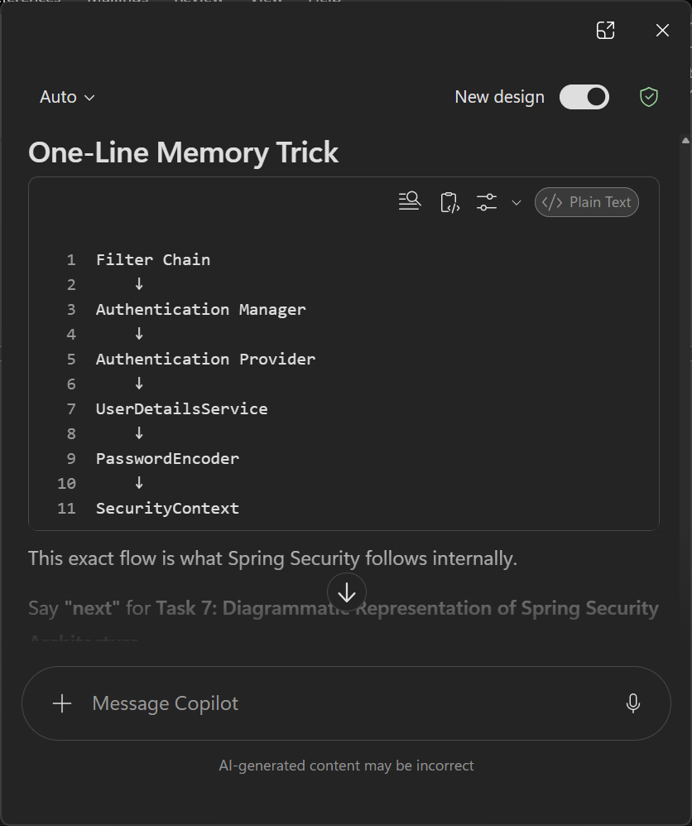
Task 7:
Can you create a diagrammatic representation of Spring Security architecture
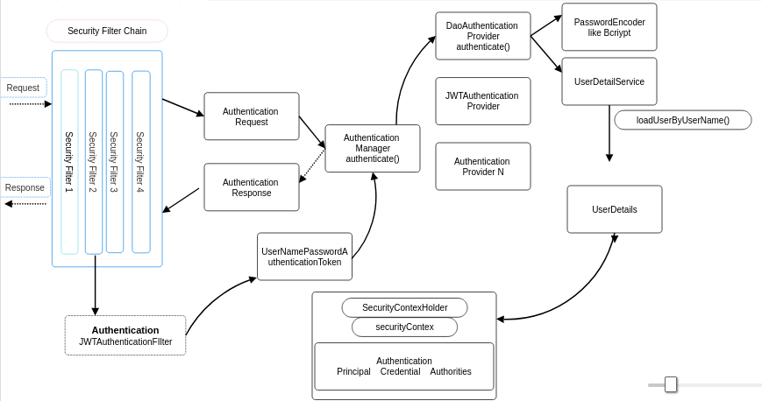
Task 8:
What is a Security filter chain? Give example code
A Security Filter Chain is a collection of security filters that process every incoming HTTP request before it reaches your Controller.

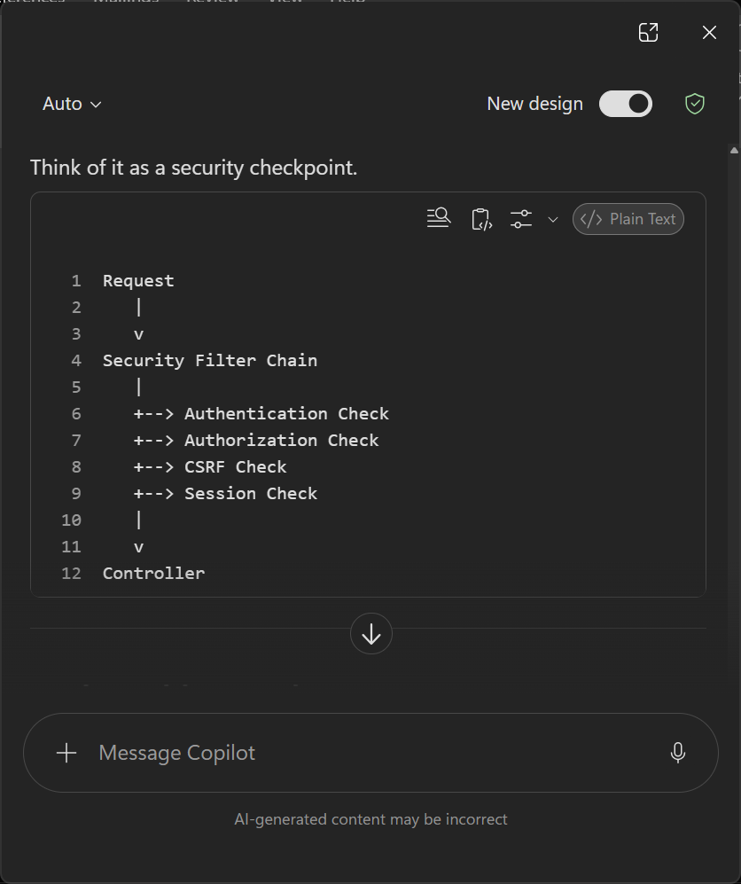
public SecurityFilterChain securityFilterChain(HttpSecurity http)
throws Exception {
http
.authorizeHttpRequests(auth -> auth
.requestMatchers("/hello").permitAll()
.anyRequest().authenticated()
)
.httpBasic(Customizer.withDefaults());

Task 9 :
What is an Authentication Manager? Give example code
@PostMapping("/login")
public String login(
@RequestParam String username,
@RequestParam String password) {
Authentication authentication =
authenticationManager.authenticate(
new UsernamePasswordAuthenticationToken(
username,
password));
if (authentication.isAuthenticated()) {
return "Login Successful";
}
return "Login Failed";
}

AuthenticationManager is the central interface in Spring Security responsible for processing authentication requests. It receives user credentials and delegates the validation process to one or more AuthenticationProviders. If authentication succeeds, it returns an authenticated Authentication object; otherwise, it throws an authentication exception.

Task 10:
What are Authentication Proividers? Give example and code
AuthenticationManager decides, AuthenticationProvider verifies.

An AuthenticationProvider is the component that actually checks whether the username and password are valid.
It performs:
✅ User lookup
✅ Password validation
✅ Role loading
✅ Authentication success/failure

@Component
public class CustomAuthenticationProvider
implements AuthenticationProvider {
@Override
public Authentication authenticate(
Authentication authentication) {
String username = authentication.getName();
String password = authentication.getCredentials().toString();
if ("udit".equals(username)
&& "1234".equals(password)) {
return new UsernamePasswordAuthenticationToken(
username,
password,
new ArrayList<>());
}
throw new BadCredentialsException(
"Invalid User");
}
@Override
public boolean supports(Class<?> authentication) {
return UsernamePasswordAuthenticationToken.class
.isAssignableFrom(authentication);
}
}

Task 11: User Detail Service:
UserDetailsService is an interface provided by Spring Security that is responsible for:
Loading user information based on the username.

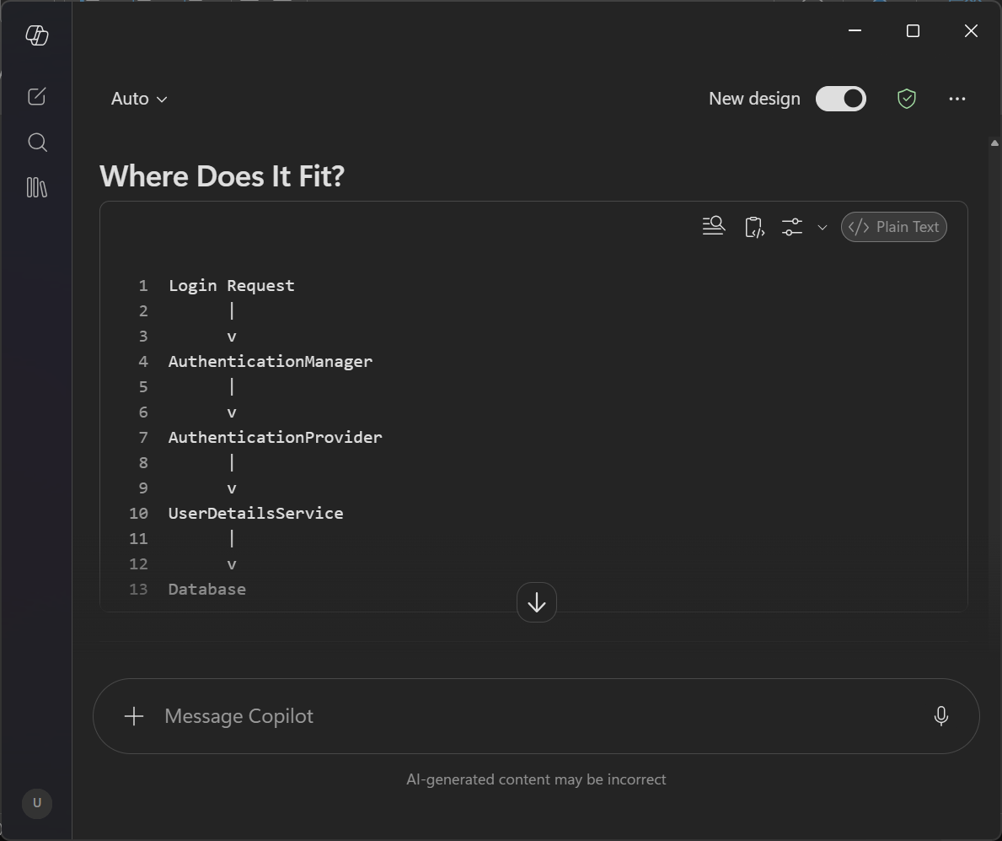
UserDetailsService is a Spring Security interface used to load user information during authentication. It contains the method loadUserByUsername(), which retrieves user details such as username, password, and roles from a database or another source and returns them as a UserDetails object. AuthenticationProvider uses UserDetailsService during the login process to validate users.

Task 12:
What is PasswordEncoder? Give Example
PasswordEncoder is a Spring Security interface used to hash and verify passwords. It prevents storing passwords in plain text and provides secure password comparison during authentication. The most commonly used implementation is BCryptPasswordEncoder.
PasswordEncoder encoder =
new BCryptPasswordEncoder();

String encoded =
encoder.encode("1234");

System.out.println(encoded);

System.out.println(
encoder.matches(
"1234",
encoded
)
);
Task 13:
What is SecurityContextHeader?
After a user logs in successfully, Spring Security needs a place to remember:
Who is logged in?
What role does the user have?
Is the user authenticated?
That place is called: SecurityContext
SecurityContext is a core component of Spring Security that stores information about the currently authenticated user. After successful authentication, Spring stores an Authentication object inside the SecurityContext. This object contains details such as username, roles, authorities, and authentication status. The SecurityContext can be accessed anywhere in the application using SecurityContextHolder.

Task 14 :
Finally give the security Architecture internal functionality? How actually it works internally… step by step if you can explain

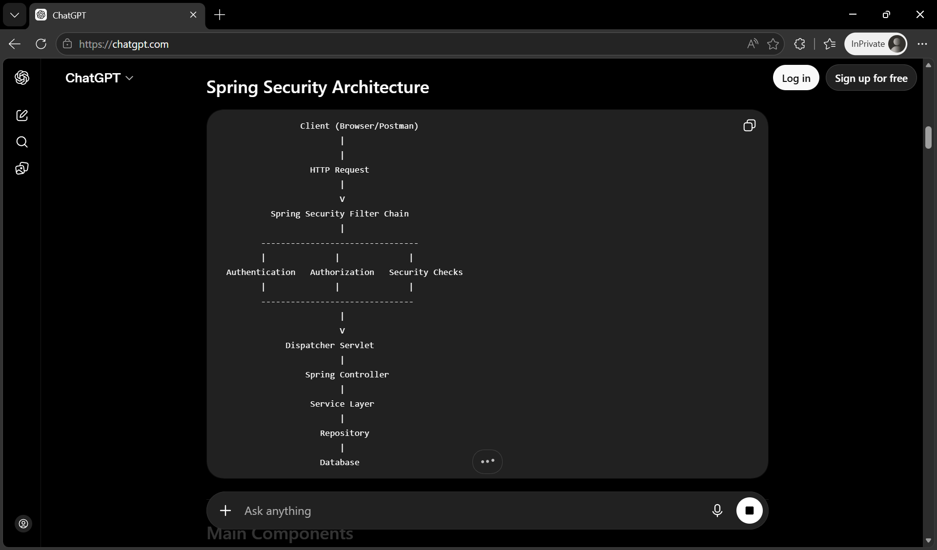
- Spring Security is a framework that secures Spring applications.
- It provides Authentication (Who are you?) and Authorization (What are you allowed to do?).

Main Components
- SecurityFilterChain – Intercepts every incoming request.
- AuthenticationManager – Starts the authentication process.
- AuthenticationProvider – Validates the user's credentials.
- UserDetailsService – Loads user details from the database.
- PasswordEncoder (BCrypt) – Encrypts and verifies passwords.
- SecurityContext – Stores the authenticated user's information.
- SecurityContextHolder – Provides access to the current logged-in user.

Task 15: What is Thymeleaf? Explain? Why is it Used?
Thymeleaf is a Java-based server-side template engine used to create dynamic web pages in Spring Boot applications.
It allows you to combine HTML with Java data so that the web page is generated dynamically before it is sent to the browser.
In simple words:
Thymeleaf takes data from the Spring Boot application and displays it inside an HTML page.
How does it work?
- Browser sends a request.
- Controller receives the request.
- Service fetches data.
- Repository gets data from the database.
- Controller adds data to the Model.
- Thymeleaf reads the HTML template.
- It replaces expressions (like ${name}) with actual values.
- The generated HTML is sent to the browser.

Task 16:
Create a demo on thymeleaf .

Task 17:
What do you think are the advantages of using thymeleaf?
Advantages of Thymeleaf
- Easy integration with Spring Boot.
- Generates dynamic HTML pages.
- Simple and HTML-friendly syntax.
- Supports loops (th:each) and conditions (th:if).
- Supports form handling and data binding.
- Provides reusable layouts (header, footer, navbar).
- Produces valid HTML templates (natural templates).
- Automatically escapes HTML to improve security.
- Improves code readability and maintainability.
Task 18: What is Caching in Springboot?
Caching is the process of storing frequently accessed data in a temporary memory (called a cache) so that future requests for the same data can be served much faster without querying the database again.
Simple Definition
Caching stores frequently used data in memory to improve application performance and reduce database access.
Task 19:
What are the features of caching in SpringBoot?
Spring Boot is a framework built on top of the Spring Framework that simplifies application development by providing:
- Auto Configuration
- Embedded Servers
- Starter Dependencies
- Production-ready features
- Minimal configuration
Simple Definition
Spring Boot is a framework that simplifies Spring application development by reducing configuration and providing built-in features for rapid development.

Task 20:
What are the types of Caching ? explain each type.
The most common types of caching are:
- In-Memory Cache
- Distributed Cache
- Database Cache
- Browser Cache
- CDN (Content Delivery Network) Cache
In-Memory Cache → Fastest local cache.
Redis → Most popular distributed cache in Spring Boot.
Browser Cache → Static resources.
CDN Cache → Global content delivery.
Session Cache → User-specific session data.
Database Cache → Optimizes repeated SQL queries.

Task 21: List down annotations of Caching with usage.
Caching annotations tell Spring Boot:
- When to store data in the cache.
- When to retrieve data from the cache.
- When to update the cache.
- When to remove data from the cache.
Instead of writing cache logic manually, you simply add an annotation.
@EnableCaching → Enables caching in the application.
@Cacheable → Stores method results in the cache and returns cached results for repeated requests.
@CachePut → Always executes the method and updates the cache.
@CacheEvict → Removes one or more entries from the cache.
@Caching → Combines multiple cache operations in a single annotation.
@CacheConfig → Defines common cache settings for a class.

Task 22:
What does @InjectMocks do
@InjectMocks creates the actual object that we want to test and automatically injects all mocked dependencies into it.

Current code:
BankRepository mockRepo =
mock(BankRepository.class);
BankService service =
new BankService(mockRepo);

With @InjectMocks
@ExtendWith(MockitoExtension.class)
class BankServiceTest {
@Mock
private BankRepository repository;
@InjectMocks
private BankService service;
}

Task 23:
What is @Spy:
@Spy creates a real object but allows Mockito to monitor or override specific methods.
@mock- Entire fake Objects
@Spy- Real Object+fake selected methods

Task 24:
Why is @Mock used?
@Mock creates a fake object and removes dependency on external systems such as:
- Database
- APIs
- File Systems
- Messaging Systems
- @Mock
private BankRepository repository;

Task 25 :
What is Partial Mocking?
Partial Mocking means:
Some methods execute real logic while some methods are mocked.
Task 26:
What is verify() used for?
verify() checks whether a method was called.
Very important in Mockito.
verify(mockRepo)
.save(account);

Task 27 :
List down few more annotations that we use for mocking
@Mock
@InjectMocks
@Spy
@Captor
@ExtendWith(MockitoExtension.class)
@MockBean
@SpyBean

