Task 1 : what is java jpa
JPA = Rules/Specification
Hibernate = One implementation of those rules
When we write:
1 @Entity
2 @Table
3 @Id
These annotations come from JPA.
Hibernate understands them and implements them.
Spring Data JPA is a Spring module that simplifies database operations in Java applications. It is built on top of JPA and helps developers interact with databases with less code.
Before Spring Data JPA, developers used JDBC where they had to write connection code, SQL queries, result set handling, and exception handling manually. This resulted in a lot of repetitive code.
Task 2 : What are the key features of Spring data JPA?
1. Automatic CRUD operations
2. Query generation from method names
3. Pagination support
4. Sorting support
5. Custom queries using @Query
6. Repository pattern
7. JPA/Hibernate integration
8. Transaction management
9. Auditing support
10. Reduced boilerplate code

Task 3 : What are core components of Spring data JPA?
1. Entity
A Java class that represents a database table.

Example:

@Entity
public class Employee {
@Id
private Integer id;
private String name;
}

2. Repository
An interface used to perform database operations.

Example:

public interface EmployeeRepository
extends JpaRepository<Employee, Integer> {
}

Example:

@Entity
public class Employee {
@Id
private Integer id;
private String name;
}

2. Repository
An interface used to perform database operations.

Example:

public interface EmployeeRepository
extends JpaRepository<Employee, Integer> {
}

Task 4 :
Now create a spring application using initializer
Create a customer entity with id and account type
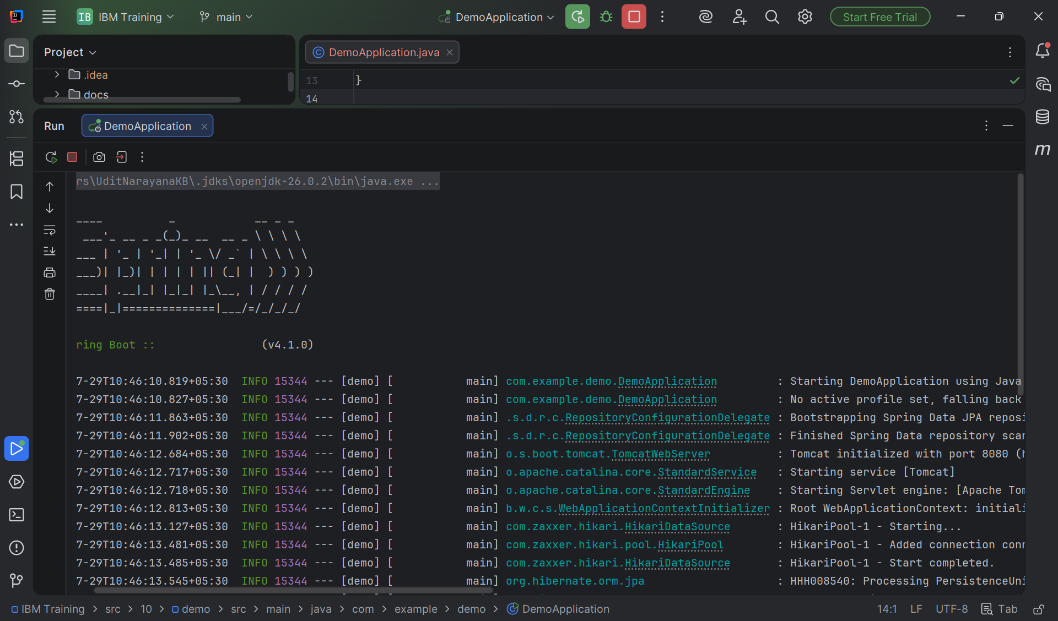

Task 6 : What is application.properties file about?
application.properties is a configuration file used in Spring Boot applications to store application settings and externalized configuration. It allows developers to define values such as server port, database connection details, logging levels, application name, and other environment-specific properties without changing the source code.

server.port=8081
spring.application.name=Employee-Service

spring.datasource.url=jdbc:mysql://localhost:3306/employeedb
spring.datasource.username=root
spring.datasource.password=root

Task 7 :
Why use application.properties? Uses?
• Centralizes application configuration in one place. [geeksforgeeks.org]
• Allows overriding Spring Boot default settings. [geeksforgeeks.org]
• Supports different configurations for Development, Test, and Production environments. [geeksforgeeks.org]
• Reduces hardcoding of values in Java code. [geeksforgeeks.org]
• Stores settings for databases, ports, Eureka, security, logging, and more. [geeksforgeeks.org]

Task 8 :
What is application.yml?
application.yml is an alternative configuration file format in Spring Boot that uses YAML (YAML Ain't Markup Language) syntax instead of the key-value format used by application.properties. It is commonly used to define application configuration in a more structured and hierarchical way.

server:
port: 8081

spring:
application:
name: Employee-Service

datasource:
url: jdbc:mysql://localhost:3306/employeedb
username: root
password: root

Task 9:
Why use/prefer application.yml instead of application.properties?
Many developers prefer application.yml because:
- It is more readable for complex configurations
- Supports hierarchical/nested structures naturally.
- Reduces repetition of property names.
- Easier to manage microservices and large applications with many configurations.
Task 10:
What is Eureka Server?
Eureka Server is a Service Registry used in a Microservices Architecture. It maintains information about all registered microservices and helps them discover each other dynamically without hardcoding service URLs. It is also known as a Discovery Server
Task 11:
Purpose of Eureka Server
The main purposes of Eureka Server are:
- Service Registration – Microservices register themselves with Eureka when they start.
- Service Discovery – Other services can find registered services through Eureka.
- Dynamic Communication – Services communicate without knowing exact IP addresses or ports.
- Load Balancing Support – Multiple instances of a service can be discovered and used efficiently.
- Health Monitoring – Eureka tracks service availability through heartbeats and removes unavailable instances.

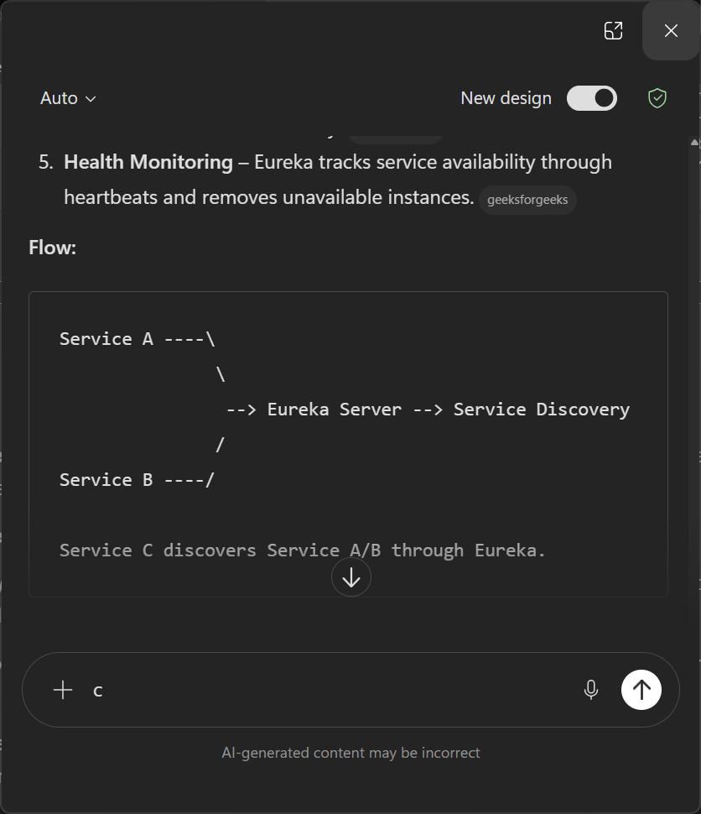

HOME TASK :
Task 1 :
What do you know about Spring MVC Framework?
Spring MVC (Model-View-Controller) is a Java-based web framework that is part of the Spring Framework. It follows the MVC design pattern to build scalable, maintainable, and loosely coupled web applications.
Features of Spring MVC
- Follows MVC architecture.
- Uses DispatcherServlet as Front Controller.
- Supports form handling and validation.
- Supports RESTful web services.
Task 2:
What is DispatcherServlet?

DispatcherServlet is the central component (Front Controller) of the Spring MVC framework. It receives all incoming HTTP requests, identifies the correct controller, processes the request, and returns the appropriate response.

Task 3:
Explain Spring MVC with Diagram
