Task 1 : Big O notation:
Describes how fast a algorithm grows based on the input size
O(1) – Const time
O(n) – takes n time

Task 2: Arrays , type of array
Arrays are the data structures which store the memory in continuous memory locations

Task 3 : String in java
Strings are the immutable sequence of characters .

Task 5 : Reverse the string :
public class ReverseString {
public static void main(String[] args) {
String str = "Hello";
for (int i = str.length() - 1; i >= 0; i--) {
System.out.print(str.charAt(i));
}
}
}

Task 6 : take a normal var and static var incremenet the value by calling static and ormal varibel and then we need to show the difference btw the normal variable and static variable
class Check {
int normalVar = 0;
static int staticVar = 0;

void increment() {
normalVar++;
staticVar++;

System.out.println("normalVar = " + normalVar);
System.out.println("staticVar = " + staticVar);
System.out.println();
}
}

public class Main {
public static void main(String[] args) {

Check obj1 = new Check();
Check obj2 = new Check();

obj1.increment();
obj2.increment();
obj1.increment();
}
}

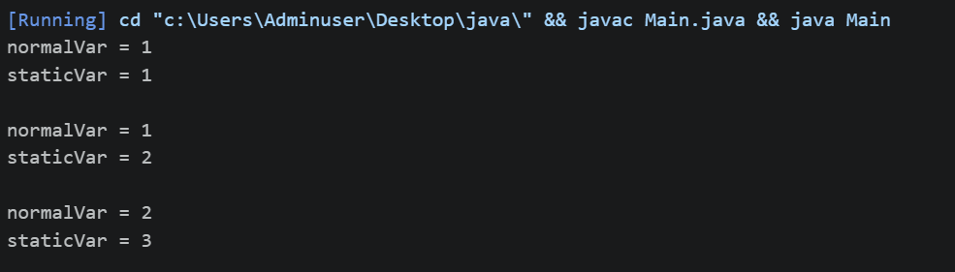

Task 7 : print 100 to 10
import java.util.*;
public class Main{
public static void Main (String args){
for (int i=100; i<=0;i--){
System.out.println(i);
}
}
}

Task 8 : accept login id and passweord and display welcome
import java.util.Scanner;

public class Main {
public static void main(String[] args) {
Scanner sc = new Scanner(System.in);

String loginId = "";
String password = "";

while (!(loginId.equals("Udit") && password.equals("4321"))) {
System.out.print("Enter Login ID: ");
loginId = sc.nextLine();

System.out.print("Enter Password: ");
password = sc.nextLine();

if (loginId.equals("Udit") && password.equals("4321")) {
System.out.println("Welcome User!");
} else {
System.out.println("Invalid Login ID or Password. Try Again.");
}
}
}
}
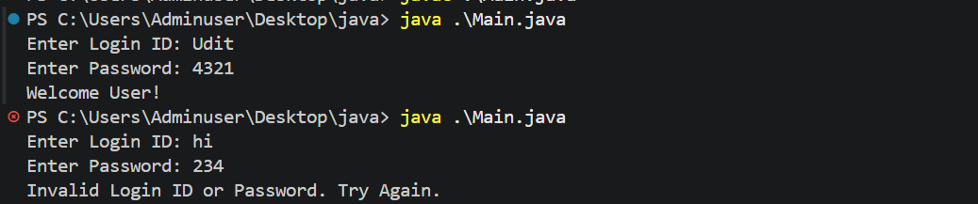

Task 10 : if , else -if , nested -if
If:
public class IfDemo {
public static void main(String[] args) {
int age = 20;

if (age >= 18) {
System.out.println("Eligible to Vote");
}
}
}

Else -if :
public class ElseIfDemo {
public static void main(String[] args) {
int marks = 75;

if (marks >= 90) {
System.out.println("Grade A");
} else if (marks >= 70) {
System.out.println("Grade B");
} else if (marks >= 50) {
System.out.println("Grade C");
} else {
System.out.println("Fail");
}
}
}

Nested-if:
public class NestedIfDemo {
public static void main(String[] args) {
int age = 25;
boolean citizen = true;

if (age >= 18) {
if (citizen) {
System.out.println("Eligible to Vote");
}
}
}
}

Task 11 : Switch case example :
import java.util.Scanner;

public class SwitchDemo {
public static void main(String[] args) {
Scanner sc = new Scanner(System.in);

System.out.print("Enter choice (1-3): ");
int choice = sc.nextInt();

switch (choice) {
case 1:
System.out.println("Monday");
break;

case 2:
System.out.println("Tuesday");
break;

case 3:
System.out.println("Wednesday");
break;

default:
System.out.println("Invalid Choice");
}
}
}

Task 12 : Access Modifiers :
Public : Can be able to access across all.
Private : Only the members of the class can access
Protected : all the members within the package can access
Default: all the members within the package can access and by default java give this if not mentioned .

Task 13 : wap to accept cust names and display them using for –each loop

import java.util.Scanner;

public class CustomerName {
public static void main(String[] args) {
Scanner sc = new Scanner(System.in);
String[] customers = new String[1];
System.out.print("Enter customer name: ");
customers[0] = sc.nextLine();
System.out.println("Customer Name:");
for (String customer : customers) {
System.out.println(customer);
}
sc.close();
}
}

Task 14 : continue and break

public class BreakContinu {
public static void main(String[] args) {
for (int i = 1; i <= 10; i++) {
if (i == 3) {
continue;
}
if (i == 7) {
break;
}
System.out.println(i);
}
}
}

Task 15 :Employee class and manager class and employee class should get all the details to the manager and display the details :
class Employee {
int empId;
String empName;
double salary;
Employee(int empId, String empName, double salary) {
this.empId = empId;
this.empName = empName;
this.salary = salary;
}
}
class Manager {
void displayEmployeeDetails(Employee emp) {
System.out.println("Employee Details");
System.out.println("----------------");
System.out.println("Employee ID : " + emp.empId);
System.out.println("Employee Name : " + emp.empName);
System.out.println("Salary : " + emp.salary);
}
}

public class Main {
public static void main(String[] args) {
Employee emp = new Employee(101, "John", 50000);
Manager mgr = new Manager();
mgr.displayEmployeeDetails(emp);
} }

