Day 7 - 24th July 2026

Task 01

Basic Test Case

package Junit;
import org.junit.jupiter.api.Test;
import static org.junit.jupiter.api.Assertions.*;

class Demo01_Basic_UnitTest {

@Test
void testAddition() {
Demo01_Calculator calc = new Demo01_Calculator();
assertEquals(15, calc.add(10, 5));
}
@Test
void testAdditionFail() {
Demo01_Calculator calc = new Demo01_Calculator();
//fails
assertEquals(20, calc.add(10, 5), "Expected 20 but actual is 15");
}
}

The java file is
package Junit;
public class Demo01_Calculator {
// Simple addition method
public int add(int a, int b) {
return a + b;
}
}

Task 02:
package Junit;
import org.junit.jupiter.api.Test;
import static org.junit.jupiter.api.Assertions.assertEquals;
import static org.junit.jupiter.api.Assertions.assertThrows;

public class Demo02_Exception_Testing {
@Test
void testWithdrawInsufficientFunds() {
Demo02_BankAccount account = new Demo02_BankAccount("123", 100.0);

Exception ex = assertThrows(IllegalArgumentException.class, () -> {
account.withdraw(200.0);
});

assertEquals("Insufficient balance", ex.getMessage());
}
}

Jav code
package Junit;

public class Demo02_BankAccount {
private String accountNumber;
private double balance;

public Demo02_BankAccount(String accountNumber, double balance) {
this.accountNumber = accountNumber;
this.balance = balance;
}

public String getAccountNumber() {
return accountNumber;
}

public double getBalance() {
return balance;
}

public void deposit(double amount) {
if (amount <= 0) {
throw new IllegalArgumentException("Deposit must be positive");
}
balance += amount;
}

public void withdraw(double amount) {
if (amount > balance) {
throw new IllegalArgumentException("Insufficient balance");
}
balance -= amount;
}
}

Task 03:

For above code create fail test cases

package Junit;

import org.junit.jupiter.api.Test;
import static org.junit.jupiter.api.Assertions.*;

class Demo02_BankAccountTest {
@Test
void testDepositFail() {
Demo02_BankAccount account = new Demo02_BankAccount("123", 500.0);
account.deposit(200.0);
//fails
assertEquals(800.0, account.getBalance(), "Expected 800 but got " + account.getBalance());
}

@Test
void testWithdrawFail() {
Demo02_BankAccount account = new Demo02_BankAccount("123", 500.0);
account.withdraw(200.0);
//fails
assertEquals(400.0, account.getBalance(), "Expected 400 but got " + account.getBalance());
}

@Test
void testExceptionFail() {
Demo02_BankAccount account = new Demo02_BankAccount("123", 100.0);
//fails
assertThrows(IllegalArgumentException.class, () -> account.withdraw(50));
}
}

Task 04:

Create a java code for the Parameterised Test case

package Junit;

import org.junit.jupiter.api.Test;
import org.junit.jupiter.params.ParameterizedTest;
import org.junit.jupiter.params.provider.ValueSource;

import static org.junit.jupiter.api.Assertions.assertFalse;
import static org.junit.jupiter.api.Assertions.assertTrue;

class Demo03_Parameterized_Test {

@ParameterizedTest
@ValueSource(strings = {"amma", "mom", "nitin"})
void testPalindromePass(String candidate) {
assertTrue(Demo03_StringUtils.isPalindrome(candidate));
}
//fail
@Test
void testPalindromeFail() {
// "hello" is NOT a palindrome, so this will fail
assertTrue(Demo03_StringUtils.isPalindrome("hello"), "Expected true but got false");
}

@ParameterizedTest
@ValueSource(strings = {"java", "spring", "bank"})
void testNotPalindrome(String candidate) {
assertFalse(Demo03_StringUtils.isPalindrome(candidate));
}
}

11.34 to 11.40

Java code 👍

package Junit;

public class Demo03_StringUtils {
public static boolean isPalindrome(String str) {
if (str == null) return false;
String reversed = new StringBuilder(str).reverse().toString();
return str.equalsIgnoreCase(reversed);
}
}

Task 05:
What is Junit Life cycle hook (set up tear down) ?
Lifecycle hooks are methods that JUnit runs automatically before and after tests.
They help you do:
- Setup (prepare data)
- Cleanup (remove data)

Task 06:

Create a java code for life cycle hook setup/ tear down test file

package Junit;

import org.junit.jupiter.api.*;
import static org.junit.jupiter.api.Assertions.*;

public class Demo04_LifeCycleHooks_Setup_TearDown {
private Demo04_DatabaseService db;

@BeforeEach
void init() {
db = new Demo04_DatabaseService();
db.connect();
}

@AfterEach
void cleanup() {
db.disconnect();
}

@Test
void testInsertAndFetchPass() {
db.insert("user1", "Prasunamba");
assertEquals("Prasunamba", db.fetch("user1"));
}

//fails
@Test
void testInsertAndFetchFailValue() {
db.insert("user1", "Prasunamba");
// This will fail because actual = "Prasunamba", expected = "WrongName"
assertEquals("WrongName", db.fetch("user1"), "Expected WrongName but got " + db.fetch("user1"));
}

//fails
@Test
void testFetchNonExistentKeyFail() {
// No insert performed, so fetch returns null
assertEquals("SomeValue", db.fetch("missingKey"), "Expected SomeValue but got null");
}
}

Java program
package org.example;
import java.util.HashMap;
import java.util.Map;
public class databaseService {
private Map<String, String> database;
private boolean connected;
public void connect() {
database = new HashMap<>();
connected = true;
System.out.println("Database Connected");
}
public void disconnect() {
connected = false;
System.out.println("Database Disconnected");
}
public void insert(String key, String value) {
if (!connected) {
throw new IllegalStateException("Database not connected");
}
database.put(key, value);
}
public String fetch(String key) {
if (!connected) {
throw new IllegalStateException("Database not connected");
}
return database.get(key);
}
}

Task 07:

What are assertions in Junit 5.. Explain

Assertions are methods provided by JUnit that help verify whether the actual result of your code matches the expected result.

Task 08:
What is time test performance service means 👍?

Performance testing checks whether a method or service completes within an expected time.

Task 09:

For the given timeout test Performance Service can you create a java code

package Junit;

import org.junit.jupiter.api.Test;
import static org.junit.jupiter.api.Assertions.assertTimeout;
import java.time.Duration;

class Demo06_TimeoutTest_PerformanceCheck {
@Test
void testQuickExecutionPass() {
Demo06_PerformanceService service = new Demo06_PerformanceService();
assertTimeout(Duration.ofMillis(500), () -> {
service.quickOperation(); // completes in 100ms
});
}
//fails
@Test
void testSlowExecutionFail() {
Demo06_PerformanceService service = new Demo06_PerformanceService();
assertTimeout(Duration.ofMillis(500), () -> {
service.slowOperation(); // takes 1000ms, exceeds timeout
});
}

//fails
@Test
void testUnrealisticTimeoutFail() {
Demo06_PerformanceService service = new Demo06_PerformanceService();
assertTimeout(Duration.ofMillis(50), () -> {
service.quickOperation(); // takes ~100ms, exceeds 50ms
});
}
}

package org.example;
public class Demo06_PerformanceService {
public void quickOperation() throws InterruptedException {
// Simulates a fast operation
Thread.sleep(100);
System.out.println("Quick Operation Completed");
}
public void slowOperation() throws InterruptedException {
// Simulates a slow operation
Thread.sleep(1000);
System.out.println("Slow Operation Completed");
}
}

Task 10:

Now what do you think are the different types of Junit 5 tests we have … list them down

JUnit 5 provides different types of tests such as:

Basic Tests (@Test)
Assertion Tests
Exception Tests (assertThrows)
Parameterized Tests (@ParameterizedTest)
Lifecycle Hook Tests (@BeforeEach, @AfterEach)
Performance/Timeout Tests (assertTimeout)
Repeated Tests (@RepeatedTest)
Disabled Tests (@Disabled)

Task 11:

Write about JVM architecture using a diagram.
JVM (Java Virtual Machine) is a part of the Java Runtime Environment (JRE) that executes Java bytecode. It acts as an intermediary between Java programs and the operating system, making Java platform-independent ("Write Once, Run Anywhere").

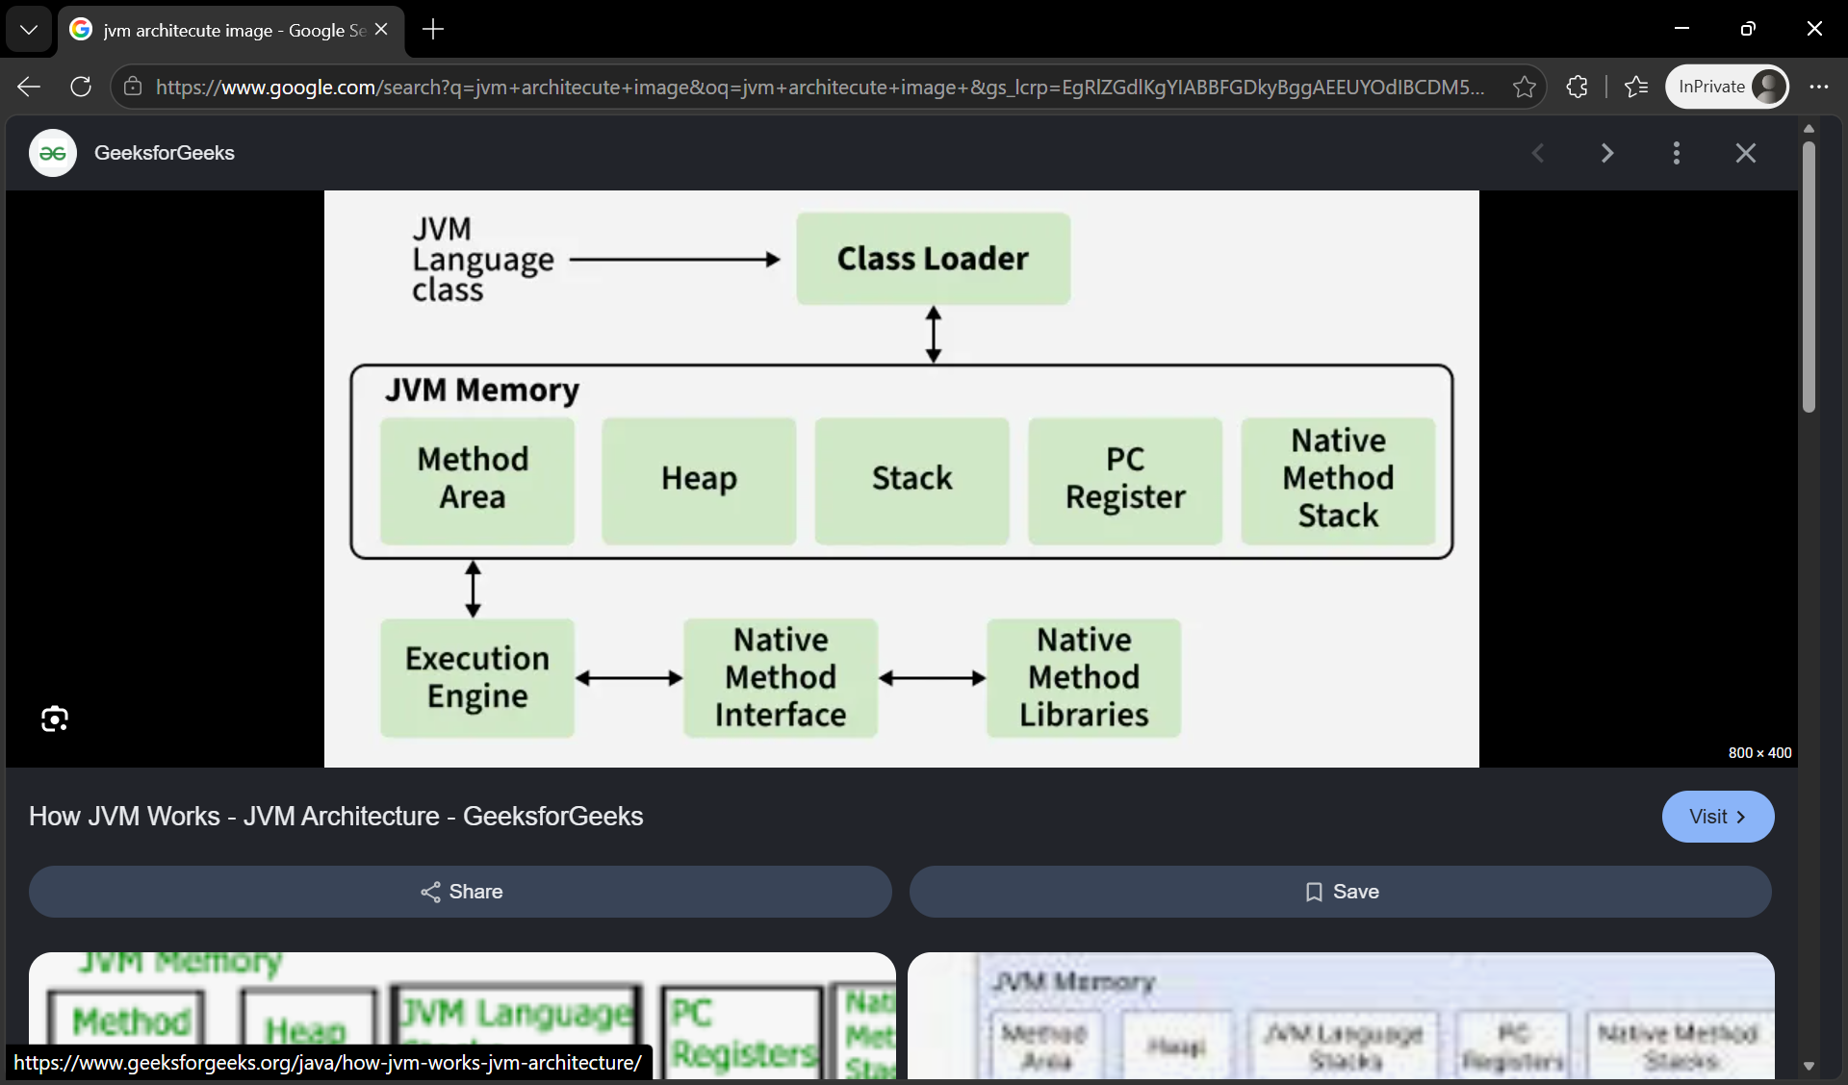

Task 12: Why are Enums Useful?
An enum (Enumeration) in Java is a special data type used to define a fixed set of constants.

