**Data :**

Location names is downloaded from nextdoor.com.

With the help of location names we got their latitude and longitude using python geocoder.

This data is then sent to foursquare API from which venues near the location is downloaded.

All this data are saved in csv for easy access in future references.

Link to the data ipynb : https://github.com/Udolf15/Coursera_Capstone/blob/master/DataExtraction.ipynb

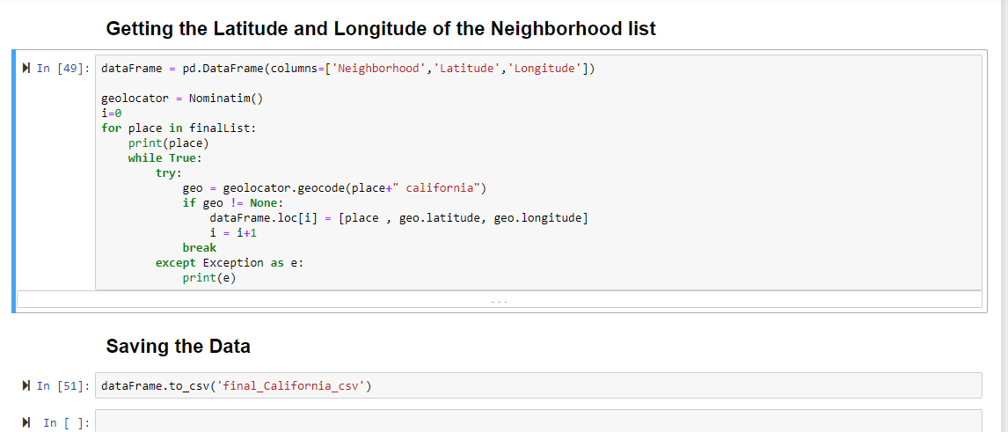Link to the data : <https://github.com/Udolf15/Coursera_Capstone/tree/master/data>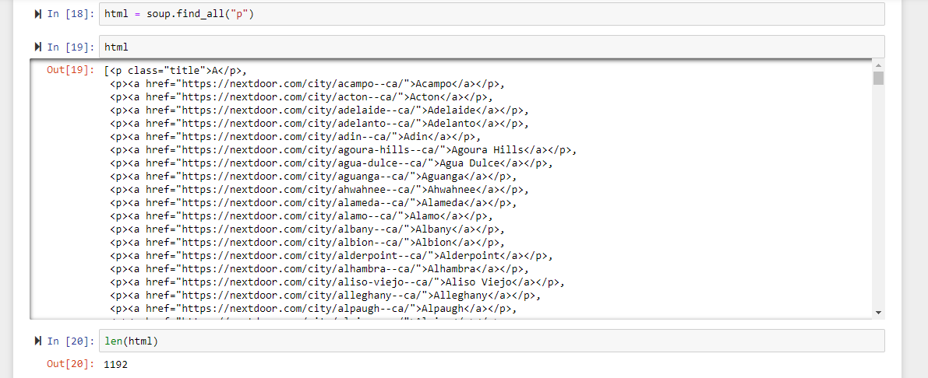

**Methodology :**

**1 : Convert location names into latitude and longitude.**

**2 : Then use the foursquare api to get nearby places.**

**3 : Then process it to get the nearby places as attributes using dummy variables.**

**4 : After that using k means to get clusters having same properties.**

**5 : Using folium library to draw the cluster on map.**

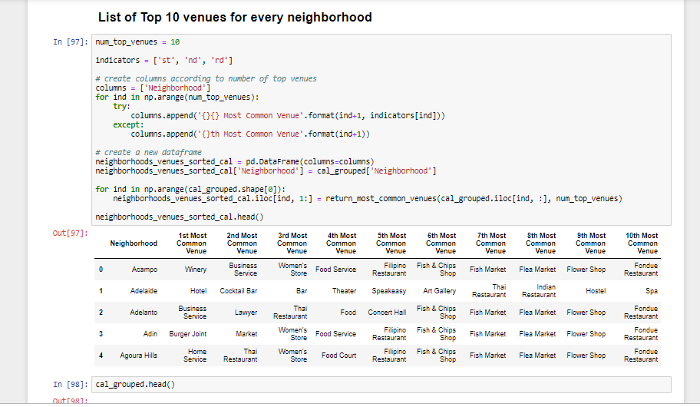

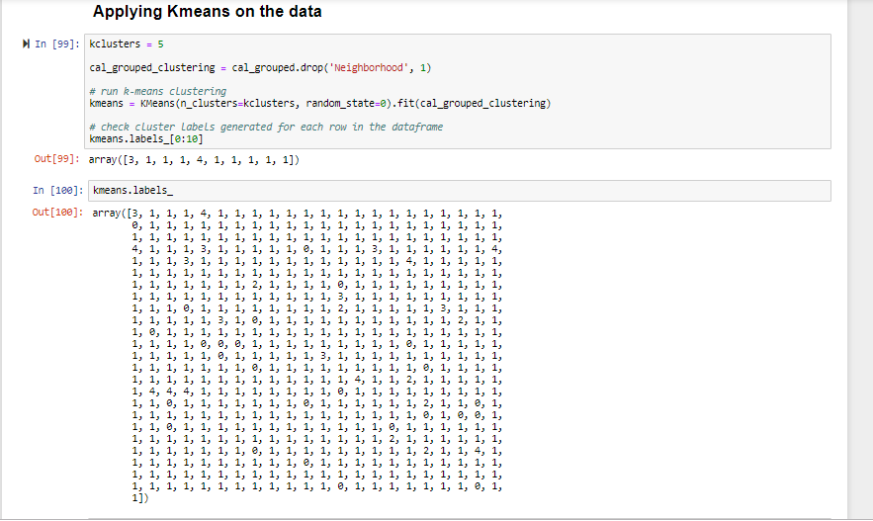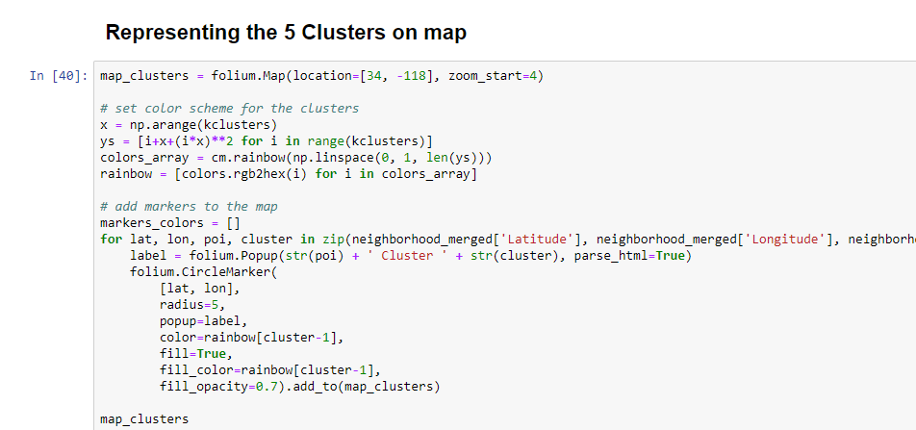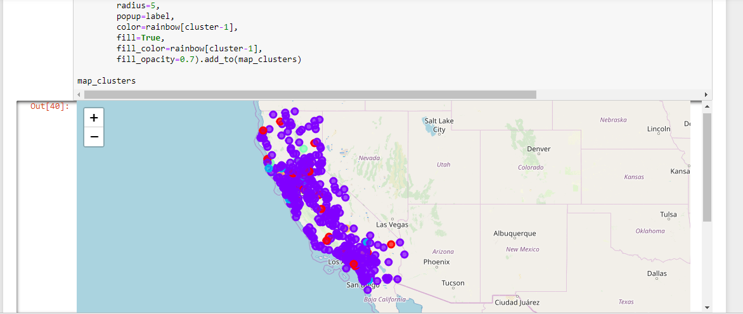

**5 Custers :**

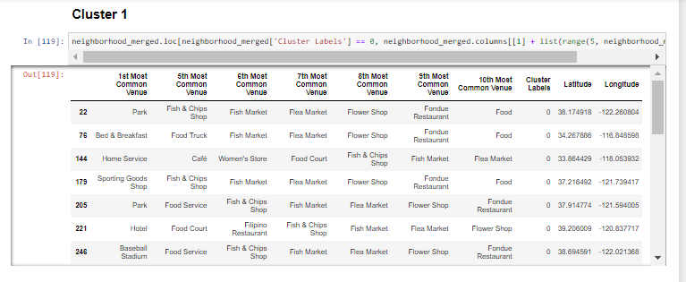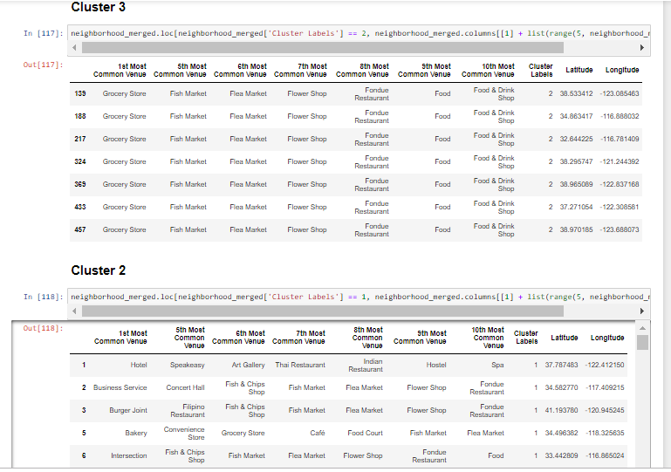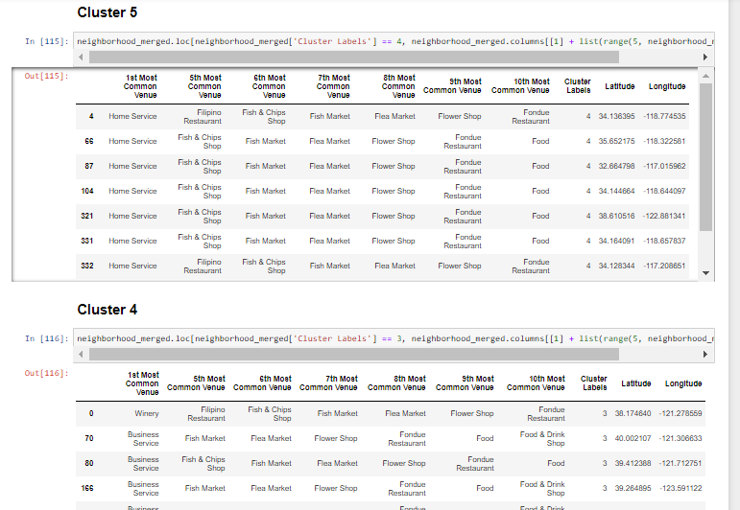

**Discussion :**

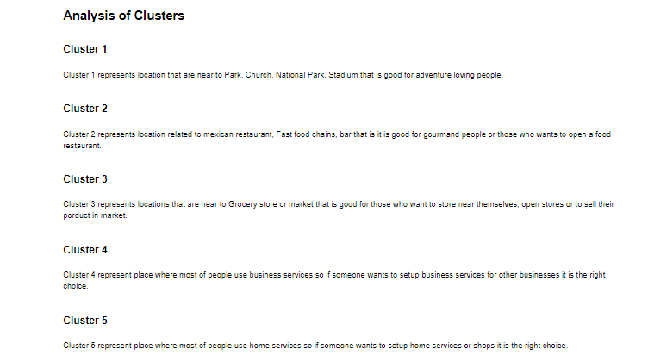

**Result :**

From the above discussion we can easily find the location or neighborhood which will be suitable for living as per need of a person whether it may be a immigrant or a business person.