**HONOR CODE**

I pledge, on my honor, to uphold UT Arlington's tradition of academic integrity, a tradition that values hard work and honest effort in the pursuit of academic excellence.

I promise that I will submit only work that I personally create or that I contribute to group collaborations, and I will appropriately reference any work from other sources. I will follow the highest standards of integrity and uphold the spirit of the Honor Code.

Udyam Sawant

1001661908

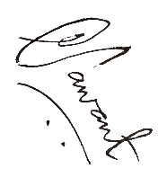

**Proof that the create table statements are executed successfully.**

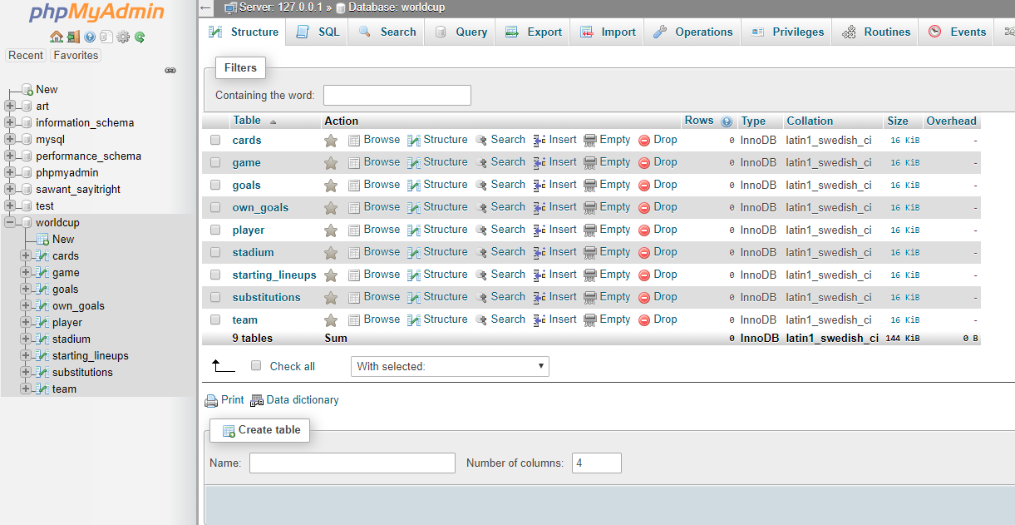

1. Retrieve the country, height, and names of all the players who hail from the African continent and are taller than 190 cm. Sort the list by country and their height.

SELECT T.Team,P.Height,P.PName from team as T JOIN player as P on T.TeamID=P.TeamID where P.Height > 190 AND T.Continent = 'Africa' ORDER BY T.Team, P.Height

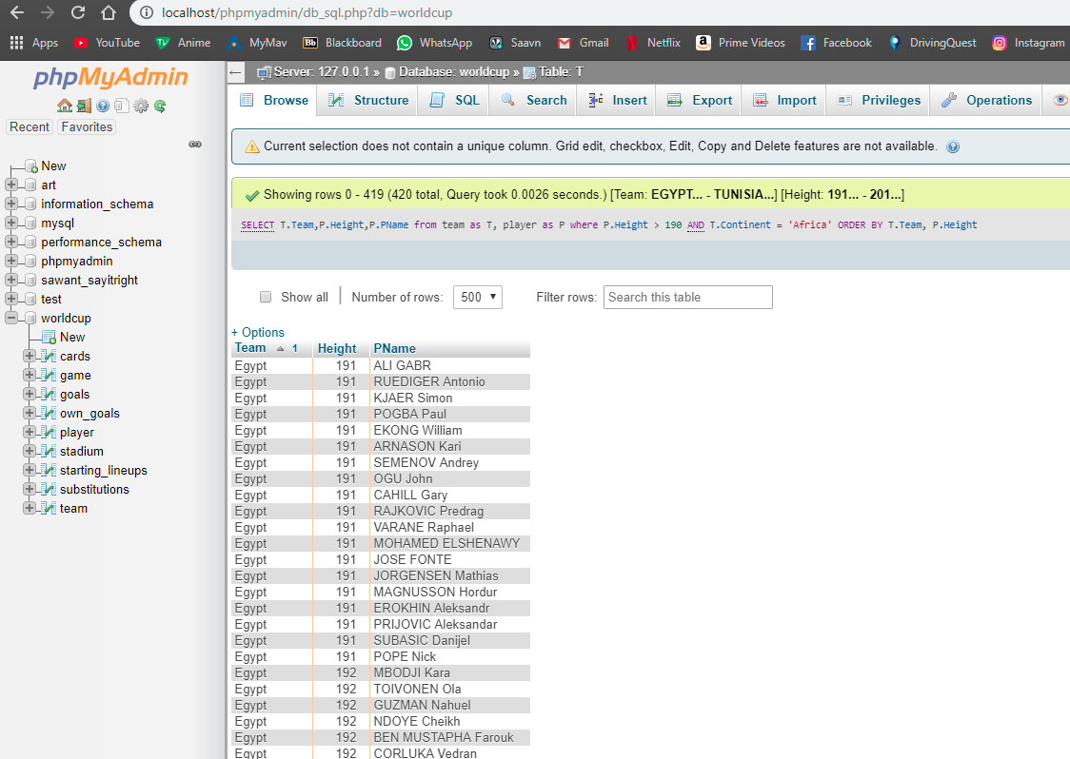

2) Retrieve the scores of all games played in Group A or B where each team had at least one score. Each result should list team 1 name, team 1 score, team 2 name, and team 2 score. Sort the result by the match type.

SELECT t1.Team, game.Team1_Score, t2.Team, game.Team2_Score FROM team AS t1, team AS t2, game

WHERE game.TeamID1 = t1.TeamID AND game.TeamID2 = t2.TeamID AND (game.Match_Type = 'A' OR game.Match_Type = 'B') AND (game.Team1_Score >0 AND game.Team2_Score >0) ORDER BY game.Match_Type;

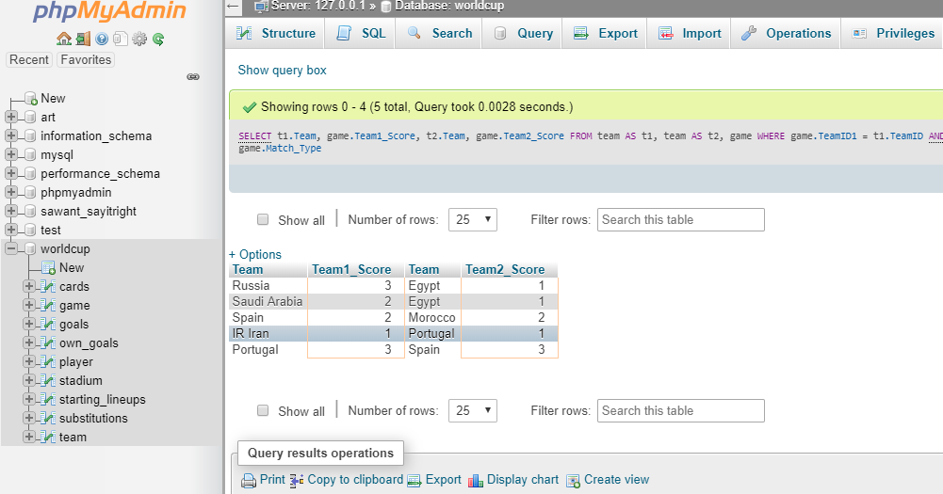

3)For all the players who received red card, retrieve their country ,player name, height and weight

SELECT DISTINCT P.Team, P.PName,P.Height,P.Weight from player AS P JOIN cards AS C on P.PNo=C.PNo AND P.TeamID=C.TeamID where C.Color='Red';

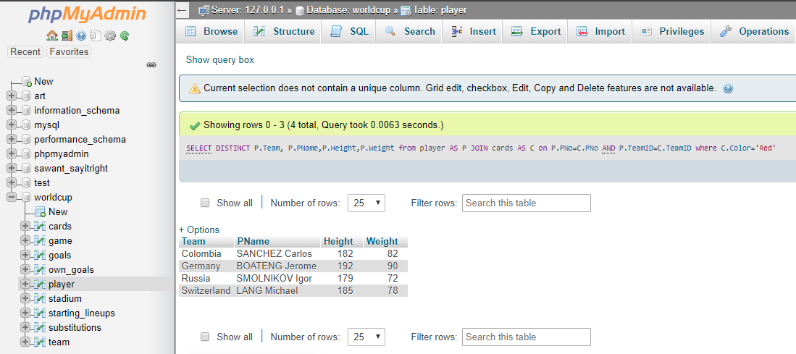

4) What is the name of the player who received the maximum number of yellow cards? How many yellow cards did he receive, and which country does he come from?

SELECT P.Team,P.PName,COUNT(C.PNo)No_of_yellow_cards from cards as C,player AS P where C.Color='Yellow' AND P.PNo=C.PNo AND P.TeamID=C.TeamID GROUP BY C.PNo,C.TeamID ORDER BY No_of_yellow_cards DESC LIMIT 1;

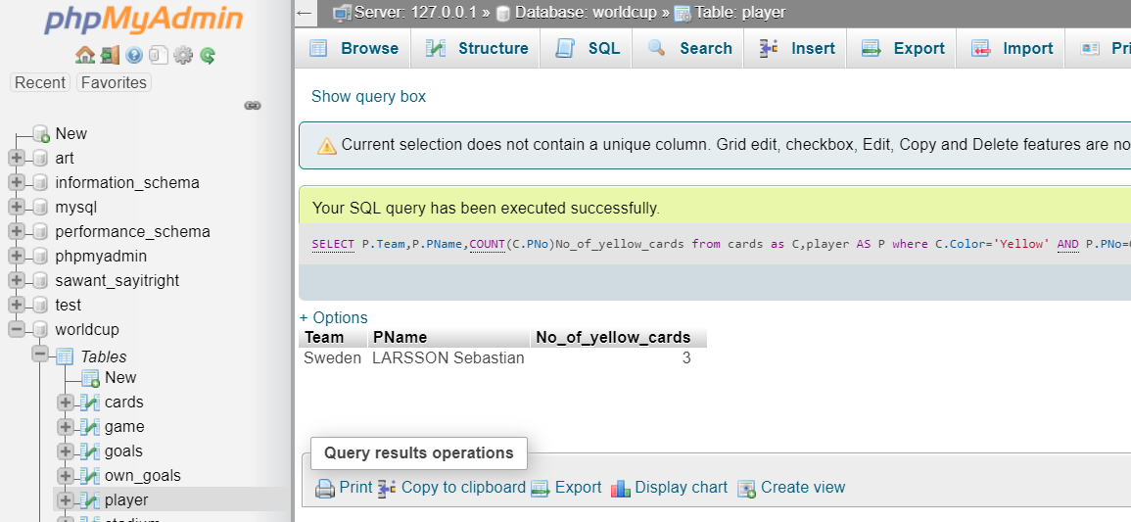

5) Retrieve the names of the teams that scored more than 1 own goals in 1 or more games. List the number of own goals that each of these team scored

SELECT T.Team, COUNT(O.TeamID) from own_goals AS O, team AS T Where T.teamID = O.TeamID GROUP BY O.TeamID HAVING COUNT(O.TeamID)>1

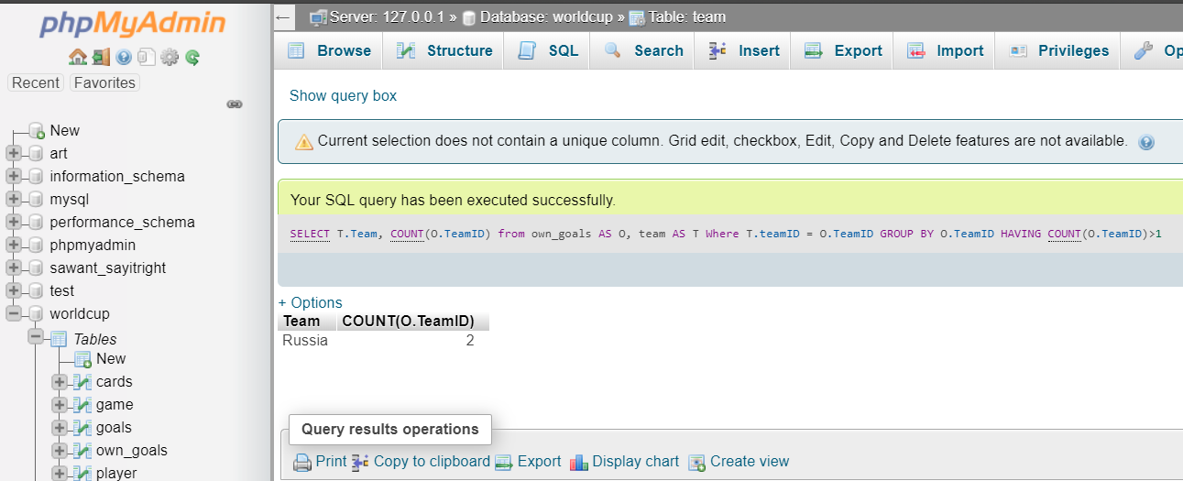

6) Create a view GAME_INFO that retrieves for each team all that team’s game scores. The view should have the following attributes: Team, and for each game that the team has participated in (either as TeamID1 or TeamID2) the following information: Match Type, Match Date, Stadium Name, SCity, Team1Name, Team1Score, Team2Name, Team2Score.

CREATE VIEW GAME_INFO AS SELECT G.Match_Type,G.Match_Date,S.SName,S.SCity,T1.Team AS Team1,G.Team1_Score,T2.Team as Team2,G.Team2_Score FROM game AS G, team AS T1 , team AS T2 ,stadium AS S WHERE G.TeamID1 = T1.TeamID AND G.TeamID2 = T2.TeamID AND G.SID=S.SID ORDER BY Match_Type;

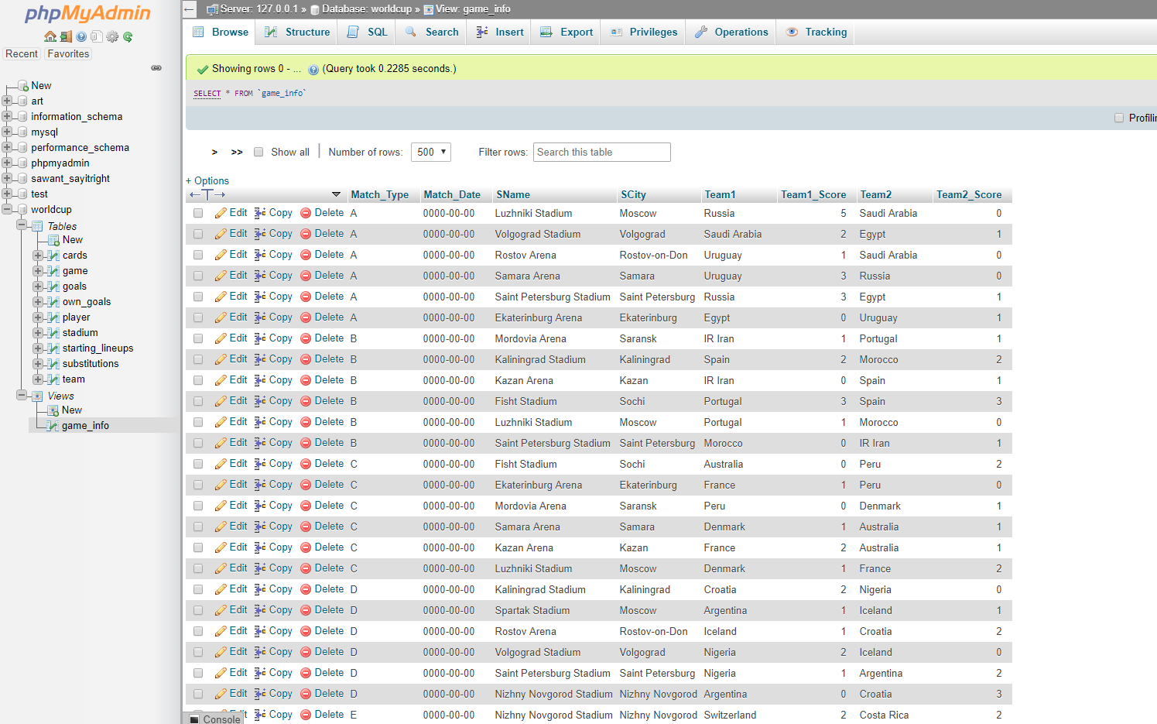

7. Write fourqueriesin the view you created:

Retrieve all game information from game_info where France played

SELECT * FROM game_info where Team1='France' OR Team2='FRANCE'

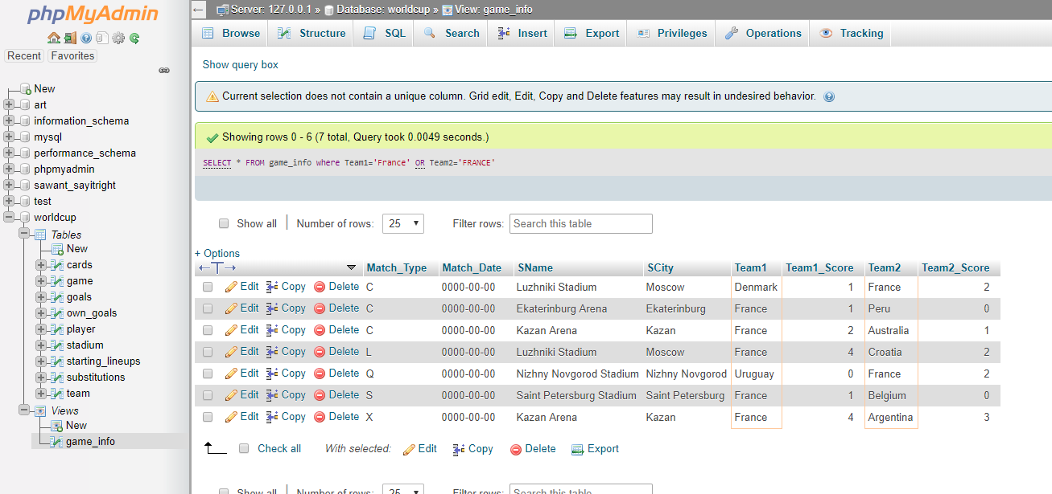

Retrieve all game information from game_info where game type is A or X

SELECT * FROM `game_info` WHERE Match_Type='A' OR Match_Type='X';

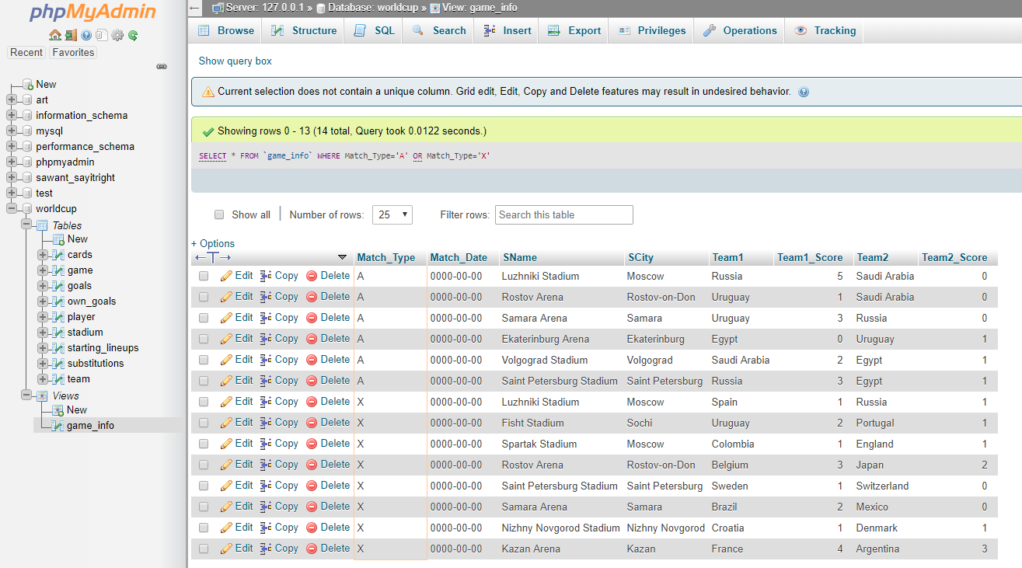

Retrieve all game information from game_info where team 1 scored more than 2 goals

SELECT * FROM `game_info` WHERE Team1_Score>2;

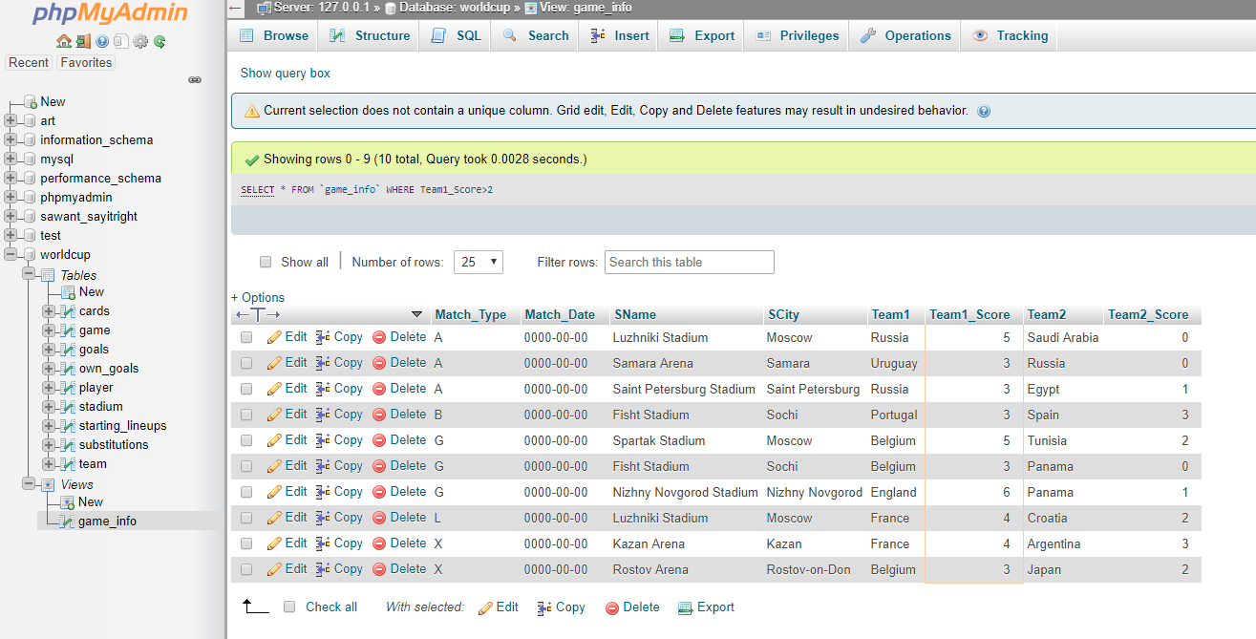

Retrieve all game information from game_info where the stadium name has Kazan in it.

SELECT * FROM `game_info` WHERE SName LIKE '%Kazan%';

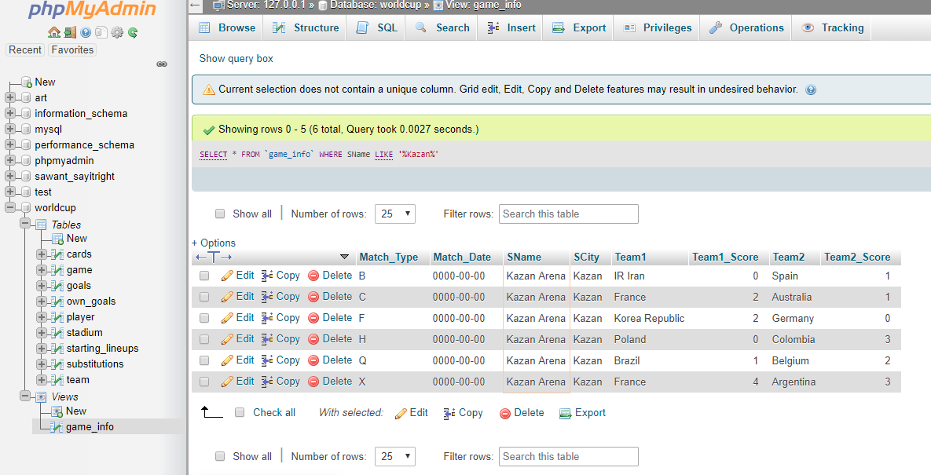

Write three additional queries on game_info and their results.

Retrieve all information from game_info where Team 2 wins.

SELECT * FROM `game_info` WHERE Team2_Score>Team1_Score;

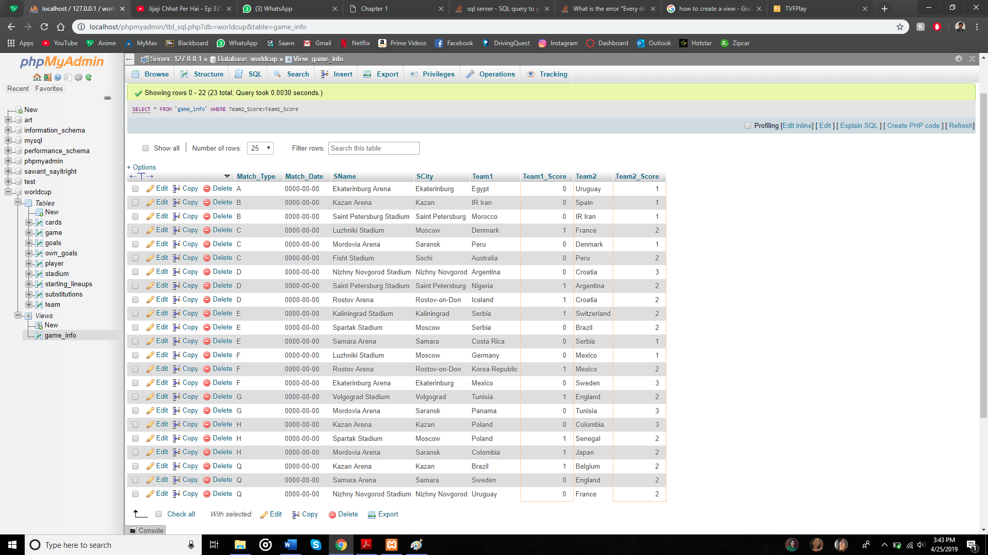

Retrieve all information from game_info where city is Moscow.

SELECT * FROM `game_info` WHERE SCity='Moscow';

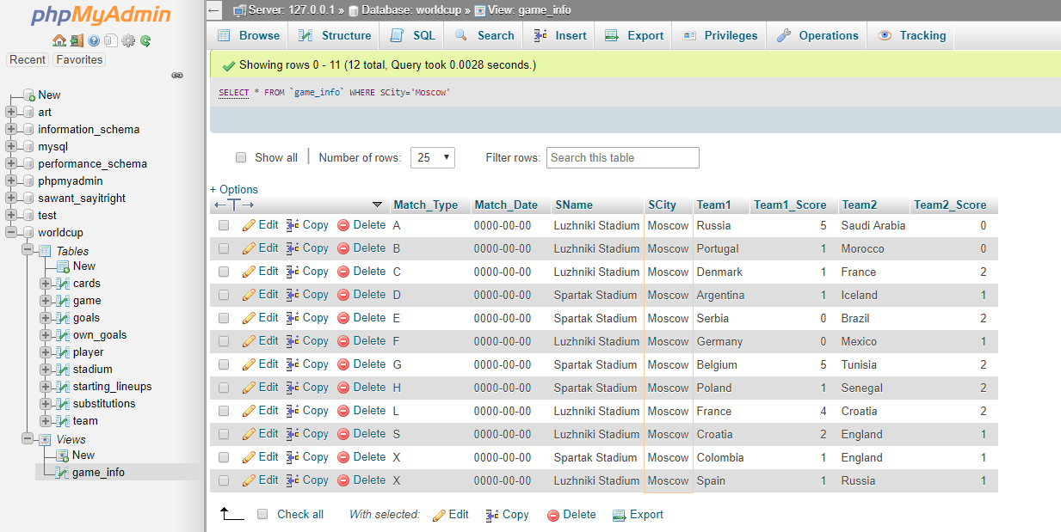

Retrieve all information from game_info where the score of both teams is equal.

SELECT * FROM game_info where Team1_Score=Team2_Score;

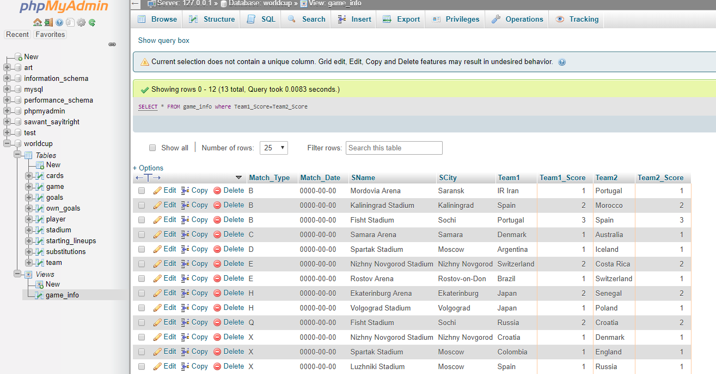

8. Write the following additional queries on the original database tables:

(i) Retrieve the name of the player and his country who received a yellow card during A game. Sort the list by country names

SELECT DISTINCT P.PName, P.Team from player as P , cards AS C ,game AS G WHERE G.Match_Type='A' AND G.GameID=C.GameID AND P.PNo=C.PNo AND P.TeamID=C.TeamID AND C.Color='Yellow' AND C.TeamID LIKE 'A%' ORDER BY P.Team;

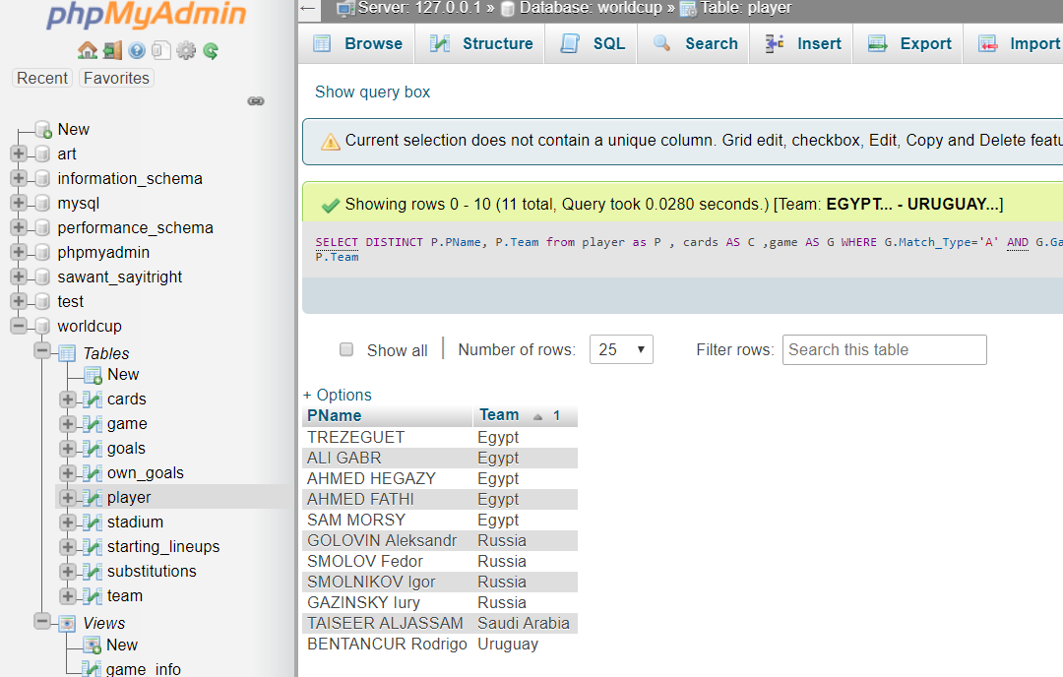

(ii) Retrieve a sorted list of the names of each country/team that played at least one game in the city of Sochi.

SELECT T1.Team AS Team_Name FROM game AS G, team AS T1 , team AS T2 ,stadium AS S WHERE G.TeamID1 = T1.TeamID AND G.TeamID2 = T2.TeamID AND G.SID=S.SID AND S.SCity='Sochi' UNION

SELECT T2.Team AS Team_Name FROM game AS G, team AS T1 , team AS T2 ,stadium AS S WHERE G.TeamID1 = T1.TeamID AND G.TeamID2 = T2.TeamID AND G.SID=S.SID AND S.SCity='Sochi' ORDER BY Team_Name;

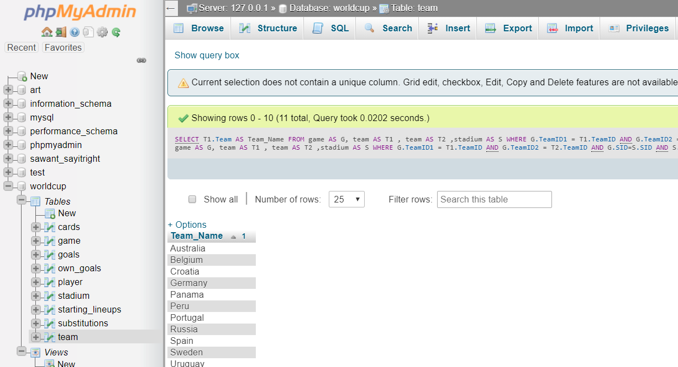

(iii) For each player who was substituted in the first 30 minutes of a game, retrieve the player name (Player Out) and the substitute player’s name (Player In), and the minute of the substitution, as well as the team name.

SELECT P.Team,S.PNoIn,S.Time,S.PNoOut FROM player AS P,substitutions AS S where P.TeamID=S.TeamID AND P.PNo=S.PNoIn AND S.Time<31;

