**HONOR CODE**

I pledge, on my honor, to uphold UT Arlington's tradition of academic integrity, a tradition that values hard work and honest effort in the pursuit of academic excellence.

I promise that I will submit only work that I personally create or that I contribute to group collaborations, and I will appropriately reference any work from other sources. I will follow the highest standards of integrity and uphold the spirit of the Honor Code.

Udyam Sawant

1001661908

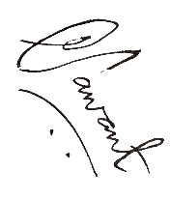

**WEB INTERFACE:**

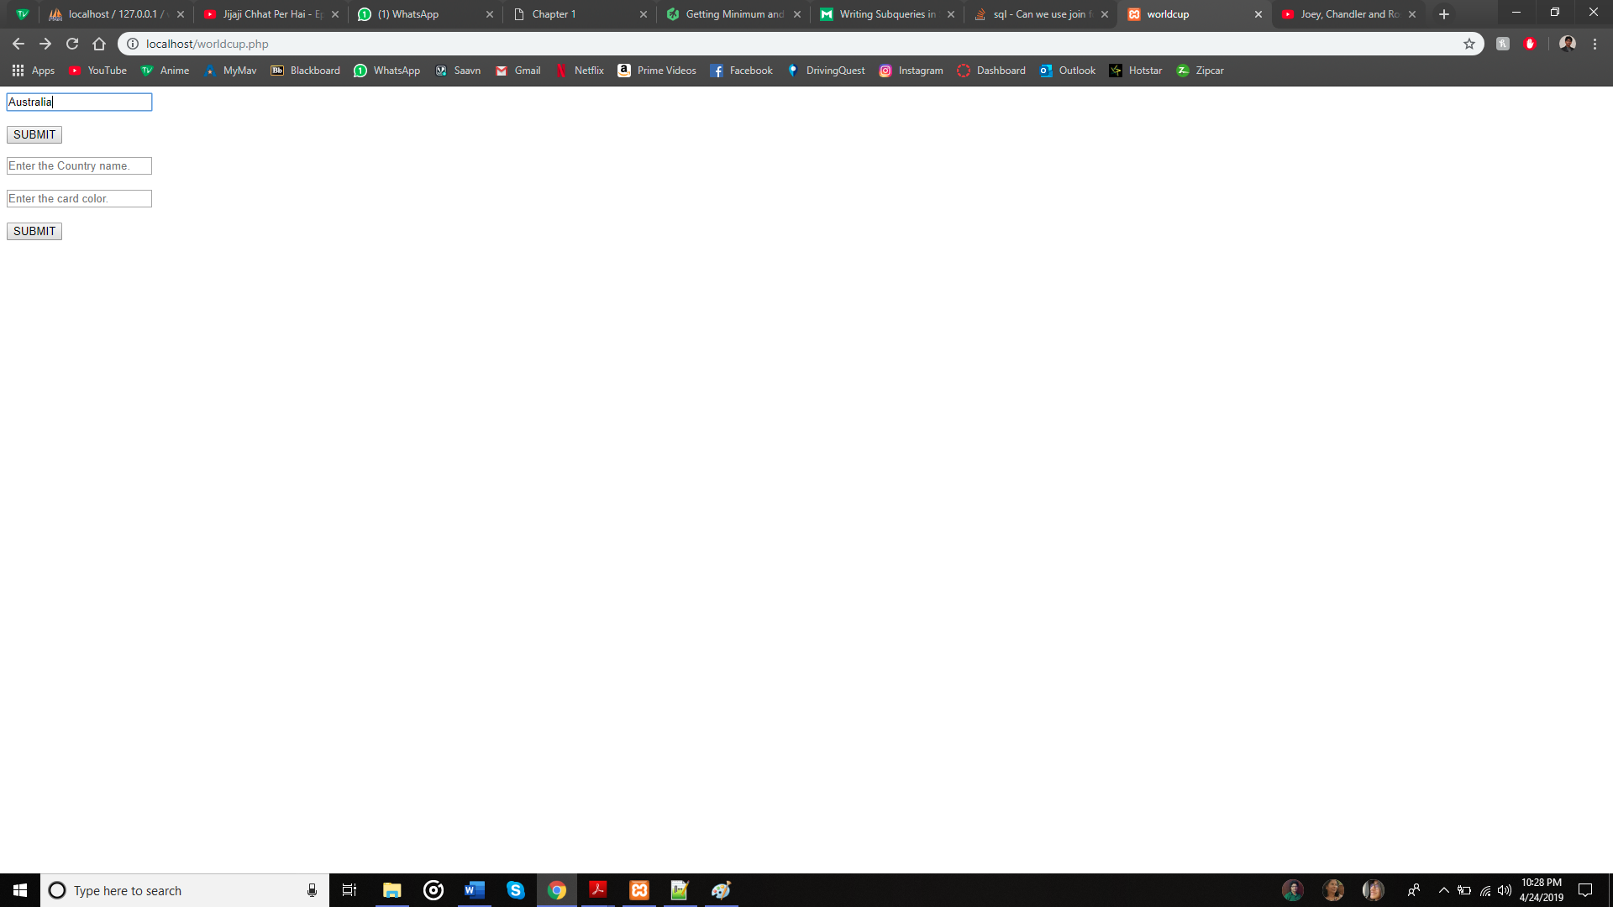

**Instructions:**

Put the php files in the xampp htdocs folder.

**QUERY A:**

**SELECT S.GameID, S.PNo, R.PName FROM player AS R JOIN starting_lineups AS S on R.PNo = S.PNo AND R.TeamID=S.TeamID WHERE R.PNo = S.PNo AND R.Team='Australia’ ORDER BY S.GameID, S.PNo;**

**RESULT A:**

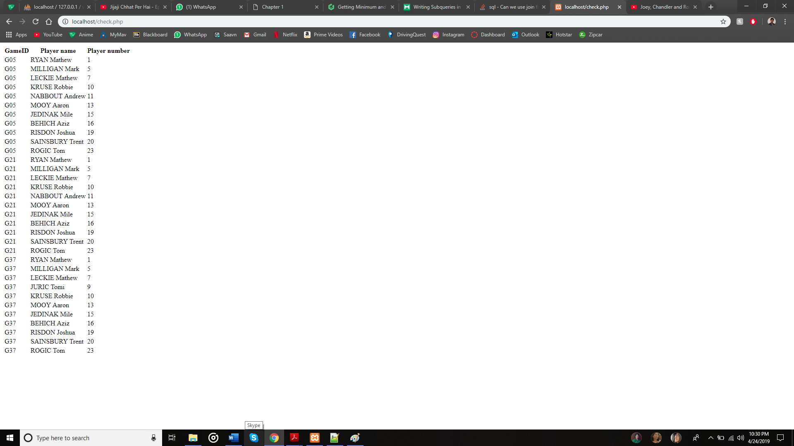

**QUERY B:**

**SELECT C.GameID, R.PName FROM player AS R JOIN cards AS C ON R.PNo = C.PNo AND R.TeamID=C.TeamID WHERE R.PNo = C.PNo AND R.Team='Australia’ AND C.Color='Yellow’**

**RESULT B:**

