

**Hawassa University**

**Faculty of informatics**

**Department of information systems**

Description for system design of web based E-learning platform

**Group members ID NO.**

1. Destaw Aschalew……………………….0845/13
2. Metsehafe Eyasu………………………..1784/13
3. Yeabsira Melaku………………………..2611/13
4. Biniyam Tilahun………………………..0594/13
5. Mohamed Endris……………………….1505/12
6. Rahel Fekde……………………………2047/13
7. Abrham Marie………………………….0161/13

Submitted to: Mr. Muluwork

Submission date: 15/02/2024

**Introduction to Ethio-Learn E-Learning Platform User Interface**

The Ethio-Learn E-Learning Platform is a groundbreaking initiative aimed at transforming the educational landscape in Ethiopia. Designed by a team of passionate developers from Hawassa University's Faculty of Informatics, Ethio-Learn is more than just an online learning platform; it's a gateway to a world of knowledge and opportunity.

The user interface (UI) of Ethio-Learn is meticulously crafted to provide a seamless and enjoyable learning experience for users. From the moment users land on the platform, they are greeted with a harmonious blend of orange and creamy white tones, creating a warm and inviting atmosphere. This thoughtful design extends to every page of the platform, ensuring that users feel engaged and inspired throughout their learning journey. One of the key principles guiding the UI design of Ethio-Learn is simplicity. The UI is clean, intuitive, and easy to navigate, allowing users to focus on learning without distractions. Whether users are signing up for an account, exploring courses, reading blog posts, or contacting support, the UI is designed to make every interaction a pleasant one.

Accessibility is another core principle of Ethio-Learn's UI design. The platform is designed to be accessible to all users, including those with disabilities. This commitment to accessibility is reflected in the platform's use of alternative text for images, sufficient color contrast, and keyboard navigability.

In addition to accessibility, the UI design of Ethio-Learn also takes into account the cultural context of its users. The platform incorporates local languages, cultural references, and aesthetics to ensure that users feel a sense of familiarity and belonging.

Overall, the UI design of Ethio-Learn is a testament to our commitment to providing an inclusive, engaging, and user-friendly learning experience for all Ethiopians. Join us on this journey of discovery and empowerment as we strive to make education accessible to everyone, everywhere.

**Web based E-Learning platform**

**Web-based e-learning platforms** commonly referred to as **Learning Management Systems (LMS)**, represent a significant advancement in the field of education. These digital tools are purposefully crafted to **disseminate educational content** and **facilitate interactive learning experiences** via the internet. By leveraging these platforms, educators and learners alike can engage in a dynamic and adaptable environment that transcends geographical boundaries.**impact of web-based e-learning platforms include:**

1. **Accessibility and Flexibility**: Web-based LMS platforms break down traditional barriers by allowing learners to access course materials and participate in activities from virtually anywhere with an internet connection. Whether a student resides in a bustling city or a remote village, they can engage in learning without the constraints of physical classrooms. This flexibility empowers lifelong learners, working professionals, and individuals with diverse schedules to pursue education at their own convenience.
2. **Diverse Learning Resources**: LMS systems offer a rich repository of resources, including multimedia content, interactive quizzes, discussion forums, and recorded lectures. Learners can explore diverse formats such as videos, e-books, and simulations, enhancing their understanding and retention. The availability of varied resources caters to different learning preferences and ensures a more engaging educational experience.
3. **Personalized Learning Paths**: These platforms adapt to individual needs, allowing learners to progress at their own pace. Customizable learning paths cater to different learning styles, ensuring a more effective educational experience. Whether a student needs additional practice, wants to revisit specific topics, or seeks advanced challenges, the LMS provides tailored content and assessments.
4. **Collaboration and Interaction**: LMS platforms foster collaboration among learners and instructors. Discussion boards, virtual classrooms, and peer assessments enable meaningful interactions. Learners can engage in dialogue, share insights, and learn from their peers. Instructors can facilitate group projects, encourage critical thinking, and build a sense of community within the virtual learning environment.
5. **Assessment and Feedback**: Educators can create assessments, quizzes, and assignments within the LMS. Real-time feedback helps learners gauge their progress and identify areas for improvement. Whether it’s an automated quiz or a peer-reviewed essay, the LMS streamlines the assessment process. Instructors can provide constructive feedback, track performance, and guide learners toward mastery.
6. **Administrative Efficiency**: Institutions benefit from streamlined administrative processes. LMS platforms handle enrollment, attendance tracking, and grading, freeing up educators’ time for teaching and mentoring. Automated notifications, progress reports, and analytics assist administrators in managing courses efficiently. This administrative support ensures smoother operations and enhances the overall learning experience.

**The aim of our project**

Education in Ethiopia faces some big problems. First, there is a scarcity of reliable online learning platforms, the sites that do exist don’t have many interactive features, which makes it hard for students to really engage and learn important skills. Lastly, the high cost of signing up for these sites makes it hard for many students to use them, which makes the education gap even worse.

Our project wants to fix these problems by creating an online learning site that’s easy to use, affordable, and interactive, made just for Ethiopians. It will be cheap, with low subscription fees so everyone can use it. It will have interactive features like quizzes and group projects to help students really understand the material. It will offer a wide range of courses to suit everyone’s interests and career goals, and it will have extra resources to make it even more accessible and flexible. Our goal is to give Ethiopian students the knowledge and skills they need to succeed, which will also help Ethiopia’s development and job readiness.

**SCOPE OF THE STUDY**

This project focuses on developing web based online learning platform specifically designed for Ethiopian learners of diverse backgrounds and interests. Unlike some platforms where instructors are encouraged to sign up, create classes and get paid ours prioritizes learners by offering a user-friendly interface for easy registration, course enrollment, and access to various learning materials like lessons, quizzes, and downloadable resources.

To foster engagement and deeper understanding, our projects facilitates learner interaction through discussion forums, enabling learners to provide questions and receive answers from peers. This collaborative learning environment complements individual study and assessment through various quizzes. Upon successful course completion, learners earn certificates acknowledging their achievements. While instructors contribute by sharing valuable resources like course materials, video lessons, and quizzes. Additionally, administrators manage course offerings, publish blogs, and collect feedback from learners and gusts to ensure continuous improvement and cater to their evolving needs.

This comprehensive, interactive, and learner-centric approach aims to significantly enhance the learning experience for Ethiopian learners, empowering them to acquire knowledge and skills effectively.

**User interface Specification of our system (i.e. Ethio-learn e-learning)**

**The** Designing a user interface (UI) for our system involves focusing on aesthetics and usability to create a pleasurable and easy-to-use experience for the users. Here are some key principles we consider:

* **Simplicity:** The UI should be simple and intuitive. Overloading the user with too much information can lead to cognitive overload. A minimalistic design can help maintain focus and promote clarity.
* **Usability:** The UI should be easy to navigate. If users struggle to orient themselves within the eLearning course, it’s a design problem. The UI should allow users to easily move forward or backward, start or stop, and return to the main menu.
* **Engagement:** The UI should be engaging and suitable to the context. It should promote learner engagement and satisfaction.
* **Consistency:** The UI should maintain consistency across the platform. This includes consistent use of colors, fonts, button styles, and layout.
* **Accessibility:** The UI should be accessible to all users, including those with disabilities. This might involve providing alternative text for images, ensuring sufficient color contrast, and making sure the platform is navigable via keyboard.
* **Localization**: Since the platform is for Ethiopian users, consider incorporating local languages, cultural references, and aesthetics into the design.

The **web-based system** encompasses several essential pages including signup, signing, forget account, home page, courses, blog and contact us page. this meticulously designed system harmoniously blends orange and creamy white tones across its pages, creating an elegant and user-friendly experience. Whether users are signing up, exploring courses, reading blog posts, or seeking assistance, the thoughtful design ensures a delightful journey through the digital landscape.

Using orange and creamy white colors for the interface and pages of a web-based e-learning platform can offer several advantages:

**Advantages of Orange**:

1. Warm and Energetic: Orange is a vibrant and energetic color that can evoke feelings of warmth, enthusiasm, and creativity. It can help create an inviting and stimulating learning environment for users.
2. Attention-Grabbing: Orange is a high-visibility color that can draw users' attention to important elements, such as call-to-action buttons, notifications, or key information on the platform.
3. Creativity and Innovation: Orange is often associated with creativity and innovation, making it suitable for fostering a dynamic and engaging learning experience. It can inspire users to think creatively and approach learning tasks with a fresh perspective.
4. Encourages Communication: Orange is a sociable and extroverted color that can encourage interaction and communication among users. It can be used to highlight discussion forums, collaborative activities, or group projects on the e-learning platform.

**Advantages of Creamy White:**

1. Clean and Minimalist: Creamy white is a clean and neutral color that promotes a minimalist and clutter-free design aesthetic. It can create a sense of simplicity and elegance in the interface, enhancing readability and visual appeal.
2. Professionalism and Trustworthiness: White is often associated with professionalism, purity, and trust. Incorporating creamy white tones in the interface design can convey a sense of credibility and reliability, which is crucial for an educational platform.
3. Visibility and Readability: Creamy white backgrounds provide high contrast for text and content, improving readability and ensuring that information is easily accessible to users. It can reduce eye strain and enhance the overall user experience.
4. Versatility and Flexibility: White serves as a versatile backdrop that can complement various colors, images, and design elements. It allows other colors, such as orange accents or highlights, to stand out and create visual interest without overwhelming the user.

**Advantages of white:**

1. Purity and Clarity: White is often associated with purity and clarity, enabling a sense of openness and space in the platform design.
2. Versatility: White is a versatile color that can be used as a background to make other colors pop or as a primary color for a clean and modern look.

**Advantages of black:**

1. Sophistication: Black is a timeless and sophisticated color that can add a touch of elegance to the platform design. It can help convey a sense of professionalism and luxury.
2. Contrast: Black can be used to create strong contrast with other colors, making important elements stand out and improving overall visual hierarchy.

By combining orange, creamy white, black, and white, the interface of the e-learning platform can strike a balance between engaging design elements and functional usability, ultimately enhancing the overall user experience and facilitating effective learning interactions.

**Common features on all pages**

1. **Audio support button:**  **Incorporating an audio support button into a system enhances its accessibility for individuals with visual impairments. By implementing voice recognition technology, the system becomes interactive, allowing users to navigate and interact with it using spoken commands. This inclusive design approach ensures that people with sight disabilities can fully participate in and benefit from the system’s features.**
2. **Language support button: The inclusion of a language support button significantly enhances the system’s interactivity and accessibility. By incorporating this feature, the system becomes welcoming to a diverse user base, regardless of their language preferences. Our system supports English, Amharic, and Oromifa, ensuring an inclusive experience for all.**
3. **Alternative navigation button:** **The inclusion of a navigation bar in the system serves as a time-saving feature by eliminating the need for excessive scrolling. Users can easily access essential functionalities and move between different sections without having to navigate through lengthy pages. This streamlined approach enhances efficiency and ensures a smoother user experience.**
4. **Existence of the name of the platform with a green yellow and red ( considering Ethiopian culture):**  i**ncorporating the colors of green, yellow, and red into the platform design pays homage to Ethiopian culture. These colors hold deep significance and symbolism. The green represents the lush landscape and vegetation of Ethiopia, while the yellow signifies hope, justice, and equality. The vibrant red embodies the resilience and determination of the Ethiopian people, reflecting their history of successfully resisting colonial powers. By infusing these colors into the platform, we create an inclusive and culturally rich environment, inviting users from diverse backgrounds to engage and participate.**
5. **Interactivity of the system** : **The incorporation of various buttons and icons within the system enhances its interactivity. These interactive elements empower users to engage with the system in meaningful ways. Buttons allow for direct actions, such as submitting forms or navigating between pages, while icons provide visual cues and represent specific functionalities. By strategically placing these elements, the system becomes more dynamic and responsive, enabling users to manipulate and control their experience effectively.**
6. **Sign-up page**

* The **sign-up page** acts as the gateway for new users. It invites them to create an account by providing necessary details such as username, email, and password.
* The design of this page seamlessly balances functionality and aesthetics. The use of **soft orange hues** against a **creamy white background** creates a welcoming and approachable interface. Buttons and input fields are strategically placed for intuitive navigation.

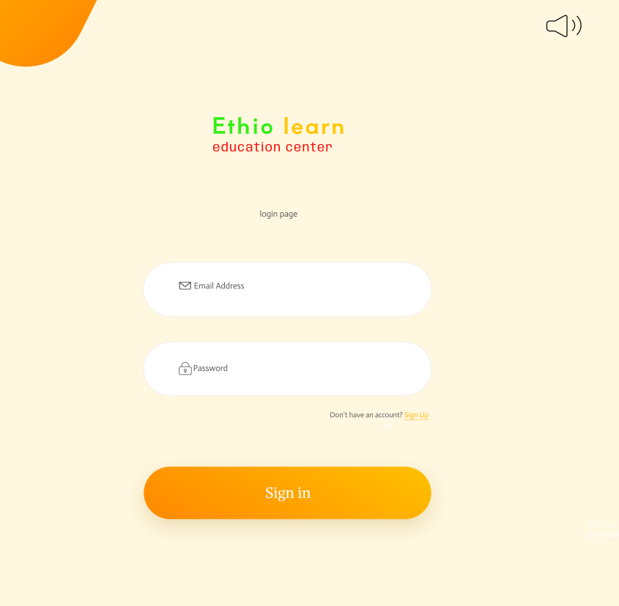

Figure 1: sign-up design

1. **Sign-In Page**:

* Existing users access the system through the sign-in page. Here, they input their credentials to gain entry.
* The design maintains consistency with the overall theme. The orange accents, perhaps in the form of subtle gradients or icons, reinforce brand identity. The creamy white backdrop ensures readability and a clean visual experience.

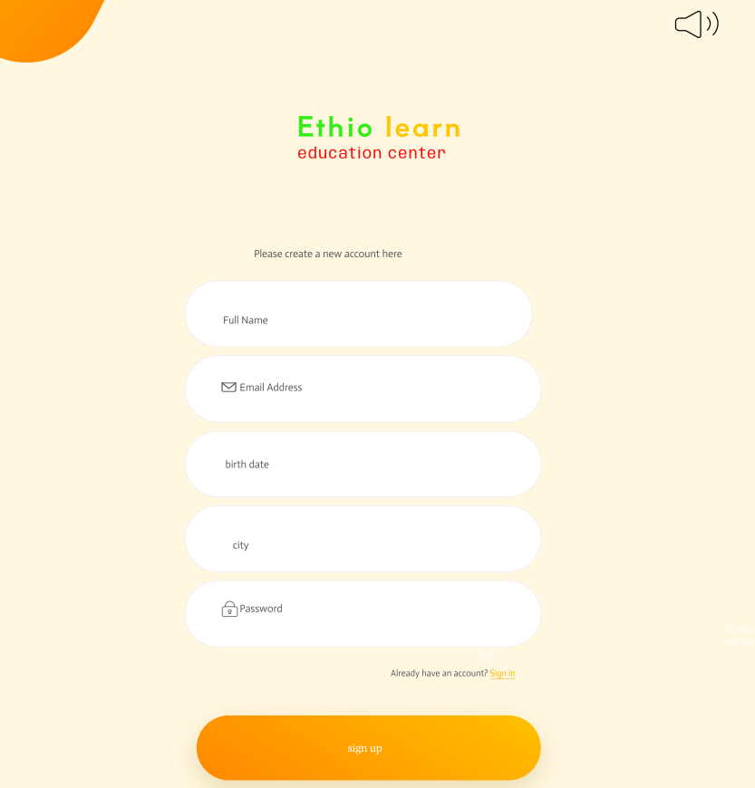

Figure 2: sign-in design

1. **Forget Account page**

* When users encounter account-related issues (such as forgotten passwords), they turn to the “**forgot account” page**.
* The design here strikes a balance between empathy and functionality. Gentle prompts guide users through the account recovery process. The color palette remains consistent, instilling confidence and trust.

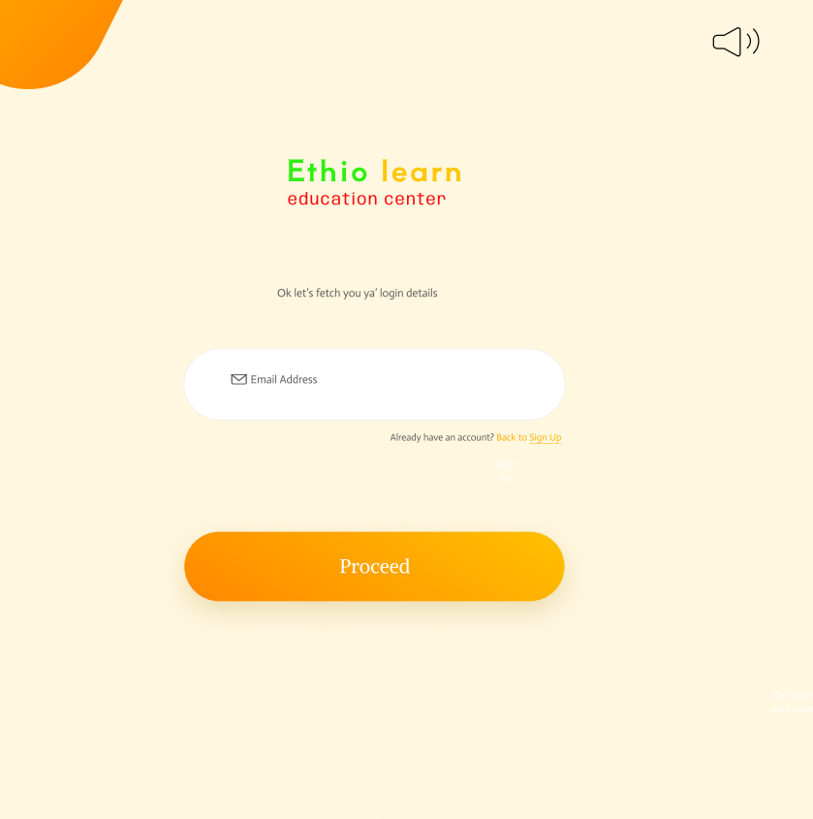

Figure 3: forget account page design

1. **Home Page**:

* The **home page** serves as the system’s central hub. It’s the first impression users receive upon logging in.
* The elegance of this page lies in its simplicity. A hero image or banner, adorned with harmonious shades of orange and creamy white, greets users. Clear navigation menus lead to other sections, ensuring a seamless browsing experience.
* Additionally, the page holds cards with “learn more” instead of bullets or paragraph like phase to show the existing courses provides, price range for each course (this way the affordable courses by the individual will be answer shortly) and a navigation part which can navigate us to any page the system holds without scrolling back to the top.
* These components included under the design makes the system more attractive and more user friendly.

Below lies the page home page.

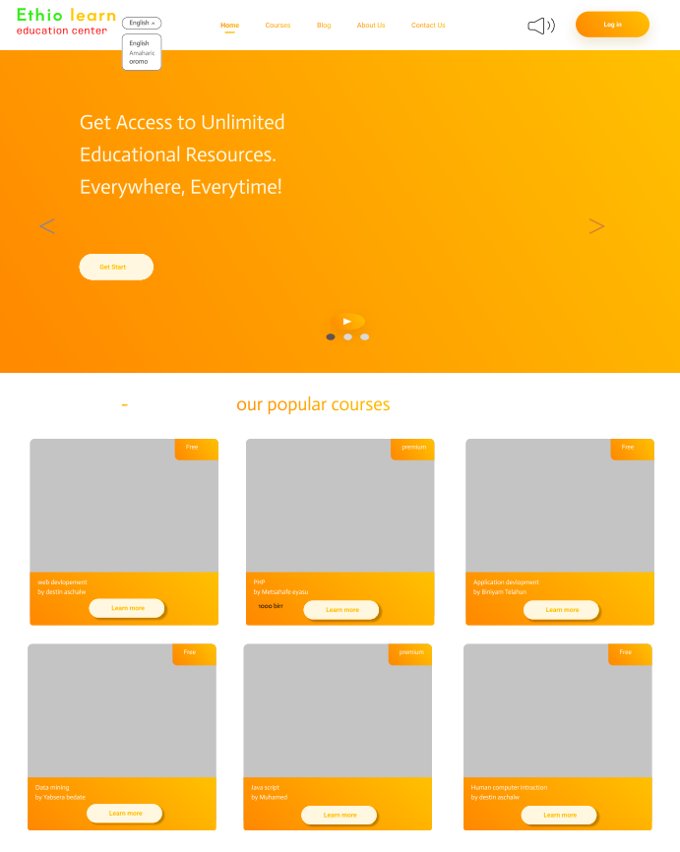

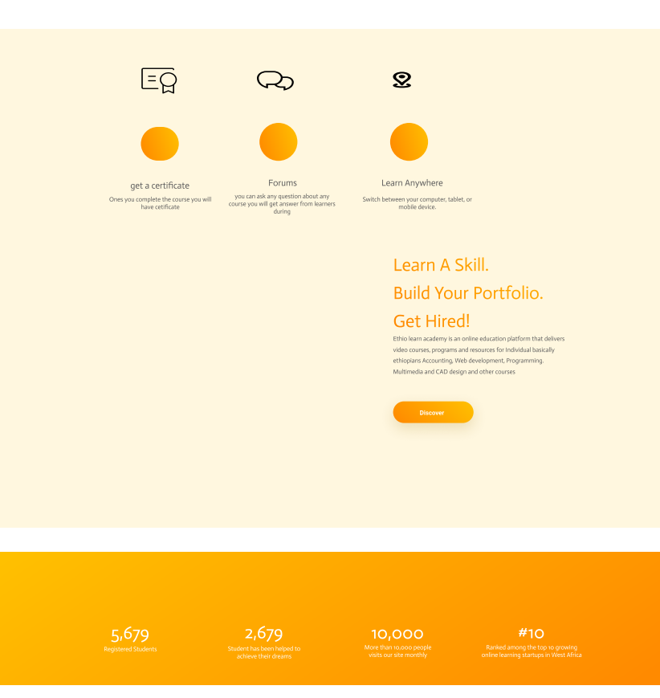

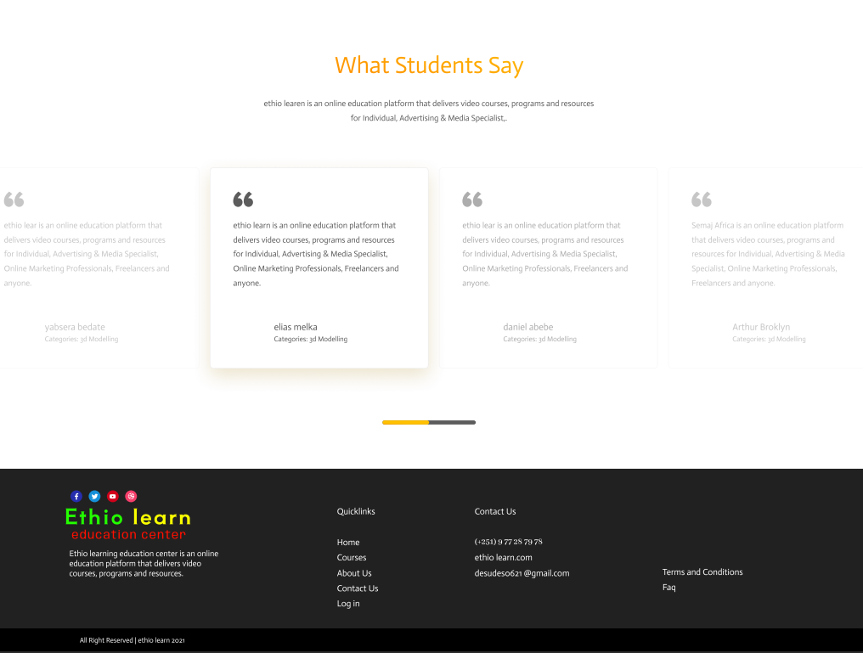

Figure 4: home page design

1. **Courses Page**:

* The **courses page** is where learners explore educational offerings. Whether it’s academic courses, workshops, or skill-building modules, this page provides a comprehensive overview.
* The design prioritizes readability and visual hierarchy. Course cards, categorized by subject or level, feature enticing visuals and concise descriptions. The orange accents draw attention to important elements, such as enrollment buttons.
* The system will hold a searching mechanism (which will ease up the rigorous scrolling), filtering and sorting mechanism based on some criteria, side menus and the navigation system. This way the system can maintain and uphold the “put human need first” philosophy

Below lies the course page

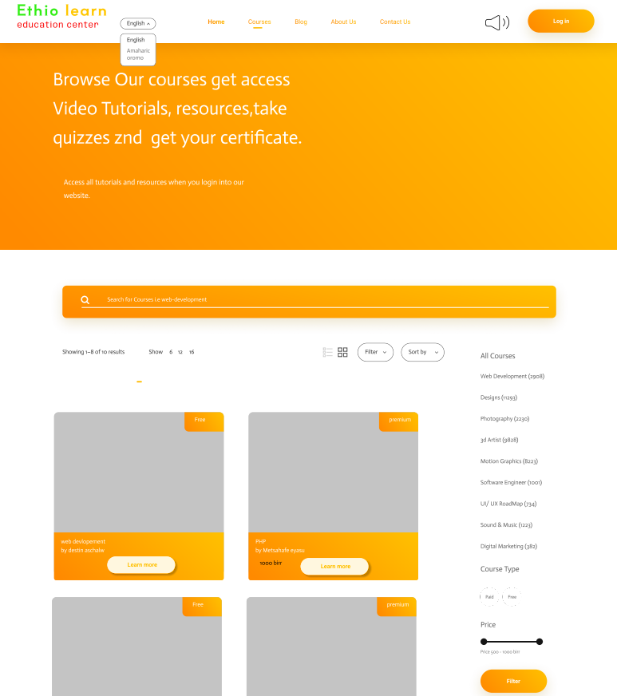

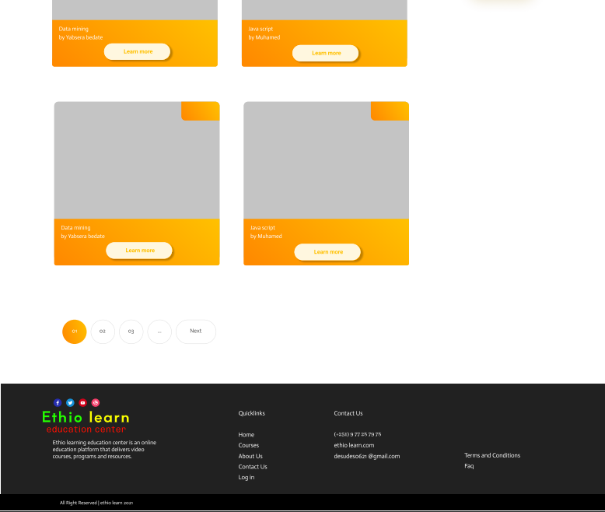

Figure 5: Courses page design

1. **Blog Page**:

* The **blog page** is a treasure trove of knowledge. Here, users discover articles, insights, and updates related to their interests.
* The elegant design ensures that blog posts are easy to read. Perhaps the orange color subtly highlights headings or call-to-action buttons. The creamy white background minimizes distractions, allowing content to shine.

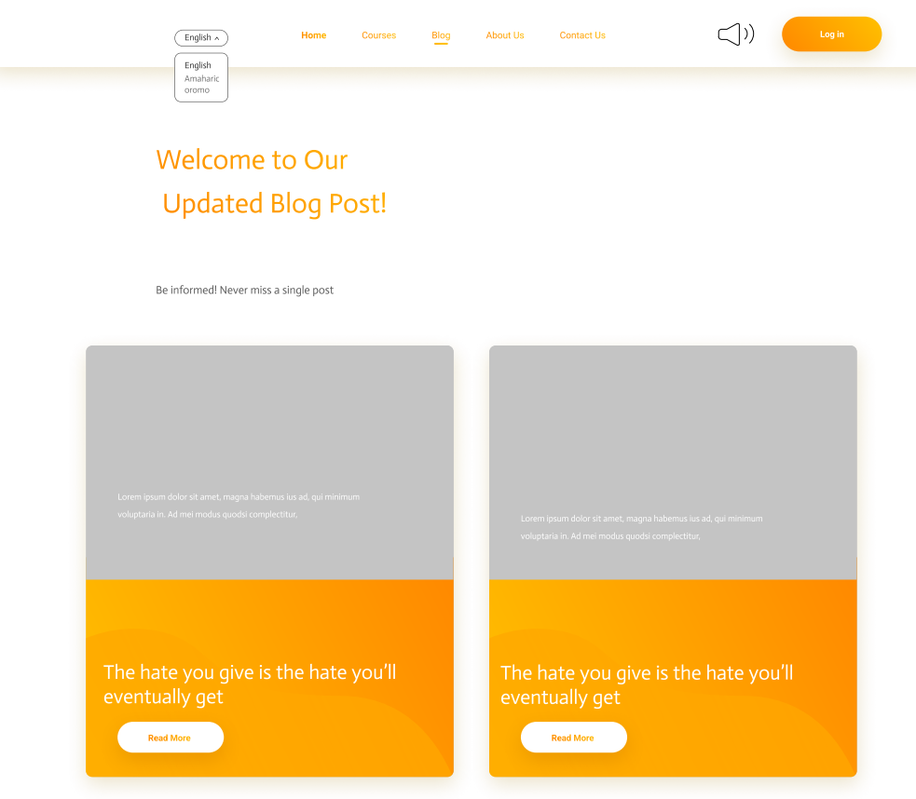

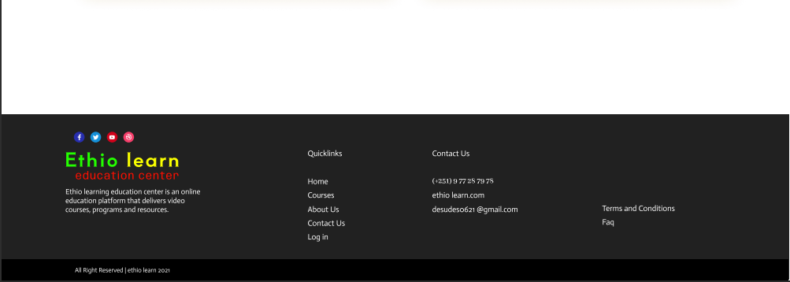

Figure 6: blog page design

1. **About us page:**

* The about use page provide a detailed information about the organization and what it stands for.
* the components hold in this page will be displayed below

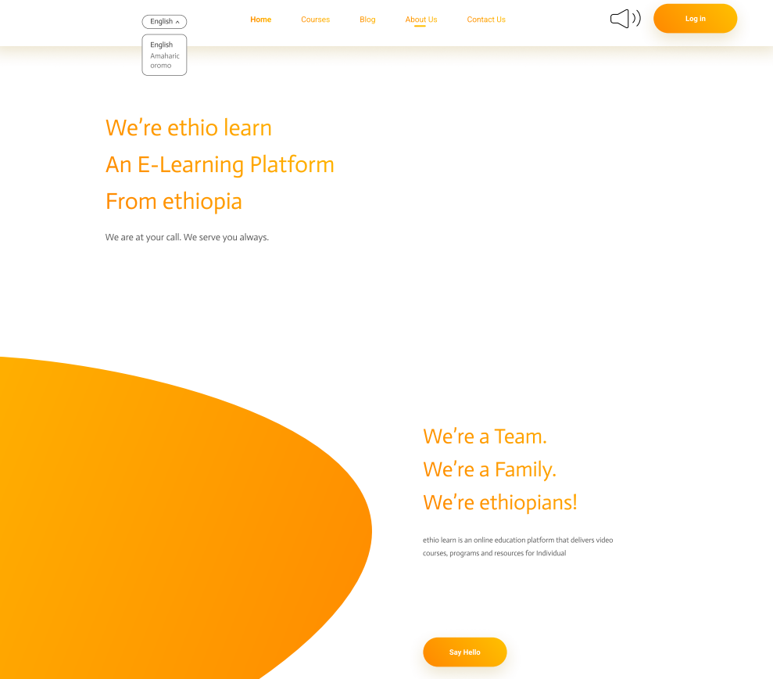

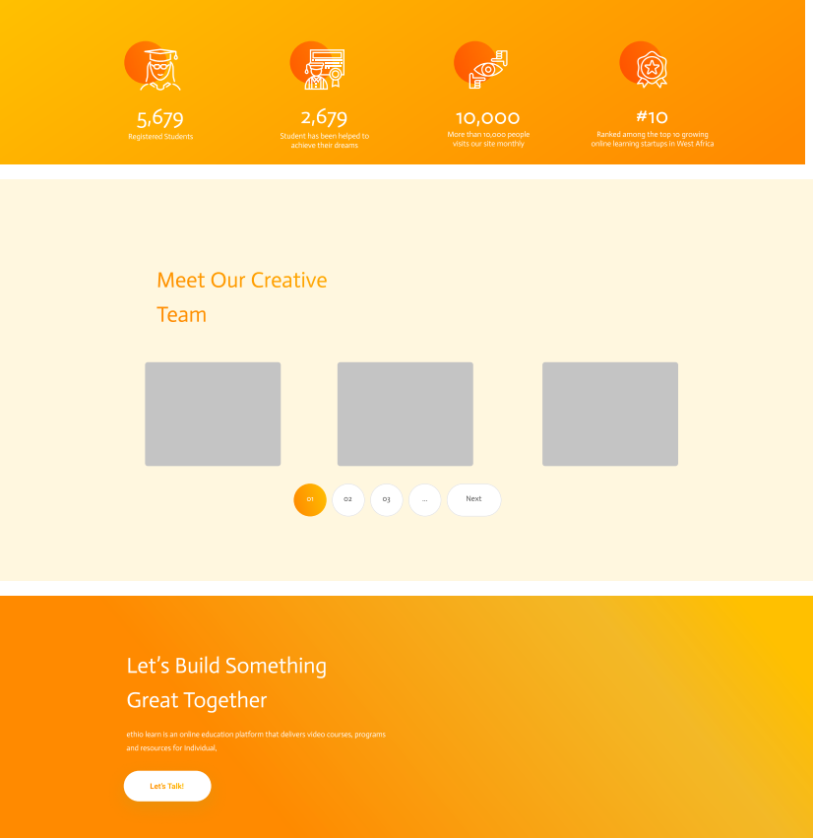

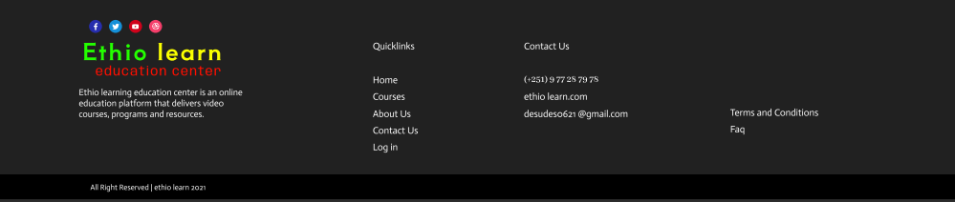

Figure 7: About US page design

1. **Contact Us Page**:

* The **contact us page** bridges the gap between users and system administrators. It’s where inquiries, feedback, and support requests find resolution.
* The design here balances professionalism and warmth. The orange accents evoke a sense of responsiveness, while the creamy white space conveys approachability. A well-organized form or chat interface facilitates communication.

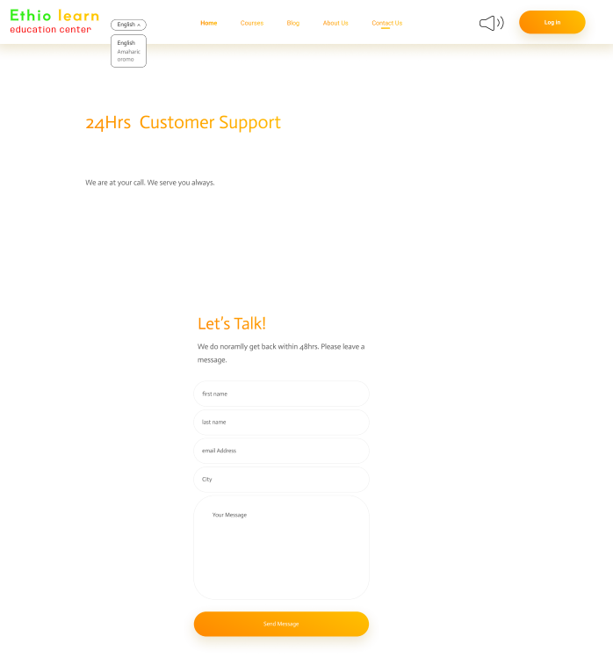

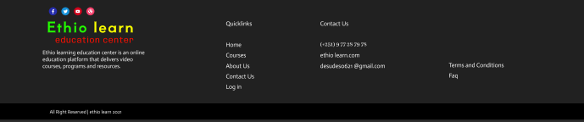

Figure 8: contact us page

1. **Course detail and Enroll page:**

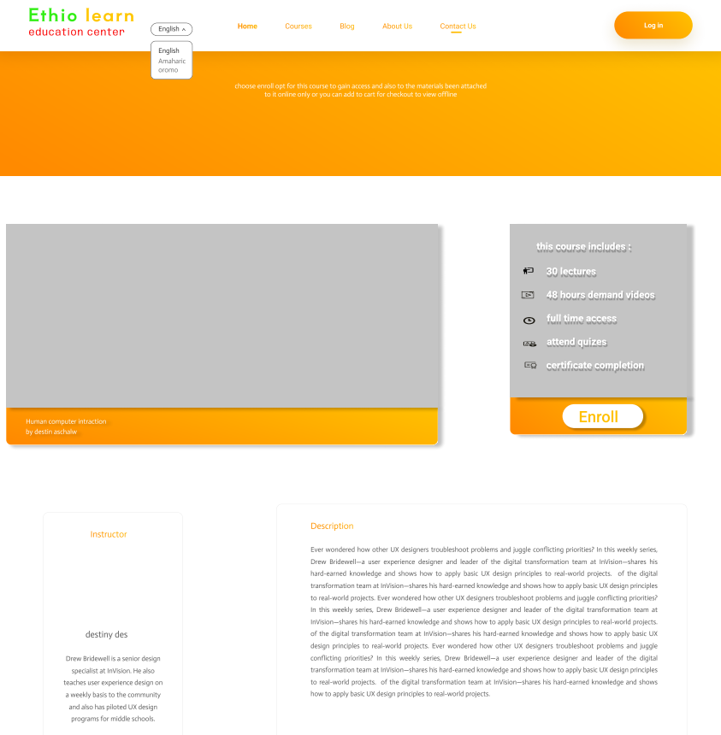

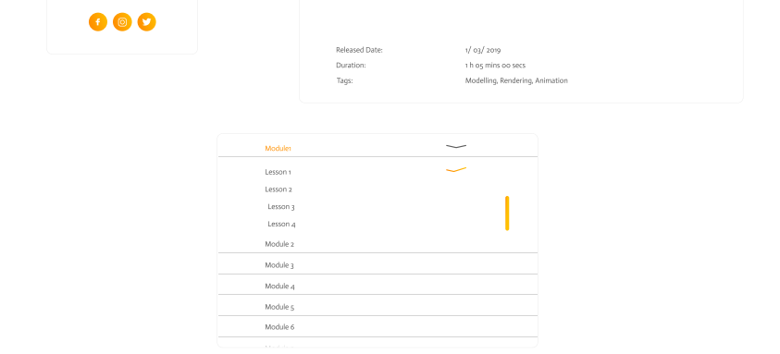

Figure 9: enroll page

**Conclusion**

The Ethio-Learn E-Learning Platform is not just a platform; it is a commitment to transforming education in Ethiopia. By providing a seamless and enjoyable learning experience, Ethio-Learn aims to make education accessible to all Ethiopians, regardless of their location or background.

The user interface (UI) of Ethio-Learn is designed with the user in mind, focusing on simplicity, usability, and engagement. The platform's use of orange and creamy white tones creates a warm and inviting atmosphere, while its commitment to accessibility ensures that all users can benefit from its features.

Through its innovative approach to online learning, Ethio-Learn addresses the key challenges facing education in Ethiopia, such as the lack of reliable online learning platforms and the high cost of access. By offering affordable, interactive, and accessible learning opportunities, Ethio-Learn is paving the way for a brighter future for Ethiopian students.

**Link to look up the original design of the system:** https://www.figma.com/proto/i2f1MGbK5RPW7dTsem4upq/Ethio-learn?type=design&node-id=0-1&t=BdnSCN3CWdfIvysn-0&scaling=min-zoom&page-id=0%3A1