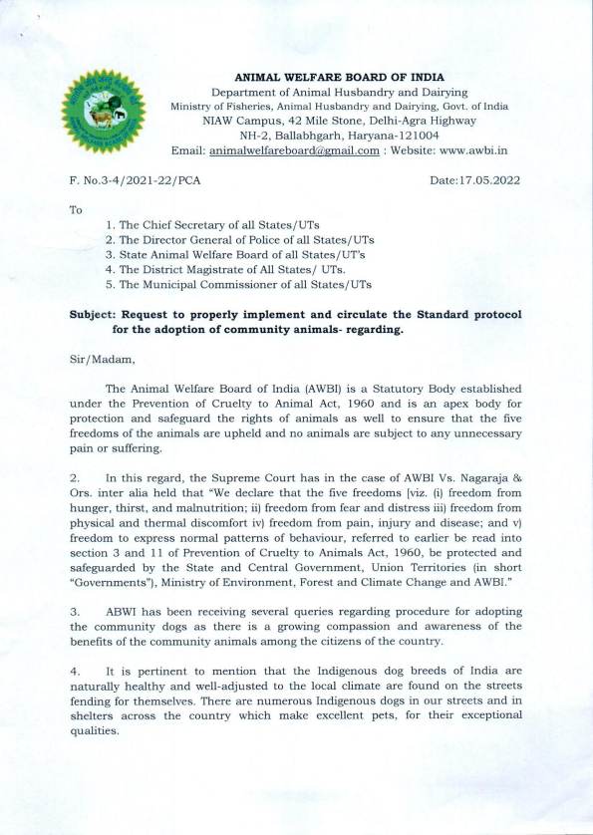
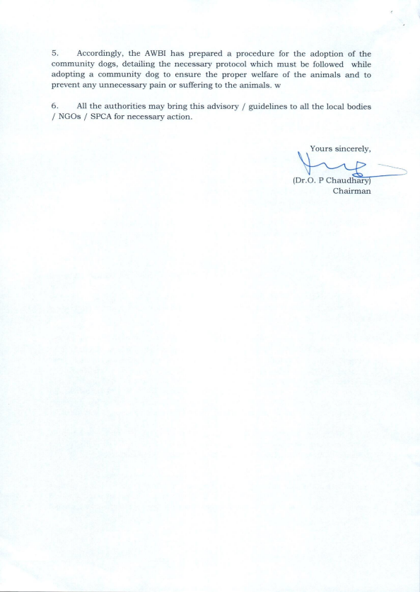
STANDARD PROTOCOL FOR ADOPTION OF COMMUNITY ANIMALS
For adoption of Community animals i:e dogs/pups from shelters or street, the following standard protocol may be followed, for necessary follow up and well being of the animal as well as of the adopter.
I.Where can one adopt a dog/pup from?
Dogs/pups can be adopted from shelters of SPCA or of Animal Welfare Organisations(AWO) recognized with the AWBI or State Animal Welfare Board by issuing adoption certificate. If one has adopted a dog/pup from the street, adoption papers can be processed through any Municipal Council / Municipal Corporation / Municipality / Panchayats or any acting legal authority / District SPCA along with medical check-up and vaccination.
II.Who can adopt a dog/pup:
1. The person desirous of adopting a pet must be older than 18 years old. 2. The person must be of sound mind.
3. The person must be capable of providing adequate care & maintenance, including but not limited to adequate nutrition, veterinary care and housing.
III. Documents to be submitted:
The following documents shall be submitted to the animal welfare organisation/SPCA by the person desirous of adopting a pet
1. House-check form (appended at Annexure I).
2. Valid Government photo ID & address proof.
3. Completed adoption form (appended at Annexure II).
*Paperwork Formalities include filling an Adoption Form and submission of copies of above mentioned ID Proof with Passport Size Photograph. The person adopting shall sign at every page, and self-attest the photo-ID & address proof copies.
IV. Procedure:
1. The House Check Form may be used for preliminary screening. The AWO from which the dog has been adopted or being adopted /Society for Prevention of Cruelty to Animals (SPCA) may assess and evaluate eligibility through a pre-and/or post-adoption house check and verify the information provided. The house check may be even conducted through a video call.
2. The person adopting the dog/pup shall take it for a veterinary check-up, and ensure vaccinations, parasite control, deworming or any other necessary medical treatment.
3. If the animal has attained maturity, it must be spayed/neutered prior to adoption.
4. The AWO from which the dog has been adopted or being adopted /SPCA upon being satisfied with the pre and/or post adoption check, veterinary check-up, inoculation etc, may issue an adoption certificate mentioning species and age of the dog/pup and may provide documents for appropriate guidance for care and maintenance of the community animal.
5. The AWO/SPCA must maintain a record of all animals adopted through it for last 2 years.
V. Pet friendly house:
1. In apartments or houses with multiple floors, the balconies and windows must be netted to avoid the risk of the pet escaping or falling.
2. Preferably, the Sharp or dangerous objects shall be covered or kept away from the reach of the pet.
3. The AWO / SPCA should inform the adopting family in advance regarding certain harmful plants, chemicals, incense sticks and food items which are toxic to pets, with guidance of a veterinarian.
4. Preferable, electrical fittings accessible to pet shall be covered with tape. 5. Comfortable bedding shall be provided for the pet in a suitable spot in the house.
6. Pet must have free access to clean drinking water at all times. 7. Regular and species appropriate meals shall be provided to the pet. 8. Dogs/puppies shall be walked at least twice a day.
ANNEXURE- I
House Check Form
* This document is a waiver. Please read carefully before signing.
I hereby give consent to an authorised representative of _________________________ (animal welfare organisation/SPCA) to visit my residence at _______________________ (address) at a mutually convenient date & time. I understand that this visit is for assessment of the suitability of the house environment for a pet I wish to adopt. I indemnify the authorised representative of the organisation or SPCA mentioned herein above from any adverse legal action or prosecution for entering my property/premises for the purpose of such assessment.
Name:
Signature:
Date:
Place:
ANNEXURE- II
Adoption Form
This document is binding and may be used in legal proceedings. Please read carefully before signing.
NOTE: Adopting a dog/pup is a big responsibility. Please make sure you are emotionally and mentally capable of dealing with a new family member who will rely solely on you for his/her care. Proceed further only if you can make a sincere commitment of time and effort and to affect scheduling and lifestyle changes in order to make this a successful adoption!
(Please affix your recent photograph here)
Name:_______________________________________________Age: ______ Address:_________________________________________________________ __________________________________________________________
Mobile: __________________________ Landline(s):____________________ E-mail: _______________________Alternate Email ID: _________________ Occupation: ______________________________________________________
Do you currently have any pets? YES NO If YES then please specify _____________________________________
INFORMATION ABOUT ADOPTED ANIMAL
Species of the pet: ___________________________________________________ Pet's name: ___________________________________________
Age of the pet [weeks/months/years]: ______________________
Description of pet [colour, identification marks etc.]:
__________________________________________________________________________________ ____________________________________________________________________
I agree that all statements I have made on this form are true and if it is found that any statements that, I have made in this form are not true, the AWO/ SPCA may re-evaluate the adoption certificate.
I DO, HEREBY SOLEMNLY AFFIRM, SAY AND UNDERTAKE THAT
I shall take all reasonable measures to ensure the well-being of the pet, and to prevent the unnecessary pain & suffering that may be caused deliberately or negligently;
I will proactively take all measures to understand and provide the dietary & veterinary needs of the pet in my care;
I have read this entire document and fully understand both the contract and my responsibility for this dog/puppy;
I am able and prepared to offer this dog/puppy a loving home for the entire duration of his/her lifespan.
Date:
Adopter's Signature:
Adopter's Full Name:
Name and Signature of the Representative of the Animal Welfare Organisation:

