Empyrean Design Document
2004.02.20

© The Empyrean Team, 2004

The Empyrean Team is: Chad Austin, Josh Delaney, Teresa Karr, Jared Knutzon, Armin Sokocevic, and Bryan Walter.

Table of Contents

- Abstract
- Overview
- Software Architecture
- Game Design
  - Game Play / Mechanics
  - Story / Setting
  - Art / Style
- Schedule

ABSTRACT

Empyrean is a multiplayer, side scrolling adventure and role-playing game set in a fantasy world. Up to four players each play one of four characters in a scripted storyline, which they can get together and play in short bursts or long sessions. The game looks somewhat cartoony, emphasizing strong colors and realistic proportions to help convey the fantasy setting.

From an innovation standpoint, we feel Empyrean is the first game to combine a strong storyline with somewhat freeform, networked multiplayer. Also, we want to take advantage of modern, 3D-accelerated graphics cards to do things nobody has done in a sidescroller.

GAME INTRODUCTION

High Concept
In an online world of fantasy and technology, four potential heroes embark on an
adventure. Empyrean combines an old-school 2D side-scrolling interface with modern
hardware graphics acceleration to create a multiplayer experience that has never been
seen.

Features
- Side scrolling 2D interface provides simple interaction with the world.
- Slightly cartoony – but proportioned – look and feel.
- Multiplayer: small groups of up to four players can adventure together.
- Player interaction: Players have to solve puzzles together using each character's special ability.
- Strong, linear storyline. Empyrean combines a linear plot with multiplayer interaction.
- Players develop their characters through the course of the story with new weapons, equipment, and skills.

Player Motivation
Players select a character, create or join a game, and progress through the storyline.
[Primary/Semi-casual play] Alternatively, a player could attempt to complete all extra
quests and find hidden items and abilities. [Alternative/Hardcore play]

Genre
Side scrolling adventure with 2D action and fig ting game elements.

Target Audience
Adventure /RPG aficionados, as well as those who enjoy online RPGs. Ages 14+.

Target Hardware
PC. Mid-to high-range systems with hardware graphics acceleration. Since the game is
2D,Empyrean has an extremely high level of visuals.

Unique Selling Points
- Multiplayer within linear setting and story.
- Side scroller with modern graphics.
- Player interaction required for completion of puzzles.

Design Goals
- To provide a solid, compelling story broken into chunks for the possibility of segmented gameplay. Individual segments or quests should be compelling enough that the player won't want to stop playing in the middle of one, but there should be plenty of good stopping points for players.
- Provide a world that can be easily explored while encouraging progress along the story axis.
- The story is serious and focuses on characters, their environment, and their interactions.
- Provide both tense excitement, urgency, and cooperation (serious battles and puzzles/traps), as well as time to casually explore and discover, either alone or partied.
- Simple: Minimal amounts of numbers and stats will be shown to the player, in contrast with traditional RPGs, especially paper and pencil ones. There should be an emphasis in the overall style and abilities of the characters, rather than who is higher level and has better stats.
- Allow semi-casual gaming by allowing any player to create a new game at any time.
- Games with more players inherently require more planning.
- Loose, fluid movement and actions. Engaging in combat with normal enemies should not require too much thought and strategy. Overall, progressing through the story should be simply fun. Defeating enemies should give a temporary, satisfying sense of pleasure. (The enemy crumbling/popping sounds in the Seiken Densetsu series are a good example of this.)

SOFTWARE ARCHITECTURE

Overview
As a system, Empyrean is split into two main components: a client and a server. The server is considered the authoritative state of the world as well as a persistent database of its players, and the client a graphical representation of it, as well as a means of interaction. These will be discussed in further detail in their respective sections. The software system will also encompass tools, such as 3ds max exporters and file editors, specifically designed to enable content creation.

Server
TBD.

Client
TBD.

Tools
TBD.

GAME MECHANICS

Game Play

The game play is going to be reminiscent of Secret of Mana, Castlevania: Symphony of the Night, and LOTR: Two Towers. The desired method of user input is with a game pad (although keyboard and mouse settings will be developed). Players will be expected to navigate their character around obstacles, jump from platform to platform, and attack moving targets in real-time. This type of side scrolling game play will be similar to Castlevania. As characters get more powerful, they will gain access to special attacks that are used with combinations of buttons. This type of game mechanic can be seen in LOTR: Two Towers. Finally, characters will work in teams, sharing items and healing one another like in Secret of Mana.

Game Rules

The underlying rules behind Empyrean are still in development but a rough version has been developed. The game rules describe what attributes make up a character, how that character improves, how characters get injured, how they do damage to other creatures, and much more. This section will outline these rules.

Symbols and Math
Symbols are used in this section for shorthand purposes. A list of these symbols follows:
- [X-Y] : denotes a uniformly distributed random number between X and Y.

Most variables in the game are integer values but may increase by decimal amounts. In these cases, the value will be rounded to the nearest integer with 0.5 rounding to the nearest even number (banker’s rounding).

Character Basics
A character has six basic stats that describe it. These stats are strength (STR), agility (AGI), endurance (END), intelligence (INT), resolve (RES), and charisma (CHA). Each character has a number of vitality points that record how healthy they are. They also have an ether rating that is used for magic or special abilities. The starting stats for the four characters are shown in the table below.

 | Caphriel | Robot | Warrior | Ninja
STR | 8 (m) | 18 (s) | 20 (p) | 14 (t)
AGI | 13 (t) | 6 (m) | 18 (s) | 19 (p)
END | 11 (q) | 20 (p) | 17 (t) | 16 (s)
INT | 19 (p) | 16 (t) | 10 (q) | 15 (t)
RES | 16 (t) | 14 (t) | 8 (m) | 13 (q)
CHA | 17 (s) | 10 (q) | 12 (t) | 7 (m)
VITALITY | 76 | 108 | 104 | 90
ETHER | 38 | 23 | 12 | 27

Characters also have battle skills. There are six battle skills: jump attack, sniper, rush, dodge, slide attack, and block. Characters start out with zero ranks in each skill except that the player will get to choose one skill to have at rank one. The maximum rank in any battle skill is ten. Battle skills are applied in combat rolls. The specific battle skill used in a combat roll is determined by the nature of the attack. The battle skills are described below:

- Jump Attack: this skill is applied when the character executes an attack while in the air from a jump (or fall).
- Sniper: this skill is applied to all long-range weapons.
- Rush: this is applied to all melee attacks that are performed from a standstill.
- Dodge: this defensive skill is always applied when the character is attacked.
- Slide Attack: this skill is applied when an attack is made during or just after a slide maneuver.
- Block: this defensive skill is applied if the player hits the block button at the right time during an opponent’s attack.

At Level Up
When a character has accumulated enough experience (XP) they advance a level. Characters start at level 1 and can advance to level 30. At each level, several changes to the character are made. A list of these is provided below.

- Vitality increases by: [8-16] + END/5 + char. bonus
- Vitality character bonus: 1 for Robot and Warrior, 0 for Caphriel and Ninja
- Ether increase by: [0-2] + INT/10 + char. bonus
- Ether character bonus: 0 for Robot and Warrior, 1 for Caphriel and Ninja
- Battle skills increase in the following fashion:
  - Any battle skill used by the player in the last level increases by 0.2 ranks.
  - Unused battle skills increase by 0.1 ranks.
  - The battle skill used most by the player in the last level increases by an additional 0.2 ranks.
  - The second most used battle skill in the last level increases by an additional 0.1 ranks.
- Statistics increase in the following fashion:
  - Primary stat (p) increases by 2.5.
  - Secondary stat (s) increases by 2.
  - Tertiary stats (t) increase by 1.5.
  - Quaternary stat (q) increases by 1.
  - Minor stat (m) increases by 0.5.
  - Each stat changes by a percentage of the stat focus pool as assigned by the player. There are 3 points available in the stat focus pool and by default these points are distributed equally to all six skills. However the player can set certain skills to receive a larger percentage of these 3 points. For example STR could be set to receive 33% (thereby netting 1 more STR point at that level) and the other 5 skills would divvy up the remaining 2 points. The percentage distribution can be set by the player for all 6 stats. Furthermore, once these percentages are set, they are applied to all levels that pass until the user decides to tinker with them again.

Combat
When a character attacks an enemy or an enemy attacks a character the same general combat equation is used. There are two cases of combat: melee and ranged. These two types and the equation involved are described in detail. The following equation is used whenever an attack occurs.

Attacker vs. Defender
[1-50] + AGI + WPN + HITMOD + ASKILL vs. [11-60] + AGI + ARM + DSKILL

Where the symbols mean:
WPN = the accuracy of the weapon ranging from 1 to 50.
HITMOD = the effect on accuracy based on the location of the hit. These values are different for melee and ranged attacks and are illustrated in Figures 1 and 2.

-10
+5+10
Head
TorsoLegs
-35
-15-20
High Attack
Attack
Low Attack

Figure 1: Hit modifiers for melee attacks

-10
+5+10
Head
TorsoLegs

-50
Attack

Figure 2: Hit modifiers for ranged attacks

ASKILL = the battle skill that is pertinent based on the type of attack.
DSKILL = the battle skill that is pertinent to the defender. Dodge is always applied to this and block may be additionally applied if the defender executes a block.
ARM = the deflection ability of the armor ranging from 1-50.

There are three different types of melee attacks: high, regular, and low. At the start of the game, the only high attack is a jump attack and the only low attack is a slide attack. As characters get combos there will be other moves that act as high, low or combinations of attacks. The type of attack determines where on the target the attack is aiming for. High attacks target the head, regular attacks the torso, and low attacks the legs.

If the attacker’s score is higher than the defender’s score, a hit is scored. Once a hit is scored, damage is calculated by the following equation:
DMG = [WPND + ABILMOD] * DMULT / ARMULT

Where the symbols mean:
DMG = damage dealt (to subtract from vitality points).
WPND = the specific weapon damage and it will range from 1-200 based on the weapon. Note that most weapons will actually have a damage range, for example [12-30] and the result of this roll is the number applied for WPND.
ABILMOD = the ability modifier to add to the damage: for melee use STR, for ranged use AGI
DMULT = the damage multiplier based on the weapon and hit location, ranging from 0.75 to 3. Weapon specific modifiers range from 1 to and location multipliers work as follows: head is 1.5, torso is 1, and legs are 0.75.
ARMULT = the armor multiplier based on the specific armor ranging from 1 to 4.

Character Specific Moves
Each character has a specific ability that will allow them to reach unique paths in each level.

- Caphriel has the ability to fly using her wings. She can only fly for limited amounts of time before having to rest (a stamina bar will appear when she starts flying). As her END rating increases, this bar will also increase. Also, she can pick up and carry one person with her (excluding the robot – too heavy). Doing this will reduce her stamina bar more quickly.
- The robot can switch to an amphibious mode and travel through underwater passages that are too long for others to make. Additionally, the robot can go through poisonous gas clouds.
- The ninja is adept at climbing nearly sheer walls and at fitting thorough very tight passageways.
- The warrior can phase through thin walls.

STORY

Setting
Empyrean is the spiritual world surrounding Galadia. High Empyrean is the realm of celestials, Low Empyrean is the realm of daemons. Middle Empyrean is split among several different planes (likely unimportant for the game). Denizens of the planes often materialize on Galadia to explore, cause havoc, bring miracles, or have offspring with humans. These half humans have special qualities, some of which are described below.

Half Celestial
Half celestials have the following characteristics:
- Age like humans while on Galadia, do not age when in Empyrean.
- Immune to worldly diseases.
- Immune to mind influencing effects (sleep, confusion, etc.)
- Have wings (in addition to arms) that allow them to fly.
- Typically athletic and fit.

Galadia
Galadia is the common term for the world. The setting will be focused on one main continent (map of it is shown in Fig. 3), which is the known world for all the peoples on it. Galadia has a strange mix of technologies. Steam power has just been discovered and the scientists and engineers that know how to use it are revered and called vapotencers. Their craft is seen as nearly as magical as sorcerers. In addition, residents of Galadia enjoy electricity from crystal capacitors that can be mined from the ground. These are crystals that contain electric charge and can be used like batteries. Nations fight over control of these crystal mines like nations fight over oil supplies on Earth. The combination of magic, crystals and steam power has given rise to many new wondrous machines. Some of these are locomotives, iron sides, air ships, and robots. Laser weapons have been discovered using the crystals, but combustion (and therefore guns) has not been discovered. The robots, sometimes called steam people, are often slow and brittle, but a handful of vapotencers and sorcerers are working together to create a new, more effective type of robot (the robot character is a prototype of this kind, and that is why Marcus has been abducted – to try and blackmail his father into helping a rival kingdom build a robot army unit).

The advanced kingdoms, Patagonia, Solvaria, Hevatia, Oran Republic, and Rhodan have cultures similar to ancient Mediterranean cultures (Rome or Greece). Other advanced kingdoms Peruvia, Nayar, Holy Savan Empire have cultures that are closer to ancient Persia. There are many different religions practiced on the continent, one of which is the Order of the Seraphim who worship the celestials. There are also nomadic peoples that live in the vast wilderness and are often referred to as barbarians. They have an unusual animal as a war mount and they also use horses in war and daily use. Finally, monsters roam the wilderness and lurk in the mountains. From time to time, they rampage into civilized lands. As a result, each kingdom has fortifications built up along its borders.

Figure 3: Galadia World Map

Character Bios

Caphriel

Caphriel is a half celestial. Her father was celestial and her mother was human. She was the second child of her parents; her brother Gabriel was born six years before her. While growing up, she and her brother were treated poorly by other children because they were different. This poor treatment made the two close friends. When she was age seven her mother got sick and a year and a half later she died. Caphriel and Gabriel were taken in by their grandparents. The townsfolk were of the opinion that she died because of the strain of bearing two half-celestials; some go so far as to say it is punishment from the gods. Gabriel takes offense to the views of the townspeople and starts getting into fights. Then, when Caphriel was 12, Gabriel got in a fight with a group of humans bullying Caphriel and killed them. The townspeople were enraged and sent the guard to arrest the children. Their grandparents hid the children and hindered the guard. As a result, they were arrested and locked in the jail. Word quickly spread and the townspeople demanded execution. The mayor agreed and an execution of their grandparents was set. Two nights before the execution, Caphriel and Gabriel went to the jail to rescue their grandparents. After flying over the outer wall, the two snuck into the jail. Caphriel used sleep darts to disable the guard. When they get to their grandparent’s cell, it becomes clear that their grandparents have been beaten. In a rage, Gabriel draws his sword and moves to kill the sleeping guard. Caphriel pleads with her brother, trying to convince him that killing humans is wrong, but he would not listen. He began the execution stroke and Caphriel made a quick decision. She shot her brother with a sleep dart. Gabriel was unaffected by the dart and killed the guard. He then looked towards his sister with a hurt rage. He managed to summon enough willpower to flee the jail before hurting his sister. Caphriel helped her grandparents escape the jail.

Caphriel and her grandparents traveled to a far away town in Patagonia hoping to evade their fugitive status. Gabriel never returned to his family. This time her grandparents urged Caphriel to join the Order of the Seraphim. This order would teach her magic, respect her, and protect her because of her half celestial blood. She eventually agreed and entered the Order at age 14. She proved to be a quick study with magic and by the age of 16 she was a practicing healer. Many of the land’s very sick came to her for healing because she would see those who were deemed too contagious. Her half celestial blood made her immune to worldly diseases. At age 17 she started learning offensive magic in case she would need protect herself or her family. When she was 18, the son of the preeminent vapotencer in Patagonia came to her for healing. His name was Marcus and he was very sick. Caphriel spent months healing him and watching over him, slowly improving his condition. During this time Marcus began to fall in love with her, but he was too shy to say anything. Finally, he was healed and his father invited Caphriel to the capitol to visit his house. She reluctantly agreed at the continued request of Marcus. At Marcus’ house, she met Ronan and found it to be bizarre but in some ways a little like her (trying to fit into society). She enjoyed her visit and kept in touch with Marcus. Then, a year later she got a disturbing message from Marcus’ father saying that Marcus had been abducted. Caphriel headed to the capitol to try and help find her friend.

Ronan
Ronan is the latest robot built by the famous vapotencer Xavier. He is a showcase of advanced technology. He has an aquatic mode, a built in laser gun and the ability to effectively wield a large sword. Perhaps more impressively, he has the most advanced AI to be placed in a robot. Ronan is trying to help rescue his friend and Xavier’s son, Marcus. Ronan also has made a friend in Caphriel and will try to protect her as well.

Kuya
Kuya is a mercenary fighter. He has recently been hired by Xavier to help return his son Marcus. Kuya’s past has not been worked out yet.

Akazen
Akazen is a ninja who has a long-standing working relationship with Xavier. Xavier has made some powerful enemies over the years and has used Akazen to gather vital information and on one occasion to eliminate a rival (although this is not known by anyone other than Akazen and Xavier). Akazen has gathered information about Marcus’ captors and is now going to assist the group going after him. No one is certain of Akazen’s gender or past and these two items are fiercely guarded secrets.

Xavier (NPC)
Xavier is a powerful and famous vapotencer. His skill is unrivaled in the kingdom and as such, his creations are highly sought after. Xavier has used this fact to become very wealthy and he has used his wealth to gain political power. He has one son, Marcus, whom he is trying to train in the arts of vapotency. However, the boy has proven to be a reluctant understudy. Then, two years ago Xavier’s wife was murdered on a trip to the capital city. Xavier hired Akazen to determine who was responsible. When he found out, he had Akazen eliminate him. Since then, Xavier has become ruthless and paranoid, sabotaging other potential rival’s work. His recent success in creating Ronan has left many of his enemies chaffing and it did not come as a surprise when Marcus was abducted. Xavier knows that the gang that is holding Marcus is not the ones truly behind the scheme. He hopes to use the party (the four PCs) to find out who is truly responsible and then eliminate them. In the meantime, he continues to develop his most controversial and dangerous creation yet, a devastatingly powerful airship Midir. He is using his King’s money to build it, but he is secretly trying to broker deals with other kingdoms to buy it (and his safety). Xavier will be a story focus at the beginning, seeming like the party’s ally, but will turn out to be the source of the party’s eventual problems, and perhaps an enemy down the road.

Plotline

The entire plotline is not completed yet, but the first scene in the game has been written. The first scene takes place in Xavier’s mansion with the four characters Akazen, Caphriel, Ronan, and Kuya arriving to discuss their new mission to rescue Marcus. Xavier had hired each of them separately to do this job as a group and this is the first time they have all met. Xavier’s mansion is impressively ornate with marble floors, arched passageways, columns, rich tapestries and glowing crystal statues. Xavier and the group are talking in the sitting room and a 3’ tall steam-powered service robot has brought refreshments and is idling next to Xavier. Figure 4 shows a rough sketch of what this scene will look like. This information will be given to the players in a cut scene before the first level of the game.

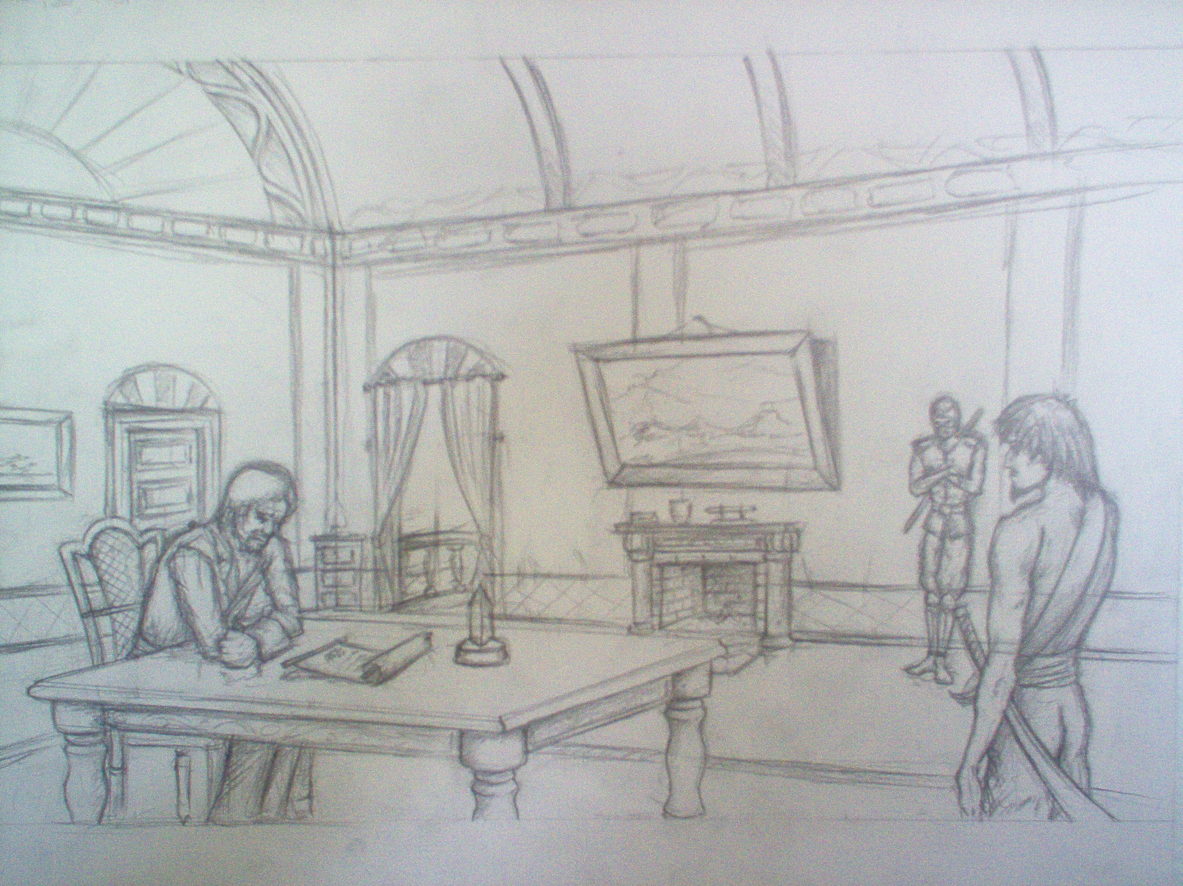
Figure 4: Initial Scene

[Scene] Xavier's Mansion

Xavier: I have assembled the four of you here to find my son Marcus. Shade discovered some information regarding his captors.
Shade: The Black Gears.
Xavier: Indeed, they are the likely culprits and we also have learned that their base is in the mountains to the north. The path up the mountains is dangerous, but that shouldn't be a problem right.
Kuya: Of course not, I'd be disappointed if it was going to be easy.
Xavier: Good, now please find Marcus.
Caphriel: We won't let you or him down.
Ronan: Affirmative.

The group will then head out and the players will find themselves in the first level of play. This level starts out in the hills around the town and gradually makes its way up the mountains to the hideout of the Black Gears. Figure 5 shows a concept drawing of this level.

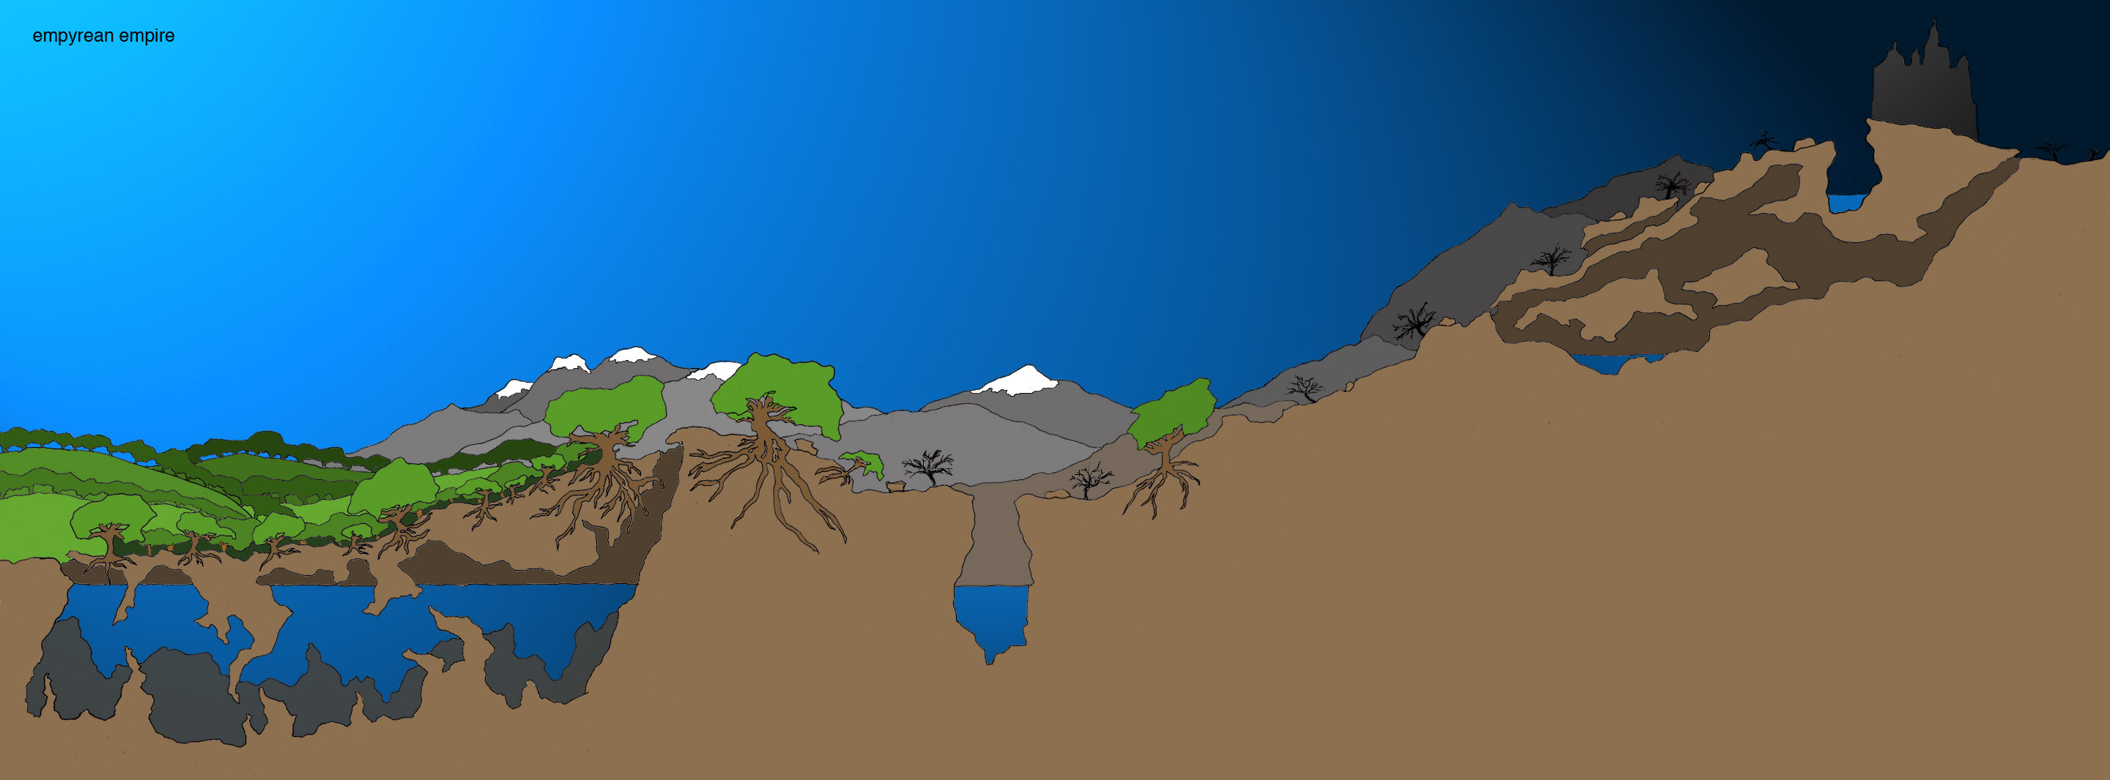
Figure 5: First level concept

The water cave at the start is an alternative path for Ronan to travel in aquatic mode while the ravine in the center of the stage is a location where Caphriel will have to fly over and release a drawbridge from the other side (after dispatching some enemies). Akazen can travel through the cave near the end of the stage (the cave entrance is too small for any other character to fit through). Finally at the end, Caphriel will have to carry Kuya across the moat at the base and Kuya will have to phase through the gate to release the drawbridge over the moat. This level showcases the cooperative aspect of Empyrean as well as the multiple path aspect.

ARTISTIC STYLE

There are many themes and ideas that are going to be incorporated into the artistic style of Empyrean. The setting of the world is Fantasy with some futuristic technology. This is described in more detail in the story and setting section of this design document. In looking for inspiration for this type of world older 2d games were used for inspiration along with Japanese Animation. The Artistic style is best described in two separate sections, the characters, world setting, and story. The primary artists are Armin, Josh, and Teresa.

Characters

The characters backgrounds and biographies are described in the story and setting section of this document. This section will describe each of the character and present the sketches for each of the four main characters.

Ronan

The robot design is inspired by knight’s armor of the middle ages and the samurai of the Japanese culture. The robot’s primary weapons are a “gun” and a sword. Figure 6 shows an illustration of the robot and Figure 7 shows the current 3D model of Ronan.

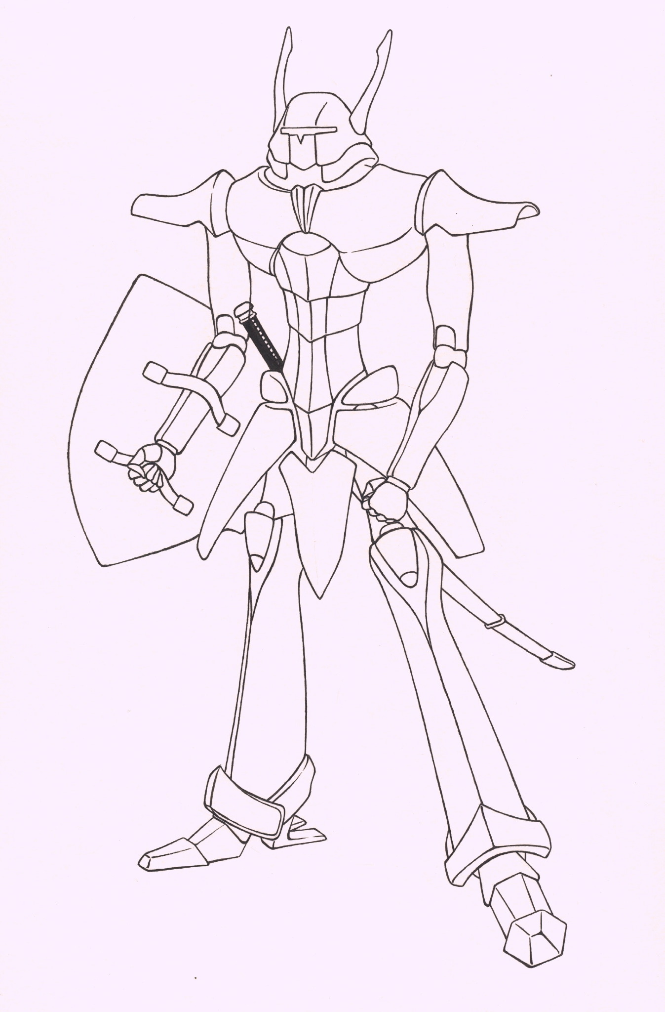
Figure 6: Ronan Illustration
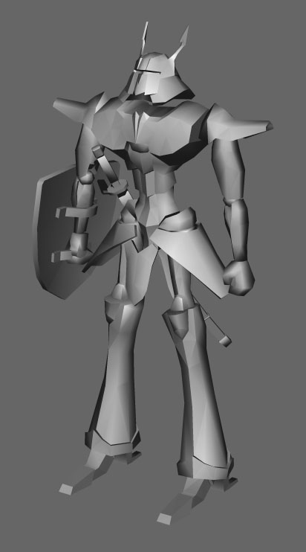

Figure 7: Ronan 3D model

Caphriel

Caphriel is inspired by the portrayal of angels in artwork and other gaming references. Her primary weapon will be a halberd or a sword. A concept illustration of her is shown in Figure 8.

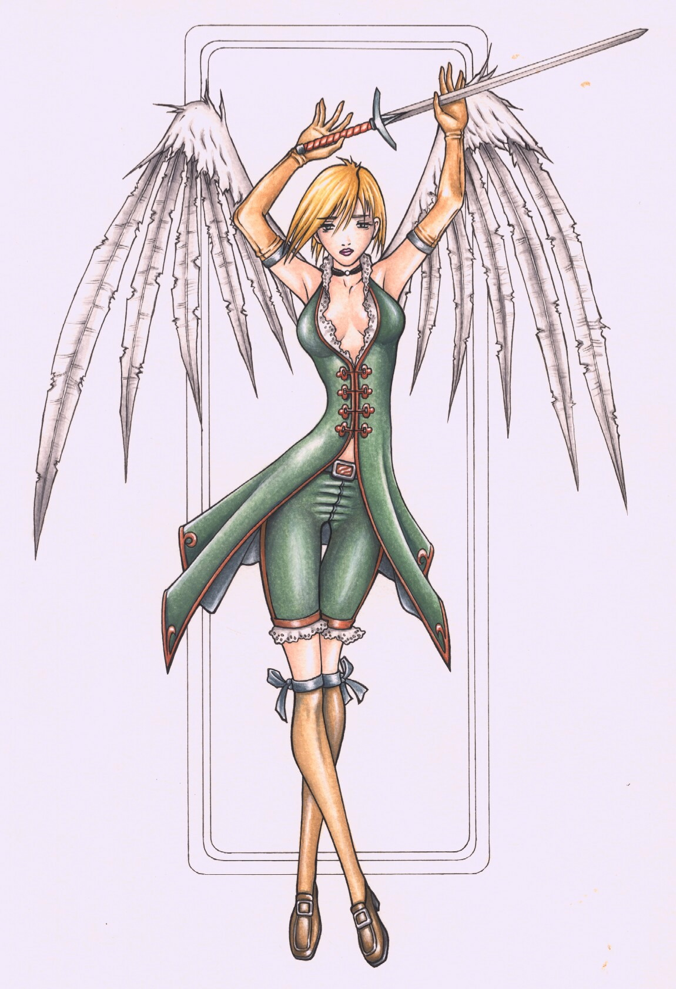
Figure 8: Caphriel Illustration

Kuya
Persian warriors such as the Prince in Prince of Persia inspired Kuya. A concept sketch of him is shown in Figure 9.

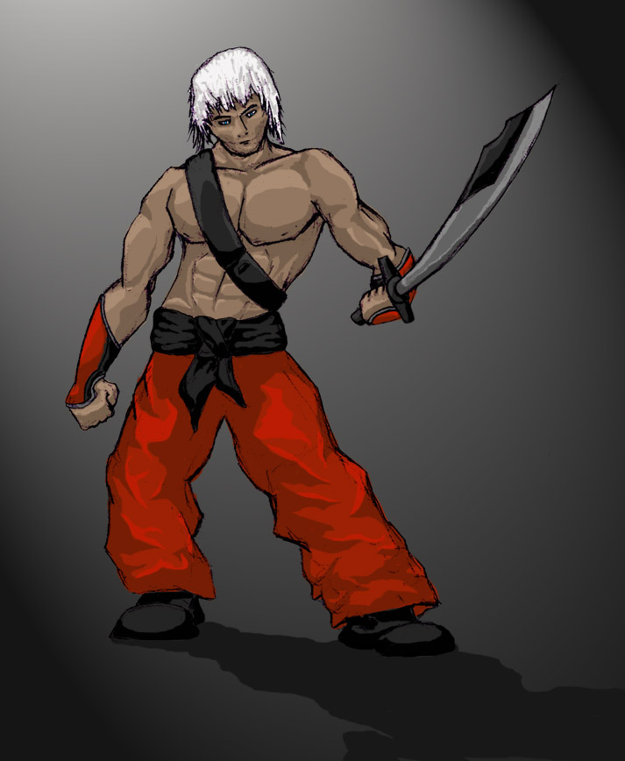
Figure 9: Kuya Illustration

Akazen
Akazen is a mysterious ninja with obvious inspirations. Figure 10 shows a concept sketch and Figure 11 shows the current 3D model.

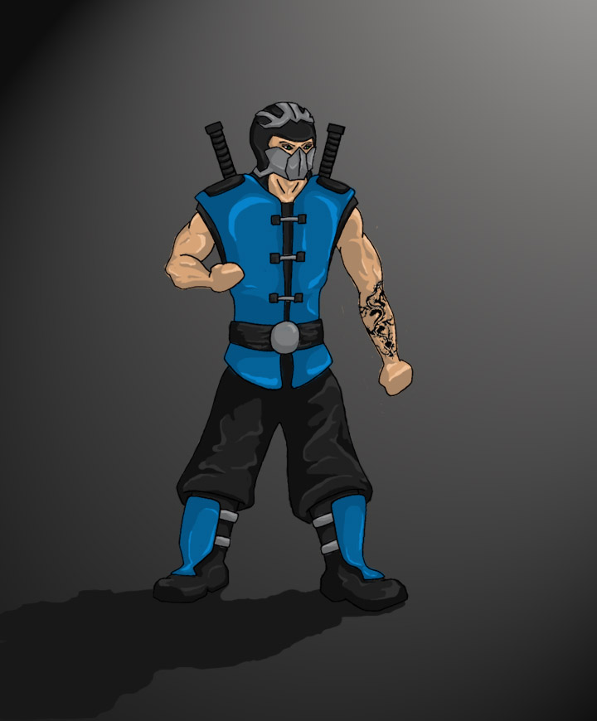
Figure 10: Akazen Illustration

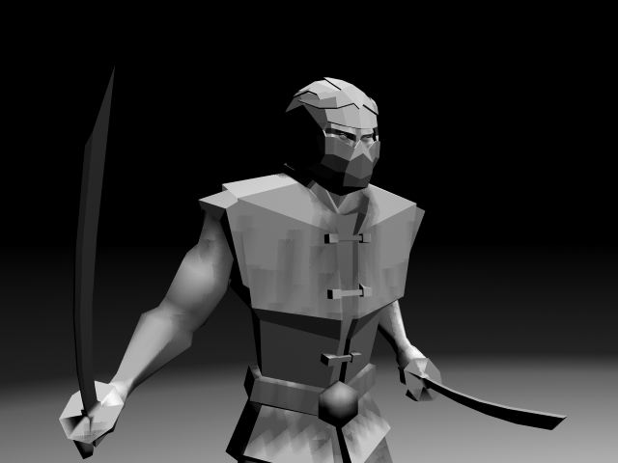
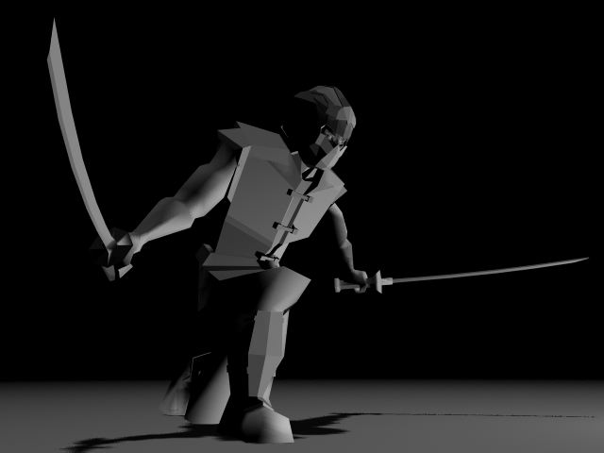
Figure 11: Akazen Model

Monsters
We have also created some sketches and models of monsters the characters are likely to encounter in the first stage. Figure 12 shows a water bug monster for the water cave, Figure 13 shows the Gargon monster likely found to be in the mountains. Figure 14 shows the 3D model of the Gargon. Figure 15 shows the 3D model of a humanoid cat that the party will have to face in the forest.

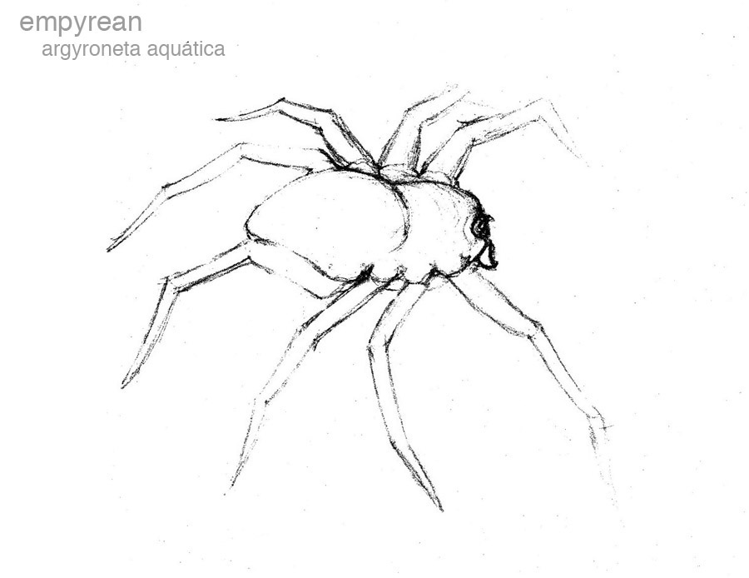
Figure 12: Water Bug Monster Illustration

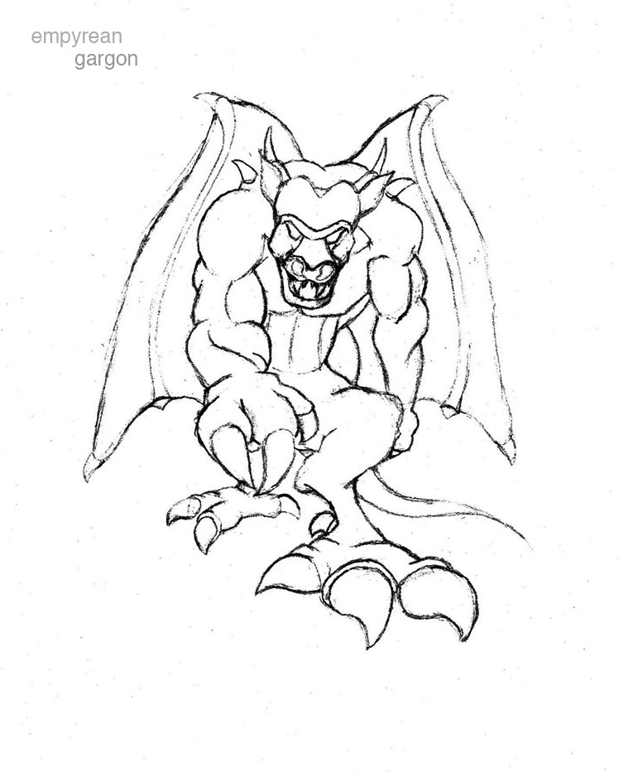
Figure 13: Gargon Illustration

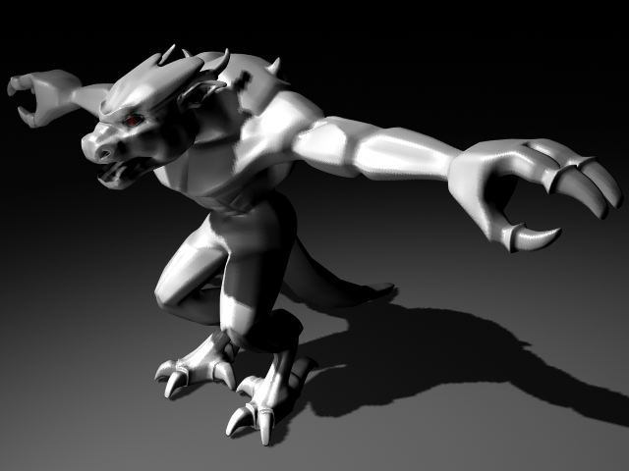
Figure 14: Gargon Model

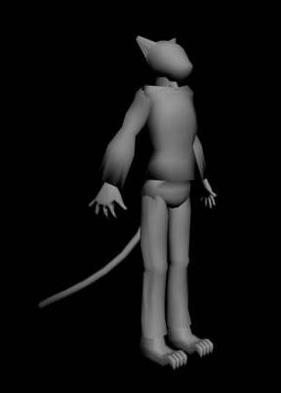
Figure 15: Cat Model

SCHEDULE

Below is a tentative schedule for all of the main deliverables for the semester.

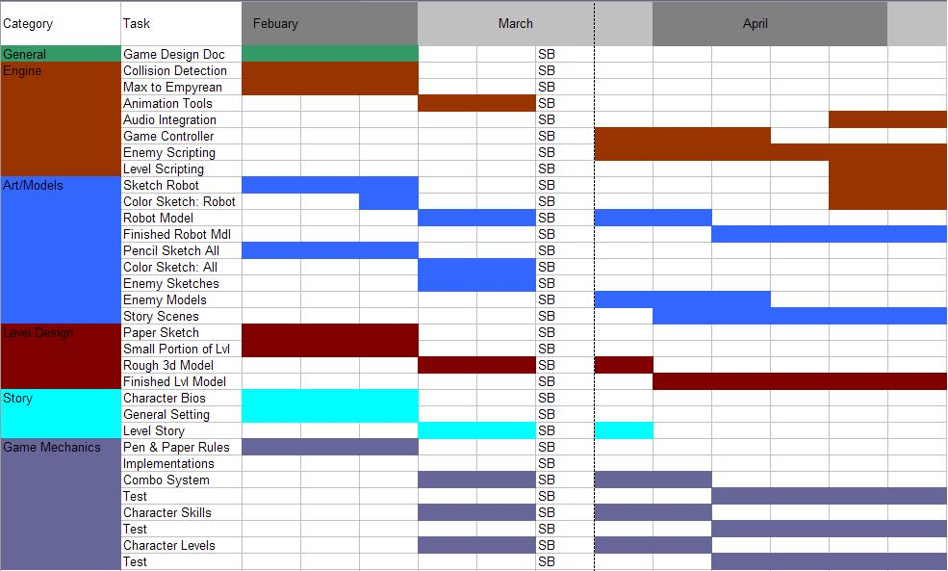

We successfully met the majority of these items and we plan to continue work in the summer. We are developing the next schedule currently.

