Ugeshprasanna AV

Restaurant Performance and Customer Insights Analysis Using Zomato Dataset

1. Project Objective
- Analyse restaurant distribution, customer ratings, and service adoption across multiple countries.
- Identify cuisine popularity, geographic hotspots, and customer engagement trends.
- Provide insights for restaurant owners and food delivery platforms.

2. Data Sources
- Dataset: https://app.gigasheet.com/spreadsheet/zomato-restaurants-dataset/20718e43_bea9_479f_b5f0_3d462aeab195?referrerId=https%3A%2F%2Fwww.gigasheet.com%2Fsample-data%2Fzomato-restaurants-dataset&_gl=1*qs7co6*_gcl_au*NDQ4Mjk5MzY3LjE3NzQ2NjM5OTI
- Attributes: Restaurant ID, Name, Country ID, Country Name, City, Cuisine, Rating, Votes, Price Range, Delivery, Table Booking, Longitude/Latitude, Month-Year.
- Domain: Food & Hospitality.

3. Problem Statement
- Restaurants face intense competition across countries and cities.
- Need to understand customer preferences (ratings, votes).
- Identify cuisine trends and service adoption (delivery, booking).
- Provide insights for strategic expansion and customer satisfaction improvement.

4. Attribute Details
Attribute Name | Description
Restaurant ID | Unique identifier for each restaurant
Restaurant Name | Name of the restaurant
Country ID / Country Name | Location dimension (country-level details)
City / Locality | City-level detail of restaurant location
Cuisine | Type of cuisine offered
Rating | Average customer rating
Votes | Number of customer votes
Price Range | Cost category (e.g., budget, mid-range, premium)
Delivery (Yes/No) | Indicates whether online delivery is available
Table Booking (Yes/No) | Indicates whether reservation/table booking is available
Longitude/Latitude | Geographic coordinates of the restaurant
Month-Year | Time dimension for trend analysis (month and year of data record)

5. Tools & Technologies
Microsoft Excel & Power Query:
- Data Cleaning
- Data Imputation
- Data Transformation
- Removing Duplicates
- Handling Missing Values
- Standardizing Formats
- Basic Analysis using Pivot Tables
Power BI
- Data Modelling (Relationships between tables)
- DAX Calculations (KPIs like Total Transactions, Avg Value)
- Interactive Dashboard Creation
- KPI Tracking (Transactions, Customers, Revenue)
- Time-Based Analysis (Year, Month trends)
- Drill-down Analysis (Bank → State → Customer Level)

6. Data Pre-Processing
- Removed duplicates (Restaurant ID).
- Standardized country and city names.
- Handled missing ratings/votes.
- Created calculated fields (Month-Year, Quarter).
- Converted categorical values (Delivery, Table Booking) into Yes/No flags.

7. Data Modeling and DAX
- Fact Table: Restaurant data (ratings, votes, services).
- Dimension Tables:
  - Country dimension
  - Cuisine dimension
  - Calendar table (Month, Quarter, Year).
- Relationships: One-to-many joins between fact and dimensions.
Sample DAX Measures:
- Average Rating = AVERAGE(Sheet1[Rating])
- % Restaurants with Delivery = DIVIDE(CALCULATE(COUNTROWS(Sheet1), Sheet1[Delivery]=“Yes”), COUNTROWS(Sheet1))
- Cuisine Popularity = COUNTROWS(Sheet1) grouped by Cuisine
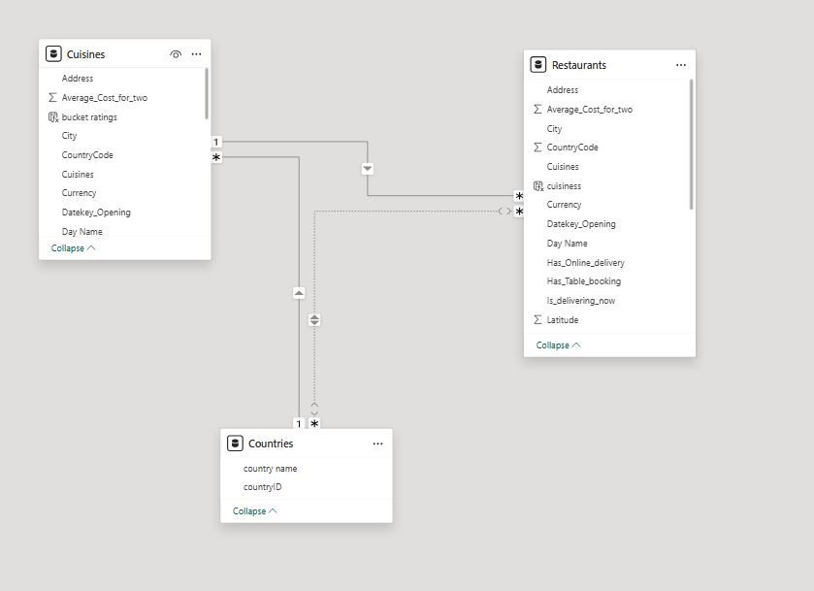

8. Analysis and Visualizations

8.1 Restaurant Overview Dashboard
- KPIs: Total Restaurants, Avg Rating, Total Votes, Countries, Cities.
- Country-wise restaurant distribution (India dominates with 8651 restaurants).
- City-wise restaurant counts (New Delhi, Gurgaon, Noida).
- 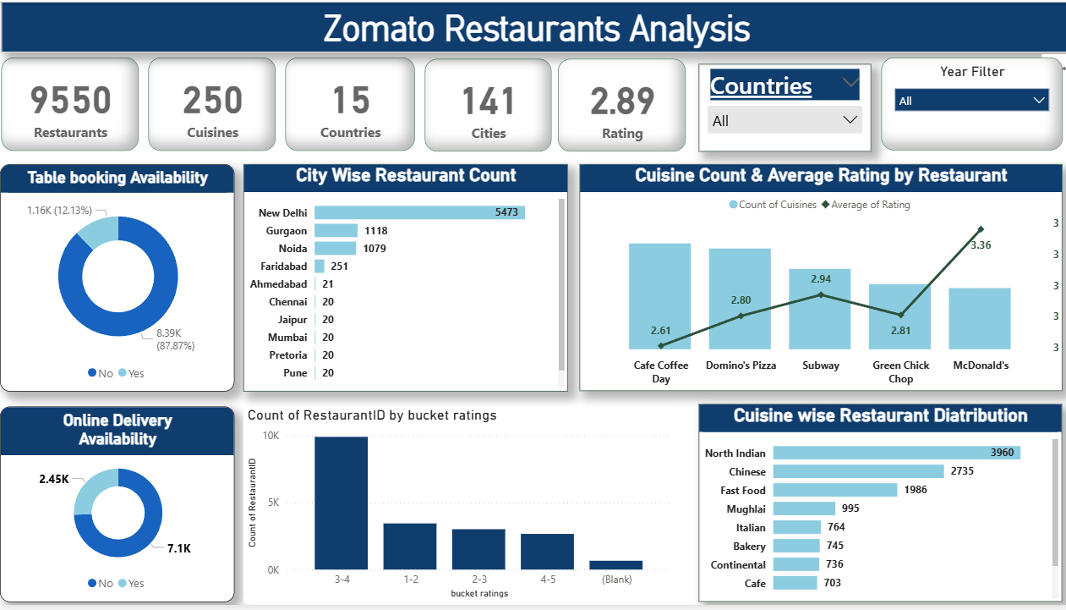

8.2 Rating Analysis
- Rating bucket chart:
  - Majority (4.6K) in 3–4 rating range.
  - Smaller counts in 1–2 and 4–5 ranges.
- Insight: Most restaurants are “average performers” — scope for improvement.

8.3 Service Adoption
- Table Booking: 1.16K Yes vs 8.39K No → low adoption.
- Online Delivery: 7.1K Yes vs 2.45K No → strong adoption.
- Insight: Delivery dominates, booking is niche.

8.4 Cuisine Dashboard
- Cuisine-wise restaurant counts: North Indian, Chinese, Fast Food lead.
- Ratings by cuisine: Compare average ratings across cuisines.

9. Insights & Conclusions
- Geographic dominance: India is the largest market (8651 restaurants).
- Customer ratings: Most restaurants fall in the 3–4 range, showing moderate satisfaction.
- Service adoption: Online delivery is widely adopted, table booking is limited.
- Cuisine trends: North Indian and Chinese cuisines dominate, but international cuisines (Italian, Continental) show growing presence.
Prescriptive Insights:
- Focus on improving ratings in the 3–4 bucket through better service.
- Expand table booking services in high-demand cities.
- Promote underrepresented cuisines to diversify offerings.
- Strengthen delivery infrastructure in countries with lower adoption.

10. Conclusion
This project demonstrates end-to-end analytics using Excel and Power BI. The dashboards provide actionable insights for restaurant owners, food delivery platforms, and policymakers to improve customer satisfaction, expand services, and identify growth opportunities.

