Group 5 Assignment
An Introduction to Statistical Learning — Chapter 4 (Classification)

Problem 1 — Equivalence of (4.2) and (4.3)
The logistic-function form (4.2) is
p(X) = e^{β₀+β₁X} / [ 1 + e^{β₀+β₁X} ],
and the logit (odds) form (4.3) is
p(X) / [1 − p(X)] = e^{β₀+β₁X}.
Proof. Start from (4.2) and compute 1 − p(X):
1 − p(X) = 1 − e^{β₀+β₁X}/[1+e^{β₀+β₁X}] = 1 / [1 + e^{β₀+β₁X}].
Now form the odds by dividing p(X) by 1 − p(X):
p(X)/[1−p(X)] = { e^{β₀+β₁X}/[1+e^{β₀+β₁X}] } ÷ { 1/[1+e^{β₀+β₁X}] } = e^{β₀+β₁X}.
The common factor 1 + e^(β₀+β₁X) cancels, leaving exactly (4.3). Hence the two representations are equivalent. ∎
Taking logs also gives the familiar log-odds (logit) form, log( p(X)/[1−p(X)] ) = β₀ + β₁X, which is linear in X.

Problem 2 — Logistic regression for grades
Fitted model: β̂₀ = −6, β̂₁ = 0.05 (hours studied X₁), β̂₂ = 1 (undergrad GPA X₂), so
p̂(X) = e^{−6 + 0.05·X₁ + X₂} / [ 1 + e^{−6 + 0.05·X₁ + X₂} ].
(a) For a student with X₁ = 40 hours and X₂ = 3.5:
logit = −6 + 0.05(40) + 1(3.5) = −6 + 2 + 3.5 = −0.5.
p̂ = e^{−0.5} / [1 + e^{−0.5}] = 0.6065 / 1.6065 ≈ 0.378.
So the estimated probability of getting an A is about 37.8%.
(b) A 50% chance means p̂ = 0.5, i.e. the log-odds equal 0:
−6 + 0.05·X₁ + 3.5 = 0 ⟹ 0.05·X₁ = 2.5 ⟹ X₁ = 50.
With a GPA of 3.5, the student would need to study 50 hours for a 50% chance of an A.

Problem 3 — Detailed forms of aₖ, bₖⱼ, and bₖⱼₗ in (4.33)
Under QDA, X | Y=k ~ N(μ_{k}, Σ_{k}), with density
f_{k}(x) = (2π)^{−p/2} |Σ_{k}|^{−1/2} exp( −½ (x−μ_{k})^{T} Σ_{k}⁻¹ (x−μ_{k}) ).
By Bayes' theorem, Pr(Y=k | X=x) ∝ π_{k} f_{k}(x). Comparing class k to the baseline class K via the log-ratio:
log[ Pr(Y=k|x) / Pr(Y=K|x) ] = log(π_{k}/π_{K}) + log f_{k}(x) − log f_{K}(x).
The −(p/2)·log(2π) terms cancel. Expanding each quadratic form,
(x−μ_{k})^{T}Σ_{k}⁻¹(x−μ_{k}) = x^{T}Σ_{k}⁻¹x − 2μ_{k}^{T}Σ_{k}⁻¹x + μ_{k}^{T}Σ_{k}⁻¹μ_{k},
and collecting the constant, linear, and quadratic terms gives the form of (4.33):
log[ Pr(Y=k|x)/Pr(Y=K|x) ] = a_{k} + Σ_{j} b_{kj} x_{j} + Σ_{j} Σ_{l} b_{kjl} x_{j} x_{l},
with the coefficients:
a_{k} = log(π_{k}/π_{K}) − ½ log(|Σ_{k}|/|Σ_{K}|) − ½ μ_{k}^{T}Σ_{k}⁻¹μ_{k} + ½ μ_{K}^{T}Σ_{K}⁻¹μ_{K}
b_{kj} = ( Σ_{k}⁻¹μ_{k} − Σ_{K}⁻¹μ_{K} )_{j}
b_{kjl} = −½ [ (Σ_{k}⁻¹)_{jl} − (Σ_{K}⁻¹)_{jl} ]
where (·)_{j} denotes the j-th entry of a vector and (·)_{jl} the (j,l) entry of a matrix.
Remark. The quadratic coefficients b_{kjl} are nonzero because Σ_{k} differs across classes — this is what makes the QDA decision boundary quadratic. If all classes share a common covariance (Σ_{k} = Σ for every k), then Σ_{k}⁻¹ − Σ_{K}⁻¹ = 0, so every b_{kjl} = 0 and the expression collapses to the linear LDA discriminant.

Problem 4 — Predicting gas mileage on the Auto data
(a) Create the binary response mpg01.
library(ISLR2); library(MASS); library(e1071); library(class)
attach(Auto)
mpg01 <- ifelse(mpg > median(mpg), 1, 0)
Auto <- data.frame(Auto, mpg01)
The median mpg is 22.75, giving a perfectly balanced response (196 in each class).
(b) Explore associations.
cor(subset(Auto, select = -name)) # correlations with mpg01
par(mfrow = c(2,3))
for (v in c("cylinders","displacement","horsepower",
"weight","acceleration","year"))
boxplot(Auto[[v]] ~ mpg01, main = v, xlab = "mpg01")
Correlations of each feature with mpg01:
Feature | cylinders | weight | displ. | horsep. | origin | year | accel.
corr | −0.759 | −0.758 | −0.753 | −0.667 | 0.514 | 0.430 | 0.347
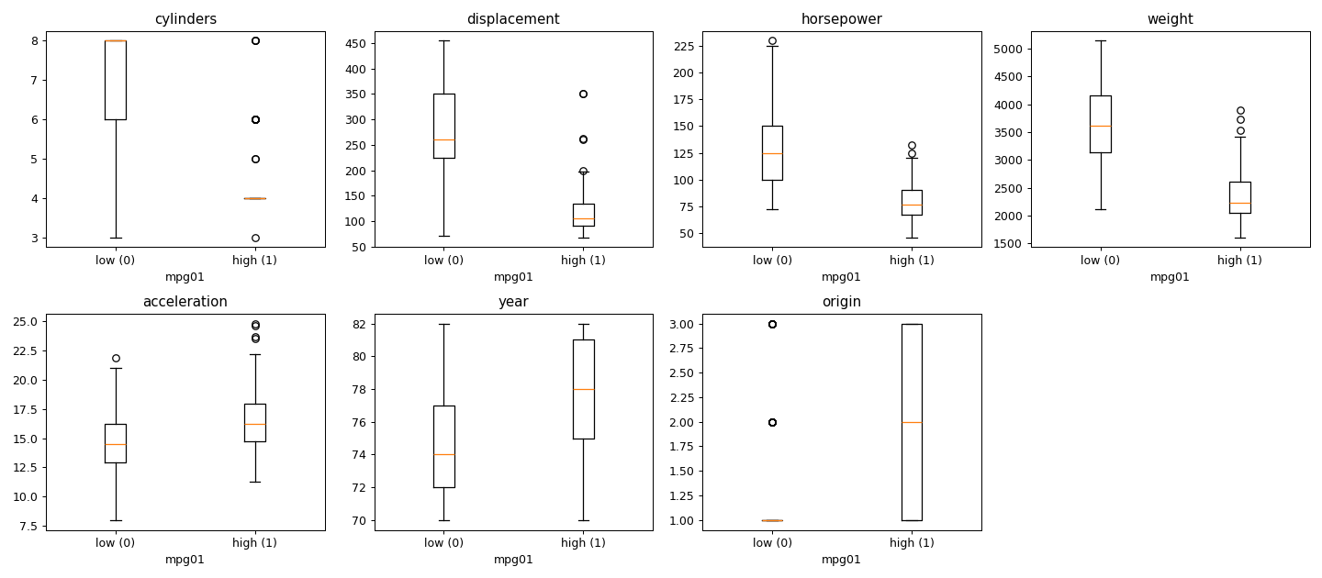
Findings. cylinders, weight, displacement, and horsepower are all strongly negatively associated with mpg01: high-mileage cars tend to have fewer cylinders and lower engine displacement, horsepower, and weight, and their boxplots show clear separation between the two classes with little overlap. acceleration, year, and origin are more weakly associated and overlap substantially. We therefore use the four strong predictors — cylinders, displacement, horsepower, weight — in the models below.
(c) Train/test split (70%/30%, stratified, seed 1).
set.seed(1)
train <- sample(nrow(Auto), 0.7 * nrow(Auto))
Auto.train <- Auto[train, ]; Auto.test <- Auto[-train, ]
mpg01.test <- Auto.test$mpg01
f <- mpg01 ~ cylinders + displacement + horsepower + weight
This yields 274 training and 118 test observations.
(d) LDA.
lda.fit <- lda(f, data = Auto.train)
lda.pred <- predict(lda.fit, Auto.test)$class
mean(lda.pred != mpg01.test) # test error
Test error ≈ 10.2%.
(e) QDA.
qda.fit <- qda(f, data = Auto.train)
qda.pred <- predict(qda.fit, Auto.test)$class
mean(qda.pred != mpg01.test)
Test error ≈ 11.0%.
(f) Logistic regression.
glm.fit <- glm(f, data = Auto.train, family = binomial)
glm.prob <- predict(glm.fit, Auto.test, type = "response")
glm.pred <- ifelse(glm.prob > 0.5, 1, 0)
mean(glm.pred != mpg01.test)
Test error ≈ 11.0%.
(g) Naive Bayes.
nb.fit <- naiveBayes(f, data = Auto.train)
nb.pred <- predict(nb.fit, Auto.test)
mean(nb.pred != mpg01.test)
Test error ≈ 11.0%.
(h) KNN (predictors standardized; several values of K).
vars <- c("cylinders","displacement","horsepower","weight")
train.X <- scale(Auto.train[, vars])
test.X <- scale(Auto.test[, vars],
center = attr(train.X, "scaled:center"),
scale = attr(train.X, "scaled:scale"))
train.Y <- Auto.train$mpg01
for (k in c(1,3,5,10,15,20,50,100)) {
set.seed(1)
pred <- knn(train.X, test.X, train.Y, k = k)
cat("K =", k, " test error =", mean(pred != mpg01.test), "\n")
}

K | 1 | 3 | 5 | 10 | 15 | 20 | 50 | 100
test error | 9.3% | 11.0% | 9.3% | 11.0% | 11.0% | 11.0% | 11.0% | 11.0%
The best KNN performance (≈ 9.3%) occurs at small K (K = 1 or 5); performance is stable and slightly worse for larger K.

Summary
Method | Test error
LDA | 10.2%
QDA | 11.0%
Logistic regression | 11.0%
Naive Bayes | 11.0%
KNN (best, K = 1 or 5) | 9.3%
All five methods perform similarly, with test errors clustered around 9–11%; KNN at small K and LDA are marginally best. The strong, roughly linear separation provided by cylinders, displacement, horsepower, and weight explains why even simple linear methods do well.
Note. The reported test errors come from a 70/30 stratified split (set.seed(1)). Exact figures depend on the particular split and the random-number generator, so your numbers may differ by a point or two, but the ranking and overall ~10% error level are robust.

