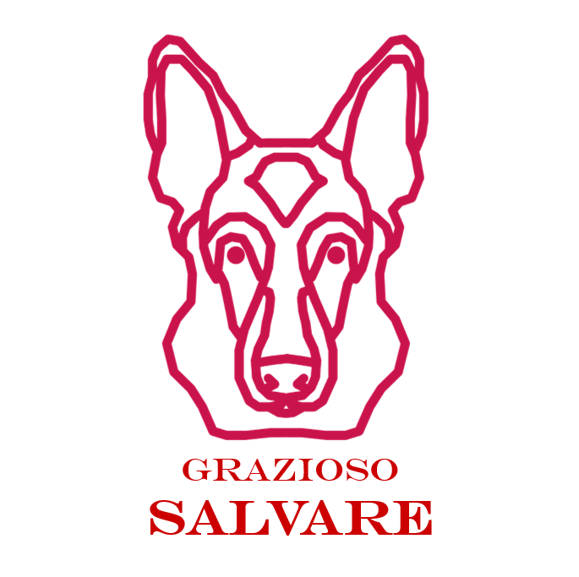

CS 340 Project Two
Grazioso Salvare Dashboard
Created by Ugljesa Stajic

Project Summary
For Project Two, I completed a dashboard for Grazioso Salvare. The dashboard connects to the Austin Animal Center Outcomes data in MongoDB and helps users find dogs that match different rescue-training categories.
The dashboard includes the required logo, my creator name, rescue filters, interactive data table, pie chart, and geolocation map.
Required Functionality
The dashboard has four filter options:
- Water Rescue
- Mountain or Wilderness Rescue
- Disaster or Individual Tracking
- Reset
When a filter is selected, the data table updates with matching dogs. The pie chart updates to show the top 10 breeds from the current results. The map updates using the selected animal’s latitude and longitude

Screenshots
Starting State / Reset
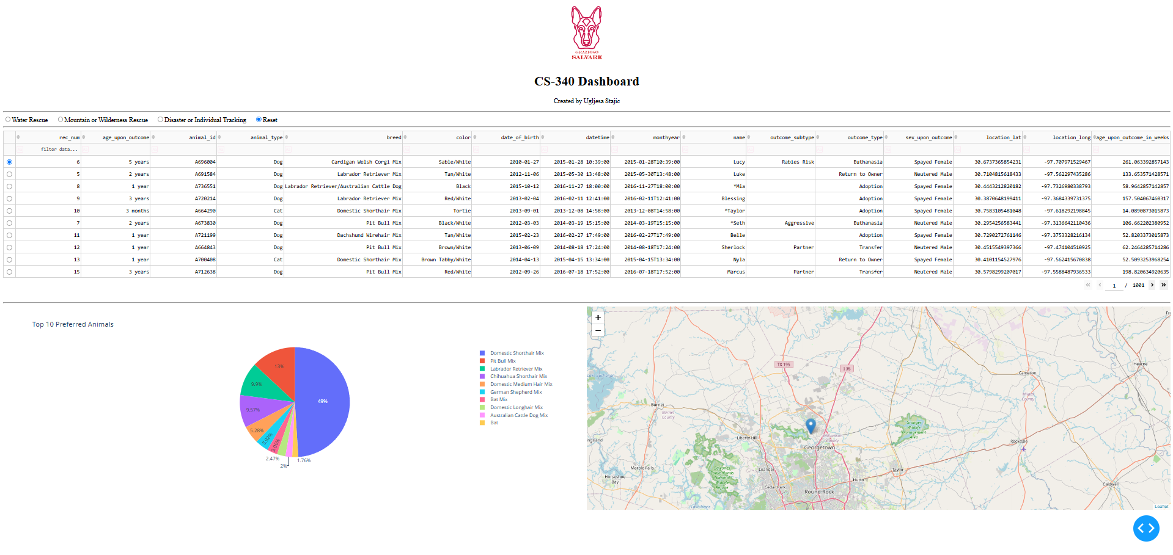
Water Rescue Filter
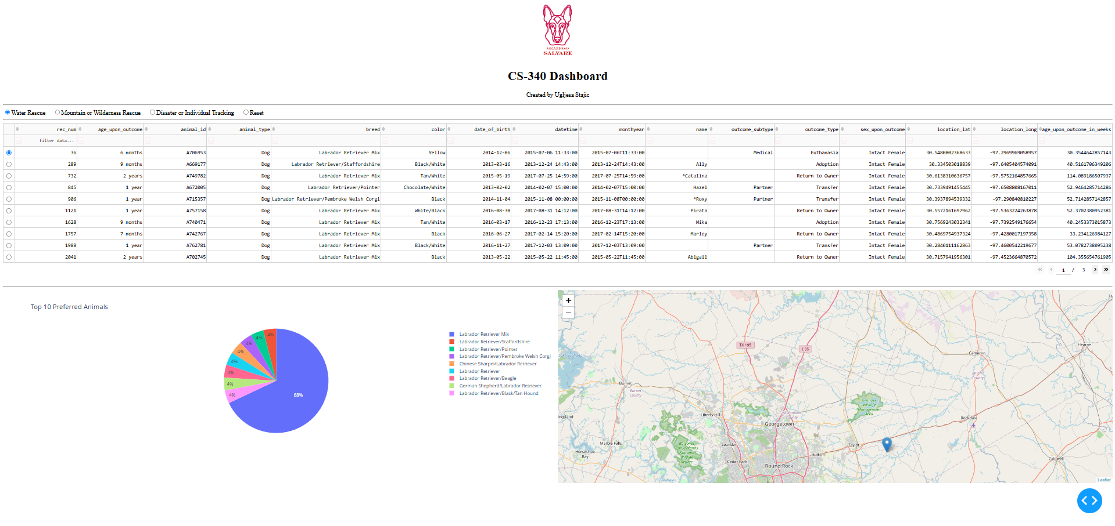

Mountain or Wilderness Rescue Filter
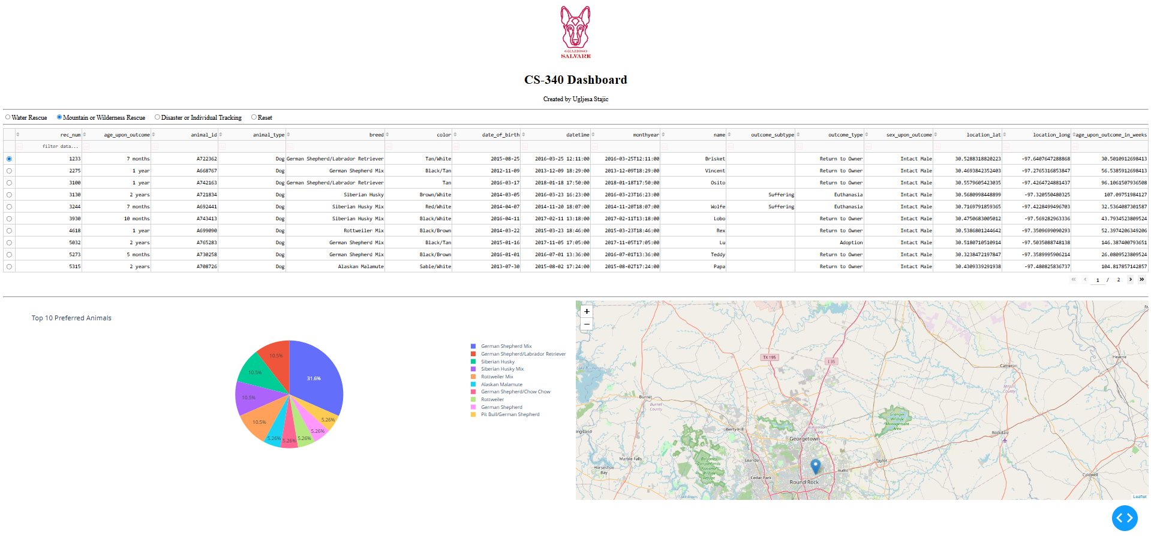
Disaster or Individual Tracking Filter
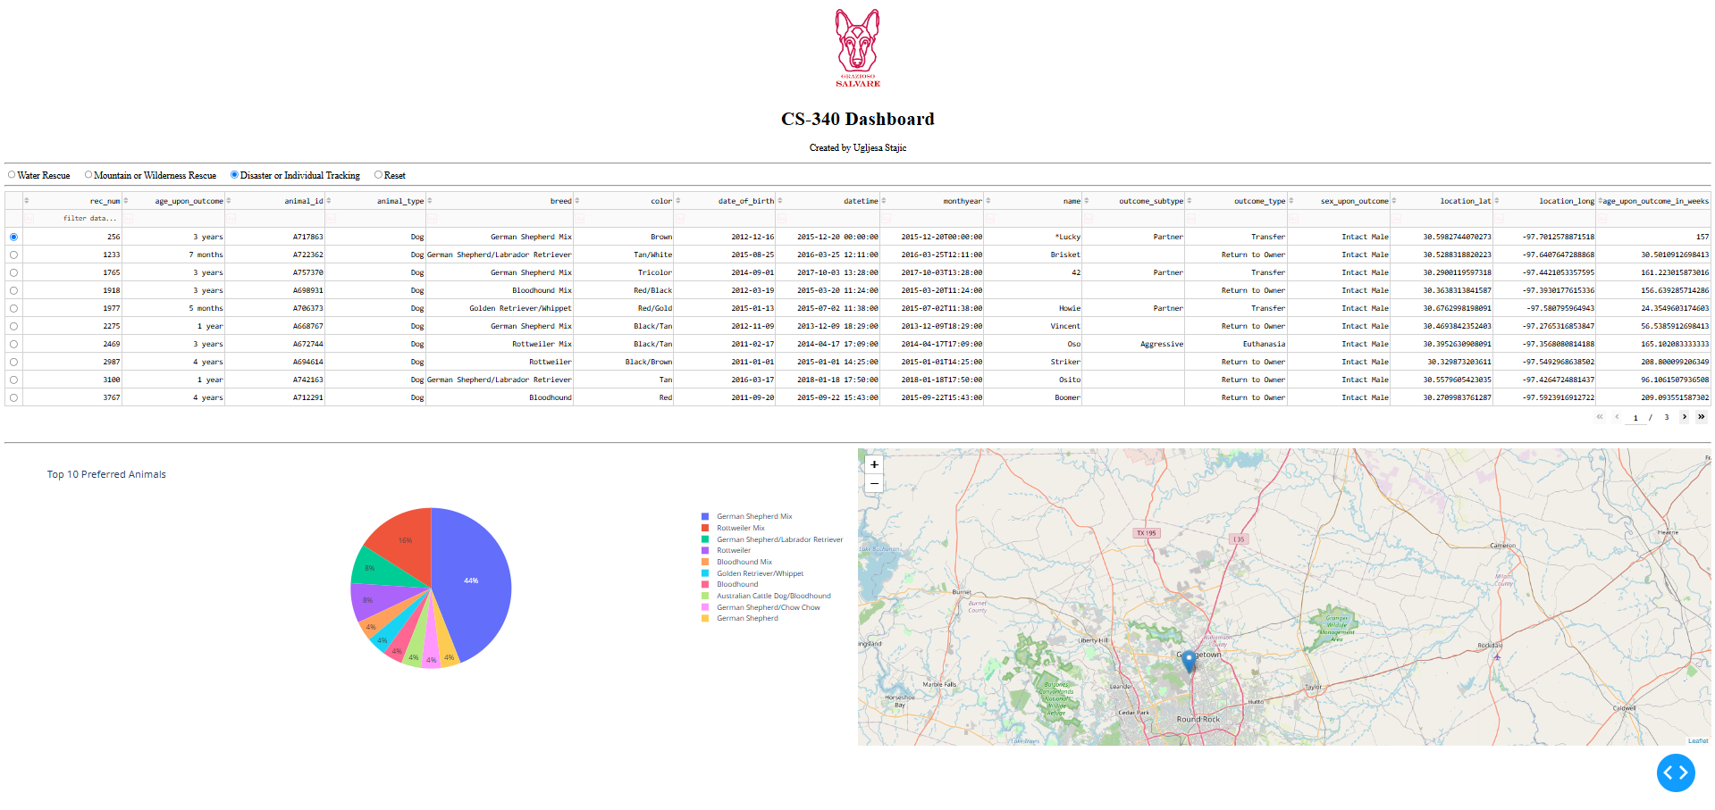

Tools Used
I used Python, MongoDB, PyMongo, Dash/JupyterDash, Plotly Express, and Dash Leaflet.
MongoDB was used because it stores the shelter data as documents and works well with Python through PyMongo. I used my Project One CRUD module to read data from the aac.animals collection.
Dash was used because it creates the dashboard layout and callbacks. The callbacks allow the filters, table, chart, and map to update together.
Steps Taken
I started this assignment first by checking all requirements and documents so I could follow everything and create a dashboard exactly as requested. I used the provided template “ProjectTwoDashboard.ipynb”, which I connected to MongoDB using my CRUD module. After that, I started editing the template and filling in the sections that were required for this assignment. I added the Grazioso Salvare logo and my name, after which I started the main requirements from the dashboard by adding the rescue filters, connecting the filters to MongoDB queries, and adding the data table, pie chart, and map. At the end, I tested each filter and took screenshots.
Challenges
My biggest challenge was the crowded pie chart. I changed it to show the top 10 breeds. On the way I got and also fixed small callback issues so the dashboard would not crash when nothing was selected. Another challenge was that the map and pie chart layout looked squeezed when they were side by side. I fixed this by changing the map width after which it fit better inside the dashboard layout.
How to Run
Place these files in the same folder:
- ProjectTwoDashboard.ipynb
- CRUD_Python_Module.py
- Grazioso Salvare Logo.png
Make sure MongoDB is running and the Austin Animal Center Outcomes data is imported into aac.animals. Open the notebook in JupyterLab, run it from the top, open the Dash link, and test each filter.

