1. Use Case Diagram

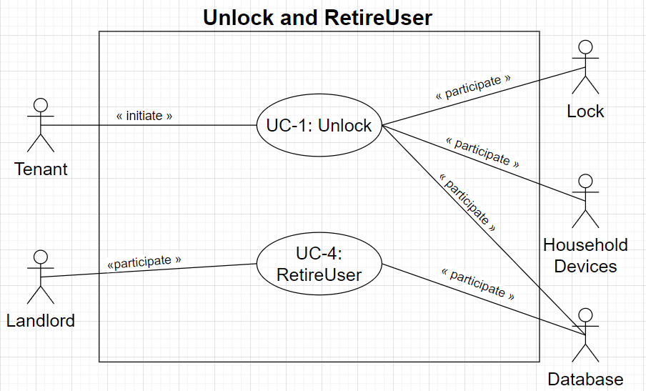

1. Use Case Schemas

|  |  |  |  |
| --- | --- | --- | --- |
| **Use Case UC-1:** | | | **Unlock** |
| **Related Requirements:** | | REQ-1, REQ-2, REQ-3, REQ-4, REQ-5, REQ-6 | |
| **Initiating Actor:** | | Any of: Tenant | |
| **Actor’s Goal:** | | To unlock and enter home. | |
| **Participating Actors:** | | Lock, Household Devices, Database | |
| **Preconditions:** | | * The set of valid phone numbers stored in the system database is non-empty. * The door keypad is backlit if it’s dark for visibility. * The lock is disarmed if there is an emergency. | |
| **Postconditions:** | | * The system has recorded the times of lock-phone pairing failures. | |
| **Flow of Events for Main Success Scenario:** | | | |
| → | 1. **Tenant** arrives at the door and puts the phone on **Lock**. | | |
| ← | 1. **System** (a) signals to the **Tenant** the lock status, (b) signals to the **Lock** to be unlocked. | | |
| → | 1. **Tenant** opens the door and enters the home. | | |

|  |  |  |  |
| --- | --- | --- | --- |
| **Use Case UC-4:** | | | **RetireUser** |
| **Related Requirements:** | | REQ-1, REQ-2, REQ-3, REQ-4, REQ-5, REQ-6 | |
| **Initiating Actor:** | | Any of: Landlord | |
| **Actor’s Goal:** | | To retire an existing user account and disable access. | |
| **Participating Actors:** | | Database | |
| **Preconditions:** | | * The set of valid phone numbers stored in the system database is non-empty. | |
| **Postconditions:** | | * The system has removed a user’s account from the database. | |
| **Flow of Events for Main Success Scenario:** | | | |
| → | 1. **Landlord** started the **Database** management system. | | |
| ← | 1. **System** reveals the **Database** to the **Landlord**. | | |
| → | 1. **Landlord** deletes a user’s account, saves and quit. | | |

1. Acceptance Tests

|  |  |  |
| --- | --- | --- |
| **Test-case Identifier:** | TC-1 | |
| **Use Case Tested:** | UC-1 | |
| **Pass/fail Criteria:** | The test passes if the user gives a phone whose phone number is contained in the database, with less than a maximum allowed number of unsuccessful attempts. | |
| **Input Data:** | Phone identifier | |
| **Test Procedure:** | | **Expected Result:** |
| Step 1. Give an incorrect phone number | | System beeps in an annoying sound to indicate failure;  records unsuccessful attempt in the database;  prompts the user to try again. |
| Step 2. Give a correct phone number | | System beeps in a peaceful sound to indicate success;  records successful access in the database;  disarms the lock. |

|  |  |  |
| --- | --- | --- |
| **Test-case Identifier:** | TC-2 | |
| **Use Case Tested:** | UC-4 | |
| **Pass/fail Criteria:** | The test passes if the user retires an existing user account and the system do remove it or disable it. | |
| **Input Data:** | Computer operation | |
| **Test Procedure:** | | **Expected Result:** |
| Step 1. Use the account which will be retired to open the door | | System beeps in a peaceful sound to indicate success;  records successful access in the database;  disarms the lock. |
| Step 2. Retire an existing user account | | The user account is removed from or disabled in the database. |
| Step 3. Use the removed account to open the door again | | System beeps in an annoying sound to indicate failure;  records unsuccessful attempt in the database;  prompts the user to try again. |