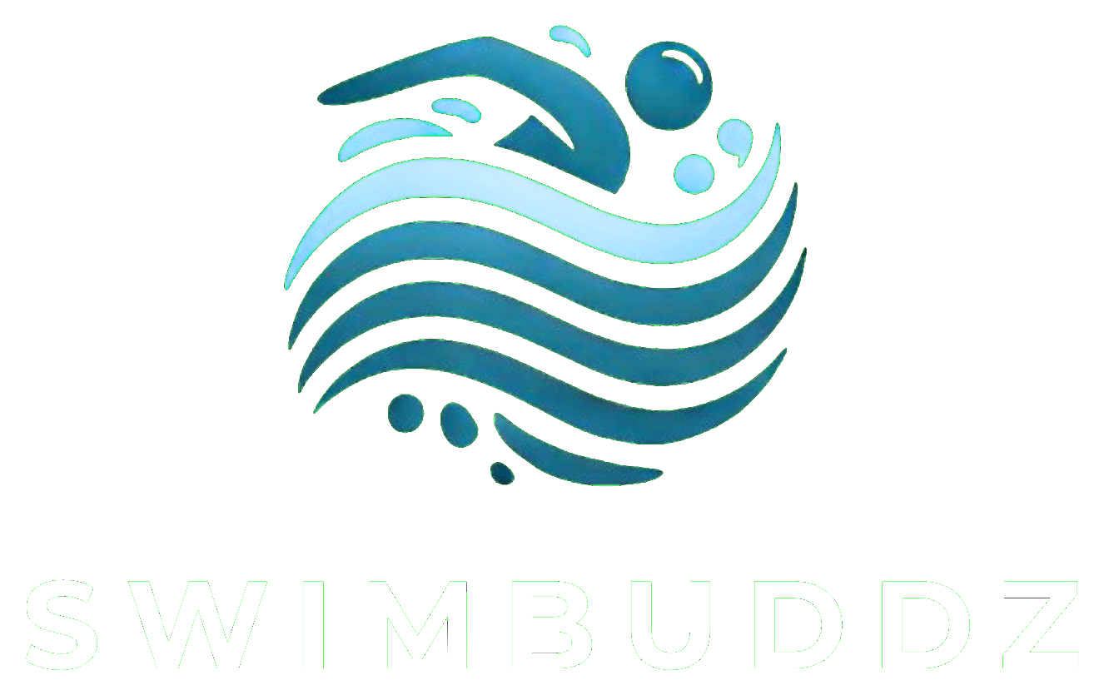 | CORPORATE WELLNESS · LAGOS  DISCUSSION OUTLINE FOR HR REVIEW
INTRO TO WATER
A low-friction employee wellness pilot
A company-sponsored weekend experience that lets employees try swimming safely before HR or staff commit to a longer programme.
The pilot is built to answer two practical HR questions: Will employees participate? And will the experience have a visible effect on how they feel?

PILOT AT A GLANCE
8–10 employees  Suggested size; adjusted to venue and coach-to-swimmer ratio. | 90 minutes  Guided, beginner-friendly water experience. | Saturday morning  Low disruption to the working week. | Lagos partner pool  Yaba, VI, Ikoyi or Festac; final venue follows participant needs.

WHAT EMPLOYEES EXPERIENCE  • A warm, beginner-friendly orientation to the water.  • Guided breathing, floating and safe movement fundamentals.  • Small-group coaching with no pressure to perform or already know how to swim.  • A clear next step only for employees who genuinely want to continue. | WHAT SWIMBUDDZ HANDLES  • Interest form and simple pre-session safety screening.  • Coach, pool, equipment and session-plan coordination.  • Employee reminders and session-day logistics.  • Feedback collection and a concise report for HR.

WHAT HR RECEIVES  • Registration, attendance and engagement summary.  • Anonymous before/after confidence and wellbeing pulse.  • Satisfaction, comments and interest in continuing.  • A short recommendation: stop, repeat, or progress to a cohort. | WHAT SUCCESS LOOKS LIKE  • Participation: interested employees register and show up.  • Experience: participants feel safer, calmer or more confident in water.  • Continuation: genuine demand exists for a longer programme.  • Convenience: HR gets useful evidence with minimal administration.

COMMERCIAL STRUCTURE  Recommended: the company sponsors the first session, so employees pay ₦0. The one-time pilot fee is confirmed after headcount and venue are agreed; there is no setup or admin fee. | PRIVACY  Personal fears, health notes and skill details stay with the coach. HR receives only agreed, aggregated feedback.
A SIMPLE FOUR-STEP START
1 Scope  20-minute HR call | 2 Confirm  Date, venue, headcount | 3 Launch  SwimBuddz opens registration | 4 Report  Session + report within 3 business days
Ugo Nwachukwu · Founder, SwimBuddz · swimbuddz@gmail.com · +234 703 358 8400 · @swimbuddz

