MCP3426

- On-Board Voltage Reference (V REF ):
  - Accuracy: 2.048V ± 0.05% → 0,001V = 1mV
  - Drift: 15 ppm/°C
- ± 2.048V differentially, (full scale range = 4.096/PGA)
- PGA: gain of x1, x2, x4, or x8
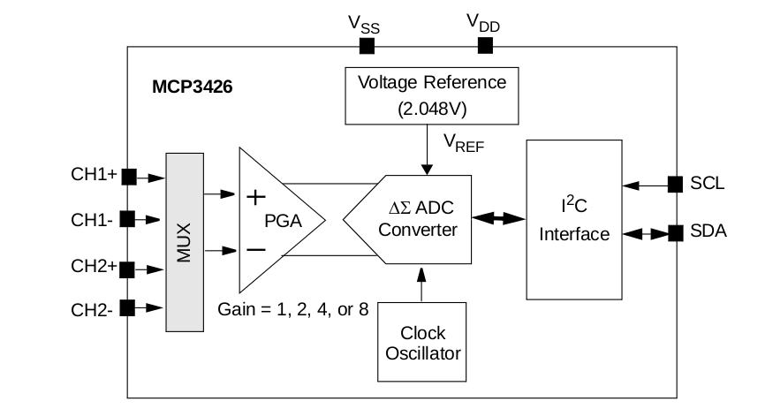
- Output Noise: 2.5μV RMS
- Offset Error: 30µV
- CHn- pin to V_{ss} for a single-ended operation
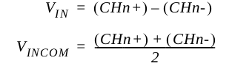
- – V_{REF} ≤ ( V_{IN} • PGA ) ≤ ( V_{REF} – 1LSB ) V_{REF} = 2.048V
- 12 bits 1 mV
- 14 bits 250 μV
- 16 bits 62.5 μV
- two bypass capacitors (a 10 μF tantalum capacitor and a 0.1 μF ceramic capacitor)
- The device can measure the input voltage as low as 7.8 μV range (or current in ~ μA range) with 16 bit resolution and PGA = 8 settings.
