**RESUME**

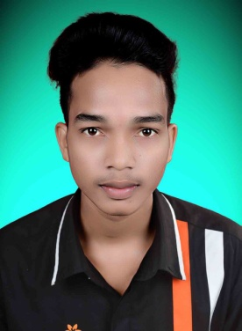

**PERSONAL DETAILS**

* **NAME - JAGESHWAR PANDEY**
* **DATE OF BIRTH - 31/07/2005**
* **FATHER NAME - LACHHMU RAM**
* **MOTHER NAME - SANTOSHI BAI**
* **NATIOANLITY - INDIA**
* **LANGUAGE - HINDI ( S, R, W, ) / ENGLISH ( R, W )**
* **ADDRESS - DHANORA , DIST.- KONDAGAON ( C.G.)**

**ADUCATION**

* **QUALIFICATION - 12TH PASS**
* **COMPUTER SKILLS - BASIC COMPUTER KNOWLEDGE**
* **TRAINING - ELECTRONIC & ROBOTIC TRAINIG , DURG**

**CONTACT DETAIL**

* **MOBILE NO. - 9340071182**
* **E-MAIL -** [**cgjagesh123@gmail.com**](mailto:cgjagesh123@gmail.com)