
Calorie Tracking Application

CE443 – Mobile Programming
Project Report

Düzce University, Faculty of Engineering
Department of Computer Engineering
Student:
Fatih Arslan-211015048
Uğur Avşar-211015040
Osman Akdeniz-211015007
Muhammed Talha Bulut-211015052

Table of Contents
1. Introduction 3
1.1 Goals and Scope 3
2. System Requirements 4
2.1 Minimum Requirements 4
2.2 Dependencies 4
3. Data Layer 5
3.1 Entity Overview 5
3.2 Food Entity and Catalog 6
3.3 Disease-Based Food Warning System 6
3.4 Cloud Firestore Structure 7
4. Application Architecture 8
4.1 Activity Catalog 8
4.2 Background Workers 9
4.3 Utility Classes 9
4.4 Repository Layer 10
5. Key Features 11
5.1 User Authentication 11
5.2 Profile & Goal Management 11
5.3 Meal Logging 11
5.4 Notifications 11
5.5 Weekly Report 11
5.6 Password Change 12
5.7 Localisation & Theming 12
6. User Interface . 12
6.1 Login & Registration 12
6.2 Dashboard 14
6.3 Add Meal & Food Search 15
6.4 Weekly Report – Monthly Report 16
6.5 Settings 17
6.6 Icon 17
7. Security Considerations 18
8. Known Limitations 18
9. Conclusion and Future Improvements 19
Appendix A – AndroidManifest.xml 20
Appendix B – app/build.gradle.kts (Key Sections) 21
Appendix C – Food Catalog (FoodCatalog.java) – Selected Entries 22
References 23

1. Introduction
Our KaloriQ application is a native Android mobile application developed to help users track their daily calorie intake, manage their dietary habits, and receive health-conscious food recommendations based on pre-existing medical conditions such as diabetes, hypertension, and high cholesterol. The application is built with Java, targeting Android API level 33 and above, and integrates Firebase (Authentication + Cloud Firestore) for user management and persistent data storage.
The project was developed as part of the CE443 – Mobile Application Development course at Düzce University. It demonstrates the use of modern Android architecture patterns including Repository pattern, WorkManager for background tasks, Room ORM (local cache), and Google Gemini AI for image-based food recognition.

1.1 Goals and Scope
- Enable users to log daily meals with calorie and quantity information.
- Provide a searchable catalog of 103 predefined Turkish foods with localized names.
- Show disease-specific dietary warnings (sugar, salt, fat) when adding meals.
- Support food photo recognition via Google Gemini 2.5 Flash AI.
- Generate weekly calorie reports with visual progress indicators.
- Send configurable push notifications (meal reminders, water reminders, goal-close alerts, calorie limit exceeded alerts).
- Allow profile management including password change for email/password accounts.
- Support Turkish/English language switch and Light/Dark/System theme.

2. System Requirements

2.1 Minimum Requirements
The application was developed for modern Android devices using Android SDK API level 33 and above. Java 17 is used as the primary programming language, and the project targets API level 36 to ensure compatibility with the latest Android features and security updates. Internet access is required for Firebase synchronization and AI-based food recognition features, while camera and notification permissions are optional depending on the features used by the user.
Table 1 – Minimum System Requirements
Requirement | Value
Minimum SDK | API 33 (Android 13 – Tiramisu)
Target SDK | API 36
Compile SDK | API 36
Build Tools | 36.0.0
Language | Java 17
Internet | Required (Firebase sync)
Camera | Optional (AI food recognition)
Notifications | Optional (meal/water reminders)

2.2 Dependencies
Several external libraries and services were integrated into the project to improve functionality, performance, and user experience. Firebase services are used for authentication and cloud data storage, while WorkManager handles background reminder tasks. Material Components 3 provides modern Android UI elements, and Gemini AI is integrated for image-based food recognition. Additional libraries such as MPAndroidChart and Glide are used for data visualization and image management within the application.
Table 2 – External Libraries and Dependencies
Library | Version | Purpose
Firebase Auth | 23.x | User authentication (email/password & Google Sign-In)
Firebase Firestore | 25.x | Cloud database for user profiles and meal entries
Room ORM | 2.7.x | Local SQLite abstraction (legacy cache)
WorkManager | 2.10.x | Background notification scheduling
Gemini AI (generativeai) | 0.9.x | Image-based food recognition
Material Components 3 | 1.12.x | UI components and theming
MPAndroidChart | 3.1.0 | Weekly calorie bar charts
Glide | 4.16.x | Image loading and caching
Google Sign-In | 21.x | OAuth login with Google accounts

3. Data Layer
The application uses Firebase Cloud Firestore as the primary and authoritative data store. Room ORM (AppDatabase) is retained in the codebase as a legacy local cache but is not used by the active data flow at runtime. All CRUD operations go through AppRepository, which communicates exclusively with Firestore.

3.1 Entity Overview

User Entity
Table 3 – User Entity Structure
Field | Type | Description
id | String | Firebase Auth UID (primary key)
name | String | Full display name
email | String | Email address
age | int | Age in years
height | float | Height in centimetres
weight | float | Weight in kilograms
gender | String | "MALE" or "FEMALE"
activityLevel | String | Activity level enum (SEDENTARY … VERY_ACTIVE)
dailyCalorieGoal | int | User-defined or BMR-calculated calorie goal
hasDiabetes | boolean | Triggers sugar-related food warnings
hasHypertension | boolean | Triggers salt-related food warnings
hasCholesterol | boolean | Triggers fat-related food warnings
authProvider | String | "email" or "google" – used for password change eligibility

MealEntry Entity
Table 4 – MealEntry Entity Structure
Field | Type | Description
id | String | Auto-generated UUID (primary key)
userId | String | Firebase Auth UID of the owner
foodId | int | Reference to Food entity
foodName | String | Snapshot of food name at entry time
mealType | String | "BREAKFAST" | "LUNCH" | "DINNER" | "SNACK"
quantityGrams | float | Serving size in grams
totalCalories | float | Computed: caloriesPer100g × quantityGrams / 100
date | String | ISO date string "yyyy-MM-dd"
timestamp | long | Unix epoch milliseconds
notes | String | Optional free-text note

3.2 Food Entity and Catalog
The Food entity represents both predefined catalog items and user-created custom foods. The catalog is managed by FoodCatalog.java (103 entries) and seeded into Firestore via AppRepository.ensureFoodsSeeded() on first launch.
Table 5. Food Entity Structure
Field | Type | Description
id | int | Stable numeric ID (1–103 for predefined foods)
nameTr | String | Turkish food name
nameEn | String | English food name
caloriesPer100g | int | Caloric value per 100 grams
category | String | "BREAKFAST" | "LUNCH" | "DINNER" | "SNACK"
isPredefined | boolean | True for catalog items; false for user-added
sugarWarning | boolean | True = high sugar content (diabetes warning)
saltWarning | boolean | True = high sodium content (hypertension warning)
fatWarning | boolean | True = high saturated fat content (cholesterol warning)

The catalog contains 103 Turkish foods spread across four categories:
Table 6. Food Catalog Category Distribution
Category | Count
BREAKFAST | 24
LUNCH | 24
DINNER | 20
SNACK | 35
Total | 103

3.3 Disease-Based Food Warning System
When a user has declared a medical condition in their profile, the app applies color-coded risk warnings when they select a food in AddMealActivity. Each warning is driven by a dedicated boolean flag on the Food entity:
Table 7. Disease-Based Food Warning Rules
Flag | Condition | User Field | Warning Shown
sugarWarning | Diabetes | hasDiabetes | High sugar content alert
saltWarning | Hypertension | hasHypertension | High sodium content alert
fatWarning | Cholesterol | hasCholesterol | High saturated fat alert
The warning logic is implemented in AddMealActivity.buildFoodRiskWarning(). It reads the current user's condition flags from AppRepository and checks them against the selected food's warning booleans. If a match is found, a red-highlighted warning message is displayed in the UI before the user confirms the meal entry.

3.4 Cloud Firestore Structure
Collections and their access rules:
Firebase Cloud Firestore is used as the primary cloud database for storing user profiles, meal entries, and food catalog data. The database structure is organized into separate collections to improve scalability, maintainability, and data security. User-specific information is stored under authenticated user IDs, ensuring that each user can access only their own data.
Firestore Security Rules are implemented to restrict unauthorized access and protect sensitive user information. Authentication checks are performed before allowing read or write operations, and ownership validation is applied for user-related collections such as meal entries and daily statistics. This structure provides secure cloud-based data management while supporting real-time synchronization across the application.
Table 8. Cloud Firestore Collections and Access Rules
Collection | Document ID | Access Rule
users | Firebase Auth UID | Read/write only by owner (request.auth.uid == userId)
users/{uid}/mealEntries | Auto UUID | Read/write only by owner
foods | Food ID (string) | Read/write by any authenticated user

Firestore Security Rules (simplified):
rules_version = '2';
service cloud.firestore {
match /databases/{database}/documents {
function signedIn() {
return request.auth != null;
}
function isOwner(userId) {
return signedIn() && request.auth.uid == userId;
}
match /users/{userId} {
allow read, create, update, delete: if isOwner(userId);
match /meal_entries/{mealId} {
allow read, create, update, delete: if isOwner(userId);
}
match /daily_stats/{date} {
allow read, create, update, delete: if isOwner(userId);
}
}
match /foods/{foodId} {
allow read, write: if signedIn();
}} }

4. Application Architecture
The application follows a layered architecture: Activities (UI) → Repository (data access) → Firebase Firestore (remote) / FoodCatalog (local seed). There is no ViewModel layer; Activities call AppRepository directly on background threads provided by AppDatabase.databaseWriteExecutor.

4.1 Activity Catalog
The application is composed of multiple activities, each responsible for a specific part of the user experience and application workflow. The activity structure was designed to separate authentication, profile management, meal tracking, reporting, and settings operations into independent and manageable components.
Each activity communicates with the AppRepository layer to perform data operations through Firebase Firestore and Firebase Authentication services. This modular structure improves maintainability, readability, and scalability of the application while providing a consistent user experience across different screens.
Table 9. Application Activity Catalog
Activity | Purpose | Key Features
SplashActivity | Launch screen, session check | Auto-navigates to MainActivity if session exists, otherwise to LoginActivity
LoginActivity | Email/password and Google Sign-In | Firebase Auth; re-authenticates returning users
RegisterActivity | New account creation | Validates email format, password length ≥ 6, creates Firebase Auth user
ProfileSetupActivity | First-run profile wizard | Collects age, height, weight, gender, activity level, medical conditions
MainActivity | Dashboard — daily calorie summary | Shows consumed vs. goal calories, meal list, navigation bar
AddMealActivity | Log a new meal entry | Food search, quantity input, disease-based food warnings, AI photo recognition
FoodSearchActivity | Search the food catalog | Searches both nameTr and nameEn fields; shows category badge
CameraActivity | AI-powered food detection | Sends camera photo to Gemini 2.5 Flash; returns recognized food name
WeeklyReportActivity | Weekly calorie bar chart | MPAndroidChart bar chart; goal line overlay; calorie totals per day
ProfileActivity | View and edit profile | Shows BMI, BMR; links to ProfileEditActivity
ProfileEditActivity | Edit profile fields | Updates Firestore user document; recalculates daily goal
SettingsActivity | App preferences and account actions | Theme (Light/Dark/System), language (TR/EN), notification switches, time pickers, password change, logout

4.2 Background Workers

ReminderWorker
Scheduled by WorkManager (periodic — once per day) to send daily reminder notifications. On execution it:
- Reads today's consumed calories and the user's daily goal from Firestore.
- If notifications are enabled and the user is within 300 kcal of the goal, sends a "goal close" notification.
- If consumed calories exceed the goal, sends a "calorie limit exceeded" notification.
- Sends meal reminder and water reminder at the scheduled times.

BootReceiver
A BroadcastReceiver registered for BOOT_COMPLETED. Re-schedules WorkManager periodic tasks after device restart to ensure reminders survive reboots.

4.3 Utility Classes
Utility classes are responsible for handling common application operations such as notification management, session persistence, reminder scheduling, and calorie calculations. These helper classes reduce code duplication and improve the maintainability of the application by separating reusable logic from activity classes.
The utility layer also supports cleaner architecture by centralizing frequently used operations, making the application easier to manage, update, and extend in future development stages.

Table 10. Utility Classes and Responsibilities
Class | Responsibility
NotificationHelper | Creates notification channels; builds and posts notifications; reads/writes reminder preferences (SharedPreferences)
ReminderScheduler | Schedules / cancels WorkManager periodic work requests for meal and water reminders
SessionManager | Persists login state in SharedPreferences; provides clearSession() for logout
CalorieCalculator | Computes BMR (Mifflin–St Jeor) and daily calorie goal from user profile

4.4 Repository Layer
The Repository Layer acts as the central data management component of the application. AppRepository is responsible for handling all communication between the application and Firebase services, including Firestore database operations and Firebase Authentication processes. This approach separates data access logic from UI components and improves code organization and maintainability.
The repository provides methods for user management, food catalog retrieval, meal entry operations, and password management. It also includes fallback mechanisms and error handling to prevent application crashes when cloud services are temporarily unavailable. By centralizing all data-related operations in a single layer, the application achieves a cleaner and more scalable architecture.
Key methods:

Table 11. Repository Layer Methods and Behaviors
Method | Behaviour
getUser() | Fetches the current user document from Firestore. Returns null on failure (no crash).
saveUser(User) | Writes/merges the user document to Firestore.
getAllFoods() | Reads the foods collection from Firestore. Falls back to FoodCatalog.getPredefinedFoods() if Firestore is unavailable, ensuring the UI always has data.
ensureFoodsSeeded() | Seeds the 103 predefined foods from FoodCatalog into Firestore if the collection is empty. Errors are silently caught to prevent crashes.
getMealEntriesByDate(date) | Returns meal entries for a given date. Returns empty list on failure.
getMealEntriesBetween(start, end) | Returns meal entries within a date range. Returns empty list on failure.
saveMealEntry(entry) | Saves a meal entry document to users/{uid}/mealEntries.
deleteMealEntry(id) | Deletes a meal entry document by ID.
changePassword(current, new) | Re-authenticates via signInWithEmailAndPassword to verify the current password, then calls updatePassword. Throws Exception("WRONG_PASSWORD") if verification fails.
isEmailPasswordUser() | Returns true if the Firebase user has an EmailAuthProvider linked, used to gate the password change feature.

5. Key Features

5.1 User Authentication
- Email/password registration and login via Firebase Auth.
- Google Sign-In (OAuth 2.0) integration.
- Session persistence — users remain logged in across app restarts.
- Password change supported for email/password accounts only (Google accounts show an informational Snackbar).
- Logout clears the local session and navigates to LoginActivity.

5.2 Profile & Goal Management
- First-run wizard collects age, height, weight, gender, activity level, and medical conditions.
- BMR is computed with the Mifflin–St Jeor formula; multiplied by an activity factor to derive the daily calorie goal.
- Users can declare diabetes, hypertension, or high cholesterol; these flags drive food warnings.
- Profile can be edited at any time; goal recalculates automatically.

5.3 Meal Logging
- Users choose meal type (Breakfast, Lunch, Dinner, Snack) and search the food catalog.
- Quantity is entered in grams; total calories are computed automatically.
- Disease-based warnings are shown if the selected food carries a risk flag matching the user's conditions.
- AI food recognition: the user can take a photo and Gemini 2.5 Flash identifies the food.
- Entries are saved to Firestore and reflected on the Dashboard immediately.

5.4 Notifications
- Meal Reminder – configurable daily notification at a user-chosen time.
- Water Reminder – configurable daily notification at a user-chosen time.
- Goal Close Alert – sent when remaining calories drop below 300 kcal.
- Limit Exceeded Alert – sent when consumed calories surpass the daily goal.
- All notification types can be individually enabled/disabled from SettingsActivity.
- Notification permission is checked at runtime (Android 13+); a status indicator in Settings shows current permission state.

5.5 Weekly Report
- MPAndroidChart bar chart showing total calorie intake for each of the past 7 days.
- Goal line overlaid on the chart for at-a-glance comparison.
- Each bar is color-coded: green (under goal), orange (within 300 kcal), red (exceeded).
- Daily totals listed below the chart via WeeklyReportAdapter (RecyclerView).

5.6 Password Change
Email/password users can change their password from SettingsActivity → "Change Password". A Material Dialog prompts for the current password and the new password (with confirmation). Validation rules:
- All fields must be non-empty.
- New password must be at least 6 characters.
- New password and confirmation must match.
The dialog does not dismiss on validation failure — errors are shown inline via TextInputLayout.setError(). On success, Firebase Auth re-authenticates with the current password before applying the change.

5.7 Localisation & Theming
- Turkish and English language support via Android per-app locale (API 33+).
- All food names are stored in both nameTr and nameEn; the displayed name respects the active locale.
- Light, Dark, and System (follow device) themes selectable at runtime.
- Theme and language preferences are persisted in SharedPreferences and applied immediately.

6. User Interface
The UI is built with Material Components 3 (Material You). All screens follow a consistent design language using MaterialToolbar, MaterialCardView, MaterialButton, SwitchMaterial, and TextInputLayout components.

Table 12. User Interface Screens and Layout Files
Screen | Layout File
Login | activity_login.xml
Register | activity_register.xml
Profile Setup | activity_profile_setup.xml
Dashboard (Main) | activity_main.xml
Add Meal | activity_add_meal.xml
Food Search | activity_food_search.xml
Camera / AI | activity_camera.xml
Weekly Report | activity_weekly_report.xml
Profile View | activity_profile.xml
Profile Edit | activity_profile_edit.xml
Settings | activity_settings.xml
Change Password Dialog | dialog_change_password.xml

6.1 Login & Registration
The Login and Registration screens allow users to securely access the application using email/password authentication or Google Sign-In integration. Firebase Authentication is used for user management and session handling.
During registration, users are also asked to provide profile information such as age, weight, height, activity level, and medical conditions. This information is later used to calculate personalized calorie goals and generate health-based food recommendations.
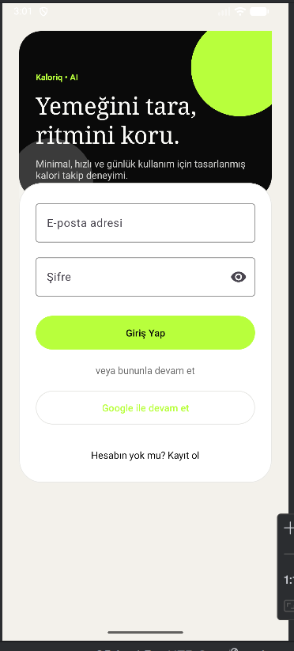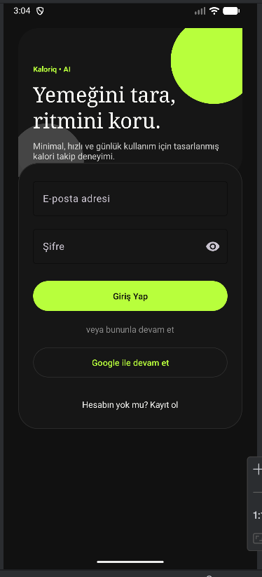
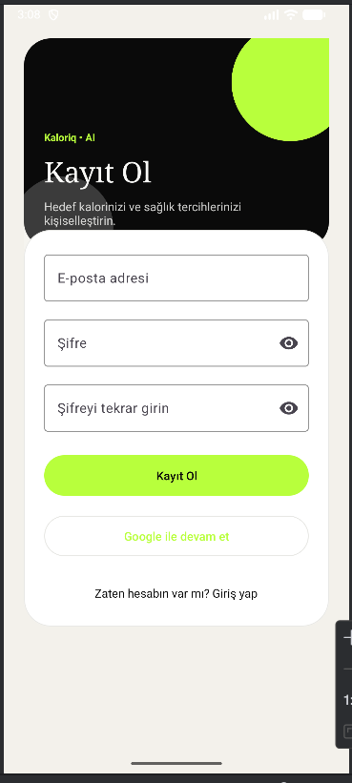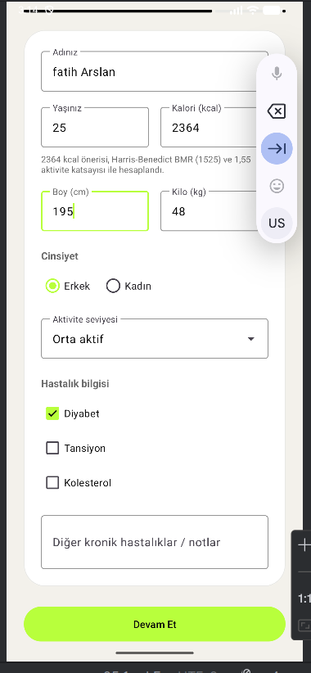
Figure 1 – Login Screen and Registration Screen

6.2 Dashboard
The Dashboard screen serves as the main interface of the application and provides users with a real-time summary of their daily health and nutrition data. Users can monitor their daily calorie goal, consumed calories, and remaining calorie balance through visual indicators and progress components. Additional health-related information such as water intake, step count, and exercise calories can also be displayed on the dashboard.
The screen includes an AI-supported health insight section that provides personalized recommendations based on the user’s eating habits and profile information. Users can quickly access meal logging features, scan meals using the camera-based AI recognition system, and review recently added meals. The dashboard is designed to give users a clear and organized overview of their daily nutrition progress and encourage healthier lifestyle decisions.
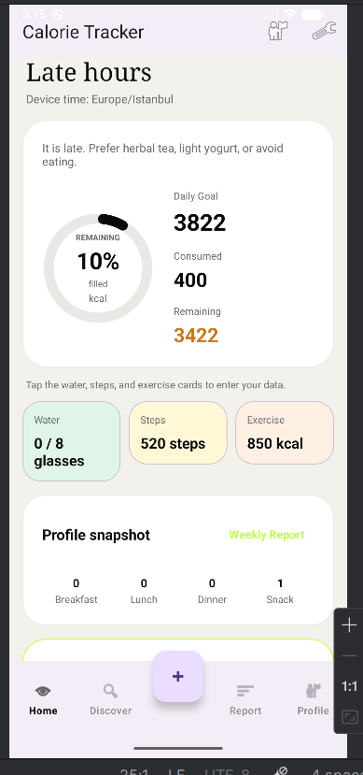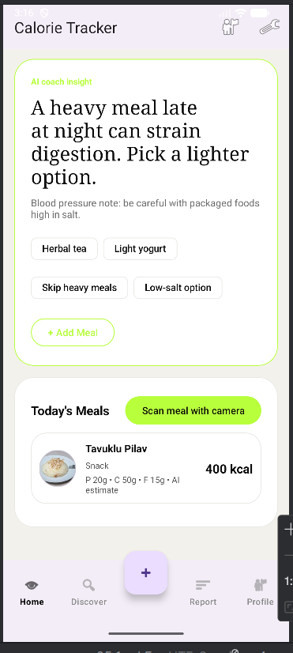
Figure 2 –Dashboard Screen

6.3 Add Meal & Food Search
The Add Meal screen enables users to record their daily food consumption by selecting a meal category, entering portion size, and choosing foods from the predefined catalog. Calorie values are automatically calculated according to the entered quantity in grams. Users can search foods dynamically through the integrated food search system, which supports both Turkish and English food names.
The screen also includes an AI-supported food recognition feature powered by Google Gemini AI. Users can take a photo or select an image from the gallery, and the system analyzes the food image to estimate the detected meal and its approximate calorie value. The generated result can be reviewed and edited before saving. This feature improves usability by reducing manual food entry and providing a faster meal logging experience.
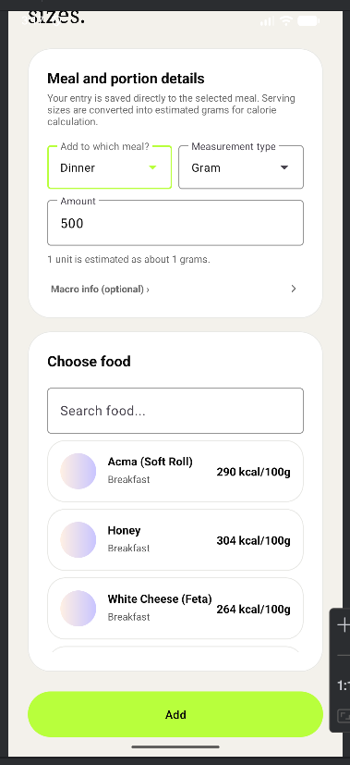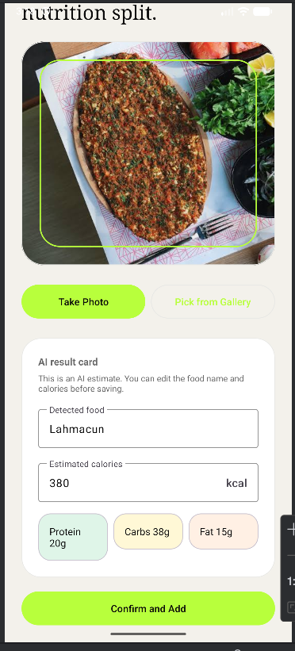
Figure 3 – Add Meal Screen

6.4 Weekly Report - Monthly report
The Weekly and Monthly Report screens provide users with a visual overview of their calorie consumption and diet progress over time. The Weekly Report section displays average calorie intake, diet adherence rate, diet streak information, and a calorie trend chart for the last seven days. Users can also view the most frequently consumed foods and a daily calorie status table.
The Monthly Report section presents long-term diet tracking using a calendar-based interface. Each day is color-coded according to the user’s calorie status, such as under goal, close to goal, or limit exceeded. This allows users to quickly analyze their eating habits and identify patterns in their nutrition behavior. The report system improves user awareness and supports healthier dietary decisions through visual feedback and statistical summaries.
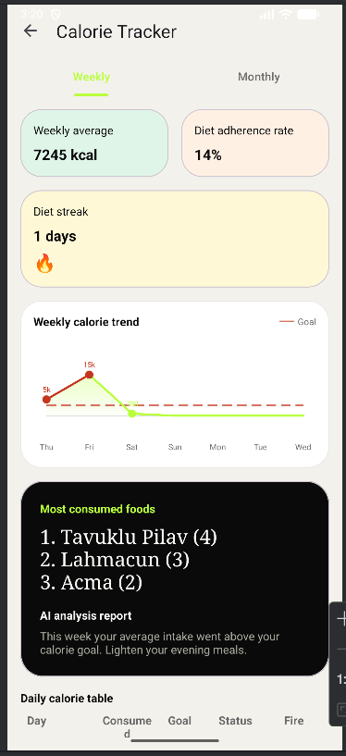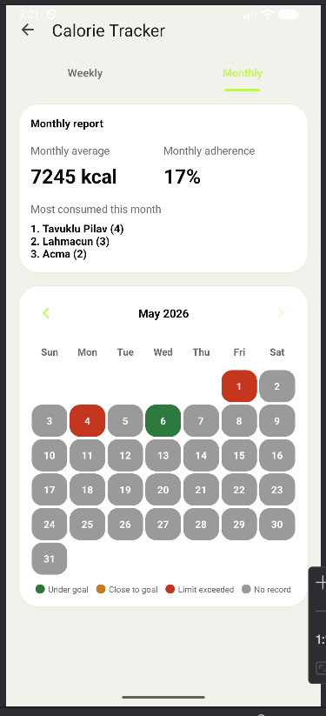
Figure 4 – Weekly Report Screen

6.5 Settings
The Settings screen provides personalization and account management features such as language selection, theme preferences, notification settings, password change, and logout functionality.
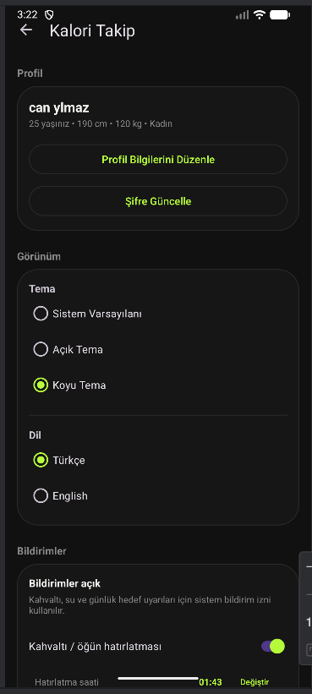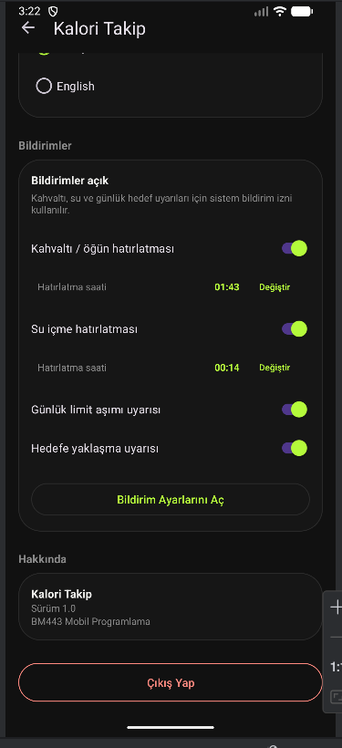
Figure 5 – Settings Screen

6.6 Icon

Figure 6 – Application Icon

7. Security Considerations
- All network communication is over HTTPS (Firebase SDK enforced).
- Firestore Security Rules prevent users from reading or modifying other users' data.
- Password change requires re-authentication with the current password via Firebase Auth, preventing unauthorized changes from an unattended unlocked device.
- The foods collection allows any authenticated user to read and write, enabling the seed operation on first launch without exposing it to unauthenticated requests.
- Google Sign-In tokens are managed entirely by the Google Sign-In SDK; no credentials are stored locally.
- The google-services.json file is excluded from version control via .gitignore.

8. Known Limitations
- No offline mode — meal entries cannot be written when there is no internet connection.
- Room ORM (AppDatabase) is present in the codebase but unused at runtime; it exists as a historical artifact from an earlier offline-first design.
- Gemini AI food recognition depends on network availability and Gemini API quota.
- The daily calorie goal is recalculated only when the profile is saved; weight changes throughout the day are not reflected until a manual update.
- The application targets API 33+; older Android versions are not supported.

9. Conclusion and Future Improvements
The Caloriq application successfully achieved its primary goal of helping users monitor their daily calorie intake, manage eating habits, and increase health awareness through a modern Android mobile application [1, 2]. Throughout the development process, various Android development concepts and technologies were applied, including Firebase Authentication, Cloud Firestore, WorkManager, Material Design 3 components, and Google Gemini AI integration [3, 4, 5, 6].
The application provides users with a practical and user-friendly experience by combining calorie tracking, meal management, AI-supported food recognition, disease-based dietary warnings, and personalized notifications in a single platform [7, 8]. Support for multiple languages, dark/light themes, and customizable reminder settings also improved usability and accessibility for different user preferences.
One of the most challenging parts of the project was integrating cloud-based services such as Firebase and Gemini AI while maintaining a responsive and stable user experience [3, 4]. Managing notification scheduling with WorkManager and designing a scalable Firestore structure were also important technical challenges during development [5]. These challenges provided valuable experience in Android architecture, cloud integration, and mobile application design.
From an academic perspective, the project demonstrates the practical usage of:
- Android SDK and Material 3 UI components [6]
- Firebase Authentication and Firestore [3, 4]
- Repository-based application architecture
- Background task management using WorkManager [5]
- Localization and dynamic theme support
- AI-assisted image recognition technologies [7, 8, 9]
Although the application is functional and stable, several improvements can be implemented in future versions. Planned future enhancements include:
- Full offline mode support using Room Database synchronization [3]
- More advanced AI food recognition with nutritional estimation [7, 8]
- Barcode scanning support for packaged foods
- Detailed monthly and yearly analytics
- Social features such as sharing progress with friends
- Wearable device integration (smartwatch support)
- Personalized diet recommendations generated by AI [8, 9]
Overall, the project provided significant practical experience in modern Android application development and demonstrated how mobile technologies and artificial intelligence can be combined to support healthier lifestyle habits [1, 2].

Appendix A – AndroidManifest.xml
<?xml version="1.0" encoding="utf-8"?>
<manifest xmlns:android="http://schemas.android.com/apk/res/android"
xmlns:tools="http://schemas.android.com/tools">
<!-- Permissions -->
<uses-permission android:name="android.permission.INTERNET" />
<uses-permission android:name="android.permission.CAMERA" />
<uses-permission android:name="android.permission.POST_NOTIFICATIONS" />
<uses-permission android:name="android.permission.RECEIVE_BOOT_COMPLETED" />
<uses-permission android:name="android.permission.SCHEDULE_EXACT_ALARM"
android:maxSdkVersion="32" />
<application
android:name=".CaloriqApplication"
android:allowBackup="true"
android:icon="@mipmap/ic_launcher"
android:label="@string/app_name"
android:supportsRtl="true"
android:theme="@style/Theme.CalorieTrackingApp"
tools:targetApi="31">
<!-- Activities -->
<activity android:name=".activities.SplashActivity"
android:exported="true">
<intent-filter>
<action android:name="android.intent.action.MAIN" />
<category android:name="android.intent.category.LAUNCHER" />
</intent-filter>
</activity>
<activity android:name=".activities.LoginActivity" />
<activity android:name=".activities.RegisterActivity" />
<activity android:name=".activities.ProfileSetupActivity" />
<activity android:name=".activities.MainActivity" />
<activity android:name=".activities.AddMealActivity" />
<activity android:name=".activities.FoodSearchActivity" />
<activity android:name=".activities.CameraActivity" />
<activity android:name=".activities.WeeklyReportActivity" />
<activity android:name=".activities.ProfileActivity" />
<activity android:name=".activities.ProfileEditActivity" />
<activity android:name=".activities.SettingsActivity" />
<!-- BootReceiver -->
<receiver android:name=".receivers.BootReceiver"
android:exported="true">
<intent-filter>
<action android:name="android.intent.action.BOOT_COMPLETED" />
</intent-filter>
</receiver>
<!-- WorkManager Provider -->
<provider
android:name="androidx.startup.InitializationProvider"
android:authorities="${applicationId}.androidx-startup"
android:exported="false"
tools:node="merge" />
</application>
</manifest>

Appendix B – app/build.gradle.kts (key sections)
android {
namespace = "tr.edu.duzce.mf.bm.calorietrackingapp"
compileSdk = 36
defaultConfig {
applicationId = "tr.edu.duzce.mf.bm.calorietrackingapp"
minSdk = 33
targetSdk = 36
versionCode = 1
versionName = "1.0"
}
compileOptions {
sourceCompatibility = JavaVersion.VERSION_17
targetCompatibility = JavaVersion.VERSION_17
}
}
dependencies {
// Firebase
implementation(platform("com.google.firebase:firebase-bom:33.13.0"))
implementation("com.google.firebase:firebase-auth")
implementation("com.google.firebase:firebase-firestore")
// Google Sign-In
implementation("com.google.android.gms:play-services-auth:21.3.0")
// Room (legacy local cache)
implementation("androidx.room:room-runtime:2.7.1")
annotationProcessor("androidx.room:room-compiler:2.7.1")
// WorkManager
implementation("androidx.work:work-runtime:2.10.1")
// Gemini AI
implementation("com.google.ai.client.generativeai:generativeai:0.9.0")
// Material Components 3
implementation("com.google.android.material:material:1.12.0")
// MPAndroidChart
implementation("com.github.PhilJay:MPAndroidChart:v3.1.0")
// Glide
implementation("com.github.bumptech.glide:glide:4.16.0")
// Core + AppCompat
implementation("androidx.core:core:1.16.0")
implementation("androidx.appcompat:appcompat:1.7.0")
implementation("androidx.constraintlayout:constraintlayout:2.2.1")
}

Appendix C – Food Catalog (FoodCatalog.java) – Selected Entries
The complete catalog contains 103 foods. A representative sample is listed below showing the warning flag pattern.

Table 13. Sample Food Catalog Entries
ID | Turkish Name | English Name | Cal/100g | Category | Warnings
9 | Bal | Honey | 304 | BREAKFAST | Sugar
11 | Tereyagi | Butter | 717 | BREAKFAST | Fat
61 | Sucuk | Turkish Sausage | 450 | BREAKFAST | Salt, Fat
18 | Doner (tavuk) | Chicken Doner | 215 | LUNCH | Salt
44 | Cips (patates) | Potato Chips | 536 | SNACK | Salt, Fat
45 | Cikolata (sutlu) | Milk Chocolate | 535 | SNACK | Sugar, Fat
50 | Baklava | Baklava | 428 | SNACK | Sugar, Fat
58 | Findik | Hazelnut | 628 | SNACK | —
59 | Ceviz | Walnut | 654 | SNACK | —
22 | Pilav (beyaz pirinc) | White Rice | 130 | LUNCH | —
26 | Tavuk Gogsu (izgara) | Grilled Chicken Breast | 165 | LUNCH | —
35 | Izgara Balik | Grilled Fish | 150 | DINNER | —
46 | Elma | Apple | 52 | SNACK | Sugar
28 | Salata (karisik) | Mixed Salad | 20 | LUNCH | —

References
[1] Direito, A., Carraça, E., Rawstorn, J., Whittaker, R., & Maddison, R. (2017). mHealth Technologies to Influence Physical Activity and Sedentary Behaviors: Behavior Change Techniques, Systematic Review and Meta-Analysis of Randomized Controlled Trials. Annals of Behavioral Medicine, 51(2), 226–239. https://doi.org/10.1007/s12160-016-9846-5
[2] Iribarren, S. J., Akande, T. O., Kamp, K. J., Barry, D., Kader, Y. G., & Suelzer, E. (2021). Effectiveness of Mobile Apps to Promote Health and Manage Disease: Systematic Review and Meta-analysis of Randomized Controlled Trials. JMIR mHealth and uHealth, 9(1), e21563. https://doi.org/10.2196/21563
[3] Google. (2024). Firebase Authentication – Android. Google Firebase Documentation. https://firebase.google.com/docs/auth/android/start
[4] Google. (2024). Get started with Cloud Firestore. Google Firebase Documentation. https://firebase.google.com/docs/firestore/quickstart
[5] Google. (2025). Schedule tasks with WorkManager. Android Developers Documentation. https://developer.android.com/develop/background-work/background-tasks/persistent
[6] Google. (2023). Material Design 3 – Components. Material Design. https://m3.material.io/components
[7] Anam, R. K. (2025). Evaluating Gemini LLM in Food Image-Based Recipe and Nutrition Description with EfficientNet-B4 Visual Backbone. arXiv preprint arXiv:2511.08215. https://arxiv.org/abs/2511.08215
[8] Amugongo, L. M., Kriebitz, A., Boch, A., & Lütge, C. (2023). Mobile Computer Vision-Based Applications for Food Recognition and Volume and Calorific Estimation: A Systematic Review. Healthcare, 11(1), 59. https://doi.org/10.3390/healthcare11010059
[9] Sun, J., Radecka, K., & Zilic, Z. (2019). FoodTracker: A Real-time Food Detection Mobile Application by Deep Convolutional Neural Networks. arXiv preprint arXiv:1909.05994. https://arxiv.org/abs/1909.05994

