**COMPUTER GRAPHICS**

**HW2**

*UĞURCAN ÇIRAK 190315051*

*EMİNE AYDIN 190315053*

***22 MARCH 2023***



We used and applied the basics of Webgl programming in our homework. By working on modeling simple geometric objects, we did what was asked of us.

**Source Code:**

There are also necessary explanations on the codes. First, we defined the desired parameters. We wrote the function of the output that we will obtain using the defined parameters.

**metin içeren bir resim

Açıklama otomatik olarak oluşturuldu**

**Javascript Code**

Here are the libraries we used in the lesson. We just added indexBuffer and sent it to GPU. IndexBuffer is a function that allows you to plot the indexes of the triangle.

**metin içeren bir resim

Açıklama otomatik olarak oluşturuldu**

**Javascript Code**

**metin içeren bir resim

Açıklama otomatik olarak oluşturuldu**

**HTML CODE**

**Output:**

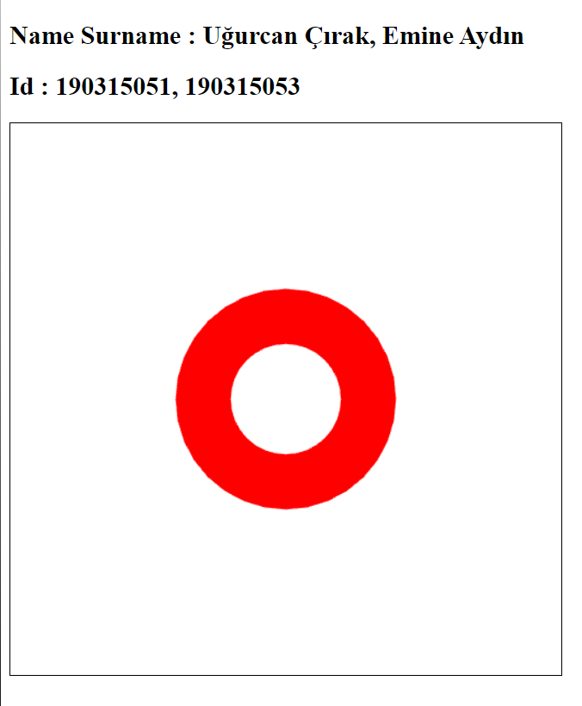

**TRIANGLE_FAN**

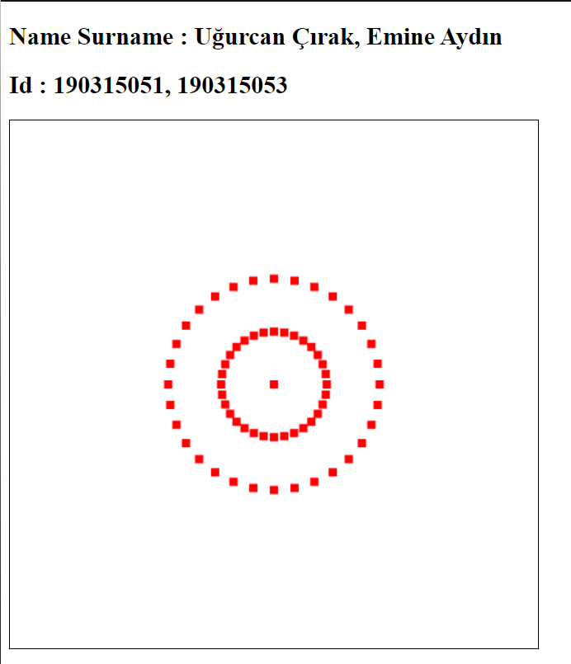

**POINTS**

**çizelge içeren bir resim

Açıklama otomatik olarak oluşturuldu**

**LINE_STRIP**

We learned to define PointSize for point representation. We learned how to draw donuts in Webgl. We learned how to upload new data to GPU. The difficulties we faced, we could not get the shape when we took the points of the triangle as 2. After typing 3 instead of 2, we got the desired output. We had a hard time defining the function of the desired output, and we did research on internet resources and watched videos. As a result of our efforts, we achieved everything that was asked of us.