SOFTWARE REQUIREMENT SPECIFICATIONS

Project Topic: QUIZIFY

Submitted by: UGYEN LHAMO (12190102)

Introduction

1. Purpose
- To make useful and entertaining mobile application for user
- For educational purpose and to test their level of IQ

2. Scope
a. System scope
Participant can get into my app besides any login information and they are given option to select which area they prefer to do quiz. When user click that particular option they are given to select stage they favor to take a look at in accordance to their IQ. Finally their rating will be display at the end and additionally they are given chance to reattempt the quiz or if they don’t prefer to do it they simply have to click on quit button.

b. User scope
My project aims the students and staff of Gyalpozhing College of Information Technology.

Requirements
1. Functional requirements
- This app will have six option to select which area the participant want to do quiz.
- While done selecting the option, they will be directed to the level option where they can choose level of quiz like easy, medium and hard.
- Each question carries two points and after done with answering the question, participants will be able to view their score.
- Additionally they are given chance to reattempt the quiz or if they don’t prefer to do it they simply have to click on quit button.

2. Non-Functional requirements
- Usability
In my app, the participant need not have to login register and they will be given option field at where they are good. If they are not satisfied with the score then they are given chance to re-attempt the quiz.

- Responsiveness
Android devices come in all shapes and sizes, so my app's layout will be flexible. That is, my app’s layout will be gracefully respond to different screen sizes and orientations. By supporting as many screens as possible, my app can be made available to the greatest number of users with different devices. Additionally, it is interactive application and also it will response to user without much time.
3. Software requirements
- Operating System: Windows 10/8 (64-bit) or ubuntu 20
- Android SDK: Android SDK version 16
- Android Studio: Version 3.0 and above
- Java Version: JDK 8 (Java Standard Edition Development Kit)
- Database: SQLite version 3 with DB Browser

Hardware Requirements
1. Developer requirements
1. Processor : Core i3 and above
2. Disk space : 3GB minimum(8GB recommended)
3. RAM : 4GB and above
2. User requirements
1. Android phone

System Design
- ERD

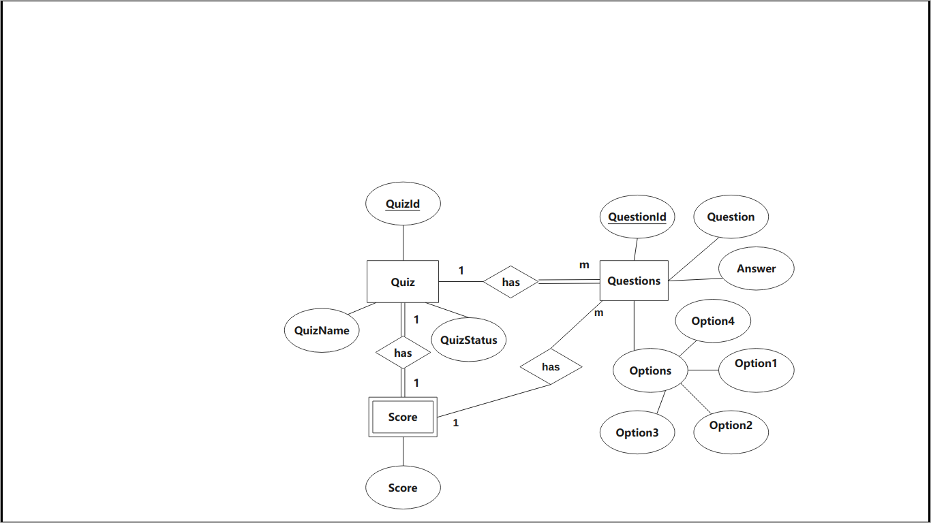

- Relational Schema

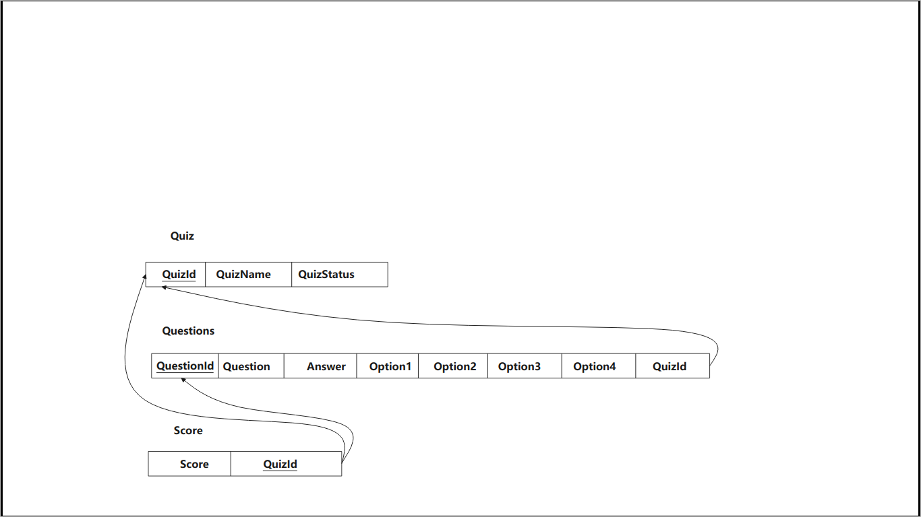

- Sequence diagram
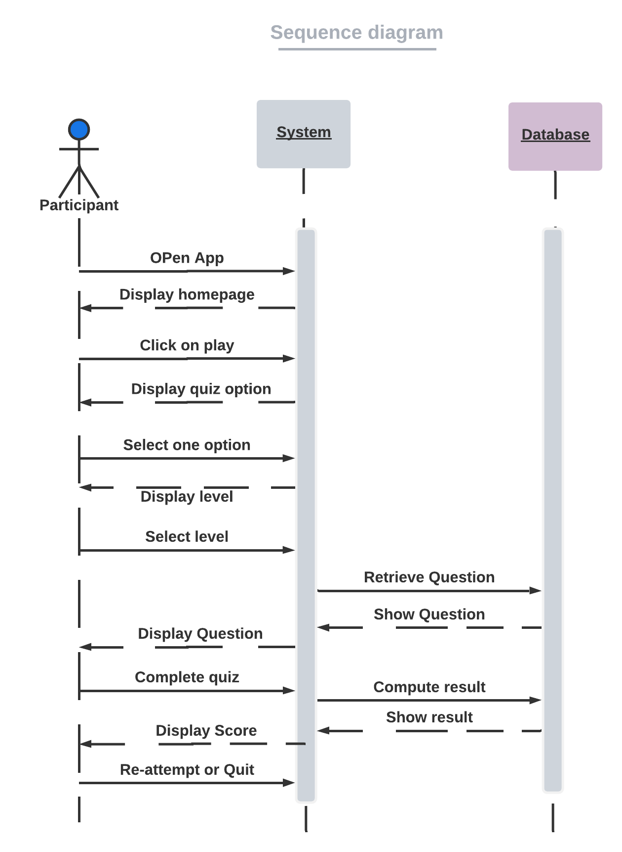

- Use Case Diagram

