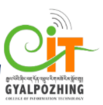

Proposal
For
Second Year Project
Bachelor of Science in Information Technology
Gyalpozhing College of Information Technology

GCIT Credit Book: Online credit book app

Submitted by
Group 6 members:
Choki Wangmo(12190044)
Samten Wangmo(12190073)
Tshering Gyeltshen(12190095)
Ugyen Tashi(12190103)

Read carefully before filling the form.

- Please do not alter the layout of the application form. Information must be filled in the spaces provided, under set format.
- Guidance notes in various fields should not be deleted.
- Required information should be duly filled in the specified fields.
- Required heads/fields which are not relevant to the project should be marked N/A (Not Applicable) or left blank and should not be deleted.
Guidelines and Forms

Submission Procedure
Duly filled proposal forms completed in all respects should be submitted in form of soft copy and a hard copy to project guide and project coordinator. On receipt of the applications the proposals will be evaluated by reviewer panel and proposal would then be defended by student groups. The project group may need to revise the proposal in light of the evaluator’s recommendations.

For further information, please contact:

Project Coordinator

Jigme Wangmo
jigmewangmo.gcit@rub.edu.bt

Tshering Lhamo
tsheringlhamo.gcit@rub.edu.bt
Table of Contents
Description Page #

1. Project Identification 1
2. Scope, Introduction and Background of the Project 3
3. Aim and Objectives of the Project 5
4. Methodology 6
5. Benefits of the Project (Expected output/outcomes): 10
6. Risk Analysis/Feasibility 10
7. Project Approval Certificate 11
8. Reviewers Panel Comments 13
10. Project Schedule / Milestone Chart /Work plan 14
13. Report Writing Guidelines 15
Bibliography 16

Note: To update the table of contents, right click in the table and select ‘update field’ and then select ‘Update Entire Table’.
Application for Final Year Project

1. Project Identification
- Reference Number:
(for office use only)
- Project Title:
GCIT Credit Book
- Project Internal Guide:
Name: | Tashi Phuntsho
Designation: | Lecturer
Organization: | Gyalpozhing College of Information Technology
Mobile # : | 17970464 | Tel. # :
Email: | tphuntsho.gcit@rub.edu.bt
C1. Project External Guide:
Name: | NA
Designation:
Organization:
Mobile # : |  | Tel. # :
Email:
C2. Student Group Lead:
Name: | Samten Wangmo
Roll No: | 12190073
Department: | Bachelor of Science in Information Technology
Mobile # : | 17328734 | Tel. # :
Email: | 12190073.gcit@rub.edu.bt

- Organizations Involved in the Project:
(Please identify all affiliated organizations collaborating in the project, and describe their role/contribution to the project.)
D1. Industrial Organizations:
# | Organization Name |  | Role / Contribution
 | NA
D2. Academic Organizations:
# | Organization Name | Role / Contribution
D3. Funding Organizations:
# | Organization Name |  | Role / Contribution
 | NA
- Key Words:
(Please provide a maximum of 5 key words that describe the project. The key words will be incorporated in our database.)
Registration, Credit account, Admin, Customer and App.
- Research and Development Theme:
To create an app that serves as a platform where the admin (canteen owner) can use the digitalized credit book instead of traditional booklet to maintain the list of customer having credit in their canteen and the user (customers) can view any changes made by the admin in their credit account through this app.
- Project Status:
(Please mark ☑)
☑ New  Modification to previous Project
❑ Extension of existing project

- Project Duration:
Expected Starting Date:
Planned Duration in months:

2. Scope, Introduction and Background of the Project
- Scope of the Project:
Limited to GCIT canteen (Gyalpozhing College of Information Technology).
The purpose of our project is to ease in maintaining the credit account for both admin and user and to build transparency in between them.

The proposed system consists of the following features:

Registration: admin has to register.

Login: Only with the valid credential users can log in to the system.

Add: Allow the admin to add customer.

Add amount: admin will add the credited amount.

Total amount: Both admin and user can view the total amount.

Clear credit: Admin can clear the amount credited when user does the payment.

Update: Allow the admin to update individual’s users credit account.

Save: After updating each account, admin can save their changes.

Delete account: admin can delete user account.

B Introduction (Project Background and Literature Review, Current State of the Art):

(Detailed summary of what all has been done internationally in the proposed area quoting references and bibliography. Please note that this section demonstrates the depth of knowledge of the project team and builds the confidence of the evaluators about capability of the team in achieving the stated objectives.)
(Please describe the current state of the art specific to this research topic.)

Project Background

In this era of the world where technology is taking its toll in modernization, digitization and automation in any field of work is nothing new for us to see. What required excessive traveling and expenditure then now people do things with the tip of their fingers sitting on a couch from their home; all made possible by advancement of technology and introduction of smart phones. Talking about easing of work-load in this digital world, the process of maintaining credit account in canteen is a straining process to mention a few. Almost every student as well as teaching and non-teaching staffs have their credit account in the college canteen. Canteen is one of the important parts of infrastructural facility provided by the college management in the campus. It is a store that sells food and drinks at a reasonable cost with variety of nutritious and attractive presentation.

Customer is the king because he keeps every business afloat. Whether an organization offers a services or product, it cannot remain in business if it cannot find a group of people willing to become its customers. So highlighting the above point our group came up with the project proposal of providing platform where customers can keep track of their credit account and view all the updates through online GCIT credit book app.

The person taking charge of the college canteen who gives credit to their customers out of good will manages all the credit details in a notebook written manually. It becomes difficult to manage all the accounts especially when there is a lot of customers coming at a time. It might also lead to the possibilities of making mistakes in calculating and writing the amount in the book. Most of customers gets indiscipline with slow services. So to overcome those challenges, the process of viewing your credits in the canteen could be digitized and made easy for mutual benefit of both customers and the canteen owner, instead of flipping the pages to find your account page number and then writing the amount you ate, date and even signatures.

GCIT credit book therefore addresses aforementioned problems and aims to aid both customers and canteen contractor to not only by saving time but also by reducing their strain and providing transparency between them. Our main motive is to digitize the traditional approach of maintaining credit account book in college canteen.

GCIT credit book is app-base system managing the credit account book in college canteen. It will offer the user (customers) to check/view the total amount and the amount made in the particular date without time consuming and making it more effective, convenient and easy to manage and use.

Literature Review:

By definition, credit is a contractual agreement between a lender and a borrower in which the borrower assumes something of value and agrees to repay to lender on the future date. In simple, the ability of a customer to obtain goods or services before payment based on the trust that payment will be made in the future defines credit. Not all the people have money every time they visit canteen so they land up making account in the canteen credit book with the agreement that they will pay in the future. Though the world is taking its toll in modernization, digitization and automation in any field of work with advanced technology, we can still see that most of the stores or shops are maintaining their customers credit account in a booklet form. So to digitalize this old traditional way, GCIT credit book is an app where it provides platform for both customers and owner to keep track of credit account and view all the updates through online GCIT credit book app.

As per the reviewed literature, Khata Book (Ledger Account Book) replaces your traditional ledger book by new digital ledger cash. It is 100% free, safe and secure for all types of business to maintain their customers account. It is tally for mobile. Shop owner can use this app to record credit and debit transactions for their trusted customers and can accept digital payment via QR at store or online by sharing payment links with customers. The difference between the reviewed literature and this project is that it deals with only the amount credited and there is no option for payment or transaction purpose. It is only to digitalize the traditional credit account book an view it through app.

The reasons for opting online GCIT credit book app are to overcome those challenges mentioned below:

Time saving- finding each person’s account page and then writing the date, amount manually for the canteen owner and for customers, visiting the canteen personally just to the check the amount or balance can be tedious and time consuming. To overcome this, this app will serve as the platform for the mutual benefit.

Backup and recovery: Paper based credit book fails to maintain backup in case of damages or misfortunes like a fire disaster could set the store back in terms of records in the account book.

Convenient spot – There is no central repository where the customers and the canteen owner can be connected and be in sync. It is a platform whereby both customer and owner can indulge in effective means of updating and viewing their credit account rather than going through all the list in the book and calculating the amount.

Current State of the Art: There is no such appropriate platform in maintaining the credit book in a digitalized way for different stores in Bhutan. GCIT canteen maintains a credit account in a booklet form. Almost every student as well as teaching and non-teaching staffs have their credit account in the college canteen.
The person taking charge of the college canteen manages all the credit details in a notebook written manually. It becomes difficult to manage all the accounts especially when there is a lot of customers coming at a time. It becomes tedious to find individual customers account page number and then writing the amount you ate, date and even signatures. There is also a possibility of making mistakes in calculating and writing the amount in the book and sometimes, the canteen workers also end up making mistakes such as forgetting to mention an individual’s credit for a day, mentioning another person’s credit in someone else account. Maintaining the account in the booklet format leads to the wastage of paper and tough job for the canteen workers to maintain the credit book for a whole year in good state. So to overcome those challenges after all these observations and experiences, it leads to the idea in creating this app where the process of viewing your credits in the canteen could be digitized and made easy for mutual benefit of both customers and the canteen workers.

.

- Challenges:
Meeting the time schedule: Completing the project within the given time period.
Device compatibility: Challenges of ensuring that app works on the android smartphone.
Security issues: Keeping in mind about developing the app which is trustworthy and secure.
- Motivation and Need:
GCIT canteen maintains the credit of students and staffs in booklet format. This leads to the wastage of paper and tough job for the canteen workers to maintain the credit book for a whole year in good state. On top of that, staffs and students lost track of their expenditure ending up with a large amount of due to pay at the end. Sometimes, the canteen workers also end up making mistakes such as forgetting to mention an individual’s credit for a day, mentioning another person’s credit in someone else and mistake in calculation. All these observations and experiences leads to the idea to create this app.

3. Aim and Objectives of the Project
(Please write the actual aim of your project. Also, describe the measurable objectives of the project and define the expected results. Use results-oriented wording with verbs such as ‘to develop..’, ‘to implement..’, ‘to research..’, ‘to determine..‘, ‘to identify..’ The objectives should not be statements and should not include explanations and benefits. The objective should actually specify in simple words what the project team intends to achieve (something concrete and measurable/ deliverable). Fill only those objectives that are applicable to the proposed project.)
AIMS: To develop an application for GCIT students and staffs to automate the working of credit book.

OBJECTIVES :

The specific objective of this project are:

- To build android application that will be used by almost all student, staff and canteen owner of Gyalpozhing College of Information Technology.

- To build transparency between a shopkeeper and customer.

- To replace old manual way of maintaining the account book.

- Exclude the use of paper entries.

5. Safe time and reduce human interventions.

4. Methodology

- Development / Research / Test Methodology:
(Please describe the technical details and justification of your development and research plan and test plan and testing strategies. Identify specialized equipment, facilities and infrastructure which are required for the project and their utilization plan. The block diagrams, system flow charts, high level algorithm details etc. have to be provided in this section. Also, describe the overall methodology to be used for the particular research topic)

- Project Team:
Title / Position | Number
Project Internal Guide
Project External Guide
Student Team Members
Others (please specify)
Add more rows if required

- Project Activities:
(Please list and describe the main project activities, including those associated with the transfer of the research results to customers/beneficiaries. The timing and duration of research activities are to be shown in the Gantt chart in Section 8.)

Installation of software and tools: Installing android studio latest version or bootstrap framework and database server.
Resource gathering: Gathering resources like research paper, book, video tutorials, and online research on app development.
Design phase: The system design shows the blueprint of any system that is to be developed. It gives the very detail about every components of the system that is to be built like designing user interface, functionalities, and flow of information.
Development of app: From this stage we will develop app using Bootstrap and android studio framework.

Testing: It will go under testing stage where each unit is check properly regarding functionality and it endure to produce desire function.

Documentation: After completing all phases we will document the project report and we will present it through presentation.

- Key Milestones and Deliverables:
(Please list and describe the principal milestones and associated deliverables of the project. A key milestone is reached when a significant phase in the project is concluded, e.g. selection and simulation of algorithms, completion of architectural design and design documents, commissioning of equipment, completion of test, etc.) The timing of milestones is also to be shown in the Gantt chart in Section 8.
No. | Elapsed time from start (in months) of the project | Milestone | Deliverables
 | - | Commencement of the project
(Please add more rows if required.)

5. Benefits of the Project (Expected output/outcomes):
Some of the Benefits are:
Inclusion: Through our app all student and staff can keep track of credit in a secure and digitalized way rather than in booklet involving paper work.

Accessibility: Provide a fast and efficient interface for easy access to the concern authority.

Flexibility: App will provide services at any point of time, and anywhere.

Satisfaction: Student and staff will achieved satisfaction as all credit made will be transparent and secure.

6. Risk Analysis/Feasibility
- Risks of the Project:
(Please describe the factors that may cause delays in, or prevent implementation of, the project as proposed above; estimate the degree of risk.)
(Please mark ☑ where applicable) Low Medium High
Technical risk ☑
Timing risk ☑
Budget risk []
A1. Comments(Describe the risk):
Timing risk: Developing the application within the given time frame would be a difficult task for us as
- Our project time period is less.
- Being this our first attempt in developing an android application completing as per schedule will be difficult.
- We will not be able to achieve our goal due to external college activities.
Technical risk: Risk associated with the software development. Some of the technical risk are as follows.
- Learning how to use software and other sophisticated hardware tools will be hard job as it is our first approach.
- It will be difficult for us to handle any crashes or malfunction in software as we are not use to it.
Budget Risk: We don’t have budget risk because we don’t have to buy any software or technology. Our project can be done using free software available on internet.

Feasibility Study: To check the feasibility of our project, we have done a survey questionnaire in GCIT. It contain questions as mentioned below:

- Student/Staff. (78 responses).

- How often do you visit canteen?

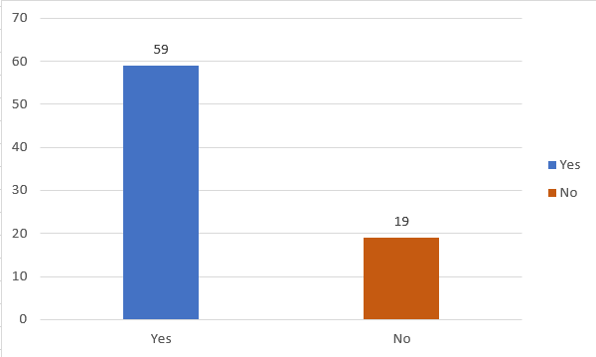

- Do you have credit account in the canteen?

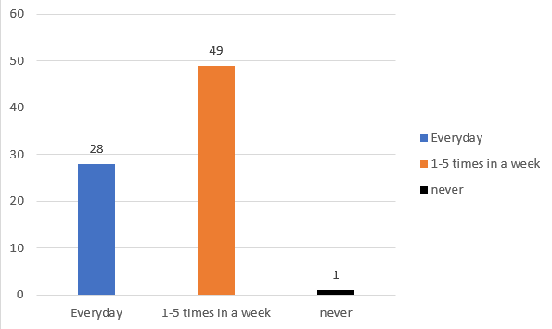

- Have you encountered some mistakes in checking the amount in your credit account in canteen?
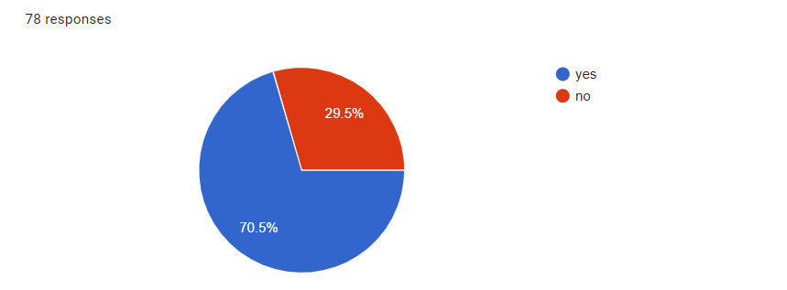

- Will you prefer digital credit book to keep track of your credit in the canteen?

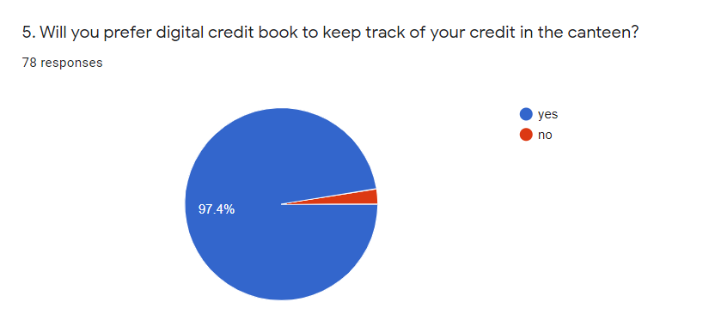

After the questionnaire had been collected and tabulated, the weighted mean result shows that it will be feasible to develop this application for the college canteen.

7. Project Approval Certificate
(Approval of Project Proposal by the Competent Authority (Department Chairman) and Project Review Team is mandatory before the start of project execution.)
Project Review Team:

Sl # Name Signature

(Please add more rows if required.)

Project Coordinator
Name:
Designation:
Email:
Date: Signature:

Competent Authority – Head of Department
Name:
Designation:
Email:
Date: Signature
& stamp:

8. Reviewers Panel Comments
10. Project Schedule / Milestone Chart /Work plan

(Project schedule using MS-Project (or similar tools) with all tasks, deliverables, milestones, clearly indicated are preferred. Task should be measured in terms of hours)

Figure 1.1: Timeline
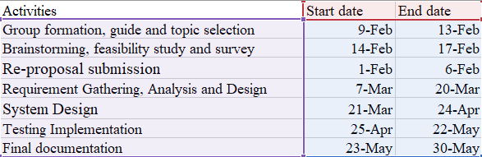

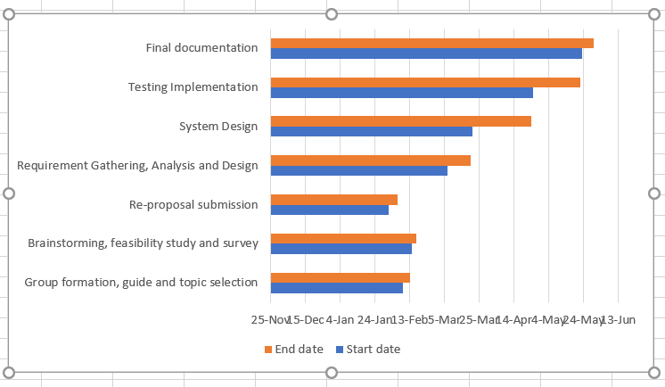

13. Report Writing Guidelines

(Project report will be written under the specified guidelines.)
Bibliography

