**Report**

**1. Name Columns Formatting**

* The columns [givenName] and [sn] currently contain a mix of upper- and lower-case letters.  
    
  A screenshot of a computer

  Description automatically generated
* **Action Required:** Confirm if the current case (upper/lower) should be retained, or if the names need to be standardized to a particular format (e.g., all uppercase, all lowercase, or capitalized first letters).

**2. Handling Personal Email Addresses**

* The Term_Time_University_Email__c field contains personal email IDs.  
    
  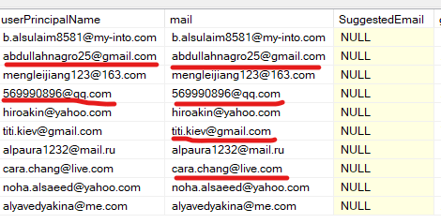
* **Concern:** Including personal email addresses in the extracted table is not ideal for privacy and standardization reasons.
* **Action Required:** Decide whether to:
  + Retain the personal email IDs as they are.
  + Replace them with newly formatted institutional email IDs as per the requirement.

**3. Display Name Formatting**

* The display name should either:  
  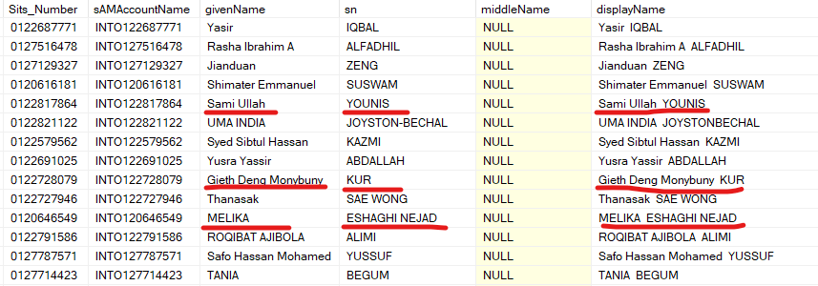
  + **Follow a Specific Format:** Ensure it adheres to a predefined format (e.g., [givenName] [sn], First Last, etc.).
  + **Remain Unchanged:** Keep the display name exactly as derived from [givenName] and [sn].

**4. Special Characters in Display Name**

* The [givenName] and [sn] fields may contain special characters such as hyphens (-) or periods (.).  
    
  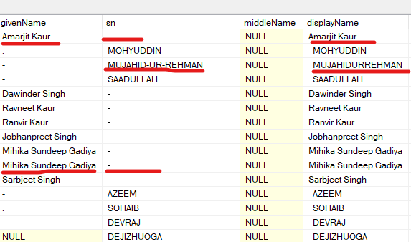
* **Action Required:** Confirm whether to:
  + Include these special characters in the display name as they appear.
  + Remove or replace these characters as per specific formatting guidelines.