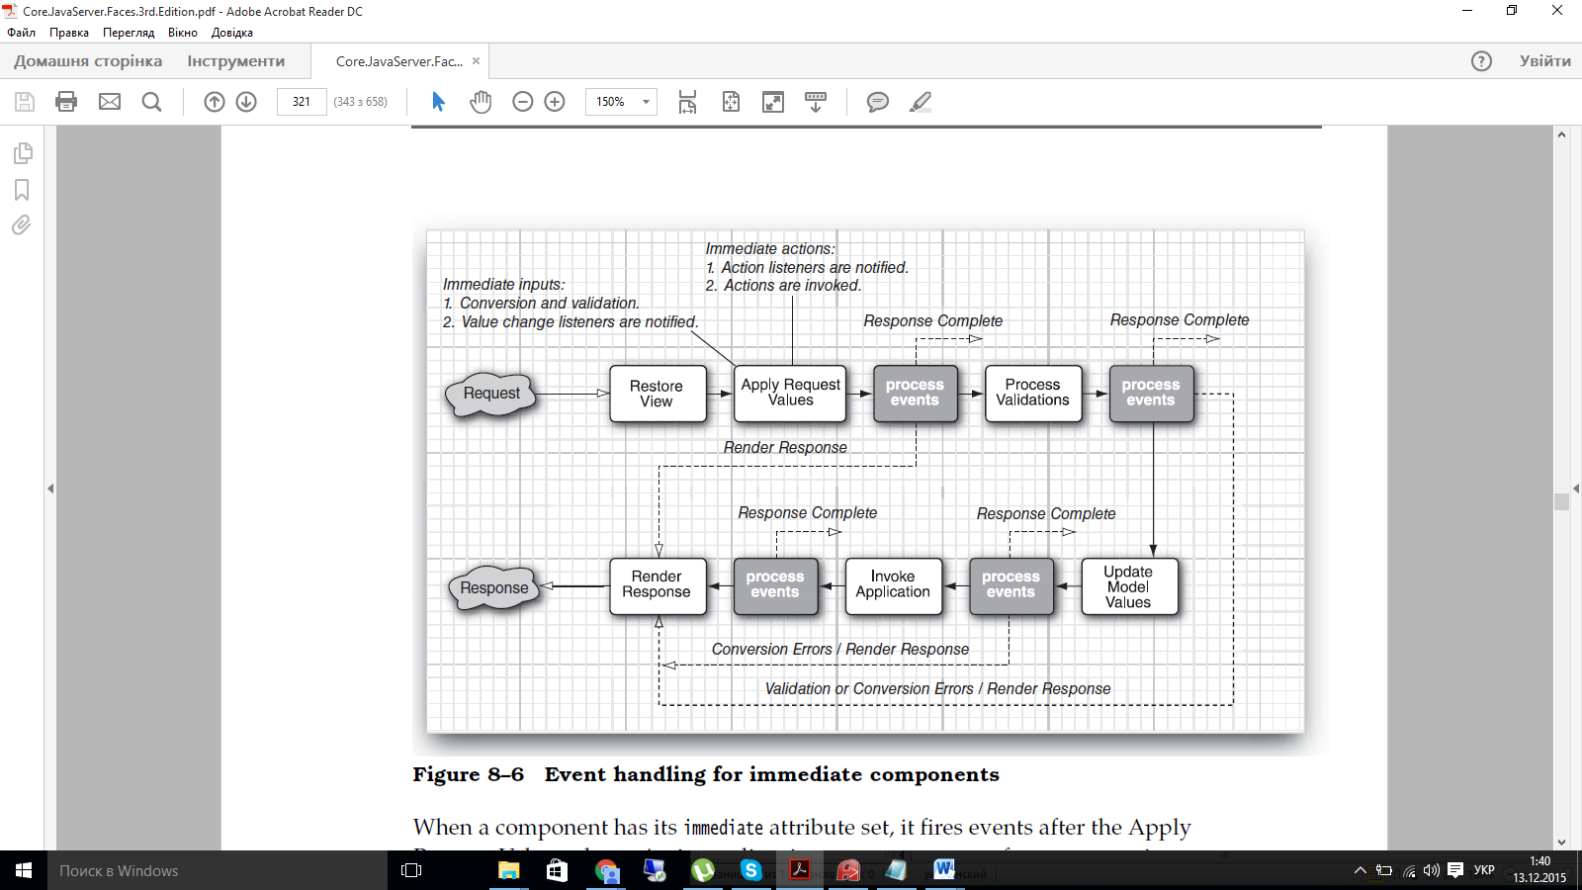

When a component has its immediate attribute set, it fires events after the Apply

Request Values phase. An immediate input component performs conversion

and validation earlier than usual, after completing the Apply Request Values

phase. Then it fires a value change event. An immediate command component

fires action listeners and actions earlier than usual, after the Apply Request

Values phase. That process kicks in the navigation handler and circumvents the

rest of the life cycle, moving directly to Render Response.