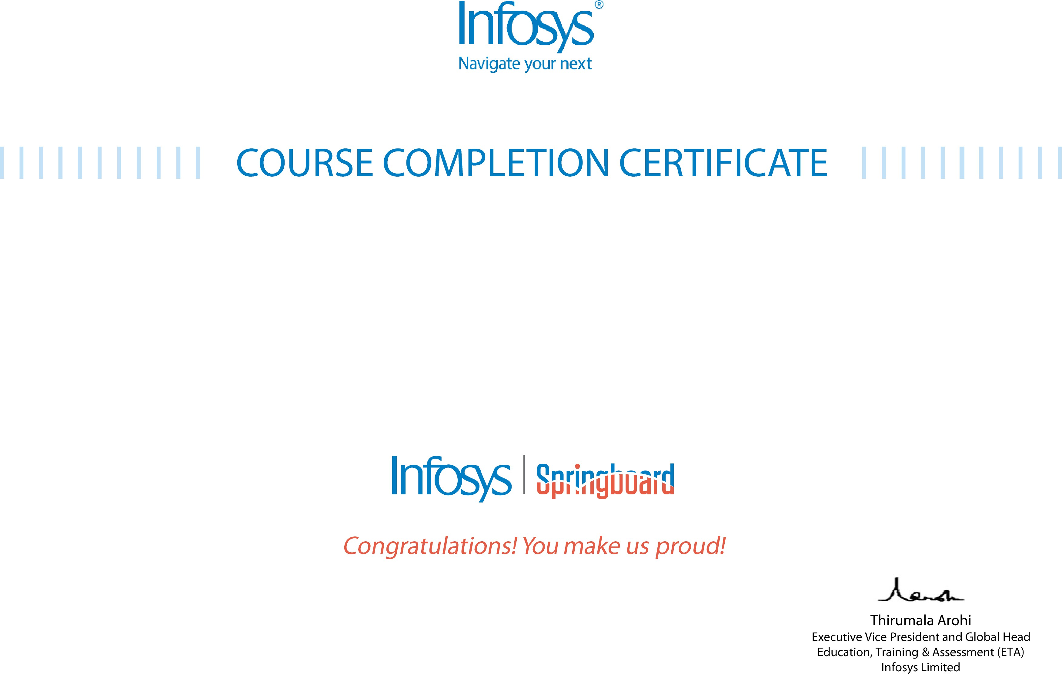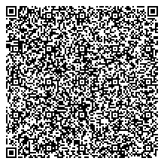

# The certificate is awarded to

Divyansh Rana

# for successfully completing the course

**Master Computer Vision™ OpenCV3 in Python and Machine Learning**

# on February 18, 2025

Issued on: Thursday, February 20, 2025

To verify, scan the QR code at [https://verify .onwingspan.com](https://verify.onwingspan.com/)