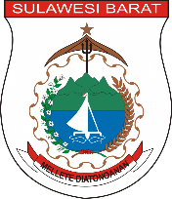**Data Pemberdayaan Masyarakat dan Desa**

|  |  |  |  |  |  |  |  |
| --- | --- | --- | --- | --- | --- | --- | --- |
| **Provinsi** | **Kabupaten** | **Kecamatan** | **Desa** | **Kelurahan** | **Nama Posyandu** | **Stara Posyandu** | **Keterangan** |
| sulawesi barat | Polewali Mandar | Campalagian | - | Pappang | bintang siaga | bima graputra | aktif |
|  |  |  |  |  |  |  |  |