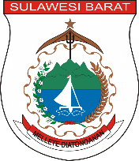**Data Pemberdayaan Masyarakat dan Desa**

|  |  |  |  |  |  |  |  |
| --- | --- | --- | --- | --- | --- | --- | --- |
| **Provinsi** | **Kabupaten** | **Kecamatan** | **Desa** | **Kelurahan** | **Nama Posyandu** | **Stara Posyandu** | **Keterangan** |
| ${provinsi} | ${kabupaten} | ${kecamatan} | ${desa} | ${kelurahan} | ${nm_posyandu} | ${stara_posyandu} | ${keterangan} |
|  |  |  |  |  |  |  |  |