Screenshots Open Sesame (test stimuli)

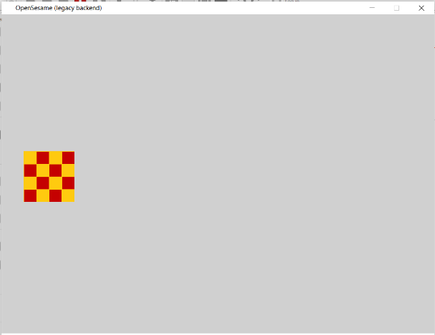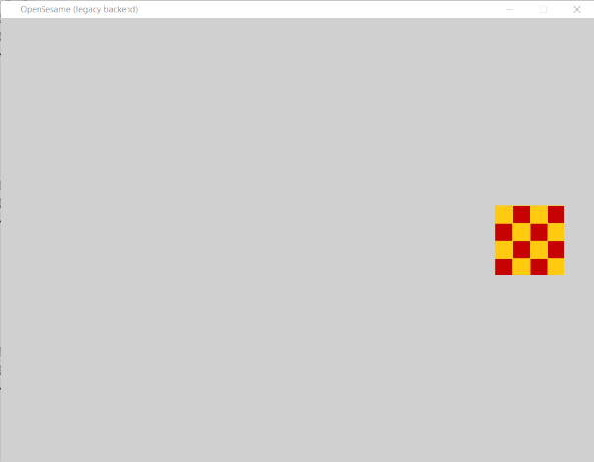Baseline

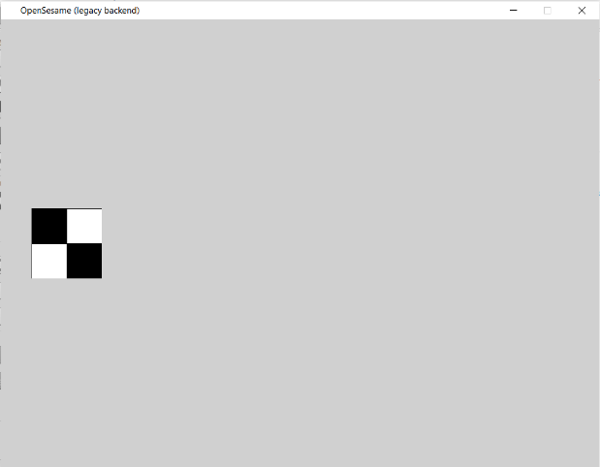Paired succession

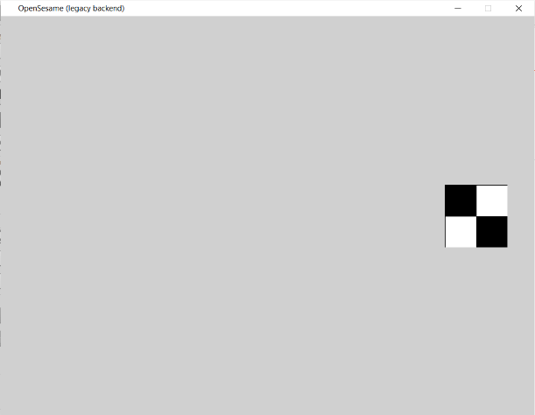

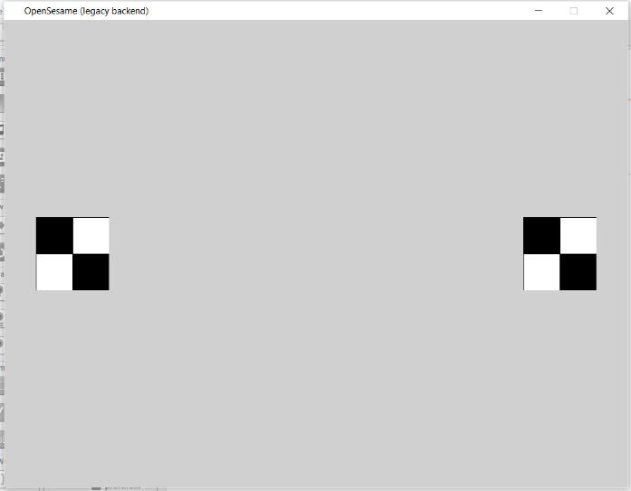Preferential looking

|  |  |  |  |  |  |  |  |  |
| --- | --- | --- | --- | --- | --- | --- | --- | --- |
| Version 1 | | | | | | | | |
| 1 | Information | “Binnen dit experiment zal er een video-opname van uw kind en de omgeving worden gemaakt ...”  “plaats een lampje achter uw computer, zodat het licht van voren komt.. etc”  “Ga zo zitten dat uw kind ongeveer tussen … en … cm van het scherm zal zitten” | | | | | | |
| 2 | Informed consent | “Ik ga akkoord met …”  “Ik ben me bewust van… en ik ga akkoord met …” | | | | | | |
| 3 | Bringing in the child | “u mag nu uw kind halen” | | | | | | |
| 4 | Start recording | Ouder start opname | | | | | | |
| 5 | Instruction | “Zorg ervoor dat het gezicht van uw kind in het midden van het scherm zichtbaar is”. (indien mogelijk met kader in midden) | | | | | | |
|  | | | | | | | | |
| 6 | Baseline | Stimulus baseline | | Right | | sound_1 | | 1950 ms |
| Stimulus baseline | | Left | | sound_1 | | 1950 ms |
| Stimulus baseline | | Right | | sound_2 | | 1950 ms |
| Stimulus baseline | | Left | | Sound_2 | | 1950 ms |
|  | | | | | | | | |
| 7 | Synchronization screen | White screen | | sound_3 | | | | 450 ms |
| 8 | Attention grabber | Stimulus attention grabber | | sound_4 | | Center | | 2450 ms |
|  | | | | | | | | |
| 9 | Paired succession | Stimulus simple | | Static | Right | Sound_5 | | 9950 ms |
| Stimulus simple | | Moving | Left | Sound_5 | | 9950 ms |
| Stimulus attention grabber | |  | Center | Sound_4 | | 2450 ms |
| Stimulus simple | | Moving | Right | Sound_5 | | 9950 ms |
| Stimulus simple | | Static | Left | Sound_5 | | 9950 ms |
| Stimulus attention grabber | |  | Center | Sound_4 | | 2450 ms |
| Stimulus complex | | Static | Left | Sound_5 | | 9950 ms |
| Stimulus complex | | Moving | Right | Sound_5 | | 9950 ms |
| Stimulus attention grabber | |  | Center | Sound_4 | | 2450 ms |
| Stimulus complex | | Static | Right | Sound_5 | | 9950 ms |
| Stimulus complex | | Moving | Left | Sound_5 | | 9950 ms |
| Stimulus attention grabber | |  | Center | Sound_4 | | 2450 ms |
| Stimulus simple | | Moving | right | Sound_5 | | 9950 ms |
| Stimulus simple | | Static | left | Sound_5 | | 9950 ms |
| Stimulus attention grabber | |  | Center | Sound_4 | | 2450 ms |
| Stimulus complex | | Moving | left | Sound_5 | | 9950 ms |
| Stimulus complex | | Static | right | Sound_5 | | 9950 ms |
| Stimulus attention grabber | |  | Center | Sound_4 | | 2450 ms |
| Stimulus simple | | Moving | left | Sound_5 | | 9950 ms |
| Stimulus simple | | Static | right | Sound_5 | | 9950 ms |
| Stimulus attention grabber | |  | Center | Sound_4 | | 2450 ms |
| Stimulus complex | | Moving | right | Sound_5 | | 9950 ms |
| Stimulus complex | | Static | left | Sound_5 | | 9950 ms |
|  |  |  | |  |  |  | |  |
| 10 | Synchronization screen | White screen | | sound_3 | | | | 450 ms |
| 11 | Attention grabber | Stimulus attention grabber | | sound_4 | | Center | | 2450 ms |
|  | | | | | | | | |
| 12 | Preferential looking | Stimuli simple | Moving right | Static left | | Sound_6 | | 14950 ms |
| Stimuli simple | Static right | Moving left | | Sound_6 | | 14950 ms |
| Stimulus attention grabber_2 | | Center | | Sound_7 | | 2450 ms |
| Stimulus complex | Moving right | Static left | | Sound_6 | | 14950 ms |
| Stimulus complex | Static right | Moving left | | Sound_6 | | 14950 ms |
| Stimulus attention grabber_2 | | Center | | Sound_7 | | 2450 ms |
| Stimuli simple | Static right | Moving left | | Sound_6 | | 14950 ms |
| Stimuli complex | Moving right | Static left | | Sound_6 | | 14950 ms |
| Stimulus attention grabber_2 | | Center | | Sound_7 | | 2450 ms |
| Stimuli complex | Static right | Moving left | | Sound_6 | | 14950 ms |
| Stimuli simple | Moving right | Static left | | Sound_6 | | 14950 ms |
|  | | | | | | | | |
| 13 | End | “Dit is het einde van het experiment...” (indien nodig er op wijzen de video te mailen naar: … @uu.nl) | | | | | Sound_3 | |

Version 2: baseline – preferential looking – paired succession

Extra data om te verzamelen:

* Beeldscherm grootte & resolutie
* Browser info
* Besturingssysteem