­­­­­

|  |  |
| --- | --- |
|  |  |



**VA Repetitive Analysis Process**

**Solution Design   
Document**



Table of Contents

I. Purpose 3

II. Document History 4

III. Automated process details 5

2 Runtime guide 6

2.1 Master Project Runtime Details 6

2.2 Project(s) workflows 7

2.3 Packages 7

2.4 Architectural structure of the Master Project 8

Other Details 15

Future Improvements 15

Other Remarks 15

Glossary 16

# Purpose



Outlines the major components of the Master Project (the overall output of the development, containing one or multiple projects that together cover the scope of the robotic process automation) taking into account all the business restrictions (scheduling, peaks, future increases in volume etc.). The focus of the Solution Architect will be on:

* Robustness;
* Scalability;
* Efficiency;
* Replicability;
* Reusability of component

The information herein is targeted primarily at the developers that will initially implement the solution and subsequently at the support developers in case of change requests.

# Document History

|  |  |  |  |  |  |  |
| --- | --- | --- | --- | --- | --- | --- |
| Date | Version | Role | Name | Organization/ Department | Function | Comments |
| 25-02-2022 | 1.0 | Author | S. Gulshiyaa Begum | SEDIN Tech. | Developer | Initial Draft |
|  |  |  |  |  |  |  |
|  |  |  |  |  |  |  |
|  |  |  |  |  |  |  |
|  |  |  |  |  |  |  |

# Automated process details

Details filled in need to reflect the actual information for the Master Project released for production. The following table will be populated:

|  |  |
| --- | --- |
| Item | Description |
| Project Name | VA Repetitive Analysis Process |
| Robot Type | FOR |
| Is Background process?  (No click like UI interaction) | No |
| Orchestrator used? | No |
| Scalable | Yes |
| UiPath version used | 21.10.0.0 |

# Runtime guide

## Master Project Runtime Details

Outlines the details of the automated process by filling in the table below.

|  |  |
| --- | --- |
| ITEM NAME | DESCRIPTION  *Fill in each bolded section - empty fields are not allowed. If the section does not apply to your automation then mark as n/a.* |
| Production environment details | *Example: Running on Sparky , the virtual backoffice machine. Scheduled every night after the report is generated from X system.* |
| Prerequisites to run | *Check excel add-in installed in studio and having Excel on the machine* |
| Input Data | *Current ,Previous and two months back excel files* |
| Expected output | *Mails sent with attachments of Excel files.* |
| How to start the automated process | *Check the Config file for correct input files paths* |
| Reporting (queues reporting, Kibana, Excel or another platform) | *mail* |
| How is Orchestrator used? | *n/a* |
| Password policies (mention any specific compliance requests) | *n/a* |
|  |  |
| Stored credentials  (Never use hardcore credentials in the workflow!) | *n/a* |
|  |  |
| List of queues names | *n/a* |
| Schedule Details | *n/a* |
| Multiple Resolutions Supported?  (in case of image automation / Citrix and VDI) | *n/a* |
| Recommended Resolution | *n/a* |
| Scalable | *Yes* |
| Environment used for development  (name, location, configuration details etc) | *Dev Machine 10.9.114.3 (VM computer)* |
| Environment prerequisites  (OS details, libraries, required apps) | *Example: Windows 7, BackOffice&Studio license, Microsoft Excel* |
| Repository for project  (where is the developed project stored) | *n/a* |
| Configuration method  (assets, excel file, Json file) | *n/a* |
| List of reused components | *n/a* |

## Project(s) workflows

For the workflow files defined below please specify the input and output parameters.

|  |  |  |
| --- | --- | --- |
| Workflow file | Arguments | Description |
| Main |  | All the workflows are invoked inside main workflow |
| Initialization | Out_Config  Out_Minus_2_Month  Out_Minus_1_Month  Out_Current_Month | Creating Dictionary Config and reading all three input excel file of current month, previous Month, and Two Months back |
| CRITICAL | in_Config  in_Minus_2_Month  in_Minus_1_Month  in_Current_Month | Filtering Critical Data and comparing with other months based on Name and Host, invoking VBA for creating a pivot table for analysis |
| High | in_Config  in_Minus_2_Month  in_Minus_1_Month  in_Current_Month | Filtering High Data and comparing with other months based on Name and host, invoking VBA for creating a pivot table for analysis |

## Packages

Include the list of packages and high-level description for each of them, to explain their purpose

|  |  |
| --- | --- |
| **Package Name** | **Description** |
| UiPath.Excel.Activities : [2.11.3] | For using Excel for manipulation |
| UiPath.Mail.Activities : [1.12.1] | For sending the Mail |
| UiPath.System.Activities : [21.10.0] | For using basic activities |
| UiPath.UIAutomation.Activities : [21.10.1] | For using UI elements in Excel |

## Architectural structure of the Master Project

1. **Initialization Workflow Flow**

* At the Initialization we are creating a dictionary argument from the Config file in which we need to paste the input file paths of current, previous and two months back VA report files. And give the output path to save the output files.
* Then we are reading the input files by using Excel application scope and creating arguments for each excel.

1. **High Work Flow**

* High Workflow contains four major sequence they are Filtering All three excels, Creating New excel every year at first run, Comparing High vulnerabilities and Analysis of High Repeated vulnerabilities.

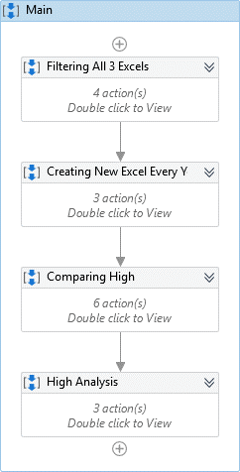

1. **In Filtering All 3 Excels** sequence , we are filtering the High from the Risk column from each input files

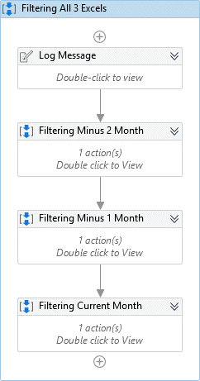

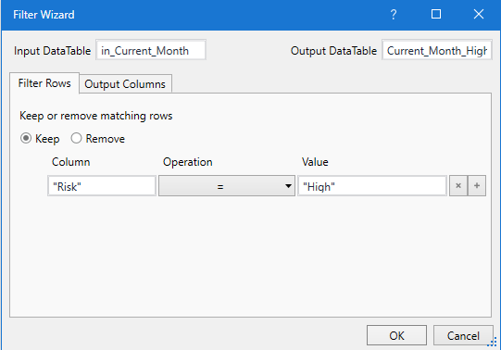

1. **In creating New Excel every year sequence,**

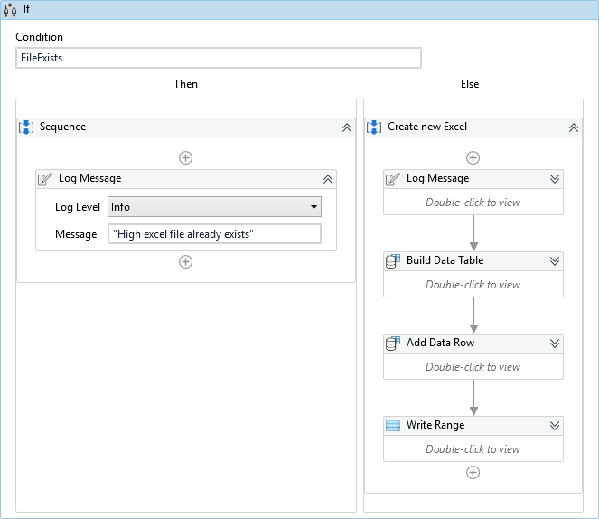

* We are checking whether the file exists in specific name format (eg: “Repetitive_Analysis_High_2022”) at every run, by using the code “Repetative_Analysis_High_+Now().ToString("yyyy"))” .
* If the file didn’t exist then it will create a new file start appending the data into the new created file. At first run of every new year it will create a new file with suffix of the year.

1. **In Comparing High Sequence,**

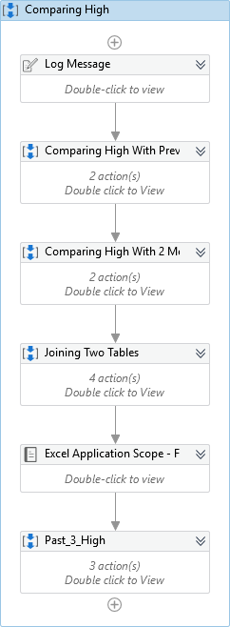

* We are comparing current month high vulnerabilities based on Name and host with previous month and with two months back and joining the output table from both comparison. Then the final output will be pasted in High_VA_Review Sheet.
* **To convert date format we are using excel application scope,** by using vba to select the J columns and by UI we are converting to needed Date format (MMM-yy). Correct date format for creating a pivot in correct format. It is done for both High_VA_Review and High_Repeated Sheets.

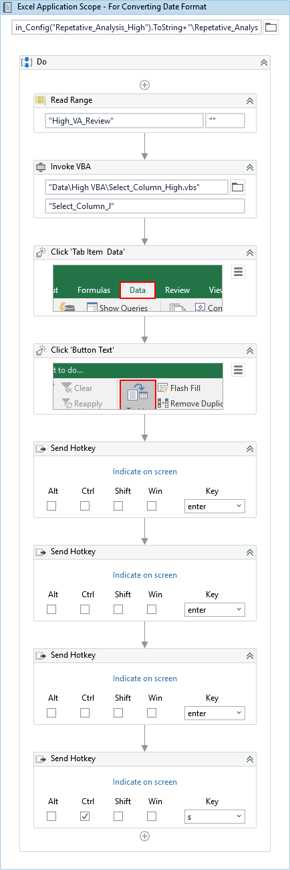

* **In Past three months sequence**, we filtering past three months data from output of comparing High, means from the High_VA_Review sheet and pasting on new sheet called High_Repeated its done for creating pivot table for period of four months alone. And will be deleting old pivot tables sheet and High_Repeated sheets by using invoke vba to maintain the output format.

1. **In High Analysis Sequence,** we are creating two Pivot table from High_VA_Review and High_Repeated sheets by invoking VBA codes

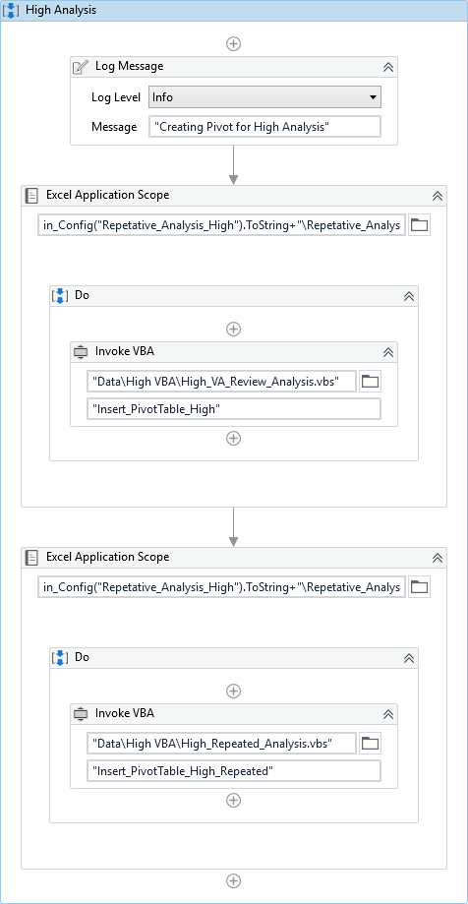

1. **Critical Work Flow**

Critical workflow is same as the High workflow only name is changed from the High to Critical and filtering Critical from Risk column

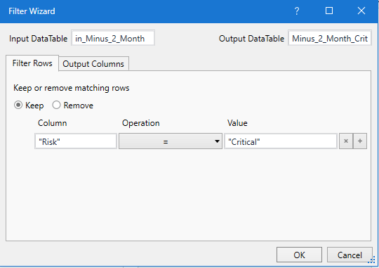

# Other Details

### Future Improvements

Can be Develop for Analyzing Medium and Low vulnerabilities if needed.

### Other Remarks

Kindly don’t make any changes in VBA codes except sheet name if required.

# Glossary

The main terms used in the Solution Architecture Document are defined below:

**Master project** - the overall output of the development, containing one or multiple projects that together cover the scope of the robotic process automation. There is a 1 to 1 connection between the Master Project and the Process to be automated (As presented in the PDD).

**Project** - an UiPath Studio project containing one or multiple workflow files. A project can be converted to a package and run independently, covering a particular scope within the master project. Or multiple projects can be converted into one package depending on the aims and restrictions of the automation. The project is used when defining the development and support phase of the automation.

**Package** - the output of compiling one or multiple projects. A package can be deployed on the robot machine and be executed by the robot service. Only one package can be executed at a given time by a robot. The package is used when defining the running phase of the automation.

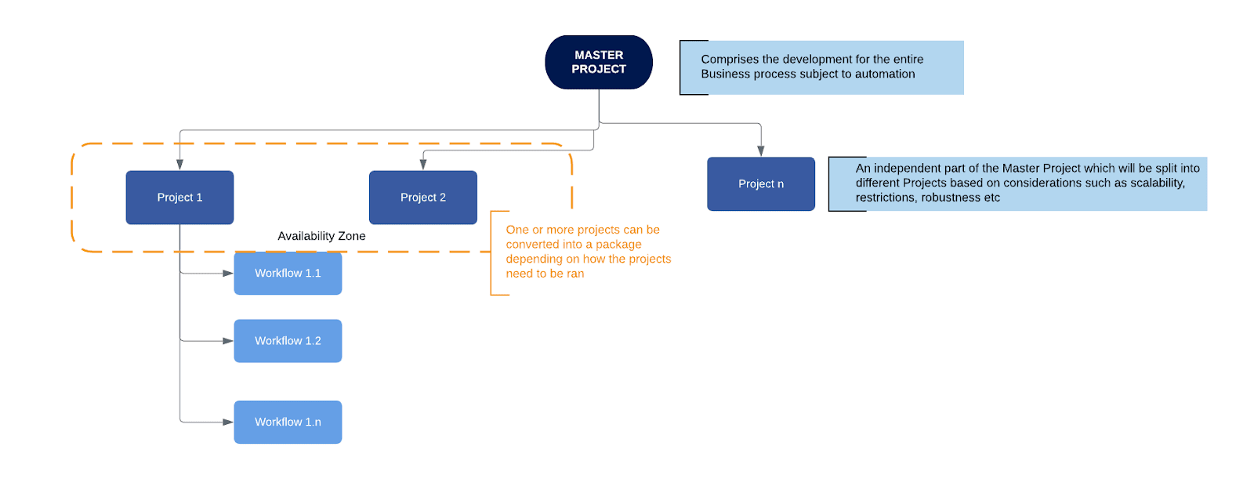Workflow - a component of the package, the workflow encapsulates a part of the project logic. The workflow can be of type: sequence, flowchart or state machine. A workflow is saved as an .xaml file inside the project folder. A workflow file can be invoked from another workflow and by default there is an initial workflow file that will run when executing the package.

**Activity** - an action that the robot executes.

**Sequence** - a workflow where activities are executed one after another, in a sequential order

**Flowchart** - a workflow where activities are connected by arrows and the logic of the workflow can be easily followed in a visual manner. The flowchart can also be exported as an image from UiPath studio.

**State machine** - a more advanced way of organizing a workflow, similar to a flowchart.

**BOR** - Back office robot

**FOR** – Front office robot

**Orchestrator** – Enterprise architecture server platform supporting: release management, centralized logging, reporting, auditing and monitoring tools, remote control, centralized scheduling, queue/robot workload management, assets management.