Week 4 – Supervised Learning Model Implementation
Classification using the Breast Cancer Wisconsin Diagnostic Dataset
Python • Pandas • Scikit-learn • Logistic Regression

1. Executive Summary
This project implements a supervised machine learning classification model using the Breast Cancer Wisconsin Diagnostic dataset. The objective is to predict whether a recorded tumour is malignant or benign from numerical measurements computed from digitized images of fine needle aspirate samples.
A Logistic Regression classifier was selected because it is a strong baseline for binary classification, produces interpretable coefficients, trains efficiently, and works well when numerical features are standardized. The workflow includes data inspection, train-test splitting, feature engineering, standardization, univariate feature selection, five-fold stratified cross-validation, final training, and test-set evaluation.
On the held-out test set, the model achieved 0.956 accuracy, 0.959 precision, 0.972 recall, 0.966 F1 score, and 0.993 ROC-AUC.

2. Problem Definition
The problem is formulated as binary classification. Given a set of numerical measurements describing cell nuclei, the model predicts one of two classes:
- Malignant (target = 0)
- Benign (target = 1)
The purpose of the exercise is not to replace clinical decision-making. It is to demonstrate a complete supervised-learning workflow and evaluate how accurately a machine learning model can classify the observations in this public benchmark dataset.

3. Dataset Selection and Source
The dataset used is the Breast Cancer Wisconsin Diagnostic dataset distributed through Scikit-learn's public dataset collection. It is based on the UCI Breast Cancer Wisconsin Diagnostic dataset and contains 569 observations with 30 original numerical predictors and a binary target.
The predictors describe characteristics such as radius, texture, perimeter, area, smoothness, compactness, concavity, concave points, symmetry, and fractal dimension. Several measurements are provided as mean, standard error, and worst values.
Using the Scikit-learn loader makes the experiment reproducible and avoids dependency on a manually downloaded CSV file.
from sklearn.datasets import load_breast_cancer
data = load_breast_cancer(as_frame=True)
df = data.frame.copy()

4. Initial Data Understanding
The loaded dataframe contains 569 rows and 31 columns, including the target column. The predictor matrix contains 30 original numerical variables.
The target is already encoded numerically. The class distribution is not perfectly balanced, so stratification is used during train-test splitting and cross-validation.
- Malignant: 212 observations (37.3%)
- Benign: 357 observations (62.7%)

5. Data Preparation
The dataset is already clean enough for direct modeling: the Scikit-learn version contains numerical predictors and does not require categorical encoding. Nevertheless, the modeling workflow explicitly checks data shape, target distribution, and the possibility of preprocessing leakage.
X = df.drop(columns=["target"]).copy()
y = df["target"].copy()
print(df.shape)
print(y.value_counts())
print(X.isnull().sum().sum())
No target variable is used as an input feature. The test set is kept separate until the final evaluation so that the reported performance is not influenced by test-set information.

6. Feature Engineering
Three interpretable ratio features were created from existing predictors. The goal is to provide the classifier with additional shape/size relationships rather than relying only on individual measurements.
- radius_perimeter_ratio = mean radius / mean perimeter
- area_radius_ratio = mean area / mean radius
- concavity_compactness_ratio = mean concavity / mean compactness
A very small epsilon is added to denominators to avoid division-by-zero problems. These features are generated only from predictors, so the target is not leaked into the engineered variables.
eps = 1e-9
X["radius_perimeter_ratio"] = (
X["mean radius"] / (X["mean perimeter"] + eps)
)
X["area_radius_ratio"] = (
X["mean area"] / (X["mean radius"] + eps)
)
X["concavity_compactness_ratio"] = (
X["mean concavity"] / (X["mean compactness"] + eps)
)

7. Train-Test Split
The data is divided into 80% training data and 20% test data. Stratification is used so that the proportion of malignant and benign observations remains similar in both sets. random_state=42 is used for reproducibility.
X_train, X_test, y_train, y_test = train_test_split(
X, y,
test_size=0.20,
random_state=42,
stratify=y
)

8. Model Selection and Rationale
Logistic Regression was selected as the primary supervised model. It is appropriate because the target has two classes and the dataset contains continuous numerical features. It is also a useful baseline because it is comparatively simple, fast to train, and easier to interpret than many complex ensemble models.
- Binary classification directly matches the problem definition.
- Standardization helps when predictors have very different numerical scales.
- L2-regularized Logistic Regression helps reduce overfitting.
- The model outputs probabilities, which allows ROC-AUC analysis.
A Pipeline is used so that scaling and feature selection are learned inside each training fold. This is important because performing preprocessing on the full dataset before cross-validation can leak information from validation folds.
model = Pipeline([
("scaler", StandardScaler()),
("selector", SelectKBest(score_func=f_classif, k=20)),
("classifier", LogisticRegression(max_iter=5000, random_state=42))
])

9. Feature Selection
SelectKBest with the ANOVA F-test is used to retain the 20 strongest individual features according to their relationship with the class label within each training fold. This reduces the feature space from 33 predictors after engineering to 20 selected predictors.
Feature selection is placed inside the Pipeline. Therefore, the selected features are determined separately within each cross-validation training fold rather than using information from the validation fold.

10. Model Validation – 5-Fold Cross-Validation
Five-fold stratified cross-validation is applied to the training set. Each fold is used once as validation data while the other four folds are used for training. Accuracy, precision, recall, F1 score, and ROC-AUC are recorded.
Metric | Mean | Std. Dev.
ACCURACY | 0.9582 | 0.0146
PRECISION | 0.9626 | 0.0184
RECALL | 0.9719 | 0.0325
F1 | 0.9667 | 0.0123
ROC_AUC | 0.9946 | 0.0038
The relatively small standard deviations across folds indicate that the model's performance is reasonably consistent for this dataset. Cross-validation is especially useful here because a single train-test split can sometimes give an overly optimistic or pessimistic estimate.
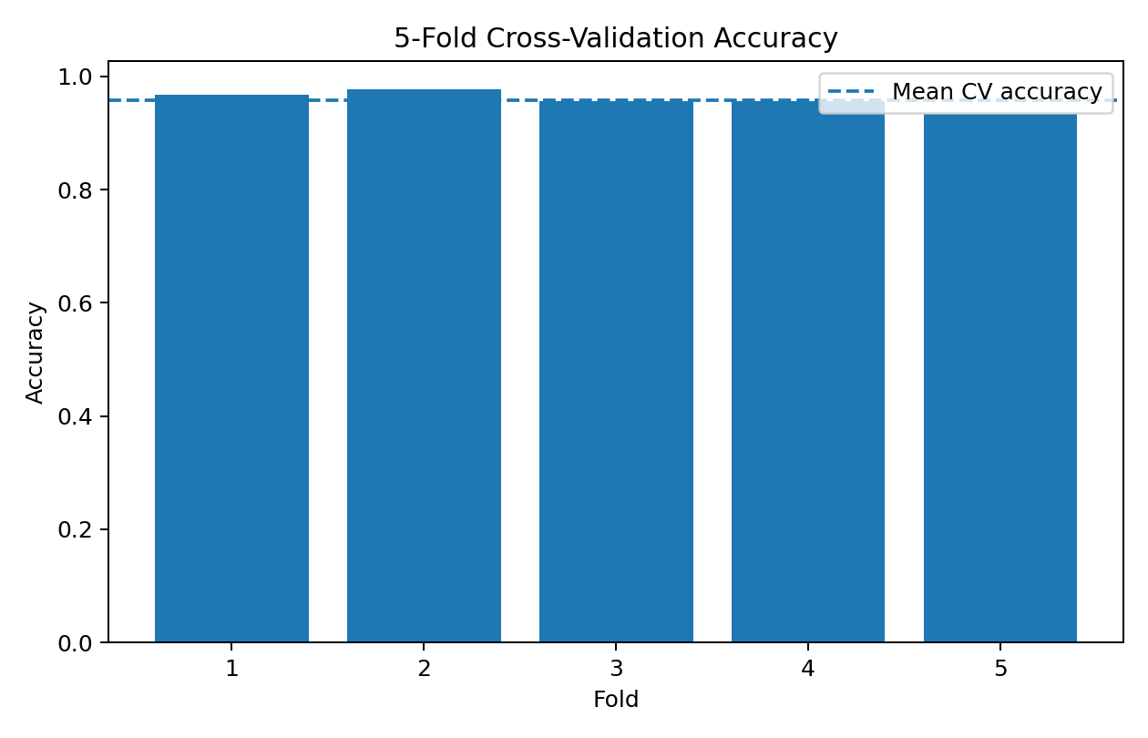
Figure 1. Accuracy across the five validation folds.

11. Final Model Training and Test Evaluation
After cross-validation, the pipeline is fitted on the complete training partition and evaluated once on the untouched test partition.
Metric | Test Result
Accuracy | 0.9561
Precision | 0.9589
Recall | 0.9722
F1 Score | 0.9655
ROC-AUC | 0.9931

12. Confusion Matrix Analysis
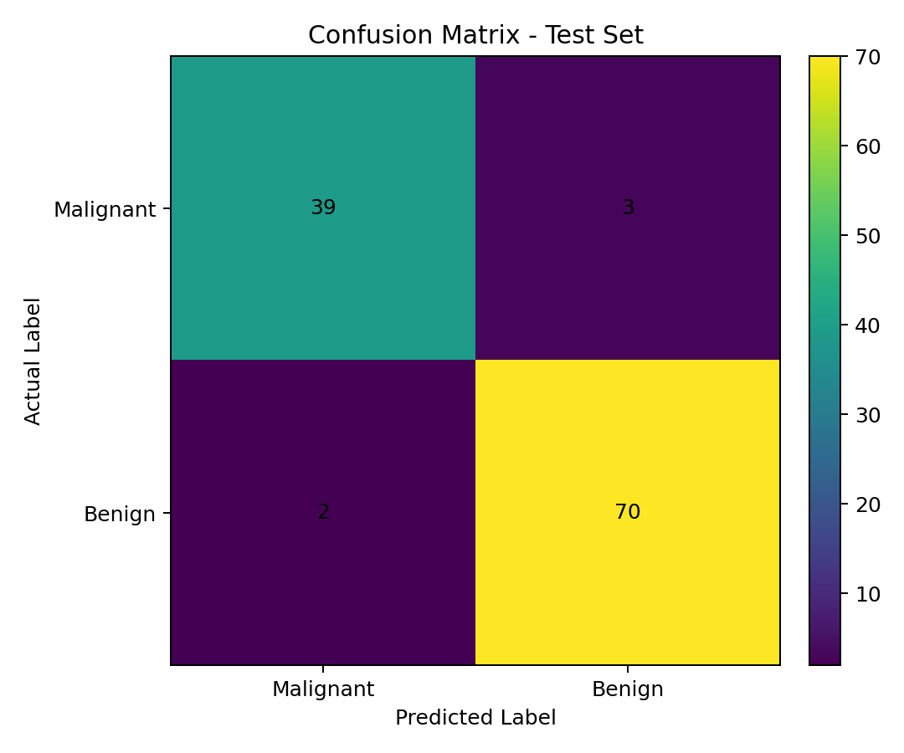
Figure 2. Confusion matrix for the held-out test set.
The confusion matrix separates correct predictions from the two types of classification error. Because the positive class is Benign in this encoding, recall measures how many benign cases were correctly identified. For practical screening-style applications, the choice of positive class and the cost of false negatives/false positives should be defined carefully before deployment.

13. ROC-AUC and Probability-Based Evaluation
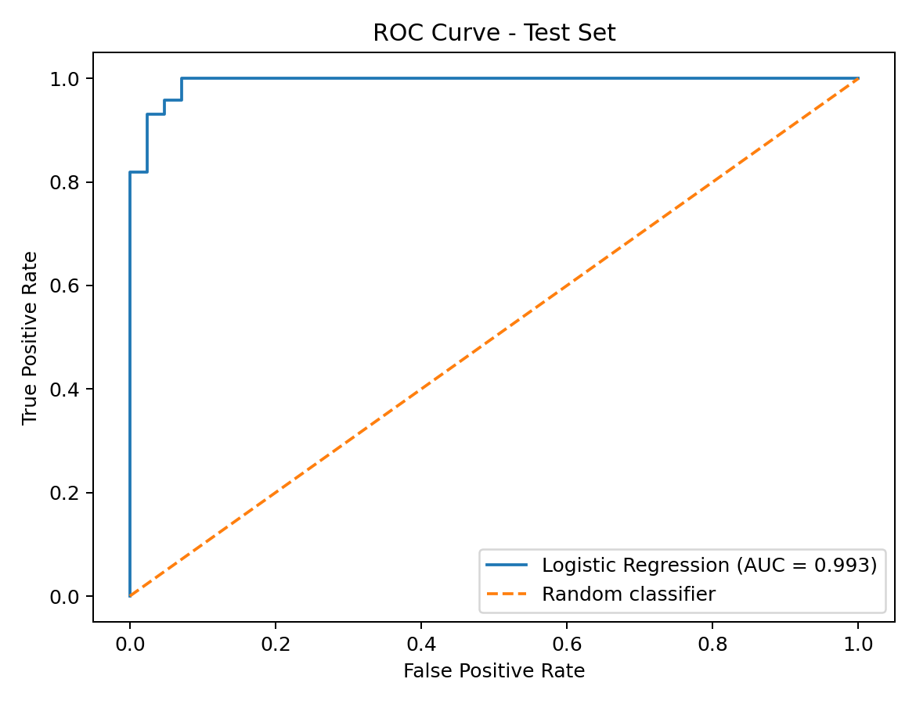
Figure 3. ROC curve on the held-out test set.
ROC-AUC evaluates how well the model ranks positive observations above negative observations across different classification thresholds. The reported AUC is based only on the test predictions and therefore provides a threshold-independent complement to accuracy, precision, recall, and F1.

14. Feature Importance Analysis
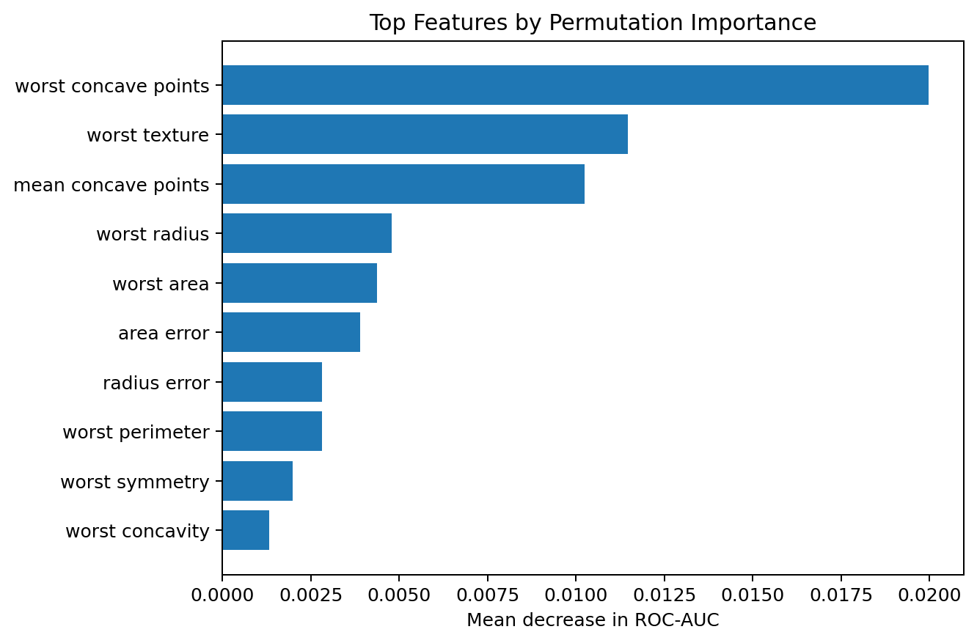
Figure 4. Top features according to permutation importance.
Permutation importance estimates how much model performance decreases when a feature's values are randomly shuffled. The chart should be interpreted as a model-level diagnostic, not as proof that an individual feature causes the target outcome.
The most influential variables provide a useful starting point for understanding which measurements the fitted model relies on most strongly. The exact ranking can vary with the random split and repeated permutation process.

15. Code Integration – Core Training and Evaluation
cv = StratifiedKFold(
n_splits=5,
shuffle=True,
random_state=42
)
cv_results = cross_validate(
model,
X_train,
y_train,
cv=cv,
scoring=["accuracy", "precision", "recall", "f1", "roc_auc"]
)
model.fit(X_train, y_train)
y_pred = model.predict(X_test)
y_prob = model.predict_proba(X_test)[:, 1]
print("Accuracy:", accuracy_score(y_test, y_pred))
print("Precision:", precision_score(y_test, y_pred))
print("Recall:", recall_score(y_test, y_pred))
print("F1:", f1_score(y_test, y_pred))
print("ROC-AUC:", roc_auc_score(y_test, y_prob))

16. Interpretation of Results
The final model produced a test accuracy of 0.956. The F1 score of 0.966 combines precision and recall into a single measure and is useful when both types of error matter. The ROC-AUC value of 0.993 indicates strong separation between the two classes for this benchmark test split.
The results should not be interpreted as clinical performance. The dataset is relatively small and structured, and real-world medical prediction requires external validation, careful handling of patient-level dependencies, calibration, domain expertise, and appropriate clinical governance.

17. Strengths of the Approach
- Clear binary classification problem with a well-defined target.
- Uses a reproducible public dataset and a fixed random seed.
- Feature engineering adds interpretable relationships between measurements.
- Pipeline design reduces preprocessing and feature-selection leakage.
- Stratified five-fold cross-validation provides a more reliable estimate than one split alone.
- Multiple evaluation metrics give a broader view of model behavior.
- ROC-AUC and permutation importance provide additional diagnostic information.

18. Limitations
- The dataset is relatively small compared with many production datasets.
- Only one main model family is used for the final implementation.
- Feature engineering is intentionally limited and does not use domain-specific clinical modeling.
- The test set comes from the same benchmark distribution as the training data.
- The model has not been externally validated on a separate real-world population.
- Performance metrics can change with a different train-test split.
- High predictive performance on this dataset does not establish clinical usefulness.

19. Possible Improvements
- Compare Logistic Regression with Random Forest, Support Vector Machine, and Gradient Boosting.
- Tune hyperparameters using nested cross-validation or GridSearchCV/RandomizedSearchCV.
- Evaluate probability calibration and select a threshold according to application-specific costs.
- Perform stronger feature analysis using domain knowledge and controlled dimensionality reduction.
- Validate the final model on an independent external dataset.
- Track precision-recall behavior when class imbalance or asymmetric errors are important.
- Add model explainability methods such as coefficient analysis or SHAP in a future extension.

20. Practical Learning Outcomes
This implementation demonstrates the complete supervised-learning lifecycle: defining a classification problem, loading public data, inspecting the dataset, engineering features, separating training and test data, building a preprocessing/model pipeline, performing cross-validation, fitting a final model, evaluating multiple metrics, visualizing errors, and discussing limitations and improvements.

21. Conclusion
The Week 4 task successfully implements a supervised classification workflow using Scikit-learn. Logistic Regression was selected as a transparent and efficient baseline, with standardization and statistical feature selection incorporated inside a Pipeline. Five-fold stratified cross-validation and a final held-out test evaluation provide evidence about the model's consistency and predictive performance.
The most important takeaway is that model implementation is not limited to fitting an algorithm. A reliable workflow also requires careful data preparation, leakage prevention, validation, multiple evaluation metrics, interpretation of errors, and a realistic discussion of limitations.

22. References
- Scikit-learn documentation – load_breast_cancer dataset.
- Scikit-learn documentation – Pipeline, StandardScaler and SelectKBest.
- Scikit-learn documentation – LogisticRegression.
- Scikit-learn documentation – cross_validate and StratifiedKFold.
- Scikit-learn documentation – classification metrics and permutation importance.
- UCI Machine Learning Repository – Breast Cancer Wisconsin (Diagnostic) dataset.

Appendix A – Full Python Script
The accompanying file week4_supervised_learning.py contains the complete reproducible implementation used for the analysis.

