WEEK 3 INTERNSHIP TASK
Unsupervised Learning and Clustering Analysis
Customer Segmentation using K-Means Clustering
Python • Pandas • Scikit-learn • Matplotlib
Submitted by: __________________________
Internship / Organization: __________________________
Submission Date: __________________________

1. Introduction
This task applies unsupervised learning to a public customer dataset to identify groups of customers with similar characteristics. Unlike supervised learning, there is no target column telling the algorithm which group each customer belongs to. The purpose is to allow the data itself to reveal useful patterns.
K-Means clustering was selected because the selected variables are numerical and the objective is practical customer segmentation. The analysis focuses on annual income and spending score, two variables that have a direct interpretation for retail and marketing decisions.

2. Dataset Selection
Item | Details
Dataset | Mall Customers
Records | 200
Original variables | CustomerID, Gender, Age, Annual Income, Spending Score
Clustering variables | Annual Income (k$), Spending Score (1-100)
Learning type | Unsupervised learning
Primary algorithm | K-Means
Purpose | Customer segmentation
The Mall Customers dataset is a commonly used public customer-segmentation dataset containing 200 customer records. Customer ID and gender were not used as clustering features because an identifier has no behavioural meaning and gender is categorical. Age was also kept out of the primary model so that the segmentation directly reflects the business dimensions of income and spending behaviour.

3. Why K-Means?
K-Means partitions observations into k groups by minimizing the within-cluster squared distance between observations and their assigned centroid. It was chosen for three reasons: it is straightforward to implement, the two selected variables can be visualized directly, and the resulting segments are easy to explain to a business audience.
A limitation is that K-Means assumes distance is meaningful and works best when clusters are reasonably compact. It also requires the number of clusters to be specified, so selecting k was treated as an analytical step rather than an arbitrary choice.

4. Data Loading and Initial Inspection
import pandas as pd
import matplotlib.pyplot as plt
from sklearn.preprocessing import StandardScaler
df = pd.read_csv("Mall_Customers.csv")
print(df.shape)
print(df.head())
print(df.info())
print(df.isnull().sum())
print(df.describe())
The initial inspection checks dimensions, data types, missing values, and basic statistics. For this clustering task, the most important question is whether the selected numerical features are complete and suitable for distance-based modelling.

5. Feature Selection and Preprocessing
The clustering variables were restricted to Annual Income and Spending Score. CustomerID was excluded because it is only an identifier. Gender and age were not used in the primary clustering model; they can instead be used later to describe the clusters.
features = ["Annual Income (k$)", "Spending Score (1-100)"]
X = df[features]
scaler = StandardScaler()
X_scaled = scaler.fit_transform(X)
Standardization was important because annual income and spending score are measured on different scales. Without scaling, the feature with the larger numerical spread could have a stronger effect on Euclidean distance and therefore on cluster formation.

6. Choosing the Number of Clusters

6.1 Elbow Method
from sklearn.cluster import KMeans
inertias = []
for k in range(2, 9):
model = KMeans(
n_clusters=k,
random_state=42,
n_init=10
)
model.fit(X_scaled)
inertias.append(model.inertia_)
plt.plot(range(2, 9), inertias, marker="o")
plt.title("Elbow Method")
plt.xlabel("Number of clusters")
plt.ylabel("Inertia")
plt.show()
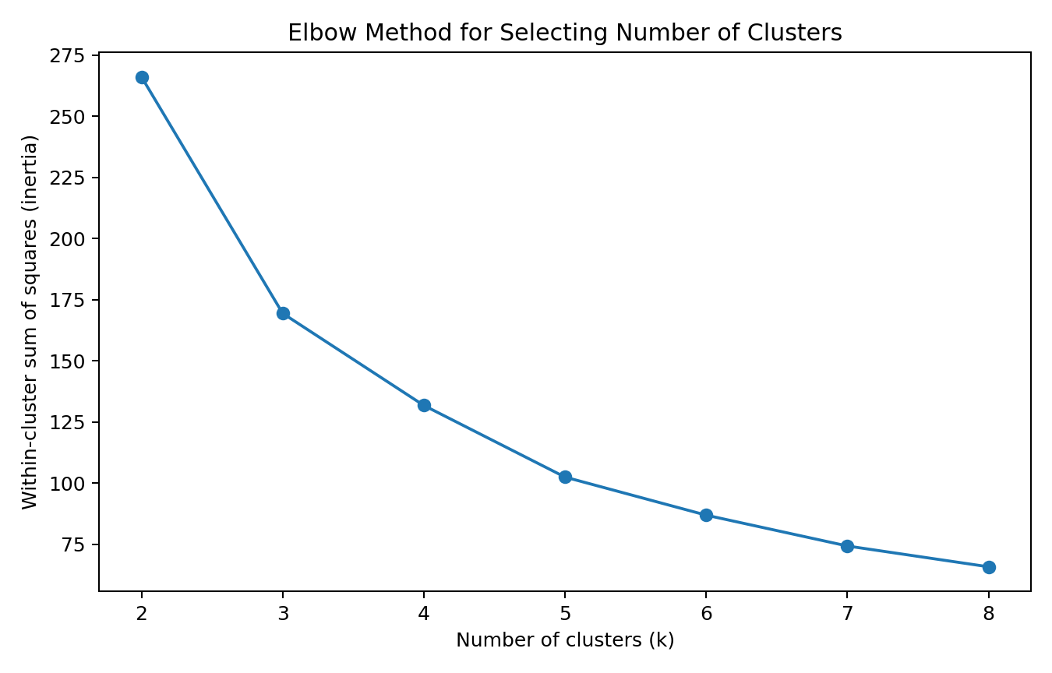
Figure 1. Elbow-method comparison of within-cluster inertia for different values of k.
The elbow method compares the reduction in within-cluster inertia as more clusters are added. The reduction is large at first and then becomes less substantial, indicating that additional clusters eventually provide diminishing returns.

6.2 Silhouette Score
from sklearn.metrics import silhouette_score
scores = []
for k in range(2, 9):
model = KMeans(
n_clusters=k,
random_state=42,
n_init=10
)
labels = model.fit_predict(X_scaled)
scores.append(silhouette_score(X_scaled, labels))
plt.plot(range(2, 9), scores, marker="o")
plt.title("Silhouette Scores")
plt.xlabel("Number of clusters")
plt.ylabel("Average silhouette score")
plt.show()
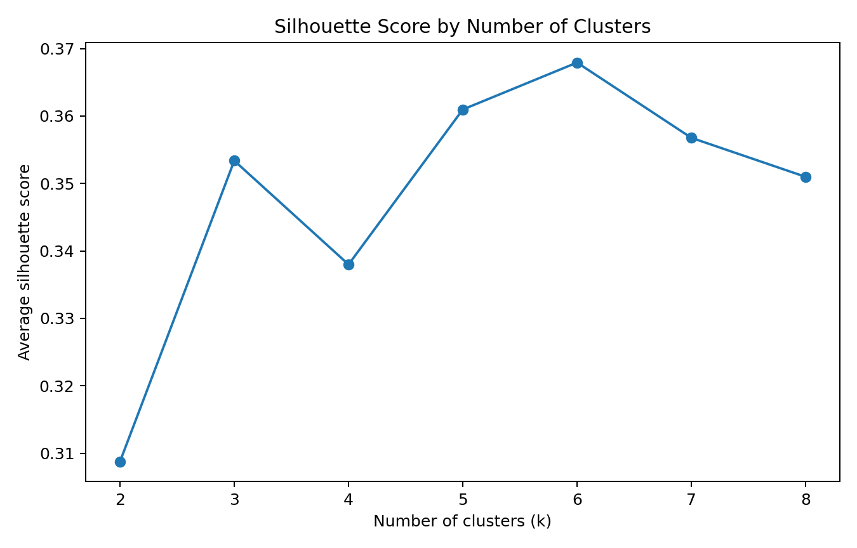
Figure 2. Silhouette scores used as a second diagnostic for choosing k.
The silhouette score considers both how close an observation is to its own cluster and how separated it is from other clusters. A higher value generally indicates better separation. The final value of k was selected using both the elbow pattern and cluster interpretability.

7. Final K-Means Model
k = 5
kmeans = KMeans(
n_clusters=k,
random_state=42,
n_init=10
)
df["Cluster"] = kmeans.fit_predict(X_scaled)
silhouette = silhouette_score(
X_scaled,
df["Cluster"]
)
print("Silhouette score:", silhouette)
print(df["Cluster"].value_counts().sort_index())
Five clusters were used for the final segmentation. The choice provides a useful balance between under-segmenting the customers and creating too many small groups. random_state=42 makes the experiment reproducible, while n_init=10 reduces the chance of selecting a poor result from a single initialization.

8. Cluster Visualization
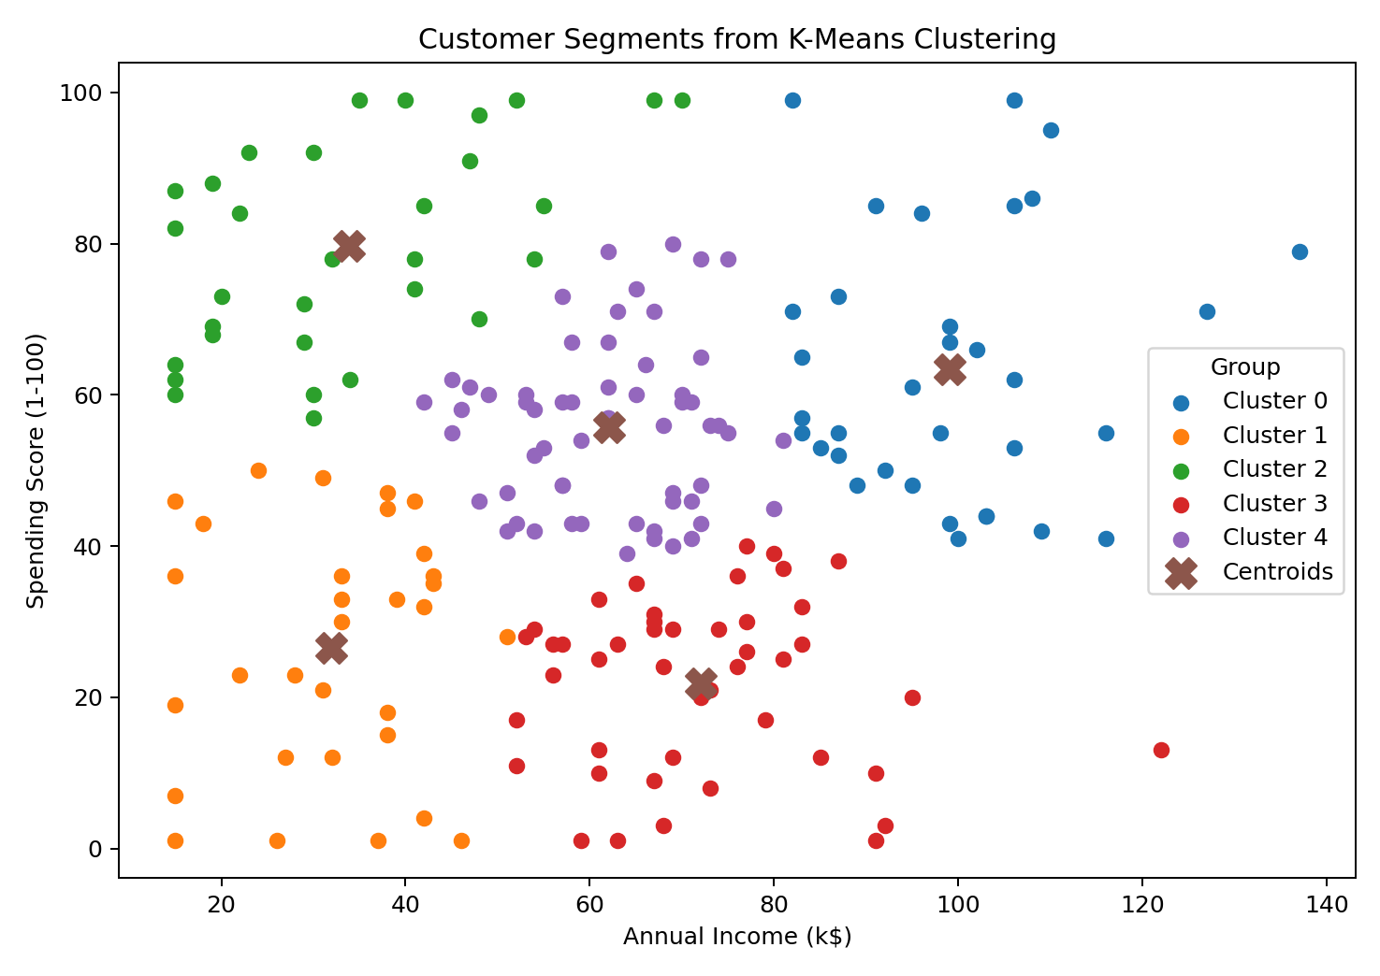
Figure 3. Customer observations segmented by K-Means using annual income and spending score.
The two-dimensional feature space makes the customer segments directly visible. Customers close to one another have similar standardized income and spending-score values, while customers farther apart are more different along these dimensions.

9. Cluster Profiles
Cluster | Customers | Avg. income (k$) | Avg. spending score
0 | 34 | 99.0 | 63.3
1 | 31 | 32.0 | 26.5
2 | 31 | 33.9 | 79.7
3 | 45 | 72.0 | 21.8
4 | 59 | 62.1 | 55.7
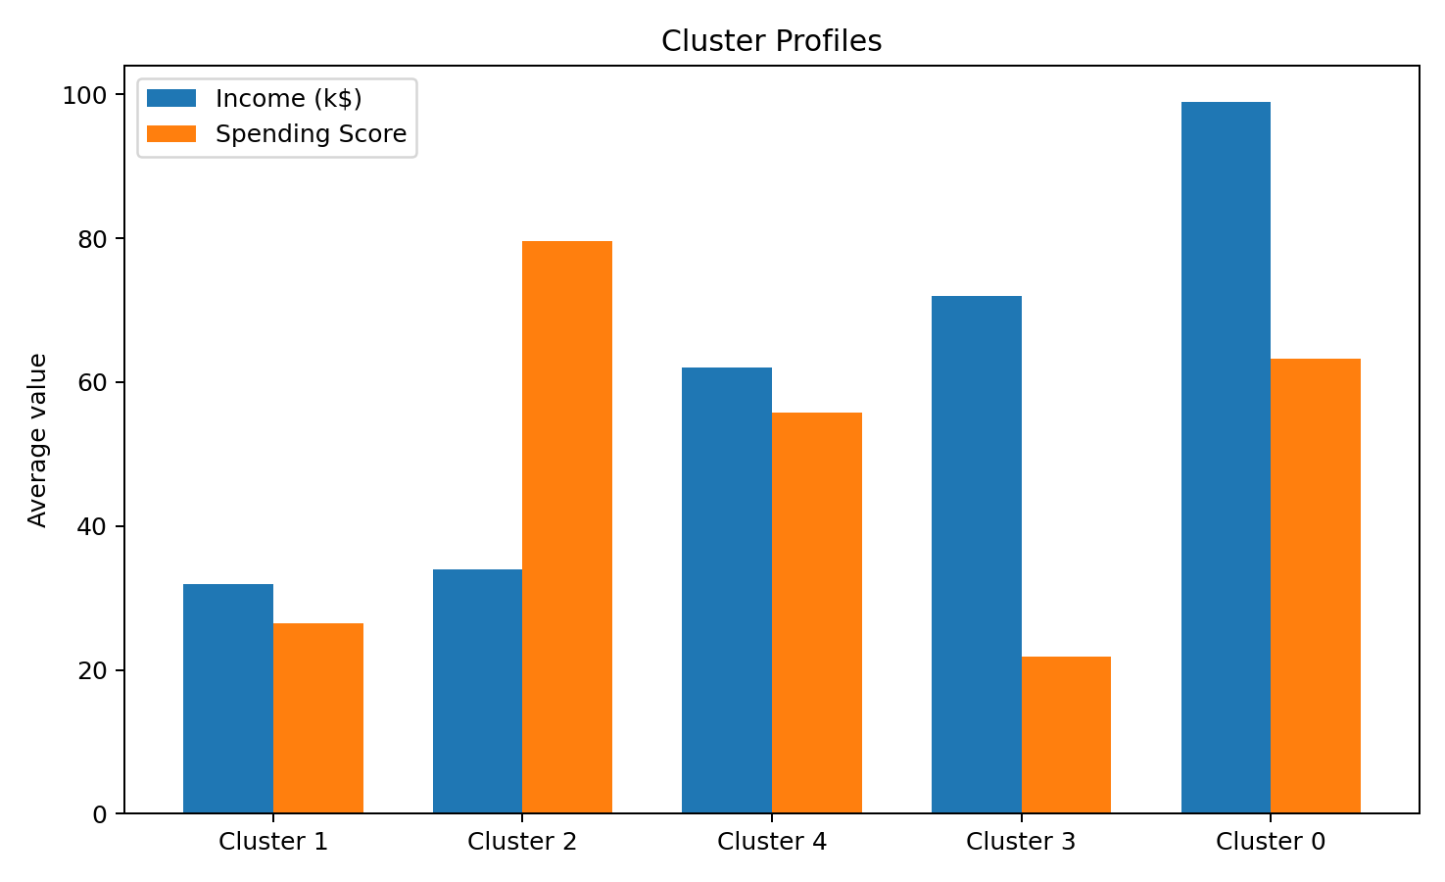
Figure 4. Comparison of average income and spending score across the five clusters.
The cluster centres provide the main basis for interpreting the segments. The exact values can vary slightly depending on the dataset version and preprocessing, so the business meaning should be based on the relative position of each cluster rather than a single threshold.

10. Interpretation of the Clusters
Cluster | Suggested segment | Size | Avg. income | Avg. spending
0 | High-income / high-spending | 34 | 99.0 | 63.3
1 | Lower-income / lower-spending | 31 | 32.0 | 26.5
2 | Lower-income / high-spending | 31 | 33.9 | 79.7
3 | High-income / lower-spending | 45 | 72.0 | 21.8
4 | High-income / high-spending | 59 | 62.1 | 55.7
The following labels are descriptive business names, not labels learned by the algorithm. They are assigned after clustering by comparing each centroid with the other centroids.

Cluster 0: High-income / high-spending
This segment combines relatively strong purchasing power with strong spending behaviour. It may be suitable for premium products, loyalty programmes, personalized recommendations, and higher-value campaigns.

Cluster 1: Lower-income / lower-spending
This group has comparatively lower income and lower spending. Broad low-cost campaigns may be less valuable than efficient retention messaging and carefully selected promotions.

Cluster 2: Lower-income / high-spending
This group spends actively despite having relatively lower income. Affordable bundles, promotions, loyalty rewards, and carefully targeted offers may be relevant, while avoiding assumptions about individual customers.

Cluster 3: High-income / lower-spending
This group has relatively high income but comparatively lower spending. The business opportunity is to understand why purchasing is restrained and test targeted offers, product discovery campaigns, or loyalty incentives.

Cluster 4: High-income / high-spending
This segment combines relatively strong purchasing power with strong spending behaviour. It may be suitable for premium products, loyalty programmes, personalized recommendations, and higher-value campaigns.

11. Business and Research Implications
- Marketing teams can use the segments to avoid sending the same promotion to every customer.
- High-income/high-spending customers may justify premium product recommendations and loyalty benefits.
- High-income/lower-spending customers may be a useful group for studying conversion barriers.
- Lower-income/high-spending customers can be approached with value-oriented products and promotions rather than premium positioning.
- Lower-income/lower-spending customers may require cost-efficient engagement strategies.
- The clusters can be used as an exploratory feature in later analysis, but the segments should be validated against actual purchase history before making operational decisions.

12. Validation and Stability Considerations
# Check cluster sizes
print(df["Cluster"].value_counts().sort_index())
# Re-run with a different initialization seed if required
model_2 = KMeans(
n_clusters=5,
random_state=7,
n_init=10
)
labels_2 = model_2.fit_predict(X_scaled)
print(
"Alternative silhouette:",
silhouette_score(X_scaled, labels_2)
)
K-Means can produce different results when its initialization changes. Using multiple initializations and checking the resulting silhouette score provides a basic stability check. For a production segmentation system, the clusters should also be tested on new data over time because customer behaviour can change.

13. Limitations
- The dataset is small, with 200 observations, so the clusters should be treated as an educational segmentation rather than a production customer model.
- Only income and spending score were used in the primary model. Including age or other behavioural variables could produce different segments.
- K-Means uses distance and tends to favour compact, roughly spherical groups.
- The selected value of k is an analytical choice and should be validated against business objectives.
- Cluster labels such as 'high value' are interpretations applied after clustering and are not ground-truth categories.

14. Conclusion
This task demonstrated a complete unsupervised-learning workflow: selecting a suitable public dataset, choosing meaningful numerical features, standardizing the features, comparing possible values of k, fitting K-Means, visualizing the resulting groups, and interpreting the cluster profiles.
The analysis shows how clustering can convert a table of individual customers into a smaller number of interpretable segments. The most important practical point is that clustering does not automatically tell us what a segment means; interpretation comes after examining the cluster centres and validating them against the intended business problem.

15. References
1. Scikit-learn — KMeans documentation: https://scikit-learn.org/stable/modules/generated/sklearn.cluster.KMeans.html
2. Scikit-learn — silhouette_score documentation: https://scikit-learn.org/stable/modules/generated/sklearn.metrics.silhouette_score.html
3. Scikit-learn — StandardScaler documentation: https://scikit-learn.org/stable/modules/generated/sklearn.preprocessing.StandardScaler.html
4. Matplotlib documentation: https://matplotlib.org/stable/
5. Pandas documentation: https://pandas.pydata.org/docs/

