Week 5 – Deep Learning Application in Data Science
Handwritten Digit Classification using a PyTorch Neural Network
Python • PyTorch • Neural Networks • Multi-class Classification

1. Executive Summary
This project applies deep learning to a multi-class image classification problem using the public Digits dataset. The objective is to classify small grayscale images of handwritten digits from 0 to 9.
A feed-forward neural network, also called a Multi-Layer Perceptron (MLP), was implemented using PyTorch. The network accepts 64 normalized pixel values, learns two hidden layers with ReLU activation, uses Dropout for regularization, and produces ten output logits.
The final model contains 17,226 trainable parameters and was trained using the Adam optimizer and cross-entropy loss. Training stopped after 39 epochs because early stopping was used to retain the best validation model.
On the held-out test set, the network achieved 0.974 accuracy, 0.975 macro precision, 0.974 macro recall, and 0.974 macro F1.

2. Problem Statement
The task is to classify an input grayscale image of a handwritten digit into one of ten classes: 0, 1, 2, 3, 4, 5, 6, 7, 8, or 9.
- Input: 8 × 8 grayscale image represented by 64 pixel values.
- Output: one of 10 digit classes.
- Learning type: supervised deep learning classification.
- Evaluation: held-out test set using accuracy, precision, recall, F1 score, and confusion matrix.

3. Dataset Selection
The project uses the Digits dataset available through Scikit-learn. It contains 1,797 labeled samples of handwritten digits. Each image is 8 × 8 pixels, producing 64 numerical input features.
The dataset is appropriate for a learning-focused deep learning exercise because it is small enough to train quickly on CPU while still requiring the model to learn non-linear patterns for a ten-class classification problem.
The dataset is publicly available through the Scikit-learn dataset collection and is commonly used for demonstrating image classification and machine learning workflows.
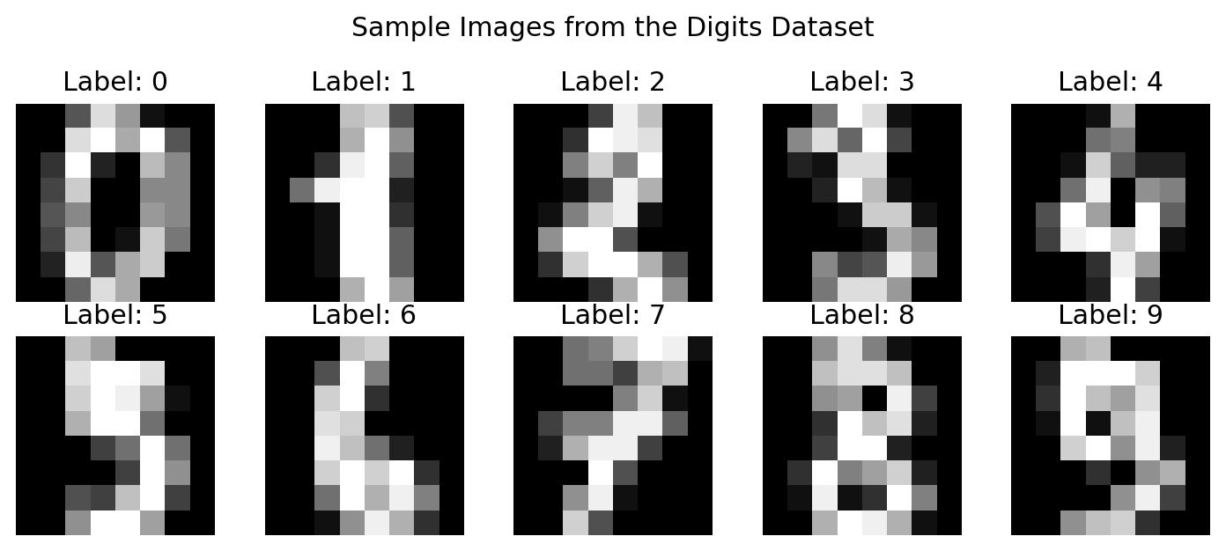
Figure 1. Example images from the Digits dataset.

4. Data Preparation
The original pixel intensity values range from 0 to 16. They are divided by 16 so that the neural network receives values approximately between 0 and 1. This makes optimization more stable and keeps the input scale consistent.
digits = load_digits()
X = digits.data.astype(np.float32) / 16.0
y = digits.target.astype(np.int64)
The dataset is split into 70% training data, 15% validation data, and 15% test data. Stratification preserves the class distribution across the three subsets.
X_train, X_temp, y_train, y_temp = train_test_split(
X, y,
test_size=0.30,
random_state=42,
stratify=y
)
X_val, X_test, y_val, y_test = train_test_split(
X_temp, y_temp,
test_size=0.50,
random_state=42,
stratify=y_temp
)

5. Why a Neural Network?
Traditional machine learning methods can perform very well on this small dataset, but the purpose of this task is to demonstrate how a neural network learns non-linear representations through multiple layers.
- The problem has multiple classes and numerical image inputs.
- Neural networks can learn combinations of pixels that are difficult to express as simple rules.
- The small dataset makes it possible to demonstrate the complete training process on modest hardware.
- PyTorch provides direct control over the model, loss function, optimizer, batches, and training loop.

6. Network Architecture
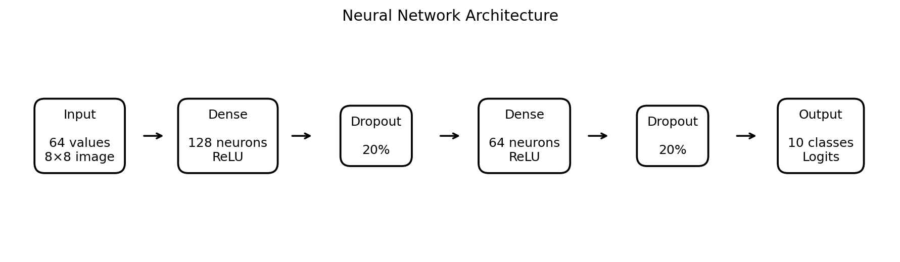
Figure 2. Architecture of the implemented feed-forward neural network.
The architecture was deliberately kept compact. The first Dense layer expands the 64-dimensional input into 128 learned representations. A second Dense layer reduces this to 64 representations, and the final layer produces ten logits corresponding to the ten digit classes.
Layer | Units | Activation | Purpose
Input | 64 | None | Normalized pixel values
Dense 1 | 128 | ReLU | Learn low-level combinations
Dropout | 20% | None | Reduce overfitting
Dense 2 | 64 | ReLU | Learn higher-level combinations
Dropout | 20% | None | Regularization
Output | 10 | Linear logits | One score per digit class

7. Architecture Design Decisions
The architecture balances learning capacity with the small size of the dataset. A very large network would introduce unnecessary parameters and could overfit. A very small network might not learn enough non-linear patterns.
- 128 neurons in the first hidden layer provide enough capacity for feature learning.
- 64 neurons in the second hidden layer create a compact intermediate representation.
- ReLU is used because it is computationally simple and supports efficient gradient-based training.
- 20% Dropout is applied after each hidden activation to reduce co-adaptation and overfitting.
- The output layer has 10 units because there are ten target classes.
- CrossEntropyLoss is used because it combines multi-class log-softmax behavior with negative log likelihood.

8. Model Implementation
class DigitMLP(nn.Module):
def __init__(self):
super().__init__()
self.network = nn.Sequential(
nn.Linear(64, 128),
nn.ReLU(),
nn.Dropout(0.20),
nn.Linear(128, 64),
nn.ReLU(),
nn.Dropout(0.20),
nn.Linear(64, 10)
)
def forward(self, x):
return self.network(x)

9. Loss Function and Optimizer
Cross-entropy loss is used because the task is a ten-class classification problem. The Adam optimizer is selected because it generally converges quickly and adapts the learning rate for individual parameters.
The initial learning rate is 0.001. A small weight-decay value of 0.0001 is also used as an additional regularization mechanism.
criterion = nn.CrossEntropyLoss()
optimizer = torch.optim.Adam(
model.parameters(),
lr=0.001,
weight_decay=1e-4
)

10. Training Strategy
Mini-batch training is used with a batch size of 32. The training data is shuffled at the beginning of each epoch. At the end of every epoch, the model is evaluated on the validation set.
A maximum of 50 epochs is allowed, but early stopping is used with a patience of 8 epochs. Whenever validation loss improves, the model state is saved. If validation loss does not improve for eight consecutive epochs, training stops and the best saved model is restored.
best_val_loss = float("inf")
patience = 8
wait = 0
for epoch in range(50):
# training pass
# validation pass
if val_loss < best_val_loss - 1e-4:
best_val_loss = val_loss
best_state = {
k: v.detach().clone()
for k, v in model.state_dict().items()
}
wait = 0
else:
wait += 1
if wait >= patience:
break

11. Training Results
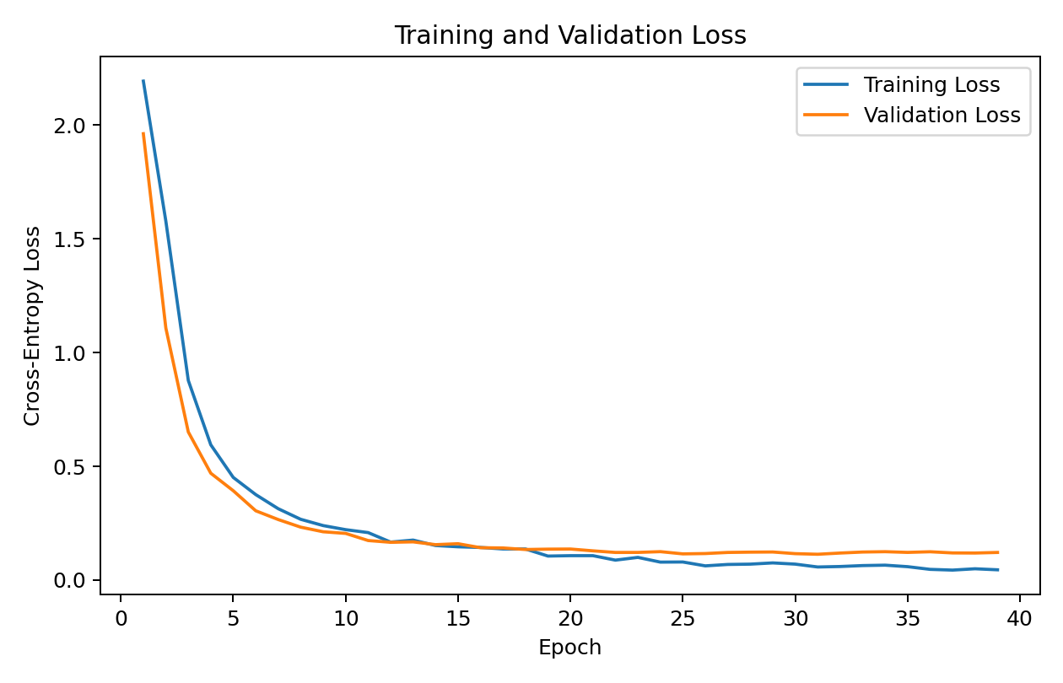
Figure 3. Training and validation loss over the training epochs.
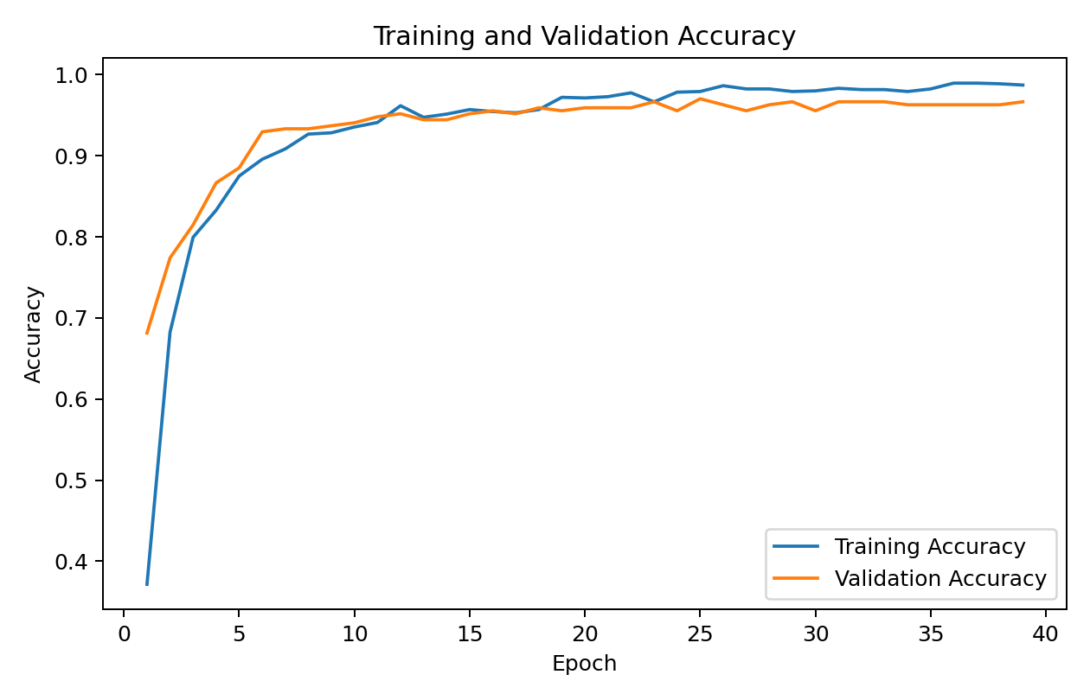
Figure 4. Training and validation accuracy over the training epochs.
The training curves provide a practical way to inspect learning behavior. A healthy training process generally shows decreasing loss and increasing accuracy. The validation curves are especially important because they indicate whether improvements on training data continue to transfer to unseen samples.
In this experiment, early stopping selected the best validation checkpoint after 39 epochs. This prevents the final model from simply being the model at the maximum epoch and provides a straightforward safeguard against unnecessary continued training.

12. Test Set Evaluation
Metric | Test Result
Accuracy | 0.9741
Macro Precision | 0.9748
Macro Recall | 0.9739
Macro F1 | 0.9742
Accuracy measures the overall proportion of correctly classified digit images. Macro precision, recall, and F1 give equal weight to each digit class instead of allowing the larger classes to dominate the summary.

13. Confusion Matrix
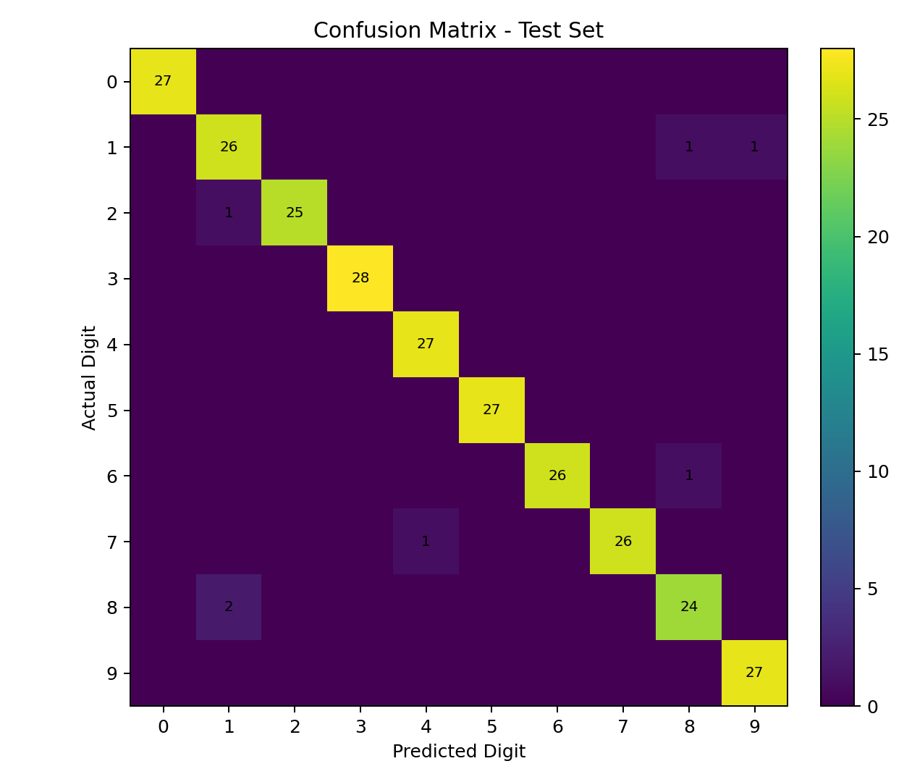
Figure 5. Confusion matrix for the held-out test set.
The confusion matrix gives class-by-class information that a single accuracy value cannot provide. The diagonal contains correct predictions, while off-diagonal cells identify which digits are confused with one another.
For handwritten digits, some errors are expected because different digits can have similar shapes depending on how they are written. These cases are useful for understanding where the network's learned representation is less discriminative.

14. Per-Class Performance
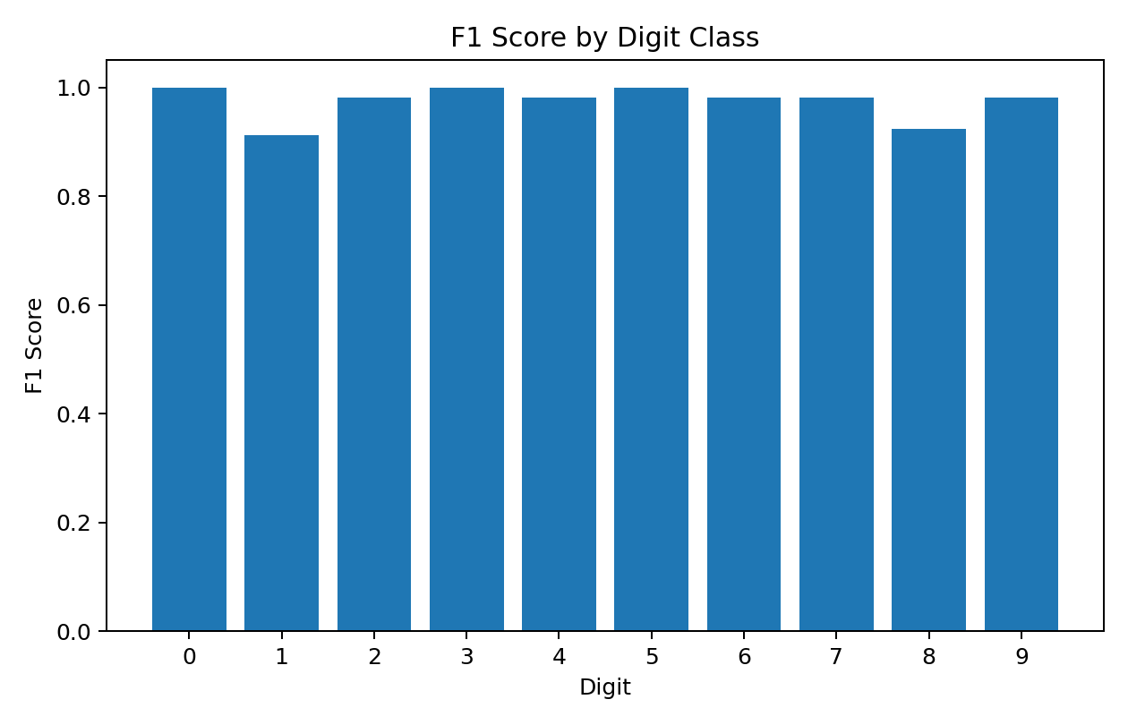
Figure 6. F1 score for each digit class.
Per-class F1 scores show whether performance is consistent across the ten digit classes. A lower score for one digit would suggest that the model has difficulty separating that class from visually similar alternatives.

15. Misclassification Analysis
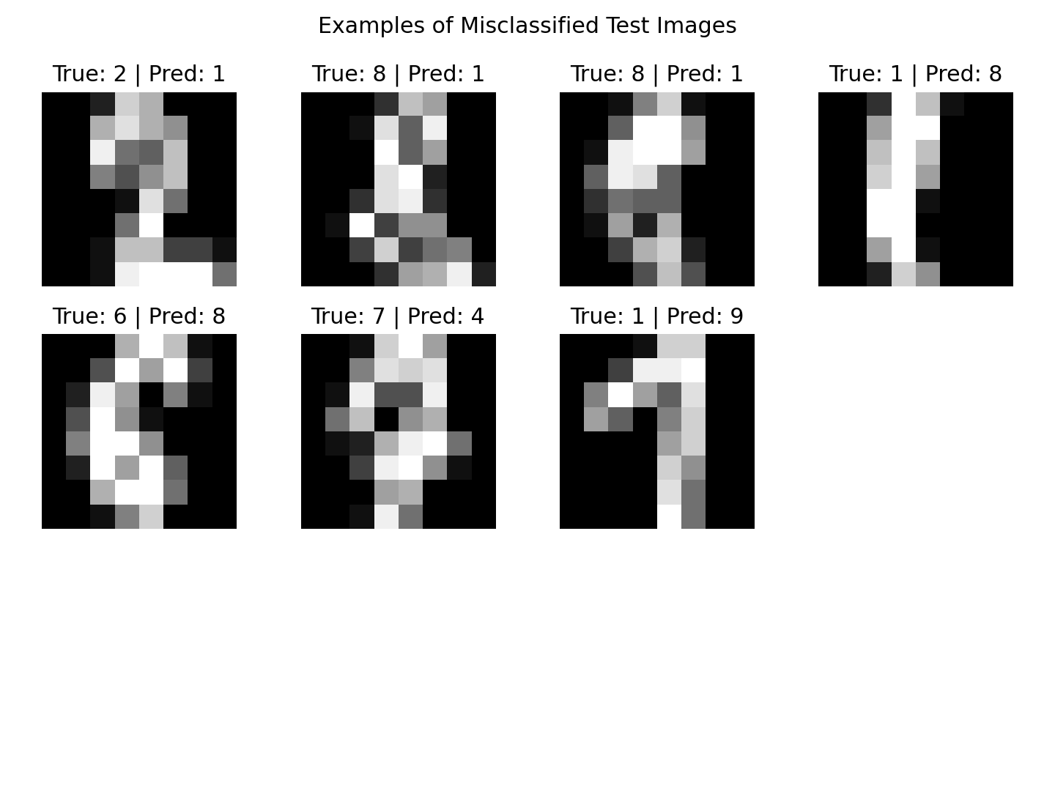
Figure 7. Examples of incorrectly classified test images.
Inspecting misclassified samples is an important part of deep learning analysis. It helps move the evaluation beyond aggregate metrics and provides evidence about the kinds of visual patterns that remain difficult for the model.

16. Challenges Encountered and Solutions
Challenge | Potential Effect | Approach Used
Small dataset | Large networks could overfit. | Use a compact MLP, Dropout, weight decay, and early stopping.
Different pixel scale | Optimization can become less stable. | Normalize pixel values from 0–16 to approximately 0–1.
Overfitting risk | Training performance may improve while validation performance stops improving. | Monitor validation loss and restore the best checkpoint.
CPU/resource constraints | Large CNNs would be unnecessary for this task. | Use a lightweight MLP and small input representation.
Class-wise differences | Overall accuracy can hide difficult classes. | Use confusion matrix and macro-averaged metrics.

17. Resource Considerations
The Digits dataset was intentionally selected because it allows the complete deep learning workflow to run on ordinary CPU hardware. The model has only tens of thousands of trainable parameters rather than millions, so a GPU is not required for this demonstration.
This is useful for understanding an important practical trade-off: deep learning does not always mean using the largest possible architecture. Model size should match the amount of data, complexity of the input, available hardware, and actual project requirements.

18. Strengths of the Approach
- Uses a genuine neural network implemented with PyTorch.
- Separates training, validation, and test data.
- Uses Dropout and weight decay to control overfitting.
- Uses early stopping and restores the best validation checkpoint.
- Reports multiple evaluation metrics rather than accuracy alone.
- Includes visual analysis of training behavior and classification errors.
- The model is small enough to reproduce on CPU hardware.

19. Limitations
- The images are only 8 × 8 pixels, so the task is much simpler than modern image recognition.
- The model is an MLP rather than a Convolutional Neural Network.
- The dataset is relatively small and controlled compared with real-world image datasets.
- No external test dataset is used for independent generalization testing.
- Hyperparameter tuning is limited to keep the experiment focused and reproducible.
- The architecture does not explicitly exploit the spatial structure of neighboring pixels.

20. Possible Improvements
- Build a small CNN so that local spatial patterns are learned directly from the image grid.
- Compare the MLP against CNN, Random Forest, and Support Vector Machine baselines.
- Use learning-rate scheduling to improve late-stage optimization.
- Perform systematic hyperparameter tuning for hidden-layer size, dropout, batch size, and learning rate.
- Use data augmentation when moving to a larger image dataset.
- Evaluate calibration and confidence of predictions.
- Use a larger public dataset such as Fashion-MNIST or MNIST for a more challenging extension.

21. Deep Learning Concepts Demonstrated
Concept | Meaning
Neural network | A layered function approximator that learns parameters from labeled examples.
Neuron / linear layer | Computes a weighted combination of inputs followed by an activation when applicable.
ReLU | Introduces non-linearity and supports efficient gradient-based learning.
Forward pass | Produces predictions from the current network parameters.
Loss function | Measures the difference between predictions and true classes.
Backpropagation | Computes gradients of the loss with respect to model parameters.
Optimizer | Updates parameters using gradients to reduce the loss.
Dropout | Randomly disables a fraction of activations during training to reduce overfitting.
Epoch | One complete pass through the training dataset.
Batch | A subset of training examples used for one parameter update.

22. Conclusion
The Week 5 task successfully demonstrates an end-to-end deep learning application using PyTorch. A feed-forward neural network was designed for ten-class handwritten digit classification, trained with mini-batch gradient-based optimization, regularized using Dropout and weight decay, and evaluated using a held-out test set.
The experiment also demonstrates that model development is more than selecting a neural network architecture. Input normalization, data splitting, validation monitoring, early stopping, multiple evaluation metrics, error inspection, and resource-aware design are equally important parts of a practical deep learning workflow.
The main extension for a future experiment would be to replace the MLP with a CNN. A CNN would be better suited to image data because convolutional layers can exploit local spatial relationships between neighboring pixels.

23. References
- Scikit-learn documentation – Digits dataset and load_digits.
- PyTorch documentation – torch.nn.Module and Linear layers.
- PyTorch documentation – CrossEntropyLoss.
- PyTorch documentation – Adam optimizer.
- PyTorch documentation – DataLoader and TensorDataset.

Appendix A – Complete Python Implementation
The accompanying file week5_deep_learning_pytorch.py contains the complete reproducible training and evaluation implementation used for this report.

