WEEK 1 INTERNSHIP TASK
Data Acquisition, Cleaning, and Preprocessing
UCI Adult / Census Income Dataset
Python • Pandas • NumPy • Matplotlib
Submitted by: __________________________
Internship / Organization: __________________________
Submission Date: __________________________

A practical report covering data acquisition, exploratory inspection, data quality checks, cleaning, outlier review, and preprocessing.

1. Executive Summary
This report documents the preparation of the UCI Adult (Census Income) dataset for further analysis. The dataset contains demographic, employment, education, and financial attributes and a binary income category. The main objective of the preprocessing work was to make the raw data consistent and suitable for exploratory analysis and future machine-learning workflows without removing meaningful observations unnecessarily.
The work covered five main areas: acquiring the public dataset, understanding its structure, identifying data-quality problems, cleaning missing and duplicate records, and preparing categorical and numerical variables for downstream analysis. A separate review was performed for potential outliers so that unusual but valid observations were not automatically treated as errors.

2. Dataset Selection and Data Acquisition
The UCI Adult dataset was selected because it is a well-documented public dataset with a mixture of numerical and categorical variables. The official UCI documentation describes 48,842 instances in the current repository version and 14 predictive attributes, with income as the target. For this report, the commonly used training file contains 32,561 records and 15 columns including the target.
The dataset was originally extracted by Barry Becker from the 1994 U.S. Census database. Its task is to determine whether a person's annual income is above $50,000 based on attributes such as age, education, occupation, workclass, hours worked, and native country.
Item | Details
Dataset | Adult / Census Income
Source | UCI Machine Learning Repository
Training records used | 32,561
Columns | 15 including target
Feature types | Numerical and categorical
Target | income: <=50K / >50K
Primary tools | Python, Pandas, NumPy, Matplotlib
Source: UCI Machine Learning Repository, Adult dataset. The repository identifies the dataset as a multivariate classification dataset and documents missing values in workclass, occupation, and native-country.
Reference: https://archive.ics.uci.edu/dataset/2/adult
Dataset DOI: 10.24432/C5XW20

2.1 Data Loading
import pandas as pd
import numpy as np
columns = [
"age", "workclass", "fnlwgt", "education", "education-num",
"marital-status", "occupation", "relationship", "race", "sex",
"capital-gain", "capital-loss", "hours-per-week",
"native-country", "income"
]
df = pd.read_csv(
"adult.csv",
names=columns,
skipinitialspace=True
)
print(df.shape)
print(df.head())
The columns were assigned explicitly because the raw training file does not contain a header row. skipinitialspace=True was used to remove the extra spaces that appear after commas in the raw file.

3. Initial Data Exploration
The first inspection was used to understand the dimensions, data types, category counts, missing-value representation, and target distribution before making any changes to the data.
print(df.shape)
print(df.info())
print(df.describe(include="all").T)
print(df["income"].value_counts())
print(df.nunique())
Observation | Initial finding
Rows | 32,561
Columns | 15
Target classes | 2
Missing-value placeholder | ?
Main affected columns | workclass, occupation, native-country
Duplicate rows | 24
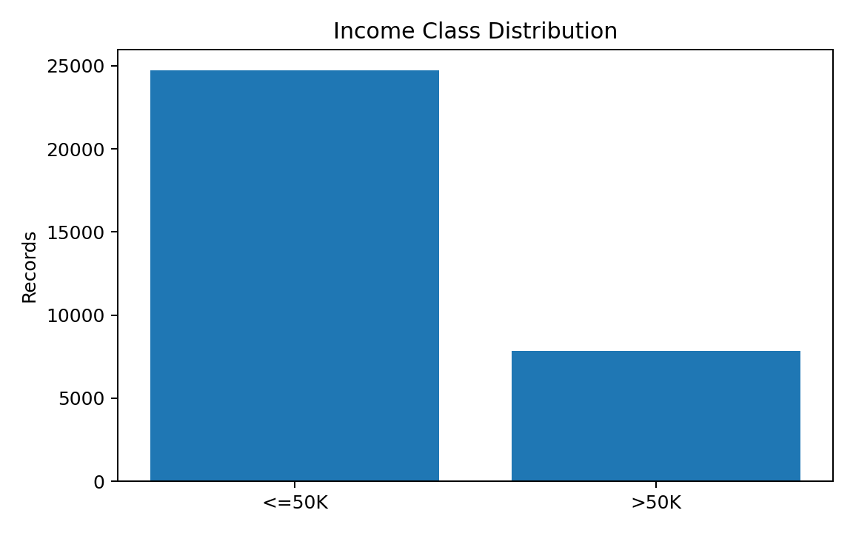
Figure 1. Distribution of the two income categories in the 32,561-record training dataset.
The target is not evenly distributed. There are 24,720 records in the <=50K category and 7,841 in the >50K category. This imbalance should be considered if the cleaned data is later used to train a classification model.

4. Missing-Value Analysis
A simple isna() check alone is not sufficient for this dataset because missing categorical values are represented by the character '?'. Therefore, the placeholder was first identified and then converted into an actual missing value.
# Count the raw missing-value marker
missing_marker = (df == "?").sum()
print(missing_marker[missing_marker > 0])
# Convert the marker to NaN
df = df.replace("?", np.nan)
# Confirm missing values
print(df.isna().sum())
Column | Missing values | Approx. percentage
workclass | 1,836 | 5.64%
occupation | 1,843 | 5.66%
native-country | 583 | 1.79%
Total missing cells | 4,262 | 0.9% of all cells
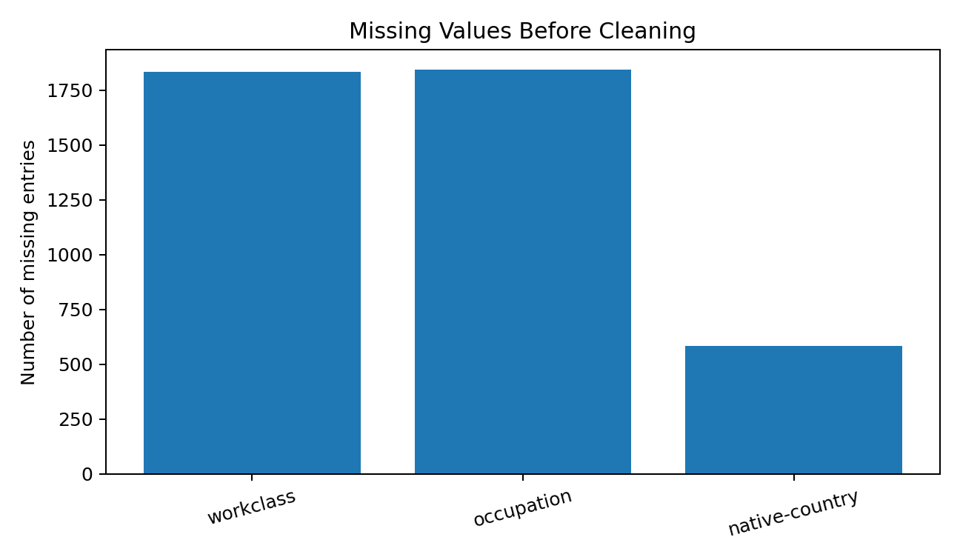
Figure 2. Missing values found in the raw training data.
The missing values are concentrated in three categorical columns. External analysis of the same UCI dataset reports 4,262 missing cells and 2,399 rows containing at least one missing value. This means the missingness is meaningful enough to handle explicitly rather than silently ignoring it.

5. Data Cleaning Procedures

5.1 Whitespace and Category Consistency
The raw file contains spaces around some categorical values. These were removed so that values such as 'Private' and ' Private' cannot accidentally be treated as different categories.
categorical_columns = df.select_dtypes(include="object").columns
for col in categorical_columns:
df[col] = df[col].str.strip()

5.2 Duplicate Records
duplicate_count = df.duplicated().sum()
print("Duplicate rows:", duplicate_count)
df = df.drop_duplicates().reset_index(drop=True)
print("Shape after removing duplicates:", df.shape)
The initial duplicate check identifies 24 duplicate rows. They were removed because keeping exact duplicate records can give repeated observations extra influence during descriptive analysis and later model training.

5.3 Handling Missing Categorical Values
Instead of deleting every row containing a missing category, the missing entries were represented using an explicit 'Unknown' category. This preserves the remaining information in those records and avoids unnecessarily reducing the dataset by approximately 7.4% of rows.
categorical_missing = ["workclass", "occupation", "native-country"]
for col in categorical_missing:
df[col] = df[col].fillna("Unknown")
This approach also keeps the fact that the original value was unavailable. Mode imputation was considered, but replacing an unknown occupation or workclass with the most common category could introduce artificial patterns.

6. Checking for Erroneous Entries
Range checks were used for variables where domain boundaries are clear. The purpose was to identify impossible values rather than remove values simply because they were uncommon.
range_checks = {
"age": (17, 90),
"education-num": (1, 16),
"hours-per-week": (1, 99)
}
for col, (low, high) in range_checks.items():
invalid = df[(df[col] < low) | (df[col] > high)]
print(col, "invalid rows:", len(invalid))
The documented Adult data was already extracted using basic validity conditions, and the observed age range is 17–90. No correction was therefore applied to ordinary values within the valid domain ranges.

7. Outlier Detection and Treatment
Outliers were reviewed using the interquartile range (IQR) method. An IQR flag is useful for finding unusually high or low observations, but it does not automatically prove that a record is incorrect.
numeric_columns = [
"age", "fnlwgt", "education-num",
"capital-gain", "capital-loss", "hours-per-week"
]
for col in numeric_columns:
q1 = df[col].quantile(0.25)
q3 = df[col].quantile(0.75)
iqr = q3 - q1
lower = q1 - 1.5 * iqr
upper = q3 + 1.5 * iqr
outliers = df[(df[col] < lower) | (df[col] > upper)]
print(col, "IQR outliers:", len(outliers))
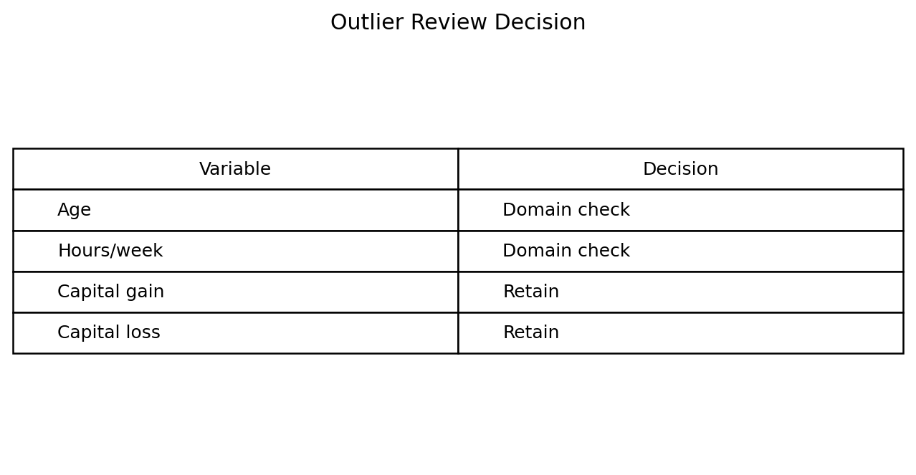
Figure 3. Outlier review approach used in the preprocessing process.
Variable | Treatment decision | Reason
age | Retain valid extremes | Older ages are possible observations
fnlwgt | Retain | Sampling weights can naturally vary widely
education-num | Retain | Valid encoded education levels are 1–16
capital-gain | Retain valid extremes | Large gains can be genuine financial observations
capital-loss | Retain valid extremes | Large losses can be genuine observations
hours-per-week | Review and retain valid values | High working hours may be unusual but not automatically erroneous
This decision is important because blindly deleting IQR outliers could remove valid high-income, high-working-hour, or high-capital-gain observations. For later modelling, robust scaling or transformations can be considered if a specific algorithm requires them.

8. Preprocessing for Further Analysis

8.1 Target Encoding
df["income"] = df["income"].str.strip()
df["income"] = df["income"].map({
"<=50K": 0,
">50K": 1
})
The target was converted into a binary numeric representation so that it can be used directly by common machine-learning algorithms.

8.2 Categorical Encoding
X = df.drop(columns="income")
y = df["income"]
X_encoded = pd.get_dummies(
X,
columns=X.select_dtypes(include="object").columns,
drop_first=False
)
print(X_encoded.shape)
One-hot encoding was selected for nominal categorical features because assigning arbitrary numbers to categories can create a false ordering. For example, assigning Private=1 and State-gov=2 would not mean that State-gov is 'greater' than Private.

8.3 Numerical Scaling
Scaling is not required for every analysis. If a distance-based or gradient-based model is used later, numerical variables can be standardized. The scaler should be fitted only on the training data to prevent data leakage.
from sklearn.preprocessing import StandardScaler
numeric_features = [
"age", "fnlwgt", "education-num",
"capital-gain", "capital-loss", "hours-per-week"
]
scaler = StandardScaler()
# Fit the scaler on training data only:
# X_train[numeric_features] = scaler.fit_transform(
# X_train[numeric_features]
# )
#
# Apply the same fitted scaler to validation/test data:
# X_test[numeric_features] = scaler.transform(
# X_test[numeric_features]
# )

9. Validation After Cleaning
print("Remaining missing values:")
print(df.isna().sum())
print("Remaining duplicate rows:", df.duplicated().sum())
print("Data types:")
print(df.dtypes)
print("Final shape:", df.shape)
The final validation stage checks that the cleaning operations actually produced the intended result. The expected checks are: no remaining missing values in the selected categorical fields, zero exact duplicate rows, consistent data types, and a documented final row count.

10. Challenges Faced and How They Were Addressed
Challenge | How it was handled
Missing values were stored as '?' | Converted '?' to NaN before applying missing-value handling.
Categorical values contained extra spaces | Applied string stripping to object columns.
Exact duplicate records | Detected with duplicated() and removed using drop_duplicates().
Unusual numerical observations | Used IQR as a detection method and then checked whether extremes were plausible.
Risk of losing too many records | Used an explicit Unknown category rather than dropping all rows with missing categories.
Potential data leakage | Documented that scaling/encoding fitted for modelling should be learned from training data only.

11. Impact of Preprocessing on Subsequent Analysis
Preprocessing changes the representation of the dataset, so the effects should be considered before interpreting results.
- Removing duplicate rows prevents repeated records from receiving unintended extra weight.
- Representing missing categories as Unknown preserves observations but introduces an additional category that should be interpreted carefully.
- One-hot encoding makes categorical variables usable by numerical machine-learning algorithms without imposing an artificial ranking.
- Keeping legitimate outliers preserves real-world variation, but some algorithms may still be sensitive to extreme numerical values.
- Target encoding makes the income label usable for classification, while the original meaning of the two categories is retained in the documentation.
- If the cleaned data is used for predictive modelling, all learned preprocessing parameters should be fitted only on the training split.

12. Reflection
The main lesson from this preprocessing task is that cleaning is not simply a process of deleting unusual records. A data-quality decision should be connected to the meaning of the variable. In this dataset, the question-mark values were clearly missing-value markers, so converting them to NaN was appropriate. In contrast, a very large capital gain or a high number of working hours is not automatically an error.
I also found that preserving information can be preferable to aggressive row deletion. Using an Unknown category for missing categorical values keeps the records available for later analysis while making the missingness visible. The resulting dataset is therefore more consistent and easier to use in later exploratory analysis or machine-learning experiments.

13. Final Summary
Stage | Result
Data acquisition | Public UCI Adult dataset selected and documented
Initial exploration | Structure, types, target distribution and cardinality reviewed
Missing values | 4,262 missing cells identified across three columns
Duplicates | 24 duplicate rows identified and removed
Consistency | Whitespace and categorical formatting standardized
Outliers | IQR-based detection followed by domain-based review
Categorical preprocessing | Missing categories represented as Unknown; one-hot encoding prepared
Target preprocessing | Income converted to binary 0/1 representation
Validation | Missingness, duplicates, types and final shape checked

14. References
1. UCI Machine Learning Repository — Adult Dataset
https://archive.ics.uci.edu/dataset/2/adult
2. Becker, B. & Kohavi, R. (1996). Adult [Dataset]. UCI Machine Learning Repository. DOI: 10.24432/C5XW20.
3. UCI Adult dataset documentation and variable descriptions.
https://archive.ics.uci.edu/ml/machine-learning-databases/adult/

