Week 6 – Integrative Data Science Capstone Project
End-to-End Analysis of the Breast Cancer Wisconsin Diagnostic Dataset
Python • Pandas • Scikit-learn • EDA • Supervised Learning • Clustering

1. Executive Summary
This capstone project integrates the main Data Science skills developed throughout the internship into one reproducible Python workflow. The project starts with acquisition of a public dataset and continues through data quality checks, exploratory data analysis, supervised classification, unsupervised clustering, model evaluation, interpretation, recommendations, and reflection.
The Breast Cancer Wisconsin Diagnostic dataset is used as the common analytical foundation. The supervised component predicts whether an observation is malignant or benign using Logistic Regression. The unsupervised component uses K-Means clustering to discover natural groups based on selected cell measurements without using the diagnosis label.
The supervised model achieved 0.974 test accuracy, 0.979 F1 score, and 0.994 ROC-AUC. The clustering analysis selected k=2 based on the strongest silhouette score among the tested values from 2 through 6.

2. Project Problem Statement
The broader analytical problem is to understand whether quantitative measurements of cell nuclei can support useful classification and descriptive segmentation.
- Supervised question: Can a machine learning model classify an observation as malignant or benign?
- Unsupervised question: Do observations naturally form groups based on their measured characteristics?
- Business/research objective: Demonstrate how predictive and descriptive analytics can be combined in one workflow.
This is an educational data science project and should not be treated as a clinical diagnostic system. Any real-world medical use would require independent clinical validation, governance, appropriate patient data handling, and domain-expert oversight.

3. Why This Dataset Was Selected
The Breast Cancer Wisconsin Diagnostic dataset was selected because it supports multiple parts of the capstone without requiring unrelated datasets. It contains a clearly defined binary target for supervised learning and a rich collection of continuous measurements that can also be explored with unsupervised learning.
- Publicly available benchmark dataset.
- 569 observations and 30 original numerical predictors.
- Binary target suitable for classification.
- Continuous measurements suitable for scaling and clustering.
- Small enough to reproduce on ordinary hardware.
- Well suited to demonstrating the complete internship data science pipeline.

4. Data Acquisition
The data was acquired through Scikit-learn's public dataset loader, which provides access to the UCI Breast Cancer Wisconsin Diagnostic dataset.
from sklearn.datasets import load_breast_cancer
raw = load_breast_cancer(as_frame=True)
df = raw.frame.copy()
The target column was renamed to diagnosis and an additional human-readable diagnosis_label column was created for analysis. The original numerical target encoding was retained for machine learning.
df = df.rename(columns={"target": "diagnosis"})
df["diagnosis_label"] = df["diagnosis"].map({
0: "Malignant",
1: "Benign"
})

5. Data Cleaning and Quality Checks
The initial dataset contains 569 rows and 32 columns after the human-readable label was added. The quality checks were designed to identify missing values, duplicate records, and inappropriate variables.
Quality Check | Result
Missing values | 0
Duplicate rows | 0
Original predictor count | 30
Target classes | 2
No missing values or duplicate rows were present in the loaded benchmark data, so no imputation or duplicate deletion was necessary. The main preprocessing requirement was to keep the target separate from predictor variables and scale features before algorithms that are sensitive to feature magnitude.

6. Exploratory Data Analysis
EDA was used to understand the target distribution, numerical ranges, relationships among features, and differences between the two diagnosis classes before modeling.
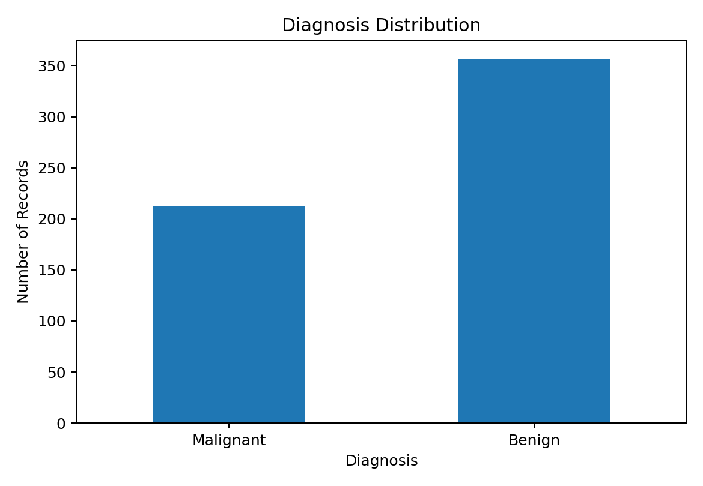
Figure 1. Distribution of the two diagnosis classes.
The dataset contains 357 benign and 212 malignant observations. Benign cases represent 62.7% of the data, while malignant cases represent 37.3%. The difference is not extreme, but stratified splitting is still used to preserve class proportions.
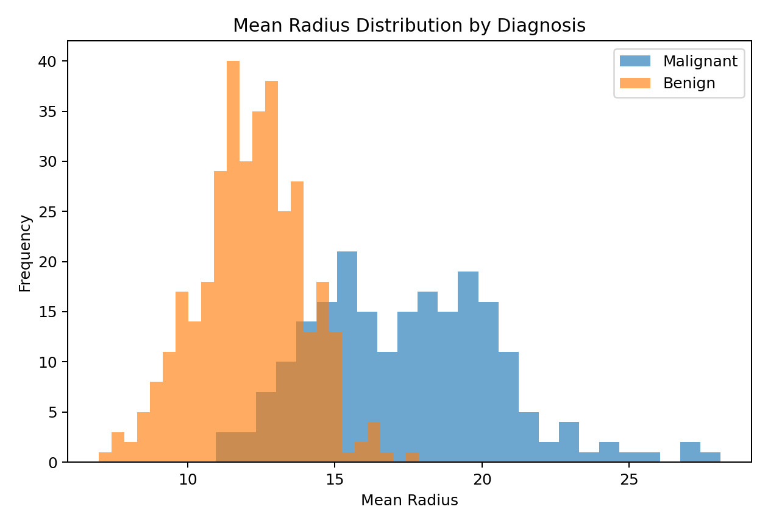
Figure 2. Mean radius distribution by diagnosis.
The distribution shows that mean radius is useful for distinguishing the two classes, although there is overlap. This is a good example of why a model should consider multiple measurements rather than relying on one feature.

7. Correlation Analysis
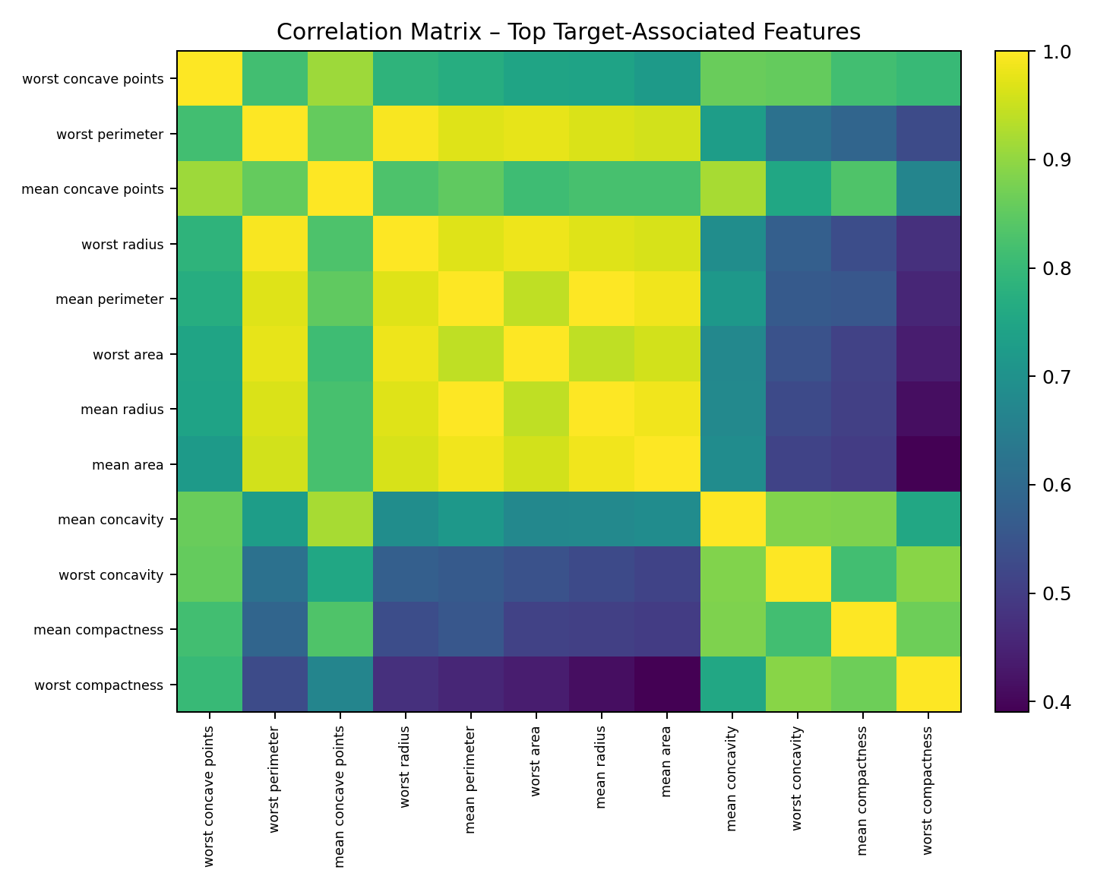
Figure 3. Correlation matrix for strongly target-associated features.
The correlation analysis highlights groups of measurements that move together. Strong relationships among size-related features are expected because radius, perimeter, and area describe related geometric properties. This also motivates the use of scaling and feature selection in the supervised pipeline.

8. Methodological Approach
The capstone pipeline was organized into seven major phases:
- Acquire and load the public dataset.
- Check data quality and separate target from predictors.
- Explore distributions, relationships, and class balance.
- Split data into training and test partitions.
- Build and validate a supervised classification model.
- Perform unsupervised clustering independently of the target label.
- Compare findings, interpret results, and formulate recommendations.

9. Supervised Learning Component
Logistic Regression was selected as the main supervised model because the target is binary, the predictors are numerical, and the model provides a strong, interpretable baseline.
The model pipeline performs StandardScaler preprocessing followed by SelectKBest feature selection and Logistic Regression. Keeping these steps inside a single Pipeline prevents preprocessing information from leaking across cross-validation folds.
model = Pipeline([
("scaler", StandardScaler()),
("selector", SelectKBest(score_func=f_classif, k=20)),
("classifier", LogisticRegression(
max_iter=5000,
random_state=42
))
])

10. Supervised Model Validation
Five-fold stratified cross-validation was applied to the training set. Stratification ensures that each fold retains a similar malignant/benign proportion.
Metric | Mean | Std. Dev.
ACCURACY | 0.9758 | 0.0082
PRECISION | 0.9726 | 0.0131
RECALL | 0.9895 | 0.0086
F1 | 0.9809 | 0.0064
ROC_AUC | 0.9955 | 0.0045
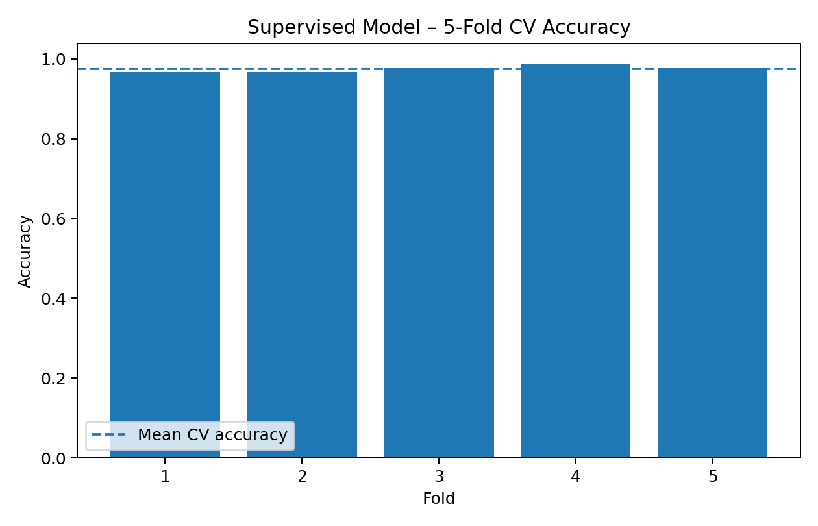
Figure 4. Five-fold cross-validation accuracy.
The relatively small variation between validation folds suggests that the supervised model is reasonably stable on this benchmark dataset.

11. Final Supervised Evaluation
Metric | Test Result
Accuracy | 0.9737
Precision | 0.9859
Recall | 0.9722
F1 Score | 0.9790
ROC-AUC | 0.9944
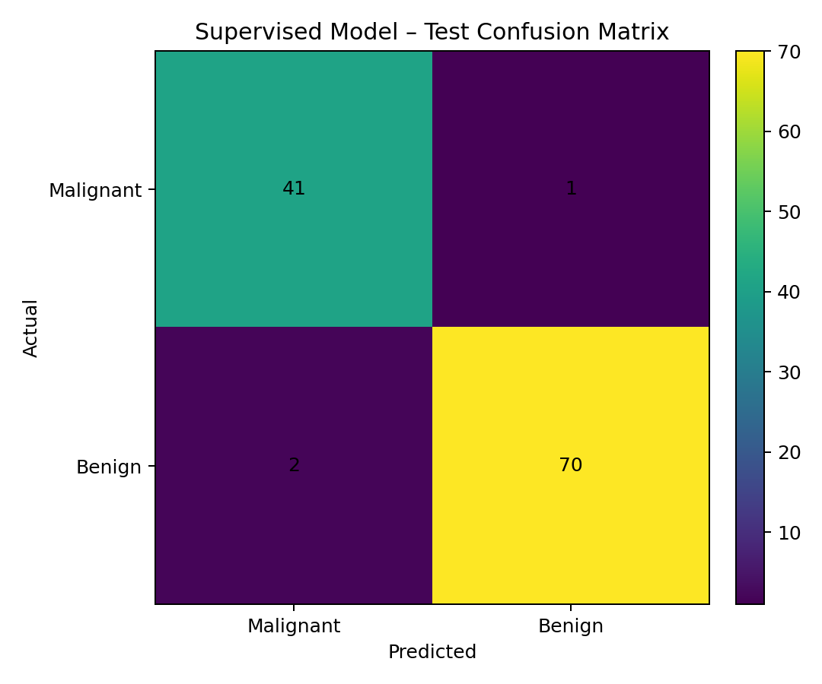
Figure 5. Confusion matrix for the held-out supervised test set.
Accuracy provides the overall proportion of correct predictions, while precision, recall, and F1 describe different aspects of classification performance. ROC-AUC measures how well the model ranks the two classes across thresholds.

12. Unsupervised Learning Component
The second analytical question was approached without using the diagnosis label. K-Means clustering was applied to eight selected continuous measurements representing size and shape characteristics.
The selected features were standardized because K-Means uses distance calculations and features with larger numerical scales could otherwise dominate the cluster assignments.
cluster_features = [
"mean radius",
"mean texture",
"mean perimeter",
"mean area",
"mean smoothness",
"mean compactness",
"mean concavity",
"mean concave points"
]
scaler = StandardScaler()
X_cluster = scaler.fit_transform(df[cluster_features])

13. Choosing the Number of Clusters
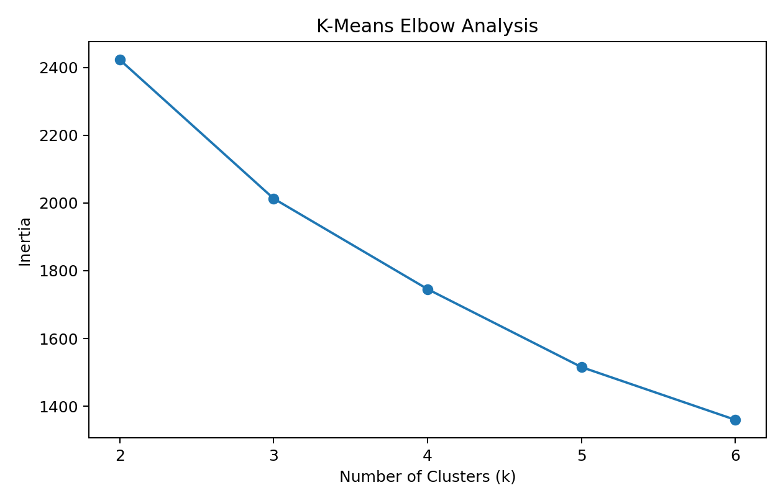
Figure 6. K-Means elbow analysis.
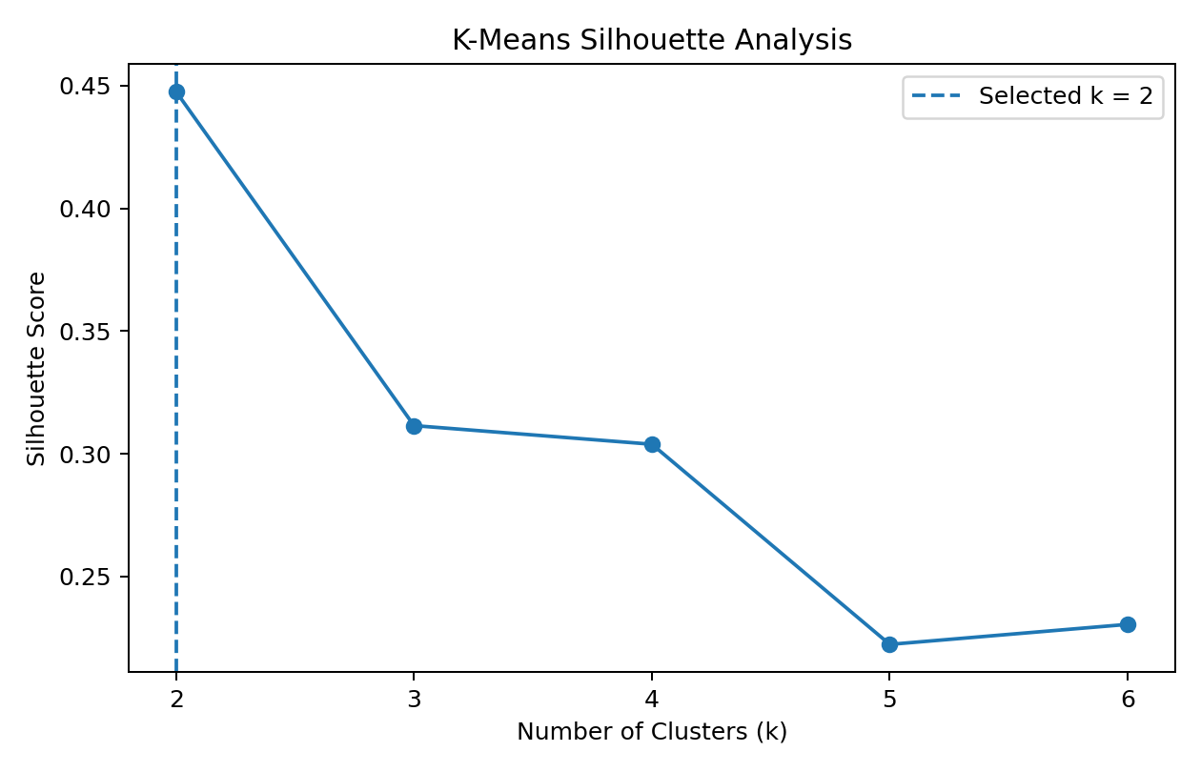
Figure 7. Silhouette analysis for k=2 through k=6.
The experiment tested k values from 2 to 6. The selected value was k=2, corresponding to the highest silhouette score among the tested alternatives (0.4475). The silhouette score complements the elbow method by measuring how well observations fit within their assigned clusters relative to neighboring clusters.

14. Cluster Results and Interpretation
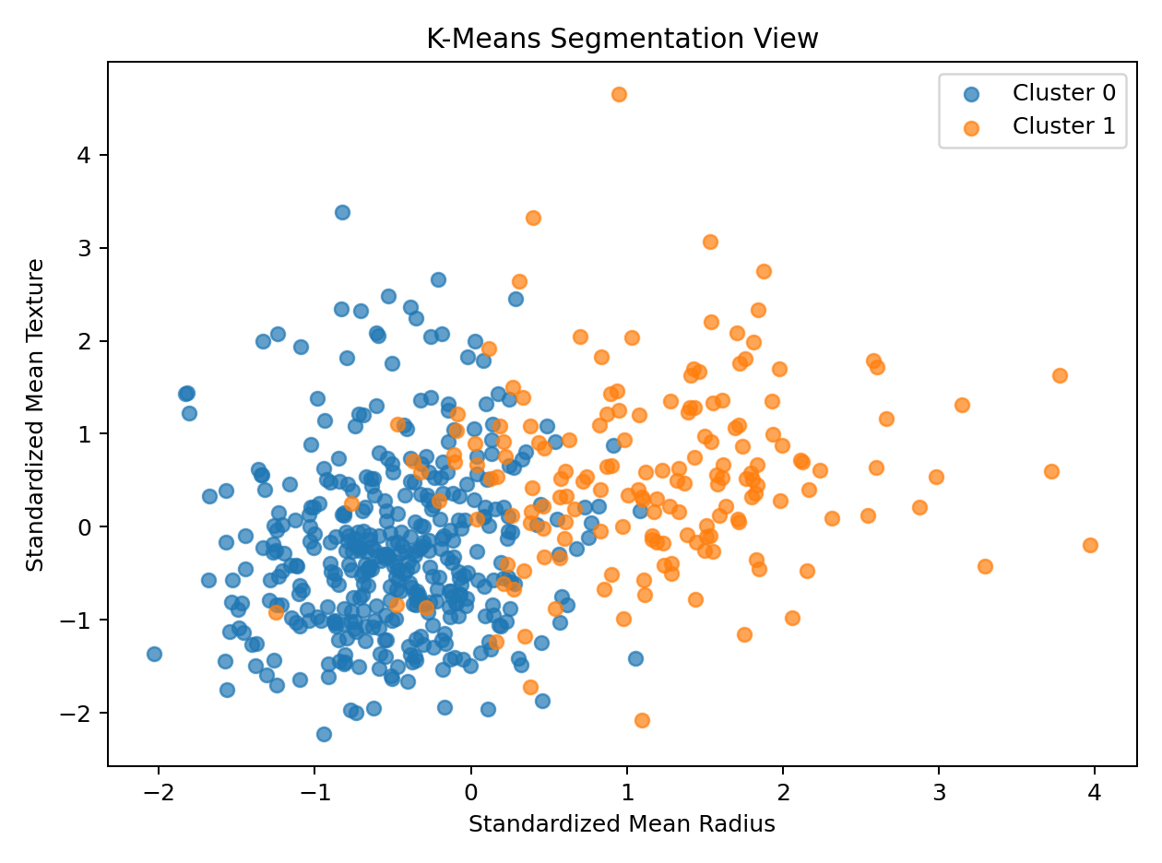
Figure 8. Two-dimensional view of the K-Means segmentation using standardized radius and texture.
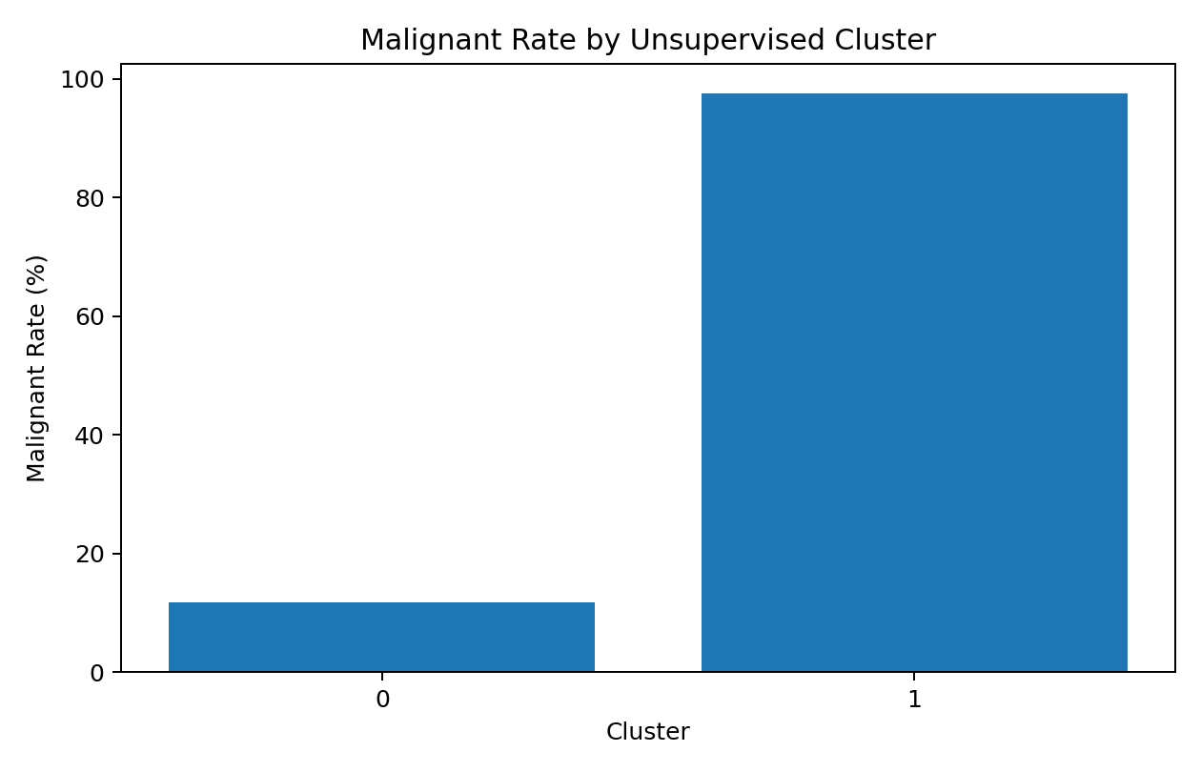
Figure 9. Malignant rate observed within each unsupervised cluster.
The clustering analysis should be interpreted as descriptive segmentation rather than as a replacement for the supervised diagnosis model. The diagnosis label was not supplied to K-Means. After clustering, the label was examined only to understand whether naturally formed groups showed different class compositions.
Cluster | Size | Malignant Rate | Interpretation
0 | 400 | 11.8% | Lower-risk measurement profile
1 | 169 | 97.6% | Higher-risk measurement profile

15. Integrating Supervised and Unsupervised Findings
The two modeling approaches answer different questions and therefore should not be treated as competing models. The supervised model uses known labels to predict diagnosis, while K-Means ignores the labels and discovers groups from the feature space.
Aspect | Supervised | Unsupervised
Goal | Predict diagnosis | Discover natural groups
Target label used? | Yes | No
Method | Logistic Regression | K-Means
Evaluation | Accuracy, F1, ROC-AUC, confusion matrix | Silhouette score, cluster profiles
Primary value | Prediction | Segmentation / structure discovery

16. Key Insights
- The supervised model achieved 97.37% test accuracy and 99.44% ROC-AUC on the held-out benchmark set.
- Size- and shape-related measurements show meaningful relationships with the diagnosis target.
- Several predictors are strongly correlated with each other, demonstrating why feature selection and regularized modeling are useful.
- The unsupervised analysis identified 2 clusters based only on selected numerical measurements, demonstrating that the dataset contains distinguishable structural patterns.
- Some clusters show different observed malignant proportions, suggesting that unsupervised structure can complement supervised analysis.
- The strongest conclusion is methodological: combining predictive and descriptive modeling provides a more complete understanding than using either approach alone.

17. Recommendations
- Use the supervised classifier as a benchmark prediction model, but do not treat its benchmark accuracy as evidence of clinical readiness.
- Compare Logistic Regression with Random Forest, Support Vector Machine, and Gradient Boosting to determine whether more flexible models provide meaningful gains.
- Evaluate clustering stability under different random seeds and feature subsets before using clusters for any operational segmentation.
- Validate the final predictive model on an independent external dataset to test generalization.
- Use domain expertise to engineer additional clinically meaningful features rather than relying only on generic statistical transformations.
- If deployed in a real decision-support setting, monitor false-negative and false-positive costs, calibration, data drift, and model performance over time.

18. Challenges Encountered
Challenge | Why It Matters | Solution / Decision
Feature scale differences | Distance-based and gradient-based methods can be affected by scale. | StandardScaler was applied inside the appropriate modeling workflows.
Correlated predictors | Many geometric measurements contain overlapping information. | Feature selection and regularized Logistic Regression were used.
Model validation | A single split can give an unstable estimate. | Five-fold stratified cross-validation was used.
Choosing cluster count | K-Means requires k to be specified. | Elbow and silhouette analyses were compared.
Interpretation risk | Benchmark performance can be mistaken for real-world performance. | Limitations and external validation requirements are explicitly documented.

19. What Worked Well
- Using one public dataset allowed the full pipeline to remain coherent.
- The data was small enough for fast experimentation and reproducibility.
- The supervised model provided strong predictive performance on the held-out benchmark.
- The unsupervised analysis added a second perspective without using the diagnosis label.
- The use of pipelines and stratified validation reduced common sources of evaluation leakage.

20. Limitations of the Capstone
- The dataset is a relatively small benchmark dataset rather than a modern production dataset.
- The analysis is based on a single source and does not include external validation.
- Only one primary supervised algorithm and one clustering algorithm are implemented.
- The unsupervised cluster count is dependent on the selected features and standardization.
- The project does not include a production deployment layer, monitoring system, or database.
- Medical interpretation requires domain expertise beyond the scope of this internship exercise.

21. Future Scope
- Compare several supervised algorithms using the same cross-validation framework.
- Build a CNN-based image model if the original image data is available.
- Perform dimensionality reduction such as PCA before clustering and compare segmentation stability.
- Use external validation and subgroup analysis to assess generalization.
- Add model explainability and calibrated probability estimates.
- Package the final pipeline into a small dashboard or API for demonstration purposes.

22. Reflective Discussion
The main learning from the capstone is that a Data Science project is a sequence of connected decisions rather than a single model-training step. Data quality determines what can be trusted; EDA determines which relationships deserve attention; preprocessing affects model behavior; validation determines whether performance estimates are credible; and interpretation determines whether the results are useful.
The project also demonstrates the difference between prediction and discovery. Supervised learning uses known outcomes to make predictions, while unsupervised learning searches for structure without being given the outcome. Using both approaches on the same feature space makes the analysis more complete and provides a stronger demonstration of practical Data Science skills.

23. End-to-End Python Pipeline
# Acquisition
data = load_breast_cancer(as_frame=True)
df = data.frame.copy()
# Cleaning / target preparation
df = df.rename(columns={"target": "diagnosis"})
df["diagnosis_label"] = df["diagnosis"].map({
0: "Malignant",
1: "Benign"
})
# Supervised modeling
X = df[feature_cols]
y = df["diagnosis"]
# train/test split
X_train, X_test, y_train, y_test = train_test_split(
X, y, test_size=0.20,
random_state=42, stratify=y
)
# supervised model
model = Pipeline([
("scaler", StandardScaler()),
("selector", SelectKBest(f_classif, k=20)),
("classifier", LogisticRegression(max_iter=5000))
])
# unsupervised modeling
X_cluster = StandardScaler().fit_transform(
df[cluster_features]
)
kmeans = KMeans(
n_clusters=best_k,
random_state=42,
n_init=20
)
clusters = kmeans.fit_predict(X_cluster)

24. Final Conclusion
This capstone successfully combines the major Data Science concepts covered during the internship into a single reproducible workflow. The project includes public data acquisition, quality checks, exploratory analysis, supervised classification, unsupervised clustering, cross-validation, model evaluation, interpretation, recommendations, and reflection.
The supervised model demonstrates that the numerical measurements contain strong predictive information for the benchmark classification task, while the clustering component demonstrates that meaningful structure can also be discovered without using the target label.
Most importantly, the project emphasizes responsible interpretation. Strong benchmark metrics are useful evidence about this dataset, but they do not automatically imply real-world deployment readiness. Independent validation, domain expertise, monitoring, and careful consideration of error costs would be required for a production system.

25. References
- UCI Machine Learning Repository – Breast Cancer Wisconsin (Diagnostic) dataset.
- Scikit-learn documentation – load_breast_cancer.
- Scikit-learn documentation – Pipeline and StandardScaler.
- Scikit-learn documentation – LogisticRegression and classification metrics.
- Scikit-learn documentation – KMeans and silhouette_score.
- Scikit-learn documentation – model_selection and cross-validation.

Appendix A – Complete Python Script
The accompanying file week6_integrative_data_science_capstone.py contains the complete reproducible implementation for the capstone analysis.

