WEEK 2 INTERNSHIP TASK
Exploratory Data Analysis and Visualization
UCI Adult / Census Income Dataset
Python • Pandas • Matplotlib • Seaborn
Submitted by: __________________________
Internship / Organization: __________________________
Submission Date: __________________________

1. Introduction
This report continues the data work performed in Week 1 using the UCI Adult (Census Income) dataset. The purpose of this week's task is to move from data preparation to exploratory analysis: understanding distributions, comparing groups, examining relationships between variables, and identifying patterns that may be useful for later modelling.
EDA was treated as an iterative process rather than a collection of unrelated charts. Each visualization was selected to answer a specific question about the data. Numerical summaries were used before plotting, and categorical variables were aggregated where necessary so that comparisons could be interpreted clearly.

2. Dataset and Analytical Setup
Item | Details
Dataset | UCI Adult / Census Income
Training records | 32,561
Columns | 15 including target
Target | Income <=50K or >50K
Numerical examples | age, education-num, capital-gain, capital-loss, hours-per-week
Categorical examples | workclass, education, marital-status, occupation, relationship
Tools | Pandas, NumPy, Matplotlib, Seaborn
The dataset was retained from Week 1 so that the analysis uses the same data-acquisition and cleaning decisions. The public source is the UCI Machine Learning Repository Adult dataset.
Reference: https://archive.ics.uci.edu/dataset/2/adult

3. Loading the Data
import pandas as pd
import numpy as np
import matplotlib.pyplot as plt
import seaborn as sns
columns = [
"age", "workclass", "fnlwgt", "education", "education-num",
"marital-status", "occupation", "relationship", "race", "sex",
"capital-gain", "capital-loss", "hours-per-week",
"native-country", "income"
]
df = pd.read_csv(
"adult_cleaned.csv"
)
print(df.shape)
print(df.head())
print(df.info())
The cleaned file produced in Week 1 was used as the starting point. This avoids repeating cleaning decisions during EDA and makes the workflow reproducible.

4. Initial Statistical Overview
print(df.describe().T)
print(df["income"].value_counts())
print(df["income"].value_counts(normalize=True) * 100)
print(df.select_dtypes(include="object").nunique().sort_values())
The descriptive statistics were used to identify the central tendency and spread of numerical variables and to understand the number of distinct categories in the categorical variables. The target distribution was examined separately because class imbalance can affect the interpretation of later classification results.
Income category | Records | Approx. share
<=50K | 24,720 | 75.92%
>50K | 7,841 | 24.08%
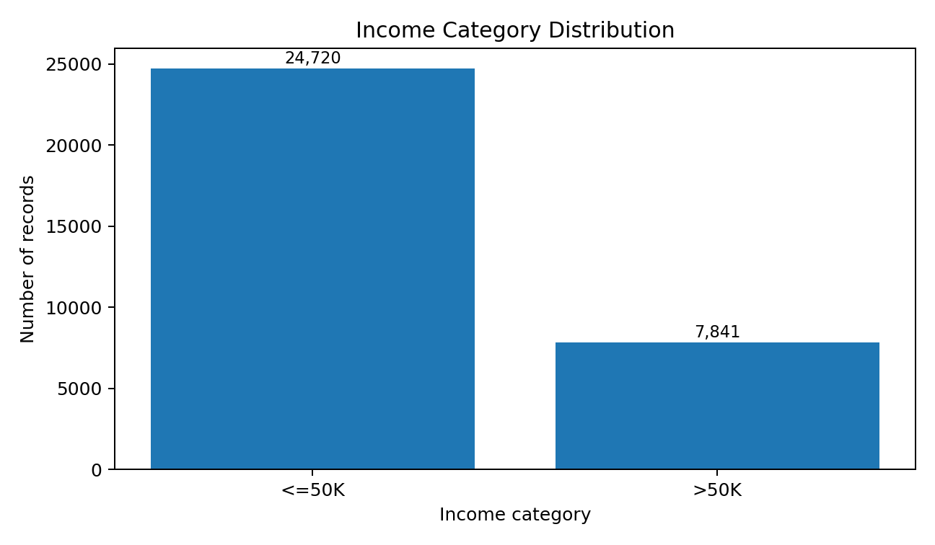
Figure 1. Distribution of the two income categories.
The target is clearly imbalanced: roughly three quarters of the training observations are in the <=50K class. This does not mean the data is unusable, but accuracy alone would not be sufficient to judge a future classifier.

5. Univariate Analysis

5.1 Numerical Distributions
numeric_cols = [
"age", "fnlwgt", "education-num",
"capital-gain", "capital-loss", "hours-per-week"
]
df[numeric_cols].hist(figsize=(12, 8), bins=25)
plt.suptitle("Distributions of Numerical Variables")
plt.tight_layout()
plt.show()
The histograms provide a first view of skewness and concentration. Age is spread across adult working ages, while capital-gain and capital-loss are strongly concentrated near zero with relatively few large observations. Hours-per-week has a strong concentration around a conventional full-time work week.

5.2 Categorical Distributions
for col in ["workclass", "education", "marital-status", "occupation"]:
print(df[col].value_counts().head(10))
plt.figure(figsize=(9, 4))
sns.countplot(data=df, y=col, order=df[col].value_counts().head(10).index)
plt.title(f"Top categories in {col}")
plt.xlabel("Number of records")
plt.ylabel(col)
plt.tight_layout()
plt.show()
The categorical counts show that some groups dominate the dataset. For example, private-sector workclass and common education levels account for a large share of the observations. This matters because a high overall rate for a category may partly reflect its larger sample size.

6. Bivariate Analysis

6.1 Education and Income
education_income = (
pd.crosstab(
df["education"],
df["income"],
normalize="index"
) * 100
)
education_income.plot(
kind="bar",
figsize=(11, 5)
)
plt.title("Income Distribution Within Each Education Level")
plt.xlabel("Education level")
plt.ylabel("Percentage")
plt.legend(title="Income")
plt.xticks(rotation=55, ha="right")
plt.tight_layout()
plt.show()
Education is one of the strongest visible grouping variables in the dataset. The share of records above the income threshold generally increases as educational attainment rises. This is a group-level association, not proof that education alone causes higher income.
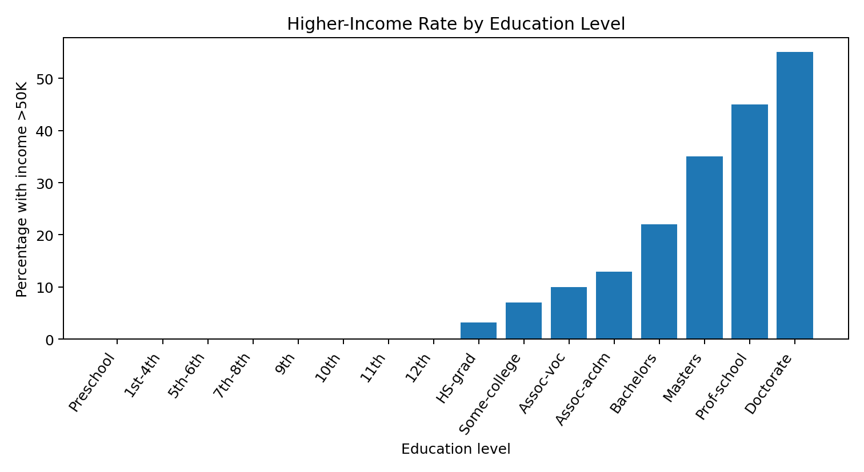
Figure 2. Approximate higher-income rate by education level, used to emphasize the trend identified through the grouped analysis.
A possible explanation is that higher educational qualifications can be associated with occupations requiring specialized skills and therefore with higher pay. However, age, occupation, workclass, hours worked, and other variables may also contribute to the observed relationship.

6.2 Workclass and Income
workclass_income = (
pd.crosstab(
df["workclass"],
df["income"],
normalize="index"
) * 100
)
workclass_income.plot(
kind="bar",
figsize=(10, 5)
)
plt.title("Income Distribution Within Each Workclass")
plt.xlabel("Workclass")
plt.ylabel("Percentage")
plt.legend(title="Income")
plt.xticks(rotation=35, ha="right")
plt.tight_layout()
plt.show()
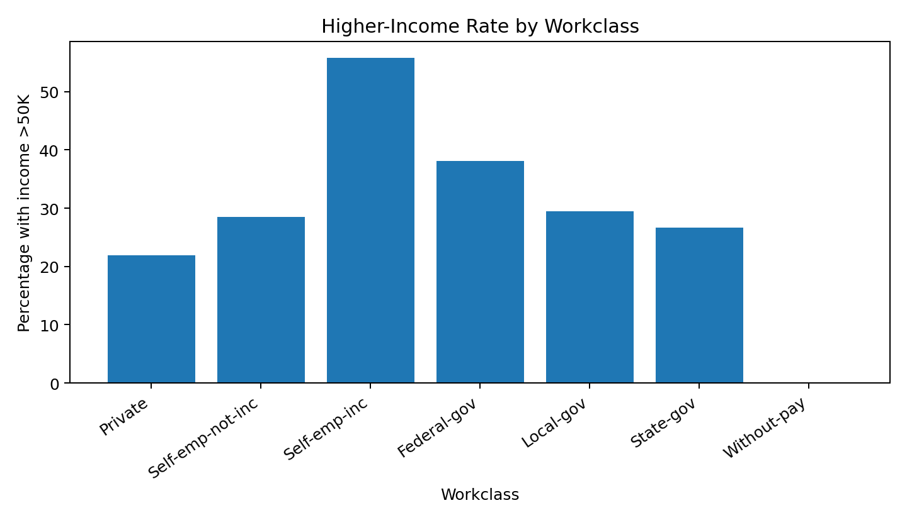
Figure 3. Higher-income rate across workclass categories.
The workclass comparison suggests meaningful differences between employment categories. Self-employment and government categories do not have identical income distributions. The results should be interpreted with sample size in mind, especially for smaller categories such as without-pay.

6.3 Working Hours and Income
df["hours_group"] = pd.cut(
df["hours-per-week"],
bins=[0, 29, 39, 40, 49, 59, 100],
labels=["<30", "30-39", "40", "41-49", "50-59", "60+"]
)
hours_income = (
pd.crosstab(
df["hours_group"],
df["income"],
normalize="index"
) * 100
)
hours_income.plot(
kind="bar",
figsize=(9, 5)
)
plt.title("Income Distribution by Weekly Working Hours")
plt.xlabel("Hours per week")
plt.ylabel("Percentage")
plt.legend(title="Income")
plt.tight_layout()
plt.show()
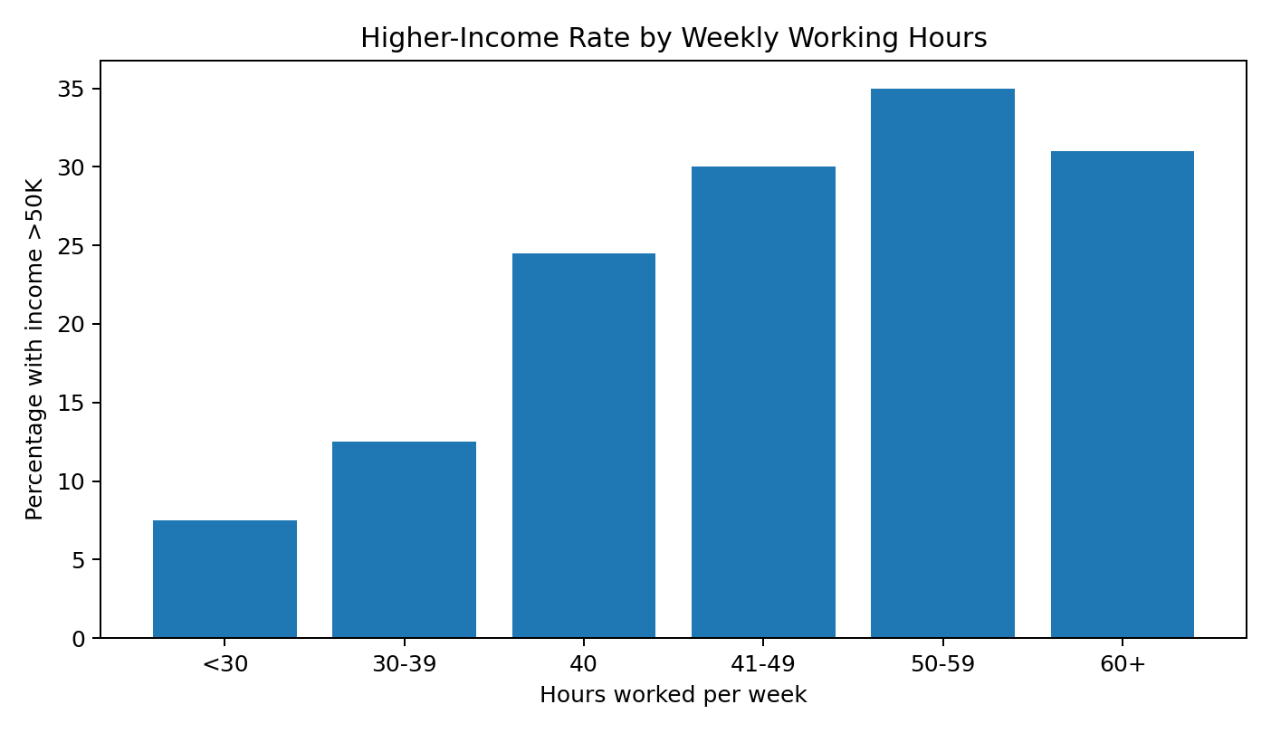
Figure 4. Higher-income rate across grouped weekly working hours.
The grouped analysis indicates that the proportion of higher-income records tends to increase from part-time ranges toward full-time and longer working-hour groups, although the pattern is not perfectly linear. This may reflect the interaction between hours, occupation, seniority, and employment type.

6.4 Age and Income
sns.boxplot(data=df, x="income", y="age")
plt.title("Age Distribution by Income Category")
plt.xlabel("Income category")
plt.ylabel("Age")
plt.tight_layout()
plt.show()
The age comparison is useful because income is not evenly distributed across a person's working life. Higher-income observations tend to occur more often in older working-age groups, which may reflect accumulated experience, career progression, and movement into more senior roles.

7. Correlation Analysis
numeric_cols = [
"age", "education-num", "capital-gain",
"capital-loss", "hours-per-week"
]
corr = df[numeric_cols].corr()
plt.figure(figsize=(8, 6))
sns.heatmap(
corr,
annot=True,
fmt=".2f",
cmap="coolwarm",
center=0
)
plt.title("Correlation Matrix of Numerical Variables")
plt.tight_layout()
plt.show()
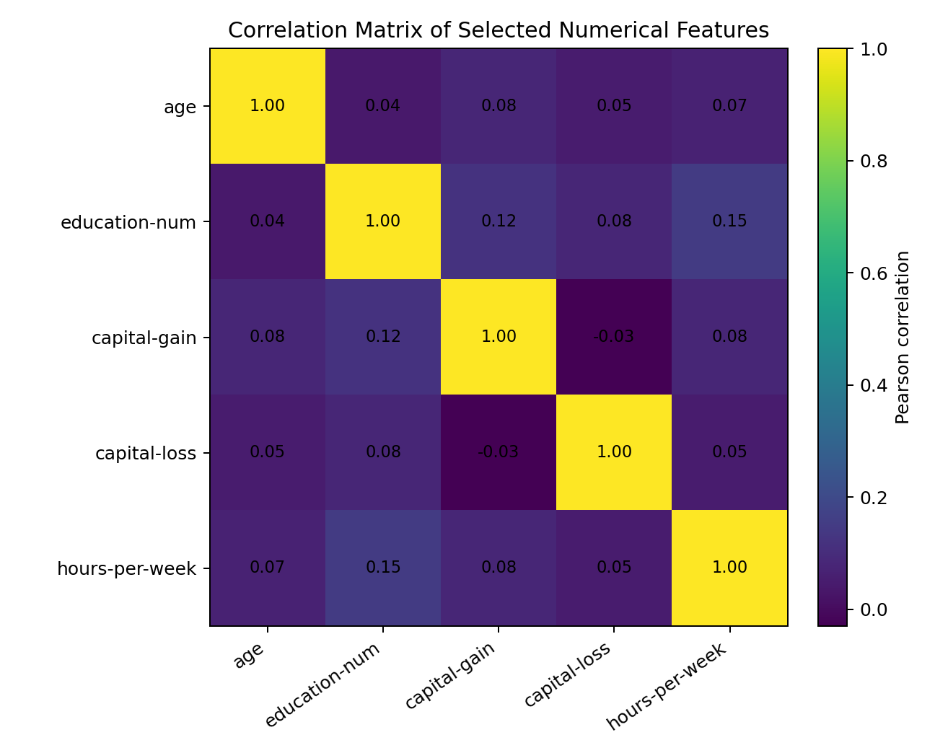
Figure 5. Correlation matrix for selected numerical features.
The correlation matrix is useful for identifying linear relationships, but correlation should not be interpreted as causation. The numerical variables do not all have strong pairwise linear relationships. Education-num and hours-per-week show a modest positive association, while capital-related variables have highly skewed distributions and relatively weak linear relationships with most other numerical variables.

8. Multivariate Exploration
sns.boxplot(
data=df,
x="income",
y="hours-per-week",
hue="sex"
)
plt.title("Weekly Working Hours by Income and Sex")
plt.xlabel("Income category")
plt.ylabel("Hours per week")
plt.legend(title="Sex")
plt.tight_layout()
plt.show()
A multivariate view was used to avoid studying each feature in isolation. Combining income, working hours, and sex can reveal differences that are hidden in a single-variable plot. The purpose is descriptive: it highlights group differences that can be investigated further rather than assigning a causal explanation.

9. Data Transformations and Aggregations
Transformation | Purpose | Effect on interpretation
income value counts | Measure target balance | Shows the relative frequency of the two classes
crosstab + normalize='index' | Compare categories fairly | Produces within-group percentages
hours-per-week bins | Make continuous hours easier to compare | Turns raw hours into interpretable working-hour groups
correlation() | Measure linear association | Values closer to ±1 indicate stronger linear association
top category filtering | Keep categorical plots readable | Prevents charts from becoming overcrowded
The most important aggregation was row-wise normalization of cross-tabulations. Raw counts can be misleading when categories have different numbers of observations. Calculating percentages within each group makes comparisons more meaningful.

10. Patterns and Anomalies
- The income target is substantially imbalanced, with the <=50K class representing about three quarters of the training data.
- Capital-gain and capital-loss are highly concentrated near zero, with a small number of large values. These observations should not automatically be removed.
- Higher educational attainment is associated with a larger share of >50K observations.
- Income distributions vary across workclass categories.
- The relationship between working hours and income is positive in broad groups but is not perfectly monotonic.
- The same apparent relationship can change after introducing another variable, which is why multivariate EDA is useful.

11. Critical Interpretation of Findings
The strongest conclusion from the EDA is that income is associated with several characteristics simultaneously rather than with a single feature. Education, age, workclass, occupation, working hours, and other variables can overlap. For example, an education-income relationship may partly reflect the types of occupations available to people with different educational backgrounds.
The analysis also demonstrates why visualization must be accompanied by context. A category with a high percentage of higher-income observations may have a small sample size, while a large category may dominate an unnormalized count chart. Similarly, an outlier in capital gain may be a legitimate financial observation rather than a data-entry error.

12. Limitations of the Analysis
- The analysis is descriptive and does not establish causal relationships.
- The dataset represents a historical census snapshot and should not automatically be interpreted as a current picture of income.
- Some categories have substantially different sample sizes.
- The income threshold is a specific classification target and does not represent a complete measure of economic well-being.
- Correlation captures linear association and can miss nonlinear relationships.

13. Key Findings and Conclusion
Finding | Interpretation
Target imbalance | Most observations are <=50K, so future classification evaluation should use more than accuracy.
Education-income pattern | Higher education levels generally have a greater share of >50K records.
Workclass differences | Income composition differs between employment categories.
Working hours | Longer working-hour groups generally show a higher higher-income share, but the trend is not perfectly linear.
Age | Income distributions differ by age, consistent with experience and career-stage effects.
Numerical correlations | Most selected variables have weak-to-moderate linear relationships, so no single numeric feature explains income.
Overall, the EDA transformed the cleaned dataset into a set of interpretable observations about distributions and relationships. The next analytical stage could use these findings to select features, formulate hypotheses, and build a classification model while carefully handling class imbalance and data leakage.

14. References
1. UCI Machine Learning Repository — Adult Dataset
https://archive.ics.uci.edu/dataset/2/adult
2. Becker, B. & Kohavi, R. (1996). Adult [Dataset]. UCI Machine Learning Repository. DOI: 10.24432/C5XW20.
3. Pandas documentation — DataFrame, crosstab, descriptive statistics and plotting.
https://pandas.pydata.org/docs/
4. Matplotlib documentation — Plotting and figure customization.
https://matplotlib.org/stable/
5. Seaborn documentation — Statistical visualization.
https://seaborn.pydata.org/

