**NTU CSIE  
104 Fall Software Engineering Class**

Project Execution Plan  
TransOn

Advisor：李允中 教授

許睿陵、秦睿謙、程至賢、林奕安

彭彥肇、林宣丞、王凱昇、吳佳芷

# Outline

Outline 2

Version Control History 3

1. Content 4

**1.1 Origin** 4

2. Life Cycle and Responsibility 5

3. Milestone 6

**4. Resource** 6

**4.1 Project Member** 6

4.2 Developer Tools and Resources 7

4.3 Knowledge and Skill Requirements 7

4.4 Training Plan 7

**5. Risk Management** 8

**6. Time and Progress Review Monitoring Mechanism** 9

**6.1 Straggly percentage** 9

**6.2 Correcting standard** 9

# Version Control History

|  |  |  |  |  |  |
| --- | --- | --- | --- | --- | --- |
| Version | Responsibility | Date | Change Description | Investigator | Investigation Date |
| 0.1 | 林宣丞 | 14/10/17 | Create PEP Draft | All | 14/10/17 |

# Content

**1.1 Origin**

The hearing-loss people have the effects of deprivation of information. The situation is like moving to a country of other languages. They have same common points that can hear the voices clearly, but don’t understand the contents of voice. We want to develop an app with the cell phone. It can improve this situation.

# 2. Life Cycle and Responsibility

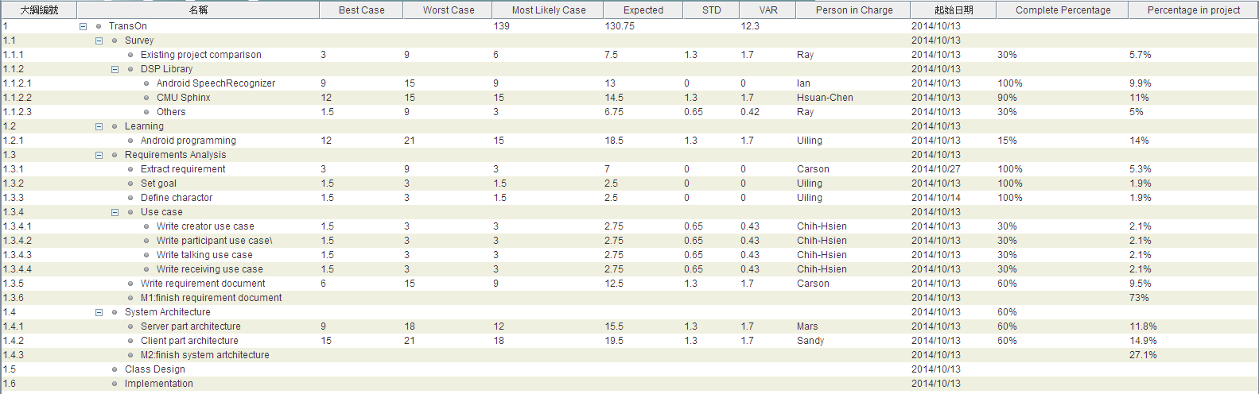

Figure 1: Gantt chart

# 3. Milestone

|  |  |  |
| --- | --- | --- |
| 里程碑 | 日期 | 內容 |
| M1 |  | Finish requirement document |
| M2 |  | Finish system architecture |

Table 1: Milestone

**4. Resource**

**4.1 Project Member**

|  |  |  |
| --- | --- | --- |
| Name | Title | Role |
| 李允中 | NTU CSIE Professor | Senior Manager |
| 許睿陵 | PhD student | Manager |
| 秦睿謙 | Master Student | Member |
| 程至賢 | Master Student | Member |
| 林奕安 | Master Student | Member |
| 彭彥肇 | Master Student | Member |
| 林宣丞 | Master Student | Member |
| 王凱昇 | Master Student | Member |
| 吳佳芷 | Master Student | Member |

Table 2: Project Member

## 4.2 Developer Tools and Resources

* Hardware：PC*8、Server*1, Smart Phone, Taiwan Academic Network
* Software：Gantt Project, Microsoft Office, Eclipse, Software Ideas Modeler, Android SDK and Git

## 4.3 Knowledge and Skill Requirements

|  |  |  |  |
| --- | --- | --- | --- |
| Skill | Persons | Participants | Remark |
| Android Programming | 8 | All |  |

Table 3: Knowledge and Skill Requirements

## 4.4 Training Plan

|  |  |  |  |
| --- | --- | --- | --- |
| Item | Participants | Method | Duration |
| Android Programming | All members | Study Group | 2014/10/17~ |

Table 4: Training Plan

**5. Risk Management**

* Low Impact：Risk items have impact less than 30%
* Medium Impact：Risk items have impact more than 30%, less than 60%
* High Impact：Risk items have impact more than 60%

|  |  |  |  |
| --- | --- | --- | --- |
| Risk Item | Impact | Probability | Solution |
| Limited budget | Low | High |  |
| Progress less than expected | High | High | Hold a meeting to discuss |
| Requirements are vague and incomplete | High | Medium | Learn related knowledge and reference to existing system |
| Unfamiliar with developer tools | High | Low | Plan a training course |
| Coding abilities vary | Medium | High | Enhance Learning and dispatch capable work |
| Coding standard inconsistent，hard to maintain | Medium | High | Set Coding Standard to follow |
| Problem with Artwork | Low | Low | Outsourcing |
| Low Recognition Performance | High | High | Develop a better model |

Table 5: Risk items

**6. Time and Progress Review Monitoring Mechanism**

Every ongoing tasks should be reviewed every week, and the project manager review the work progress in the following mechanism.

**6.1 Straggly percentage**

(Current time-Deadline)

D= * 100%

(Deadline-Start time)

**6.2 Correcting standard**

* 100/12/05~100/12/27 Set correcting standard as 20%，when progress is behind 20%, the correcting procedure should be executed.

**6.3 Correcting Procedure**

Project manager should have a meeting with stakeholders to discuss the schedule and execute procedure.

Monitoring items are as followed:

|  |  |  |  |  |  |
| --- | --- | --- | --- | --- | --- |
| No | Milestone | Expected | Actual | Correcting Standard | Correcting Mechanism |
| M1 | Finish requirement document |  |  |  |  |
| M2 | Finish system architecture |  |  |  |  |