
Dr. APJ ABDUL KALAM SCHOOL OF ENGINEERING
DEPARTMENT OF ENGINEERING

NAME OF THE STUDENT: UJALA YADAV
ROLL NO.: 24BTCE147 SEC:“A”
BRANCH: BTECH IN COMPUTER SCIENCE
COURSE: ADVANCE JAVA
ASSIGNMENT: 03
DATE ISSUED: 16/09/2026
DATE OF SUBMISSION:17/09/2026

- Establishing Database Connection
Write a Java JDBC program to connect to a MySQL database named school. Display "Database Connected Successfully" if the connection is established; otherwise, display an appropriate error message.
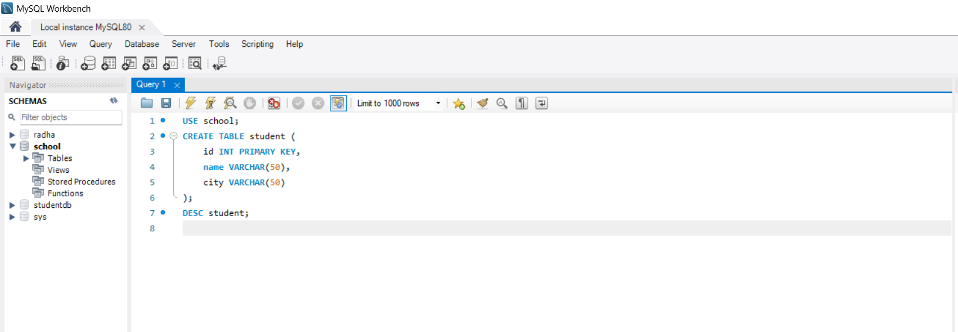

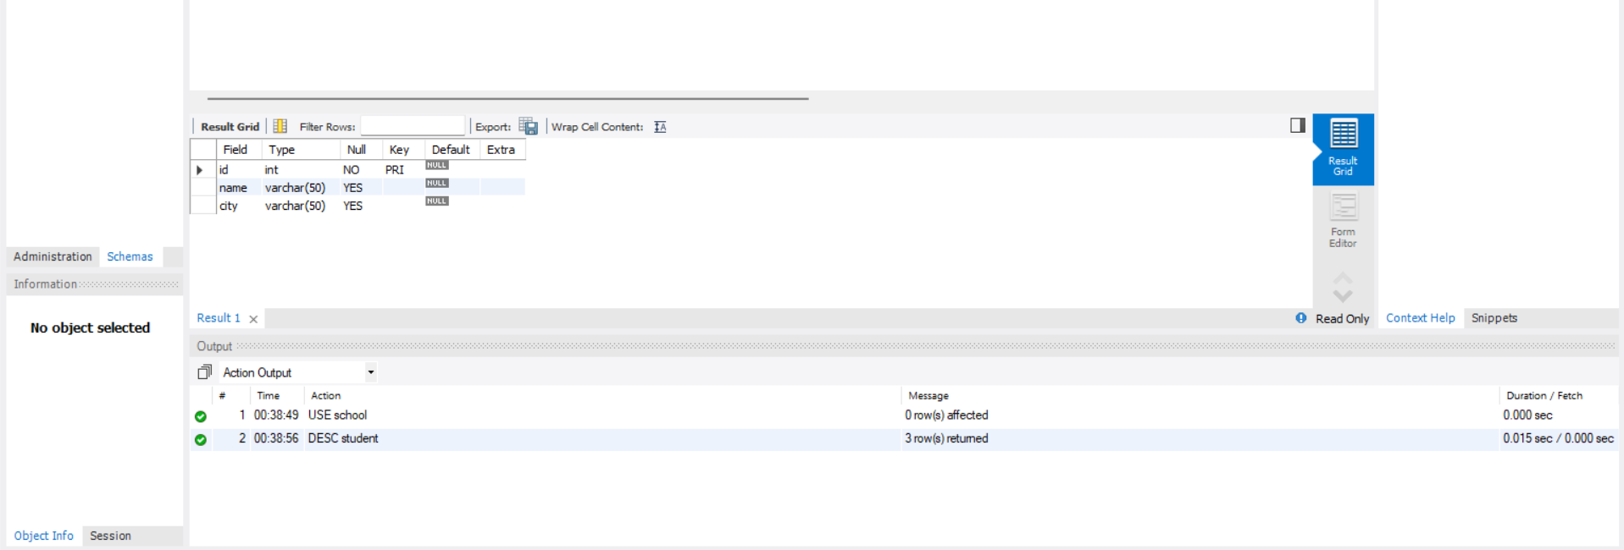

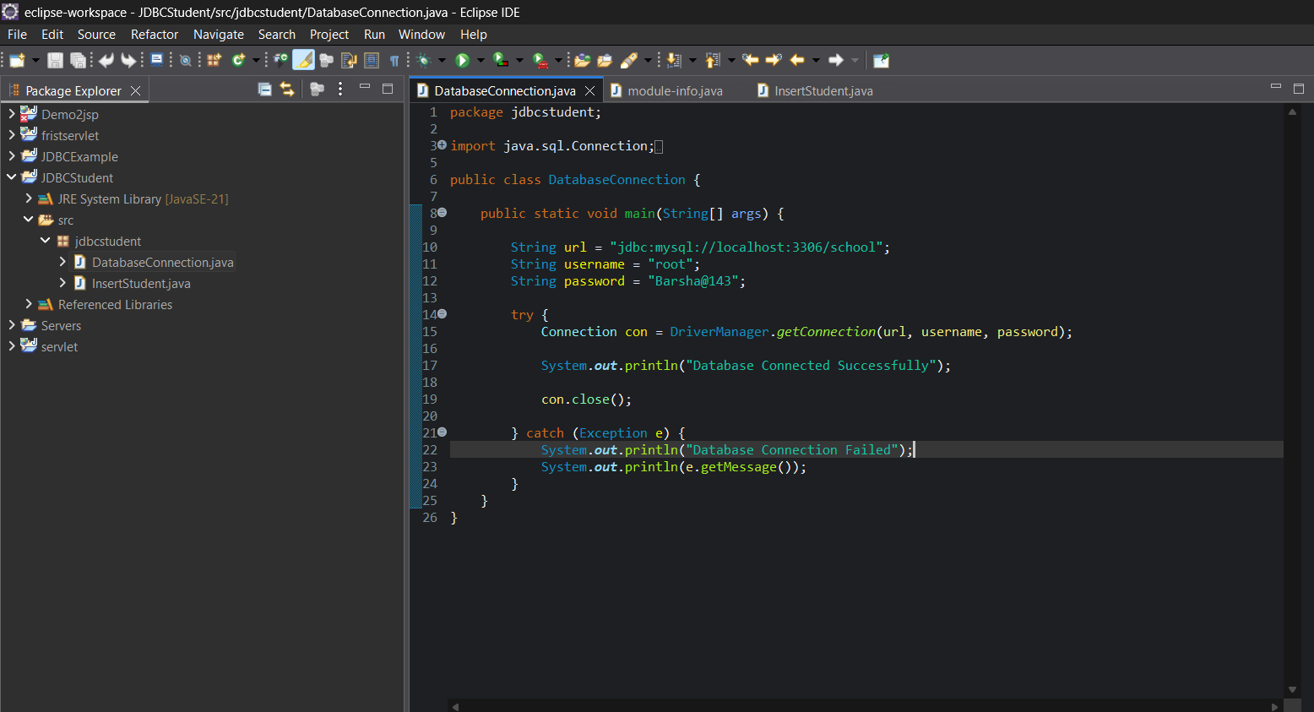

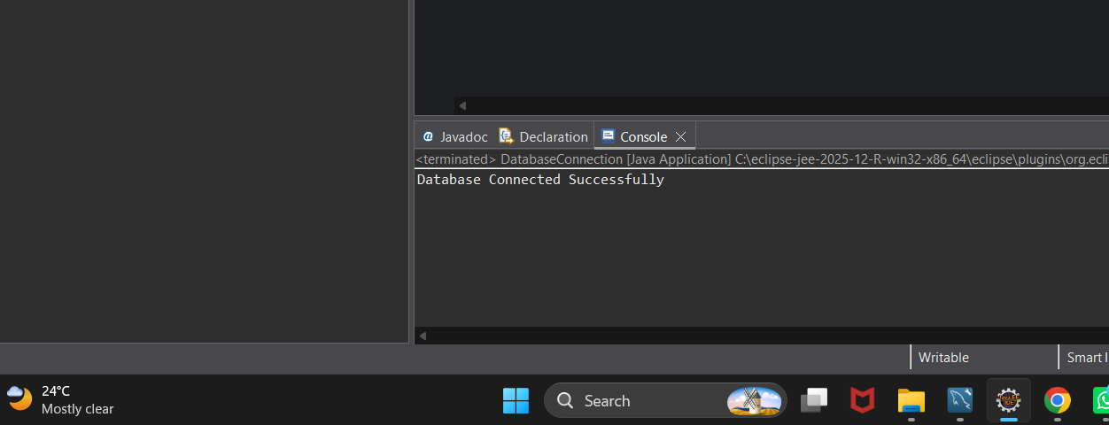
Output:

- Insert Records using JDBC
Create a table student with the following fields:
id – INT, Primary Key
name – VARCHAR(50)
city – VARCHAR(50)
Write a JDBC program to insert 5 student records into the table

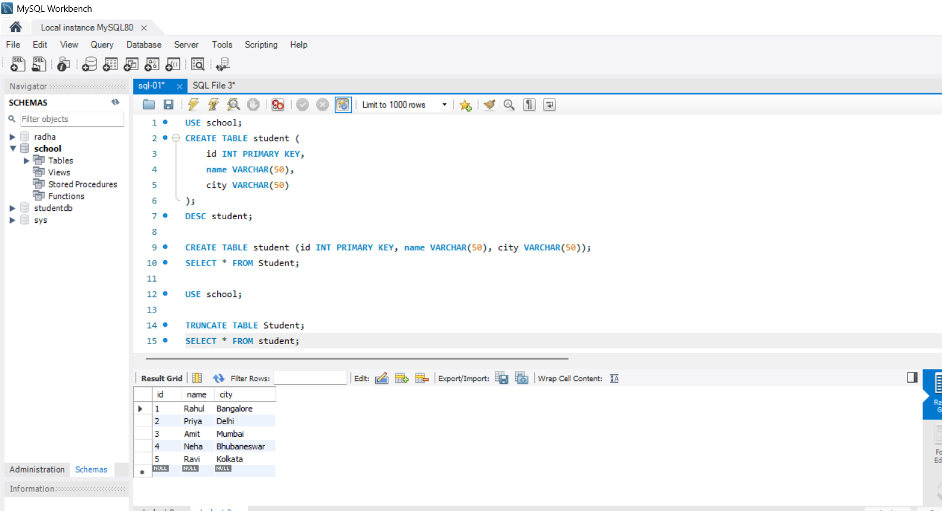
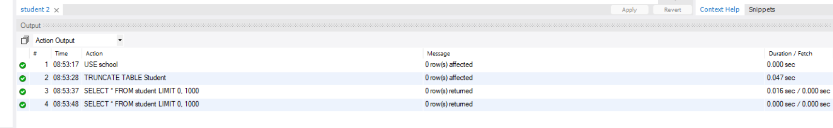
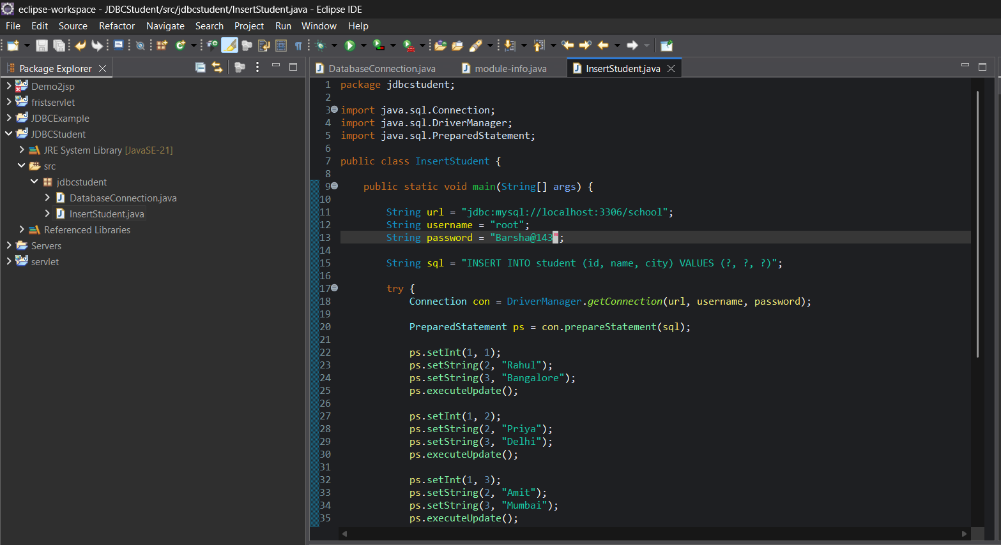
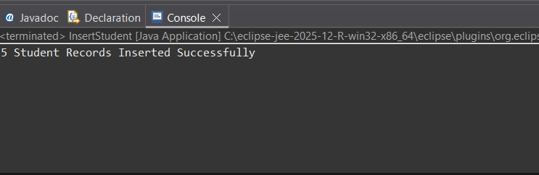
output:

