**A mini project report on**

**PERSONAL LIBRARY SYSTEM**

*for the award of the degree*

*of*

**BACHELOR OF TECHNOLOGY**

**In**

**COMPUTER SCIENCE AND ENGINEERING**

(III Year -1st Semester)

***Submitted by***

# Ashutosh Mishra ( 17B91A05P4.)

# Bikash Rana Magar ( 17B91A05P5.)

# .

# .

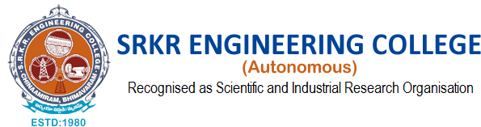

**DEPARTMENT OF COMPUTER SCIENCE AND ENGINEERING**

**SRKR ENGINEERING COLLEGE (A)**

ChinnaAmiram, Bhimavaram, West Godavari Dt.,

[2019 – 2020]

**Acknowledgement**

We acknowledge the importance of