**ECOSMART:**

**Intelligent Emission Insights and Sustainable Credit Solutions**

|  |  |  |  |  |  |
| --- | --- | --- | --- | --- | --- |
| Names and reg no. | : | **Bhavyata Kaur(22BCE1580), Abhijeet Soni(22BCE1582), Bhushan Songire(22BCE1539)** | Slot |  | **D2** |
| Programme | : | **B.Tech CSE** | Semester | : | **Fal 24-25** |
| Course | : | **Database Management Systems Lab** | Code | : | **BCSE302L** |

ER DIAGRAM:

EER DIAGRAM:

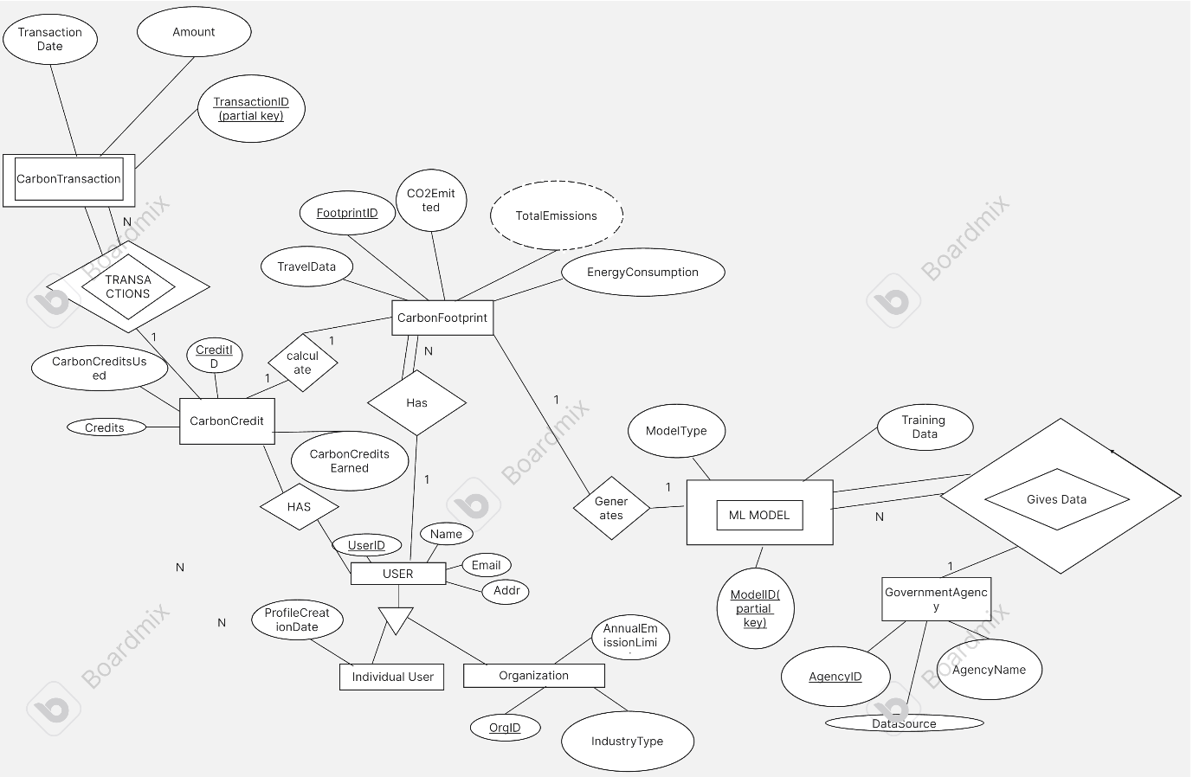

FUNCTIONAL FLOW/BLOCK DIAGRAM:

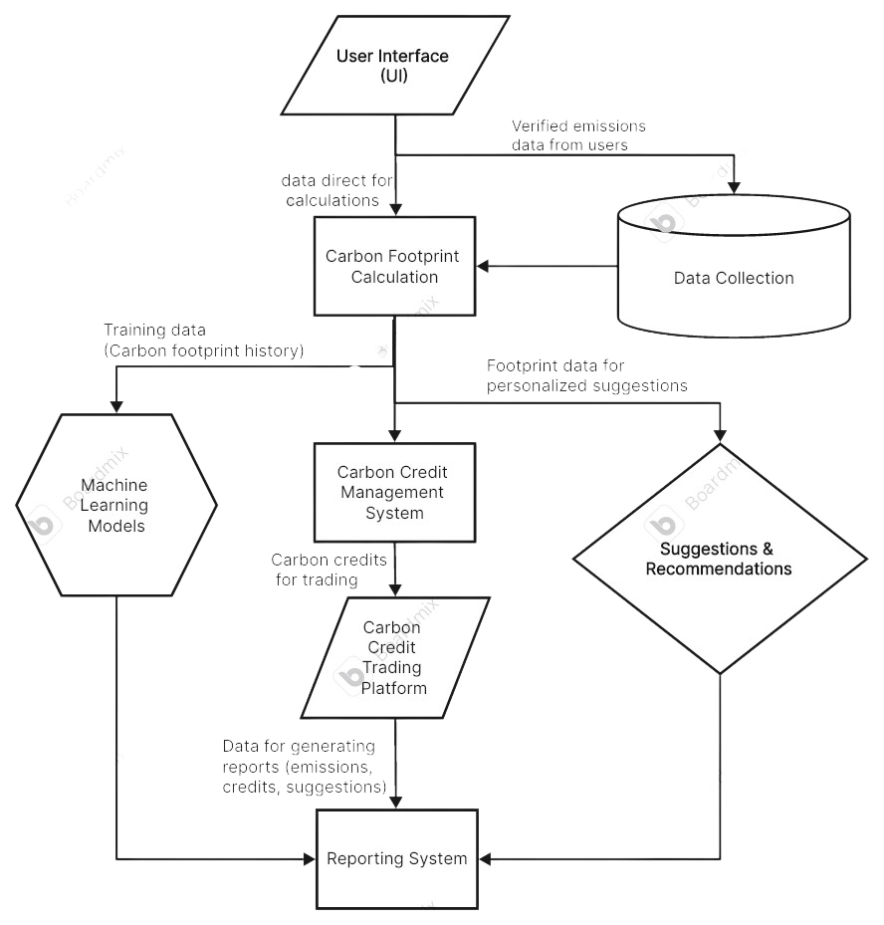

**EXPLANATION:**

**User Interaction**: Individuals and organizations input their daily activities (energy usage, travel, etc.) into the User Interface. This data is tracked to compute their carbon footprint.

**Data Collection & Validation**: Verified emissions data is gathered from government agencies to ensure the accuracy of the carbon footprint calculations. This feeds into the system along with user-provided data.

**Carbon Footprint Calculation:** The system calculates the carbon footprint based on daily activities like energy consumption, travel, etc., and stores this information in the CarbonFootprint entity. This calculation includes both users (individuals) and organizations.

**Machine Learning Integration**: The Machine Learning Models are trained using historical carbon footprint data. These models predict future emissions and provide insights for reducing carbon footprints.

**Carbon Credit System:** Based on their carbon emissions, users and organizations either earn carbon credits (for staying within emission limits) or incur penalties (for exceeding limits). This is managed through the CarbonCredit system, which tracks the credits earned, used, and available.

**Carbon Credit Trading:** Users and organizations can trade carbon credits in a marketplace. The CarbonTransaction system allows for buying, selling, and trading of carbon credits, providing financial incentives for reducing emissions.

**Suggestions & Recommendations:** Based on the carbon footprint data, the system generates suggestions on how users and organizations can reduce their emissions. This helps them make more eco-friendly decisions.

**Reporting & Tracking:** The system generates detailed reports on users’ carbon footprints, carbon credit usage, and suggestions. These reports are provided monthly or annually, allowing users to track their performance and contributions to environmental sustainability.

**Specialization & Generalization:** Both Individual Users and Organizations are specialized from the common User entity, sharing some data (like carbon footprint) but also having specific attributes and requirements (like emission limits for organizations).