VenueFlow
Antigravity Integration Brief
Google Hackathon Demo — Working Prototype Spec

Prepared for: Antigravity team
Stack: React + Tailwind + Supabase + Antigravity API

1. What We Are Building
VenueFlow is a real-time crowd intelligence system for large sporting venues. It connects three products over a shared Supabase backend:

Staff dashboard  React app — live zone heatmap, bottleneck alerts, staff dispatch | Fan / attendee app  React PWA — smart routing, live queue ETAs for stalls & gates | Antigravity engine  ML crowd prediction — congestion forecast, exit sequencing

2. End-to-End Data Flow
The diagram below shows the complete live data pipeline — from sensors to Antigravity to both UIs — completing in under 90 seconds end-to-end.

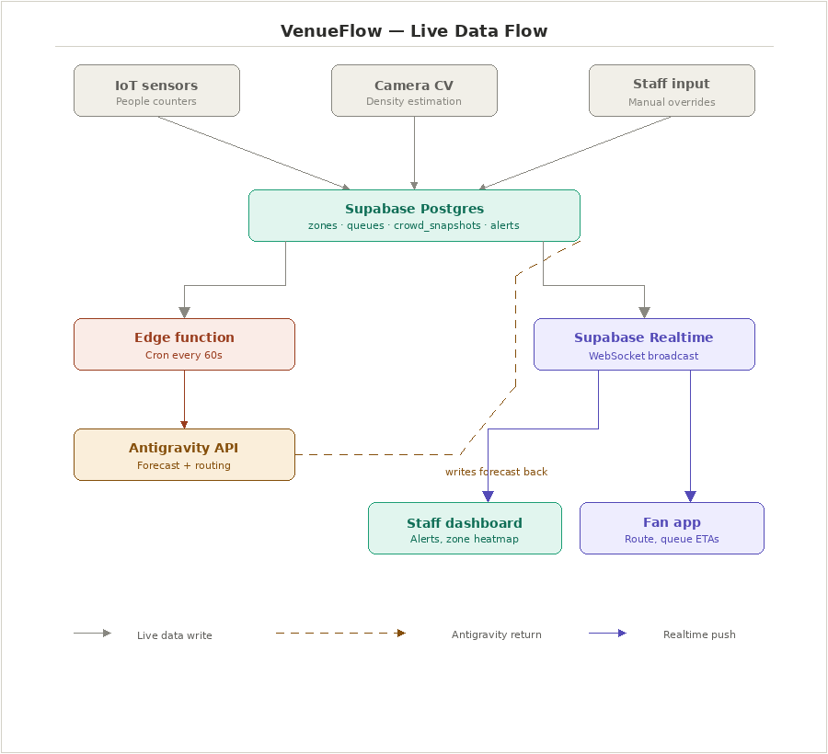

How the loop closes
1. IoT sensors / camera CV push zone density to Supabase Postgres every 3 seconds.
2. A Supabase Edge Function fires on a 60-second cron trigger.
3. It pulls the last 10 crowd_snapshots per zone and calls the Antigravity API.
4. Antigravity returns congestion forecasts + optimal routing paths.
5. Edge Function writes forecasts back to Postgres.
6. Postgres update triggers Supabase Realtime — both staff dashboard and fan app update instantly, no polling.

3. Supabase Database Schema
All tables live in Supabase Postgres with Row-Level Security. Attendees can only SELECT on zones and queues. Only Edge Functions can INSERT on alerts.

zones
Column | Type | Description
id | uuid PK | Unique zone identifier
name | text | Zone name: Gate A, Food Zone, etc.
capacity | integer | Maximum safe occupancy
current_count | integer | Live count from sensor feed
density_pct | numeric | current_count / capacity x 100
forecast_5min | numeric | Antigravity predicted density in 5 min
risk_level | text | normal | elevated | critical (from Antigravity)
updated_at | timestamptz | Last sensor update timestamp

queues
Column | Type | Description
id | uuid PK | Unique queue identifier
zone_id | uuid FK | References zones.id
name | text | Queue name: Burger Stand, Washrooms, etc.
current_depth | integer | Number of people in queue right now
throughput_per_min | numeric | How many people served per minute
eta_minutes | numeric | Predicted wait — written by Edge Function
updated_at | timestamptz | Last update timestamp

crowd_snapshots
Column | Type | Description
id | uuid PK | Unique snapshot identifier
zone_id | uuid FK | Zone this reading belongs to
density_pct | numeric | Density at time of this snapshot
timestamp | timestamptz | Exact reading time (time-series data for Antigravity)

alerts
Column | Type | Description
id | uuid PK | Unique alert identifier
zone_id | uuid FK | Zone where alert triggered
type | text | BOTTLENECK_FORMING | CRITICAL | QUEUE_SPIKE
severity | integer | 1 = low, 2 = medium, 3 = high
message | text | Human-readable description for staff
resolved | boolean | True after staff acknowledge and dispatch
created_at | timestamptz | When the alert fired

4. Antigravity API — Request Payload
The Edge Function fires every 60 seconds, pulls the last 10 crowd_snapshots per zone, and sends the following payload to Antigravity:

{
"venue_id": "stadium-001",
"zones": [
{
"id": "gate-a",
"name": "Gate A",
"capacity": 500,
"connections": ["food-zone", "north-exit"],
"snapshots": [
{ "timestamp": "2026-08-14T18:00:00Z", "count": 380 },
{ "timestamp": "2026-08-14T18:01:00Z", "count": 410 },
{ "timestamp": "2026-08-14T18:02:00Z", "count": 435 },
{ "timestamp": "2026-08-14T18:03:00Z", "count": 448 },
{ "timestamp": "2026-08-14T18:04:00Z", "count": 452 }
]
},
{
"id": "food-zone",
"name": "Food Zone",
"capacity": 300,
"connections": ["gate-a", "north-exit", "merch-stand"],
"snapshots": [
{ "timestamp": "2026-08-14T18:00:00Z", "count": 185 },
{ "timestamp": "2026-08-14T18:01:00Z", "count": 192 }
]
}
]
}

Key field — connections
The 'connections' array maps which zones are physically adjacent to each other.
Antigravity uses this to calculate routing paths and spill-over risk.
You only need to define this once — it is the static venue topology map.

5. Antigravity API — Response Payload
Antigravity returns two things: per-zone congestion forecasts, and recommended routing paths for attendees.

{
"forecasts": [
{
"zone_id": "gate-a",
"predicted_density_5min": 94,
"predicted_density_10min": 98,
"risk": "critical"
},
{
"zone_id": "food-zone",
"predicted_density_5min": 71,
"predicted_density_10min": 68,
"risk": "elevated"
}
],
"routing": [
{
"from": "seat-b12",
"recommended_path": ["upper-catwalk", "south-exit"],
"avoided_zones": ["gate-a"],
"time_saved_min": 1
}
],
"exit_sequence": [
{ "sections": ["block-3", "block-4", "block-5"], "exit_at_min": 0 },
{ "sections": ["block-6", "block-7"], "exit_at_min": 4 },
{ "sections": ["block-8", "block-9", "block-10"], "exit_at_min": 8 }
]
}

Where the response goes
- forecasts[ ] — Edge Function writes predicted_density_5min and risk back to the zones table. This triggers Supabase Realtime, updating the staff heatmap and fan app routing simultaneously.
- routing[ ] — Written to a routing table (or cached in memory). Fan app reads this to update the Smart Routing card dynamically — when Gate A goes critical, the card switches to the south exit path automatically.
- exit_sequence[ ] — Displayed on the staff dashboard's Exit Sequencer panel. Staff relay via PA system.

6. Supabase Edge Function
This is the complete Edge Function that connects Supabase to Antigravity. Deploy it with: supabase functions deploy call-antigravity

// supabase/functions/call-antigravity/index.ts
import { createClient } from 'https://esm.sh/@supabase/supabase-js@2'

const supabase = createClient(
Deno.env.get('SUPABASE_URL')!,
Deno.env.get('SUPABASE_SERVICE_ROLE_KEY')!
)

Deno.serve(async () => {
// 1. Fetch all zones with last 10 snapshots each
const { data: zones } = await supabase
.from('zones').select('id, name, capacity, connections')

const payload = {
venue_id: 'stadium-001',
zones: await Promise.all(zones.map(async (zone) => {
const { data: snaps } = await supabase
.from('crowd_snapshots')
.select('timestamp, density_pct')
.eq('zone_id', zone.id)
.order('timestamp', { ascending: false })
.limit(10)
return {
...zone,
snapshots: snaps.map(s => ({
timestamp: s.timestamp,
count: Math.round(s.density_pct / 100 * zone.capacity)
}))
}
}))
}

// 2. Call Antigravity
const res = await fetch('https://api.antigravity.ai/v1/predict', {
method: 'POST',
headers: {
'Content-Type': 'application/json',
'Authorization': `Bearer ${Deno.env.get('ANTIGRAVITY_API_KEY')}`
},
body: JSON.stringify(payload)
})
const { forecasts, routing, exit_sequence } = await res.json()

// 3. Write forecasts back to Postgres
// This triggers Supabase Realtime -> both UIs update instantly
for (const f of forecasts) {
await supabase.from('zones').update({
forecast_5min: f.predicted_density_5min,
risk_level: f.risk
}).eq('id', f.zone_id)
}

// 4. Cache routing suggestions
await supabase.from('routing_cache')
.upsert({ id: 'latest', data: routing, exit_sequence })

// 5. Fire alerts if any zone is critical
for (const f of forecasts) {
if (f.risk === 'critical') {
await supabase.from('alerts').insert({
zone_id: f.zone_id,
type: 'BOTTLENECK_FORMING',
severity: 3,
message: `Zone predicted at ${f.predicted_density_5min}% in 5 minutes`
})
}
}

return new Response('ok')
})

Set the cron schedule in supabase/config.toml:

[functions.call-antigravity]
schedule = "*/60 * * * * *" # every 60 seconds

7. Sensor Simulator (Demo Mode)
Since real IoT hardware is not available during the hackathon, run this script in the background during the demo. It nudges each zone's density every 3 seconds with a slight upward drift — and spikes Gate A to 90% at the 45-second mark for the demo narrative.

// simulate_sensors.js — run with: node simulate_sensors.js
import { createClient } from '@supabase/supabase-js'

const supabase = createClient(process.env.SUPABASE_URL, process.env.SUPABASE_ANON_KEY)

const ZONES = [
{ id: 'gate-a', base: 60 },
{ id: 'food-zone', base: 55 },
{ id: 'gate-b', base: 40 },
{ id: 'restroom', base: 50 },
{ id: 'north-exit', base: 35 },
{ id: 'merch-stand',base: 65 },
]

const state = Object.fromEntries(ZONES.map(z => [z.id, z.base]))

// Update all zones every 3 seconds
setInterval(async () => {
for (const zone of ZONES) {
const delta = (Math.random() - 0.42) * 6 // slight upward drift
state[zone.id] = Math.min(100, Math.max(10, state[zone.id] + delta))

await supabase.from('zones').update({
density_pct: Math.round(state[zone.id]),
current_count: Math.round(state[zone.id] / 100 * 500)
}).eq('id', zone.id)

// Also write snapshot for Antigravity history
await supabase.from('crowd_snapshots').insert({
zone_id: zone.id,
density_pct: Math.round(state[zone.id]),
timestamp: new Date().toISOString()
})
}
}, 3000)

// DEMO MOMENT: spike Gate A to 90% at 45 seconds
setTimeout(async () => {
state['gate-a'] = 90
console.log('DEMO: Gate A spiked to 90%')
}, 45000)

8. Frontend Realtime Wiring
Both apps use the same Supabase Realtime hook. When Antigravity writes forecasts back to Postgres, the Realtime event fires and both UIs update with zero polling.

Staff dashboard — live zone hook
// hooks/useZones.ts
export function useZones() {
const [zones, setZones] = useState([])

useEffect(() => {
// Initial fetch
supabase.from('zones').select('*').then(({ data }) => setZones(data))

// Realtime subscription — fires whenever Antigravity writes back
const channel = supabase.channel('zones-live')
.on('postgres_changes', {
event: 'UPDATE', schema: 'public', table: 'zones'
}, (payload) => {
setZones(prev => prev.map(z =>
z.id === payload.new.id ? payload.new : z
))
})
.subscribe()

return () => supabase.removeChannel(channel)
}, [])

return zones
}

Fan app — smart routing card
When Gate A's risk_level turns 'critical', the fan app automatically shows the alternative route. No manual refresh needed.

// The routing card re-renders automatically because zones is live
function SmartRoutingCard({ userSeat }) {
const zones = useZones()
const { data: routing } = useCachedRouting() // reads routing_cache table

const congested = zones
.filter(z => z.risk_level === 'critical')
.map(z => z.id)

// Antigravity already computed the best path excluding congested zones
const route = routing?.find(r =>
r.from === userSeat &&
r.avoided_zones.every(z => congested.includes(z))
)

return (
<div>
<p>Smart Routing Active</p>
<p>Start: {userSeat}</p>
<p>Via: {route?.recommended_path[0]}</p>
<p>Exit: {route?.recommended_path.at(-1)}</p>
<p>{route?.time_saved_min} min saved</p>
</div>
)
}

9. Wiring the Dispatch Button
The Dispatch Response button on the Incident Alerts panel currently does nothing. This one change makes it fully live — clicking it resolves the alert across all connected staff dashboards simultaneously.

const handleDispatch = async (alertId: string) => {
await supabase
.from('alerts')
.update({
resolved: true,
resolved_at: new Date().toISOString()
})
.eq('id', alertId)
// Supabase Realtime fires automatically — alert disappears
// from every connected staff dashboard with no extra code
}

10. Demo Script — The 90-Second Loop
This is the exact narrative sequence to run during the hackathon demo. Every step is visible on screen with no manual refreshing.

The demo moment judges need to see
One event causes visible changes in two different UIs simultaneously.
That is the proof the system is real and not a prototype with fake data.

- Start sensor simulator: node simulate_sensors.js — zones begin drifting live on the dashboard
- Show the staff dashboard — Gate A, Food Zone, and Merch Stand updating every 3 seconds
- Click Gate A — the zone detail drawer opens with live CV feed, traffic trend chart, and security protocol
- At 45 seconds — simulator spikes Gate A to 90%. The card badge turns Critical automatically
- The Incident Alert panel shows 'Critical Capacity — Gate A at 90%' — no page refresh
- Staff clicks Dispatch Response — alert status changes to 'Response Dispatched' in real time
- Switch to the fan app screen — the Smart Routing card has already updated to avoid Gate A, now routing via Upper Catwalk to South Exit
- Show the time saved badge: '1 min saved' — Antigravity calculated this from the congestion forecast
- Live Queue ETAs panel shows Burger Stand 4 min, Coffee Shop 3 min, Washrooms 1 min — all updating

VenueFlow · Google Hackathon 2025 · Antigravity Integration Brief

