OBJECTIVE: To be familiar with Panda’s library and Matplotlib THEORY:
- Introduction to pandas
Pandas is an open-source Python library used for data manipulation and analysis. It provides powerful, flexible data structures that make handling structured data easy and efficient.
Key Features
  - Fast and efficient data handling
  - Easy handling of missing data
  - Data alignment and reshaping
  - Integration with other libraries like NumPy
  - Supports reading/writing data from multiple formats (CSV, Excel, SQL, JSON)
- Introduction to Matplotlib
Matplotlib is a widely used Python library for data visualization. It helps in creating static, animated, and interactive graphs.
Key Features
  - Simple and flexible plotting
  - Supports multiple plot types
  - Customizable graphs (labels, colours, styles)
  - Works well with NumPy and Pandas
Q1. A tourism agency in Nepal maintains its booking records in a CSV file named tourism_bookings.csv. The file contains the following columns: Tour_Package, District, Bookings, and Earnings. Write a Python program using Pandas to:
- Load the data from the CSV file into a DataFrame.
- Display the first five rows of the DataFrame.
- Display basic information about the DataFrame (like shape, column types, memory usage).
- Replace any missing values in the Earnings column with the median value of that column.
- Calculate and display the total earnings for each Tour_Package.
- Filter and display only the records from the Kaski district where the number of Bookings is greater than 15.
→ code:
import pandas as pd
df = pd.read_csv("tourism_bookings.csv") print("First five rows:")
print(df.head())
print("\nBasic Information:")

print("Shape:", df.shape) print("\nData Types:") print(df.dtypes) print("\nDetailed Info:") print(df.info())

median_earnings = df['Earnings'].median() df['Earnings'].fillna(median_earnings, inplace=True)

total_earnings = df.groupby('Tour_Package')['Earnings'].sum() print("\nTotal Earnings for each Tour Package:") print(total_earnings)

filtered_data = df[(df['District'] == 'Kaski') & (df['Bookings'] > 15)] print("\nFiltered Data (Kaski & Bookings > 15):") print(filtered_data)
Output:
First five rows:
Tour_Package District Bookings Earnings

0 | Annapurna Trek Kaski | 20 50000.0
1 | City Tour Kathmandu | 10 20000.0
2 | Jungle Safari Chitwan | 25 60000.0
3 | Annapurna Trek Kaski | 18 NaN
4 | City Tour Kaski | 30 40000.0
Basic Information:
Shape: (6, 4) Data Types:
Tour_Package object District object Bookings int64
Earnings float64 dtype: object
<class 'pandas.core.frame.DataFrame'> RangeIndex: 6 entries, 0 to 5

Data columns (total 4 columns):
# Column Non-Null Count Dtype

- Tour_Package 6 non-null object
- District 6 non-null object
- Bookings 6 non-null int64
- Earnings 5 non-null float64 dtypes: float64(1), int64(1), object(2) memory usage: 320.0+ bytes
None
Total Earnings for each Tour Package:
Tour_Package
Annapurna Trek 90000.0
City Tour 60000.0
Jungle Safari 90000.0
Name: Earnings, dtype: float64
Filtered Data (Kaski & Bookings > 15): Tour_Package District Bookings Earnings
0 | Annapurna Trek Kaski | 20 50000.0
3 | Annapurna Trek Kaski | 18 40000.0
4 | City Tour Kaski | 30 40000.0
Q2. Two small DataFrames are given:
import pandas as pd students = pd.DataFrame({
'roll_no': ['S01', 'S02', 'S03', 'S04', 'S05'],
'name': ['Aarav', 'Bipana', 'Chirag', 'Dipesh', 'Esha'], 'class': [10, 10, 9, 10, 9]})
marks = pd.DataFrame({
'roll_no': ['S01', 'S03', 'S04', 'S06'], 'maths': [85, 92, 78, 88],
'science': [90, 87, 82, 95]})
Combine the two DataFrames using pd.merge() with how='left' so that all students appear, even if they have no marks recorded yet. Print the result and comment on what happens to students S02 and S05.

- Now use pd.concat() to append the marks DataFrame below the students DataFrame (vertical concat). Print it and explain in a comment why this usually doesn't make sense for this kind of data.
- Use pd.concat() again, but this time horizontally (axis=1). Print the result and comment on the alignment of rows (which students get matched correctly and why some values become NaN).
- Summarize in your own words (2–3 lines): When should you use merge() instead of concat()?
→ code:
import pandas as pd students = pd.DataFrame({
'roll_no': ['S01', 'S02', 'S03', 'S04', 'S05'],
'name': ['Aarav', 'Bipana', 'Chirag', 'Dipesh', 'Esha'], 'class': [10, 10, 9, 10, 9]})
marks = pd.DataFrame({
'roll_no': ['S01', 'S03', 'S04', 'S06'], 'maths': [85, 92, 78, 88],
'science': [90, 87, 82, 95]})

merged = pd.merge(students, marks, on='roll_no', how='left') print("Merge operation:")
print(merged)

vertical_concat = pd.concat([students, marks]) print("\nvertical concat:") print(vertical_concat)

horizontal_concat = pd.concat([students, marks], axis=1) print("\nhorizontal concat:")
print(horizontal_concat)

Output:
Merge operation:
roll_no name class maths science
0 S01 Aarav 10 85.0 90.0
- S02 Bipana 10 NaN NaN
- S03 Chirag 9 92.0 87.0
- S04 Dipesh 10 78.0 82.0

- S05 Esha 9 NaN NaN

vertical concat:
roll_no name class maths science
- S01 Aarav 10.0 NaN NaN
- S02 Bipana 10.0 NaN NaN
- S03 Chirag 9.0 NaN NaN
- S04 Dipesh 10.0 NaN NaN
- S05 Esha 9.0 NaN NaN
0 S01 NaN NaN 85.0 90.0
1 S03 NaN NaN 92.0 87.0
2 S04 NaN NaN 78.0 82.0
3 S06 NaN NaN 88.0 95.0

horizontal concat:
roll_no name class roll_no maths science
0 S01 Aarav 10 S01 85.0 90.0
1 S02 Bipana 10 S03 92.0 87.0
2 S03 Chirag 9 S04 78.0 82.0
3 S04 Dipesh 10 S06 88.0 95.0
4 S05 Esha 9 NaN NaN NaN Comment:
- how='left' → keeps all rows from students Students S02 and S05:
  - No matching roll_no in marks
  - So, maths and science become NaN
- Rows are simply stacked
  - Columns don’t match → many NaN values Why this doesn’t make sense?
  - students and marks represent different attributes of same entities
  - Vertical concat treats them as separate rows, not related data
- Alignment is based on index (0,1, 2,...), NOT roll_no. So,
- Row 1 → S02 gets marks of S03 (wrong match)
- Row 3 → S04 gets marks of S06

- Last row has NaN because marks have fewer rows This causes incorrect data association
- Final summary:
  - Use merge() when combining data based on a common key (like roll_no)
  - Use concat() when stacking or joining datasets without key-based relationship
  - merge() ensures correct alignment, while concat() may lead to misaligned or meaningless data

Q3. Write a Python program using Matplotlib to create the following plots

- Line Plot
- Bar Chart
- Scatter Plot
- Histogram

Consider the data as: x = [1, 2, 3, 4, 5] y = [10, 20, 15, 25, 30]. Include proper titles and axes.

→ code:
import matplotlib.pyplot as plt x = [1, 2, 3, 4, 5]
y = [10, 20, 15, 25, 30]

# 1. Line Plot plt.figure(figsize=(6,4))
plt.plot(x, y, marker='o', color='b', linestyle='-') plt.title("Line Plot of x vs y")
plt.xlabel("X-axis") plt.ylabel("Y-axis") plt.grid(True) plt.show()

# 2. Bar Chart plt.figure(figsize=(6,4)) plt.bar(x, y, color='orange') plt.title("Bar Chart of x vs y") plt.xlabel("X-axis") plt.ylabel("Y-axis")
plt.show()

# 3. Scatter Plot

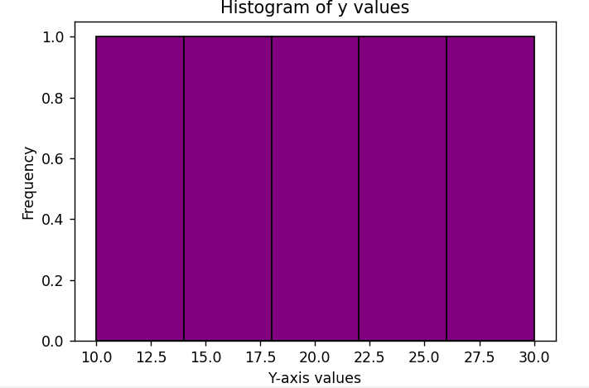
plt.figure(figsize=(6,4))
plt.scatter(x, y, color='green', s=100) plt.title("Scatter Plot of x vs y") plt.xlabel("X-axis")
plt.ylabel("Y-axis") plt.grid(True) plt.show()

# 4. Histogram plt.figure(figsize=(6,4))
plt.hist(y, bins=5, color='purple', edgecolor='black') plt.title("Histogram of y values")
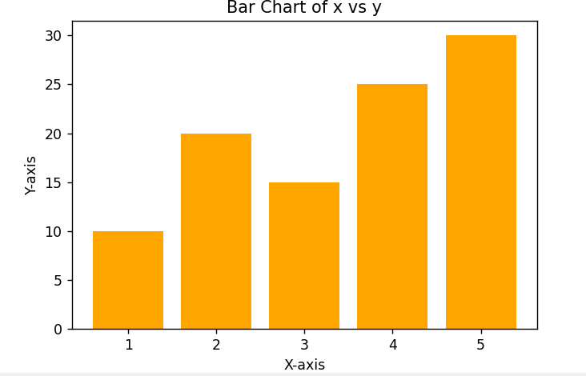
plt.xlabel("Y-axis values") plt.ylabel("Frequency") plt.show()

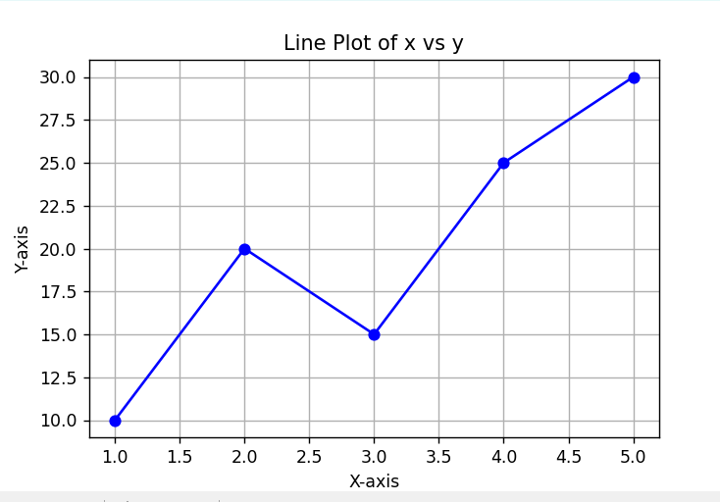

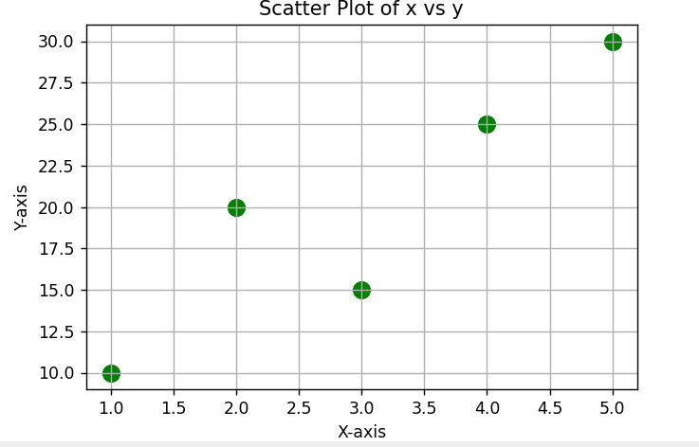

RESULT:
The experiment was successfully performed using Pandas and Matplotlib libraries in Python.
- The CSV file containing tourism booking data was successfully loaded into a DataFrame, and its structure, data types, and summary information were displayed correctly. Missing values in the Earnings column were handled by replacing them with the median value, ensuring data consistency.
- The total earnings for each tour package were calculated accurately using groupby operations. Filtering operations were also successfully applied to extract specific records (Kaski district with bookings greater than 15).
- DataFrame operations such as merge() and concat() were performed and analyzed. It was observed that:
  - merge() correctly combined related datasets using a common key.
  - concat() (vertical and horizontal) resulted in misaligned or incomplete data when used improperly.
- Various plots including line plot, bar chart, scatter plot, and histogram were successfully generated using Matplotlib. These visualizations clearly represented the given data and demonstrated different ways of presenting information graphically.

CONCLUSION:
This lab experiment helped in understanding the practical use of Pandas for data manipulation and Matplotlib for data visualization. It demonstrated how to handle real-world data tasks such as cleaning missing values, grouping, filtering, and combining datasets effectively.
The experiment also highlighted the importance of choosing the correct method (merge vs concat) when working with multiple datasets to avoid incorrect data alignment. Additionally, the creation of different types of plots improved the understanding of how data can be visually interpreted.
Overall, the lab enhanced practical knowledge of data analysis and visualization in Python, which is essential for fields like data science, machine learning, and analytics.

